Elemental Storm Design Document

Ryan Beehler
CIS 587 SS06
12/20/2006
UMID 06214776

Table of Contents
Elemental Storm Design Document 1
Overview 3
Game Mechanics 4
User Interface Design 4
Controls 4
Level Summary 5
Cut Scenes 5
Artificial Intelligence 6
Game Elements 7
Data Dictionary 7
Character Bibles 8
Story Overview 9
Game Progression 10
Level and Scenes 11
Lessons Learned 13
Bibliography 14

Overview

Elemental Storm is a 2D puzzle game where the player is a 13 year old in a fantasy world. His village needs protection from the elemental storms, therefore they send him on a quest for help. He needs to get help from the 4 elemental dragons (earth, wind, fire and water) to complete his quest.

Elemental Storm is meant to be a simple puzzle game that is playable by all ages due to the simple interface, but difficult to master. Only simple controls are used and the goal is to let the player move at their own pace. Therefore, more adept players can click as fast as they can and the game animations and game engine will react smoothly.

The game consists of a 13x7 tiled board and four elemental tiles: earth, water, wind, and fire. The player places the elemental tiles on the board, if two or more of the same elemental tiles touch, then points are awarded. In addition, when similar adjacent tiles are placed, then they change element types before removal. This results in the opportunity for adjacent elemental tiles to also be matched; this is called chaining.

Game Mechanics

User Interface Design
The game view is divided in half along the horizontal plane. Where the top half is for the computer opponent and the bottom half is for the player. Essential components to game play are the scores (left center), game timer (center), cursor icon indicating current element to place, the element queue displaying the next three elements (right side), and the chaining diagram indicating the order of element morphing (far right side).

There will be some in game comments specific to the characters displayed in the corresponding text boxes.
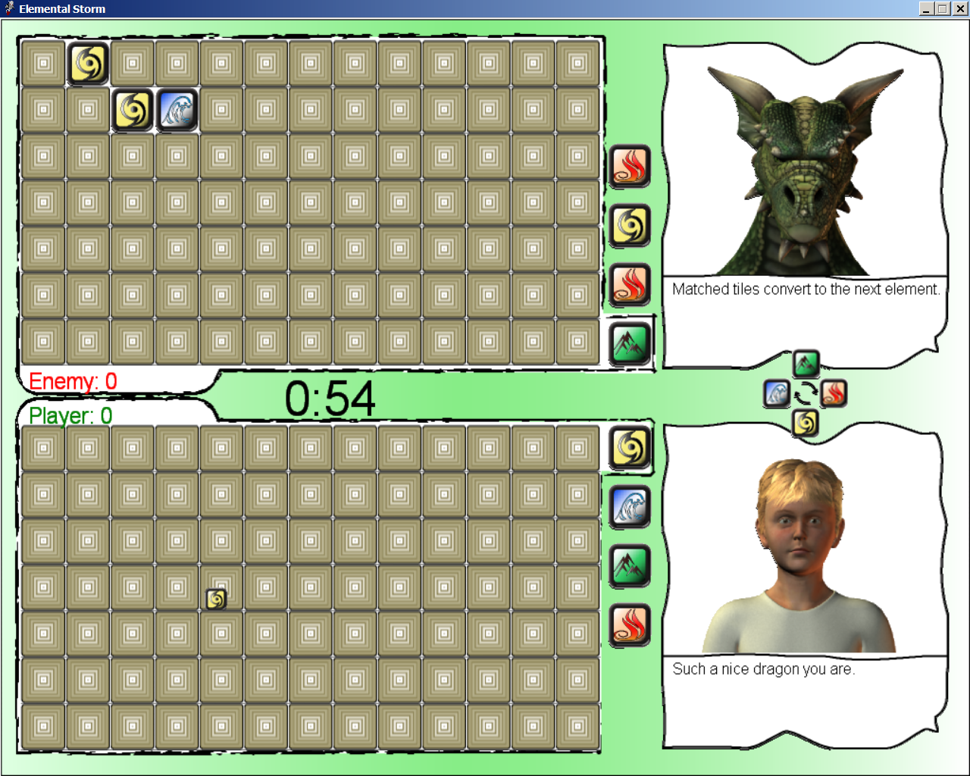

Controls
P – pause when in game mode
Q – exit game
Esc – Main menu
Mouse – tile placement when in game mode, move to desired location, then left click to place elemental tile on game board.
Space – advance from inter-game screens.

Level Summary
Earth Dragon – Easy – Play against Damascus to get a hang of the game. Game play is quite slow.

Water Dragon – Medium – Play against Cylantis to get better at the game. Computer AI is decent, which mean that the player will need to plan and play at a decent rate.

Wind Dragon – Hard – If you can beat Urgen, then you really understand and can play the game. Computer is fast and accurate.

Fire Dragon – Very Hard – Difficult to beat Firos. This is the goal in order to save your village. This is the ultimate level. Beatable, but need to click fast and plan ahead.

Cut Scenes
- Level 1 Victory Scene
  - After defeating Damascus
- Level 2 Introduction
  - Immediately after Level 1 Victory Scene. Introduction to Cylantis.
- Level 2 Victory Scene
  - After defeating Cylantis
- Level 3 Introduction
  - Immediately after Level 2 Victory Scene. Introduction to Urgen.
- Level 3 Victory Scene
  - After defeating Urgen
- Level 4 Introduction
  - Immediately after Level 3 Victory Scene. Introduction to Firos.
- Level 4 Victory Scene
  - After defeating Firos
- The End Scene
  - Immediately after Level 4 Victory Scene
- Game Over Scene
  - If lose at any level. Can restart at main menu or exit game.
Artificial Intelligence
For the Opponent AI, there are three factors that are taken into account:
- How fast can the AI place tiles?
- Where should the AI place tiles for optimal position?
- When should the AI trigger a chain?

How fast can the AI place tiles?
For the first level, Earth Dragon Damascus, the tile placement is about one every 2-3 seconds. This gives plenty of time for the player to place tiles and accumulate points. As the player advances in levels, the speed of tile placement is increased to <1 second per tile.

Where should the AI place tiles for optimal position?
Since the board is static and only the tile pieces vary, the AI uses a set pattern to place tiles. First a trigger point is chosen. Then tiles are placed in concentric circles around the trigger point. If tiles cannot be placed in the current problem set due to too many of a particular tile type, then place in the lower right corner.

When should the AI trigger a chain?
Finally, when the radius of the circles reaches five and the AI cannot place anymore pieces of the trigger element type, then the next time a trigger type element tile is available the chain will be triggered.

In the upper left of the screen below you can see where the AI is placing the tiles in the above mentioned pattern.

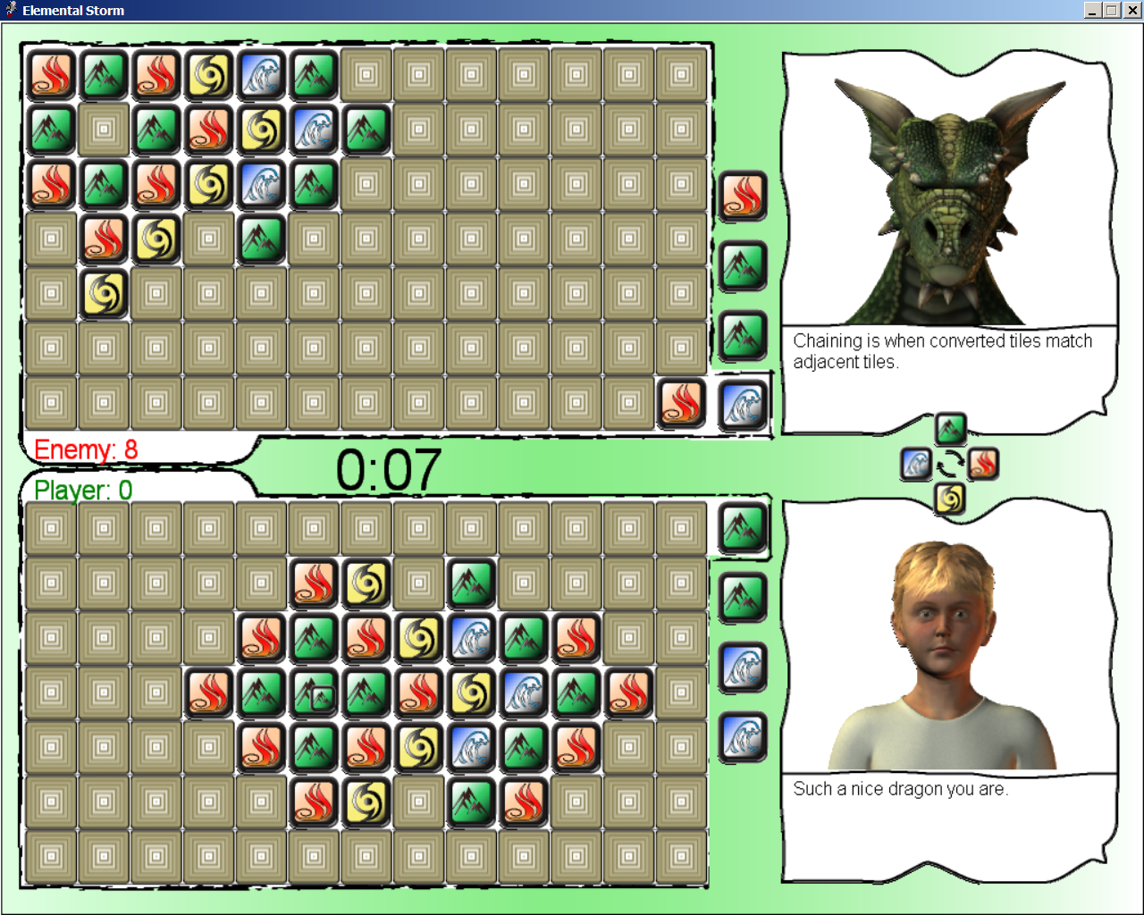

Game Elements

Data Dictionary

Four Elements Elemental Tiles Elemental Dragons
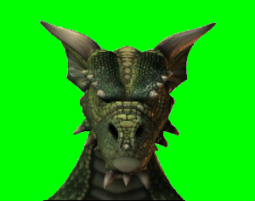


- Earth Damascus

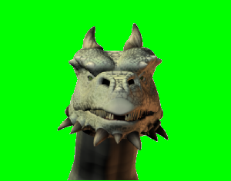

- Wind Urgen

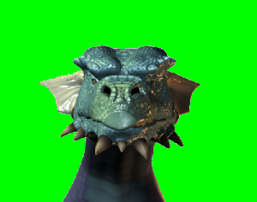

- Water Cylantis

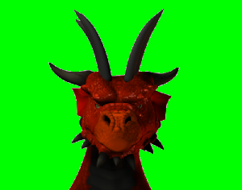

- Fire Firos

Chaining – When matched tiles change to a different element and there are tiles with that element adjacent to one of the changed tiles.


Chain Order -
Character Bibles
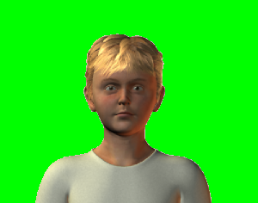
- Ethan – main character
  - Son of a blacksmith, Ethan is good at problem solving and is very responsible. Lately he has felt the urge to get out and see the world. This unfortunate crisis has given him a chance to do some adventuring. Ethan is always analyzing situations and looking for the best solution.
- Earth Dragon – Damascus
  - Earth Dragon Damascus is the oldest of all the elemental dragons and therefore the wisest. He understands the value of human allies as he has had many over the years. Damascus always wants to help the humans, but feels that he must guide and challenge them instead so they can take care of themselves and not become too reliant on him or the other dragons.
  - Helpful
  - Mentor
- Water Dragon - Cylantis
  - Water Dragon Cylantis keeps to himself in his underwater lair and rarely has human visitors. He finds humans to be very interesting and likes to have guests. Therefore, he is very polite and easy going; treating guests like long lost friends.
  - Friendly
- Wind Dragon - Urgen
  - Wind Dragon Urgen is a proud dragon and is very competitive and haughty. He doesn’t like to lose and will try his hardest to defeat any foes. Beating Urgen is the only way to gain his respect and resulting help.
  - Proud
- Fire Dragon – Firos
  - Fire Dragon Firos is extremely violent and hates everyone. He suspects everyone of plotting against him, therefore he is a master strategist; thinking many steps into the future and finding the best moves.
  - Dangerous and threatening.
  - No one except the Earth Dragon Damascus has ever defeated Firos.

Story Overview
Ethan is a 13 year old young man and the smartest one in the whole village. Every 100 years the elemental storms come and cause great devastation. The time is upon us, therefore the village sends Ethan on a quest to ask the masters of the elements for protection. The masters (dragons) will not just give anyone protection from their element; they require proof that they are worthy. Ethan must complete the challenges in order to save his village.

Ethan starts out by visiting the earth dragon Damascus. After earning Damascus’ help, he heads Northwest to visit Cylantis the water dragon. After defeating Cylantis, his friendship is obtained. Next, Urgen the wind dragon is visited where Ethan gains his respect. Lastly Firos is challenged, where Ethan must show that he is worthy of Firos’ help. After obtaining help from all four elemental dragons, Ethan’s village is saved from the impending elemental storms.
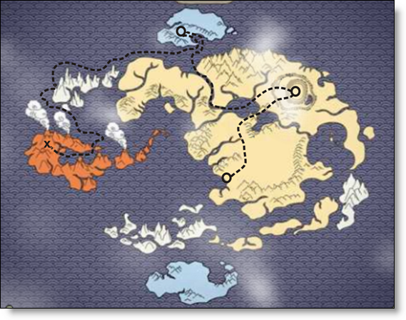
Game Progression

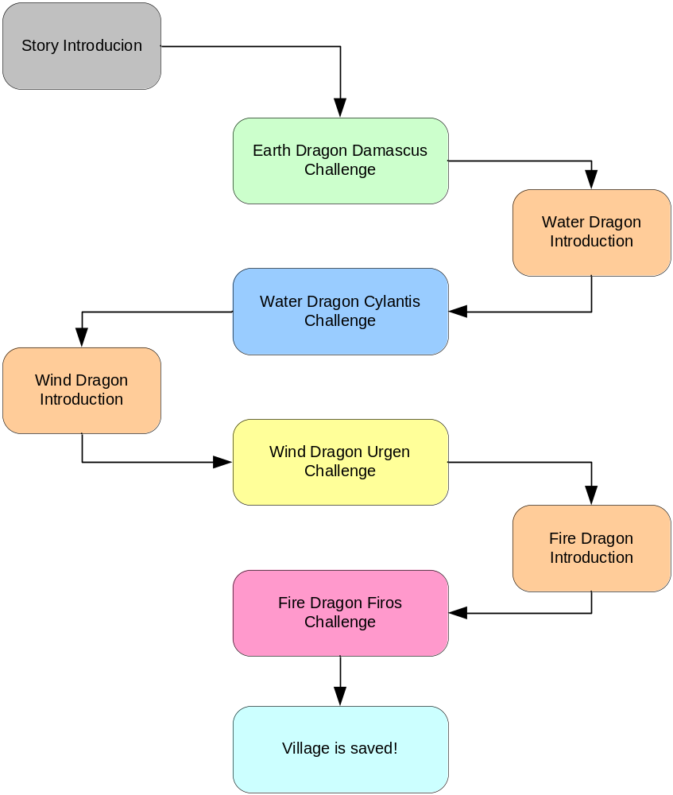
Figure 1 - Game Progression Flowchart

Level and Scenes
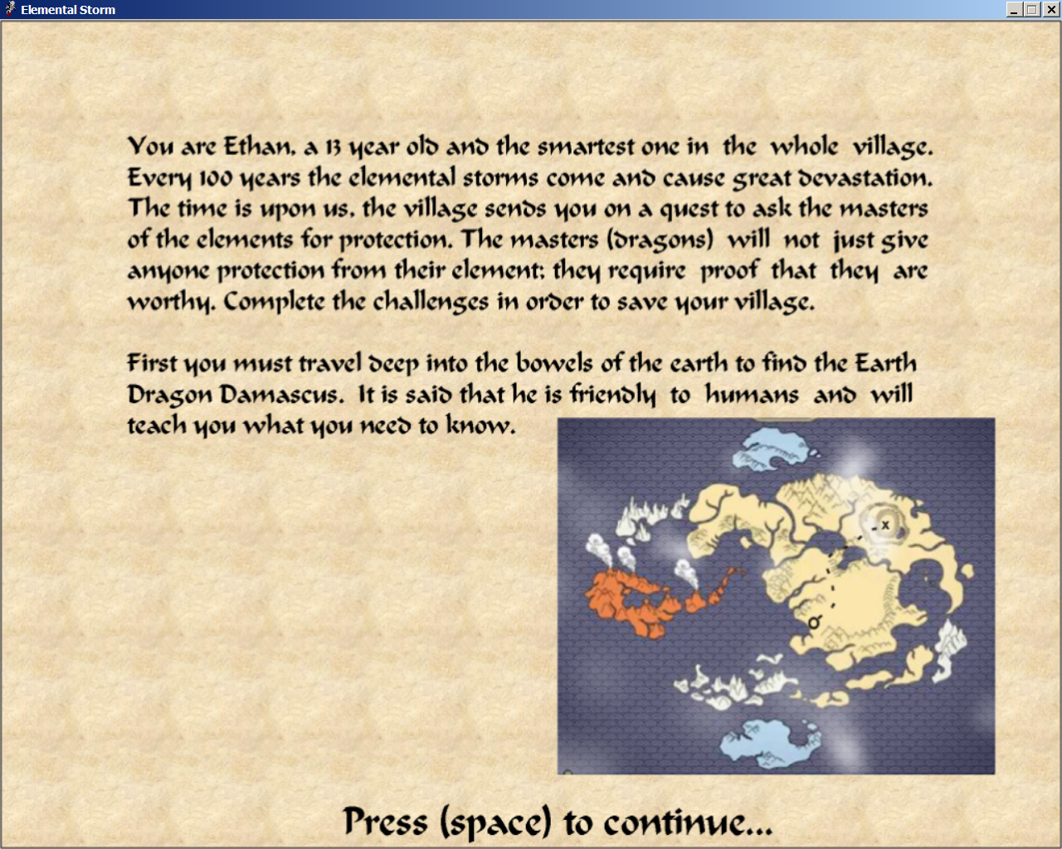
Initial introduction to the game.

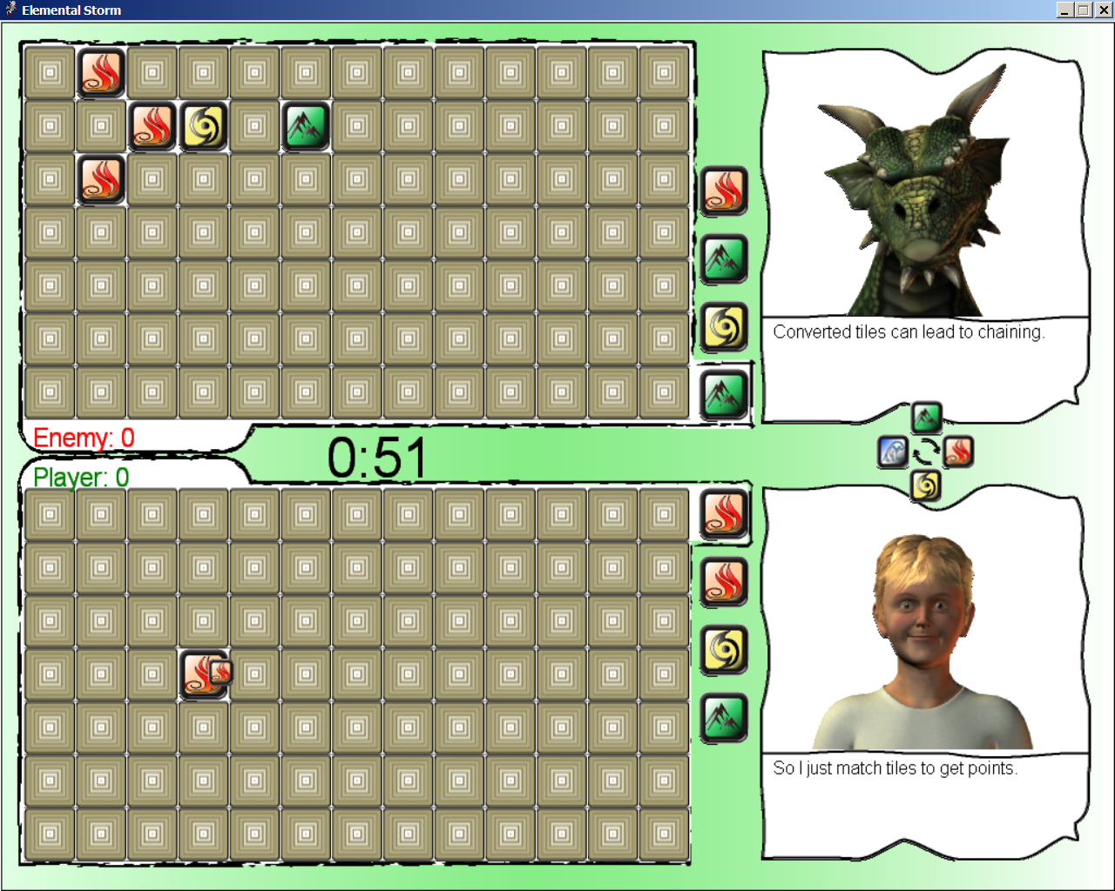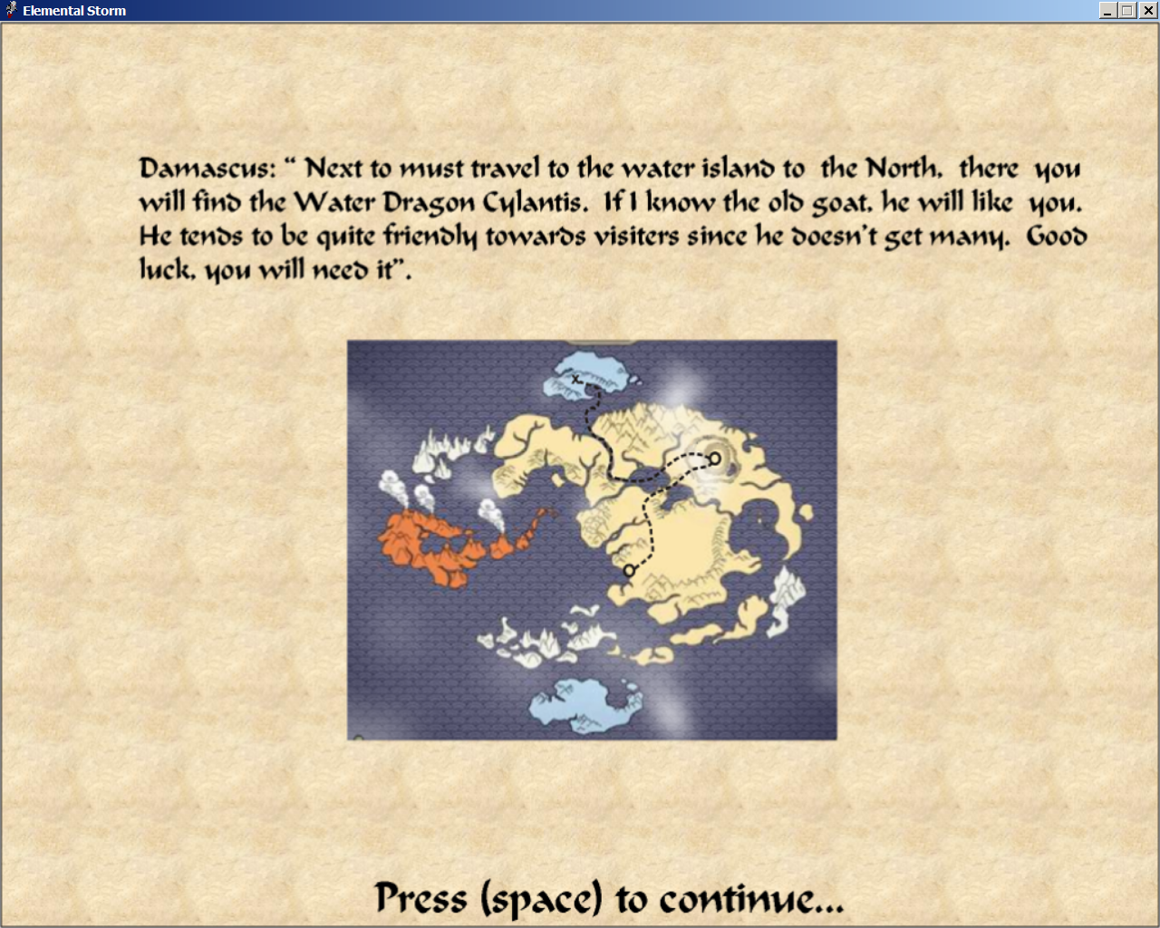
Level 1 – Earth Dragon Damascus, after defeating Damascus, the introduction to Level 2.

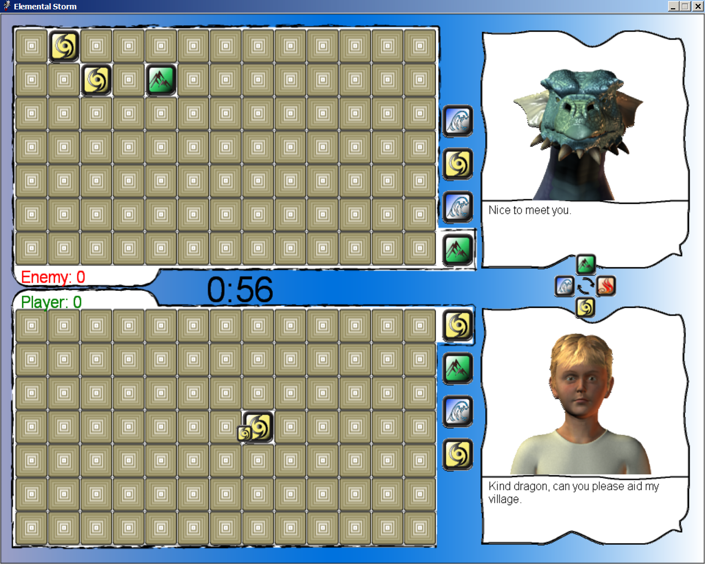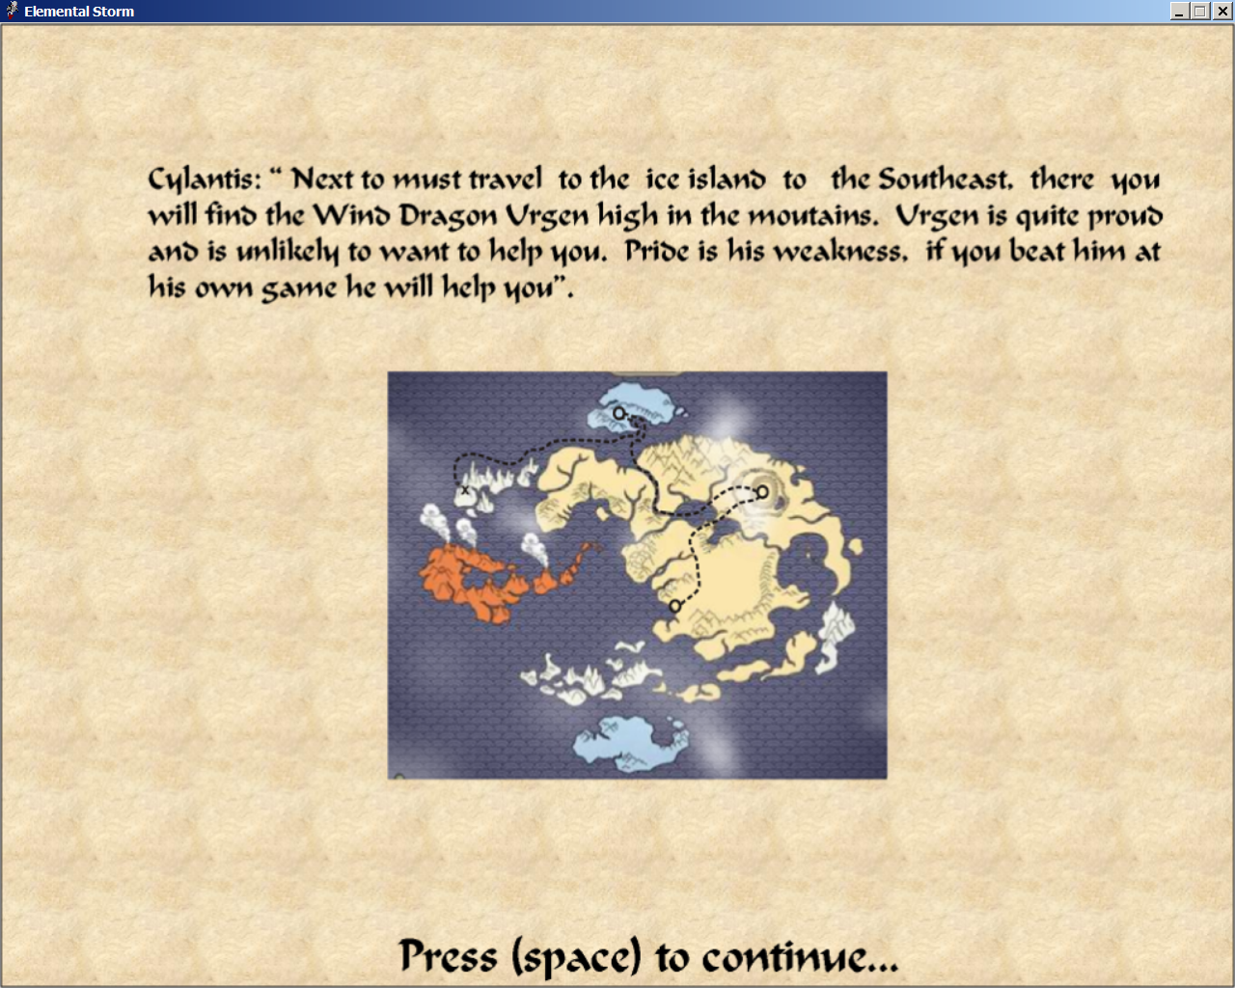
Level 2 – Water Dragon Cylantis, after defeating Cylantis, the introduction to Level 3.
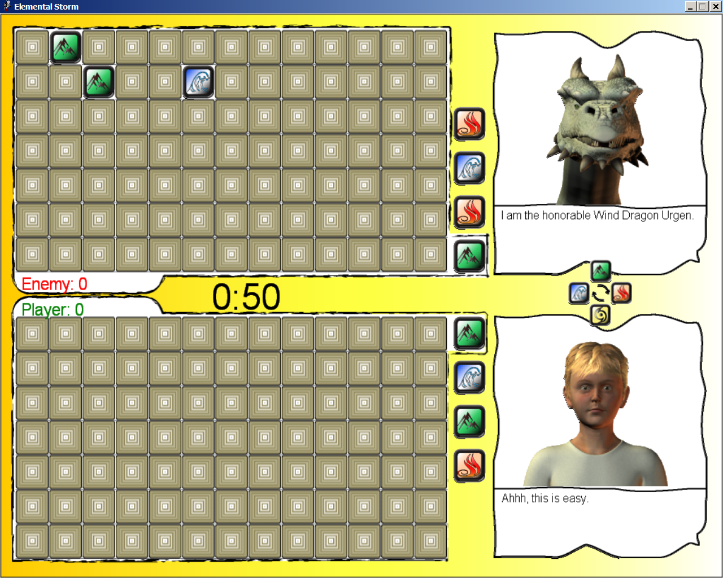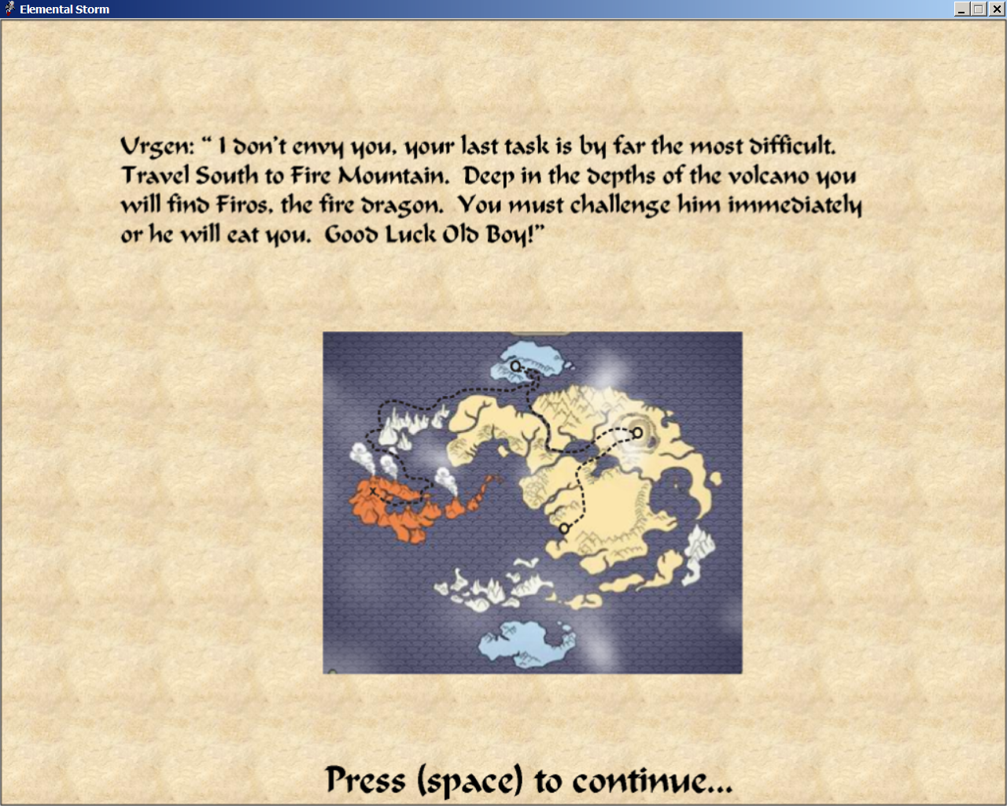
Level 3 – Wind Dragon Urgen, after defeating Urgen, introduction to Level 4.

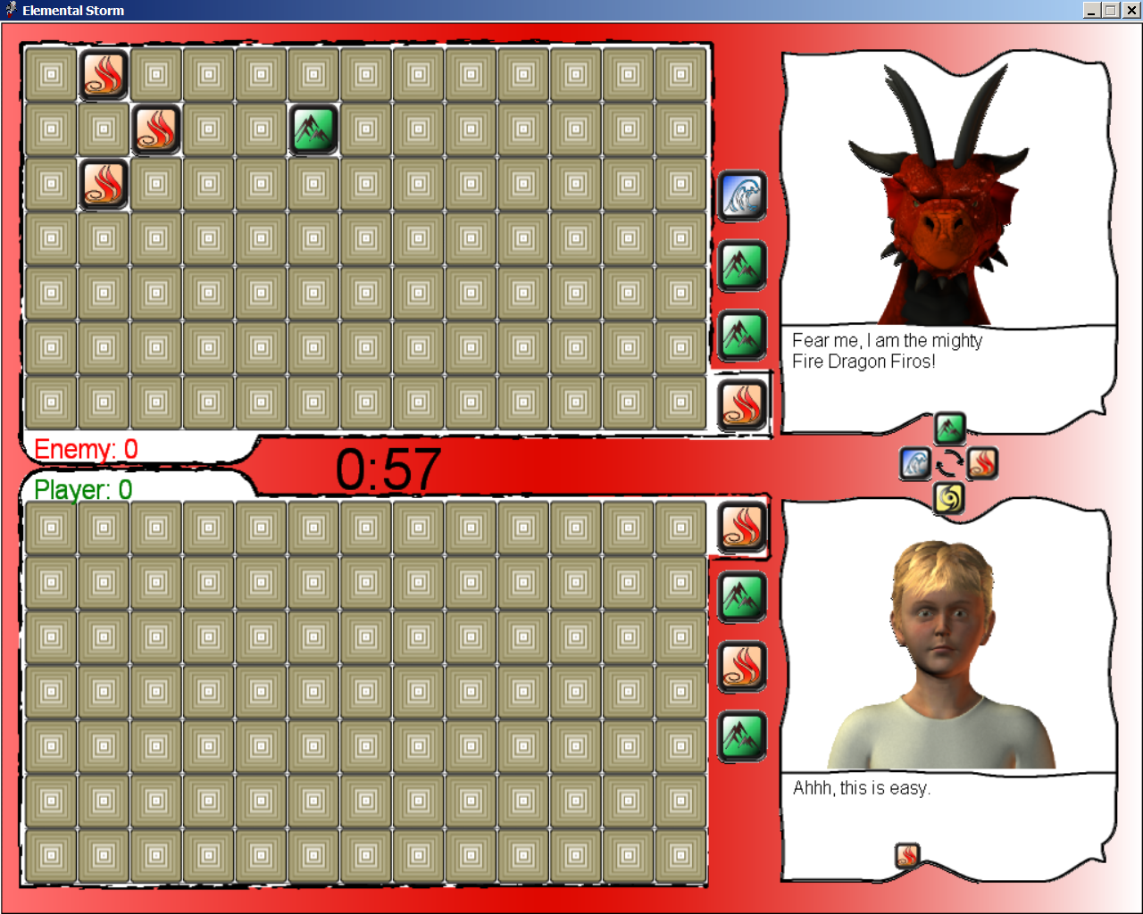
Level 4 – The big bad Fire Dragon Firos, after defeating Firos the game is won, and Ethan’s village is saved.
Lessons Learned
- Need to use a prepared game engine. In hindsight, XNA would have worked good for my needs.
- Rendering 3D artwork takes forever.
- Disposal of Directx Audio does not take effect immediately.
- When Directx Audio is told to stop, it may decide not to.
- Designing a game is tough.

Bibliography
Tricks of the Windows Game Programming Gurus by LaMothe,
Sams, 2002

Game Architecture and Design by Rollings and Morris,
New Riders, 2003

Introduction to Game Development by Rabin,
Charles River Media, 2005

CIS587 Course Website http://www.engin.umd.umich.edu/CIS/course.des/cis587.html

DigiPen Game Development C# Webcast Series http://www.microsoft.com/events/series/msdnvideodev.mspx#Introductionto2DVideoGameDevelopment

