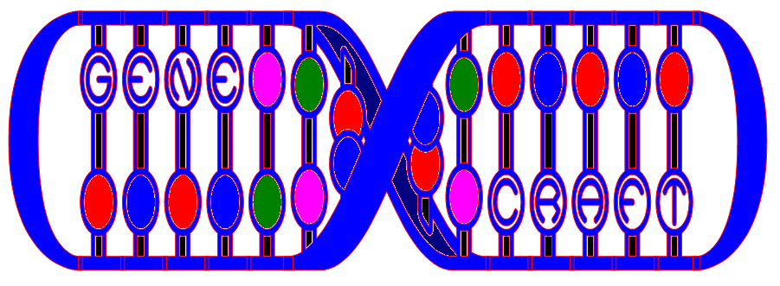

Design Specification
By, Amy Hedges
CIS 487 Term Project
11-16-05

Contents
Contents 2
Executive Summary 3
Story Abstract 3
Game Play Abstract 3
Development Specification 3
Product Specification 4
Production Team Description 4
Target Audience 4
Game Play 5
Goal 5
Control 5
Method 5
Sound 5
Animation 5
Platform and Production Tools 6
Game Specification 7
Interface 7
Summary of Story 7
The Genetic Makeup 8
Chromosome Sequences 8
Genes and the Chromosome Makeup 8
Mutations 8
Facial Feature Chart 9
Bonus Chart 10
Flow Charts 12
Game Flow 12
Program Flow 13
Sources 15

Executive Summary

Story Abstract
You, a mischievous scientist, are studying the genetic makeup of the Smiley Head race. Since Smiley Heads can only be born in your famous lab (they’re just heads…they have no way to reproduce), you have quite a reputation. You must keep this reputation by creating happy Smiley Heads. (Smiley Heads are happy when they consider themselves good looking). The happier the Smiley Heads are, the more reputation points you achieve.

Game Play Abstract
This game might be described as an arcade style game. The player moves around on the screen in the form of a microscopic eye-dropper, collecting sequences of chromosomes. Each sequence they collect will affect the appearance of the Smiley Head. The player controls the following features of the Smiley Head:

- The type of face it has – color, or pattern
- The type of eyes it has – color/shape
- The type of mouth it has – color/shape
- The type of hair it has – color/style

Once a Smiley Head gains all of its features…it is born into the world, possibly giving the player some good reputation points. The goal of the game is to get points!

Development Specification
- Gene Craft was developed for Windows using the DirectX 8.1 SDK.
- The programming was done in C++ using Microsoft Visual Studio 6.0.
- Graphics were programmed using a modified version of Andre LaMothe’s Blitter Object (BOB) Engine.
- Graphics (8-bit) were created by Amy Hedges in Jasc Animation Shop 3, Jasc Paint Shop Pro 7, and Microsoft Paint.

Product Specification

Production Team Description
Development of Gene Craft was done solely by the company:

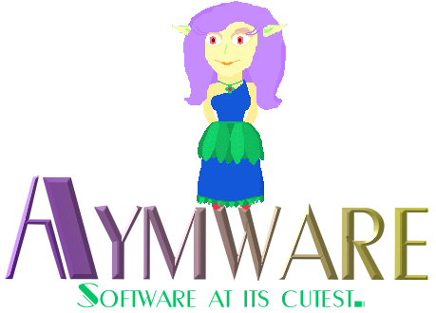

Which consists of one member, Amy Hedges. Responsibilities include:

- Research: Research was done for the design and programming aspects of this game. Most of the research involves reading and studying the Windows Game Programming book, and the Game Architecture and Design book, both of which are listed in the sources section of this document.
- Designing Graphics: All of the artwork in this game is original, drawn using Jasc Paint Shop Pro and Microsoft Paint.
- Animation: Animation was done using Jasc Animation Shop for some graphics. For others, animation was done by hand (drawing each frame separately in a painting program).
- Sound and Music Gathering: Sound was composed by me, and editing using Cool Edit 2000.
- Programming: This involves editing and using Andre LaMothe’s BOB Engine and example source code, working with the DirectX libraries, programming the genetic make-up of the Smiley Heads, implementing algorithms to manipulate chromosomes, the eye-dropper, the screen display, etc.

Target Audience
The target audience for Gene Craft is a broad age range (6+). The only skill required to play the game is the ability to use a computer keyboard. If the player chooses to try to get a high score, some memorization might be involved (ex. gene sequences and bonus types). The game pace is designed for the casual game player.

Game Play

Goal
The goal of the game is to score as many reputation points as possible. Points are scored by creating specific face patterns, and obtaining bonuses. Both of these things must be learned and discovered by experimentation. The game ends after 8 Smiley Heads have been created.

Control
The user will control the left, right, up, and down arrow keys on the keyboard. This will move an “eye-dropper” around on the screen that will suck up the chromosomes when it gets close enough to them.

Camera
The view of the game is top-down. You are looking at the chromosome soup as if it were a bowl of cereal.

Method
Chromosome sequences are 3 chromosomes long. For every sequence the player picks up, something will change on the Smiley Head’s face (unless the sequence is defective). There are 5 types of chromosomes:

- Red
- Blue
- Green
- Purple
- Mutated

There will be a set number of chromosomes on the screen at one time, these will replenish as the game goes on. Sequences beginning with red will alter the face style. Sequences beginning with blue will alter the eye style. Likewise, green – mouth style, purple – hair style, mutated – nothing. Having mutations within a sequence (after the beginning one) will cause drastic changes to the face. If a mutation happens within a hair sequence, it will cause a “random” hair mutation…etc. This may or may not be good for a players reputation points, it depends on the mutation and the rest of the facial features. The mutations seem random because it’s hard to tell which genes on the chromosome are affected by the mutation.

Sound
There is a different sound effect for the following things: when a regular chromosome gets sucked into the eye-dropper, when a mutated chromosome gets sucked into the eye-dropper, when a defective sequence is made, when a bonus is scored, and when a face is finished. There are also title screen, and score screen sounds.

Animation
The chromosomes will always be actively rotating on the screen. The eye-dropper will change directions, depending on which arrow key is pressed. The player will be able to see the chromosome being sucked into the eye-dropper. After every sequence of chromosomes collected, either the face will change or there will be a sound to indicate a defective sequence.

Platform and Production Tools
Gene Craft was developed for Windows 98/XP. The game is simple, and shouldn’t require a sophisticated graphic card. The following tools were used for production:

- Programming:
- Microsoft Visual Studio 6.0
- DirectX 8.1
- Andre LaMothe’s Blitter Object Engine

- Graphics:
- Jasc Paint Shop Pro 7
- Jasc Animation Shop 3
- Microsoft Paint
- Microsoft Word (text graphics)

- Sound:
- Cool Edit 2000

Game Specification

Interface
The main screen is divided into 2 sections – the play side (left) and the information side (right). The play side is where the player collects chromosomes. The information side is where the face is displayed, bonuses are displayed, the score is displayed, and the sequences they’ve collected so far are displayed.

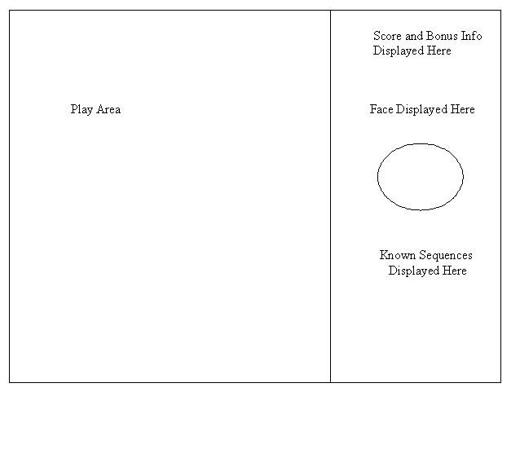

Replaying and Saving
The game ends after 8 faces are created. The player will have a chance to enter their name. Fourteen scores will be stored in a file. These scores are not yet sorted.

Summary of Story
Due to the nature of this game, there is not an extensive story line. Instead, there is a short background story:

After much hard work, and toil…you’ve finally done it! You’ve created an entire race of Smiley Heads out of genetic soup. Ethical or not, Smiley Heads are happy to exist. Of course, they would be happier if they had more friends and family to associate with. Now you must master the art of creation by bringing more Smileys into the world!

However, the Smiley Head culture is beginning to change. Looks are becoming more and more important as their population increases. If a newborn Smiley Head considers itself good looking, the portion of happy Smiley Heads in the population will increase! And so will your reputation. You must keep your reputation high…you wouldn’t want your lab to get shut down by ethical protesters. Of course, it’s up to you to figure out a Smiley Head’s standards for being good looking.

The Genetic Makeup
This section will describe the story of the genetic makeup of the Smiley Heads. This section does not necessarily need to be understood by the player of the game.

Chromosome Sequences
Smiley Heads are made up of a total of 12 chromosomes (all of the X type). These chromosomes must be processed in order, to properly create a Smiley Head. Changing the order that the chromosomes are processed will change the appearance of the Smiley Head. Chromosomes are processed 3 at a time. When 3 chromosomes are collected, they are called a sequence. The genetic makeup of the Smiley Heads is simple. The system (that is, the genetic system inside the genes of the Smiley) reuses the same genes to build different parts of the Smiley. In order to know what to build, the system is signaled on every first chromosome in the sequence. If the beginning of the sequence is a red chromosome, this sequence will control the face type of the Smiley Head. If the beginning of the sequence is a blue chromosome, this sequence will control the eye type of the Smiley Head. If the sequence starts with a purple chromosome, this will affect the Smiley’s hair. If the sequence starts with a blue chromosome, the Smiley’s mouth will be determined. If the sequence happens to start with a mutated chromosome, this will not register with the Smiley Head’s system at all, and nothing will happen. Also, chromosomes don’t fit well next to other chromosomes of the same color. Sequences that contain 2 chromosomes of the same color next to each other will also not register in the Smiley Head’s system. If a particular facial feature is repeated (for example, if genes for the face type are collected, then recollected again before the face is finished) the old sequence will be replaced by the new one.

Genes and the Chromosome Makeup
Each chromosome contains 10 genes. Therefore, each feature on the Smiley Head is controlled by 30 genes. All of the genes on each chromosome are linked together. For example, pretend the first chromosome in the sequence is blue. This will begin the creation of the Smiley Head’s eyes. Pretend the next chromosome in the sequence is a color other than blue. This chromosome may contain genes to control color, size, shape, etc. Since these genes are linked together…every Smiley Head that is born with bright blue eyes will also have medium sized long eyes. Every Smiley Head that is born with dark brown eyes will also have large round eyes…etc.

Mutations
As with all genes in the world, there is a potential for gene mutation. Processing a mutated chromosome in a sequence could result in 10 different ways, depending on which gene was mutated inside the chromosome. This will make mutations seem random.

Facial Feature Chart
The following chart shows all of the possible facial features a Smiley Head could have. It displays the sequence to obtain the feature, the type of feature and its number, and the details of that feature.
(Note: R = red, B = blue, P = purple, G = green)

Sequence | Feature | Details | Mutation Sequence | Feature | Details
RRR | face 0 | light yellow | R ? | face 10 | green
RBR | face 1 | beige | R ? | face 11 | splotchy
RBP | face 2 | light pink | R ? | face 12 | 2 colors
RBG | face 3 | dark pink | R ? | face 13 | yellow spotted
RPR | face 4 | orange | R ? | face 14 | white speckled
RPB | face 5 | grey | R ? | face 15 | brown target
RPG | face 6 | dark beige | R ? | face 16 | brown star
RGR | face 7 | bright yellow | R ? | face 17 | blue triangle
RGP | face 8 | brown | R ? | face 18 | blue snowflake
RGB | face 9 | dark brown | R ? | face 19 | yellow X
BBB | eyes 0 | teal / wide | B ? | eyes 10 | cat
BPB | eyes 1 | blue / long | B ? | eyes 11 | red
BPR | eyes 2 | light blue / round | B ? | eyes 12 | 3 eyes
BPG | eyes 3 | green / small | B ? | eyes 13 | triangle
BRP | eyes 4 | dark green / long | B ? | eyes 14 | 2 colors
BRB | eyes 5 | blue-green / long | B ? | eyes 15 | peacock feathers
BRG | eyes 6 | purple / wide | B ? | eyes 16 | big
BGB | eyes 7 | dark brown / round | B ? | eyes 17 | squiggly
BGR | eyes 8 | light brown / long | B ? | eyes 18 | small
BGP | eyes 9 | yellow / small | B ? | eyes 19 | flat
PPP | hair 0 | yellow / long | P ? | hair 10 | medusa
PRP | hair 1 | yellow / short | P ? | hair 11 | flower
PRB | hair 2 | red long | P ? | hair 12 | peacock feathers
PRG | hair 3 | red short | P ? | hair 13 | nest
PBP | hair 4 | brown long | P ? | hair 14 | 2 colors
PBR | hair 5 | brown short | P ? | hair 15 | spiked
PBG | hair 6 | black long | P ? | hair 16 | cousin it
PGP | hair 7 | black short | P ? | hair 17 | leopard
PGR | hair 8 | mixed long | P ? | hair 18 | blue
PGB | hair 9 | mixed short | P ? | hair 19 | spiral
GGG | mouth 0 | red /closed | G ? | mouth 10 | fangs
GRG | mouth 1 | red / open | G ? | mouth 11 | 2 rows of teeth
GRB | mouth 2 | pink closed | G ? | mouth 12 | beak
GRP | mouth 3 | bright red / half | G ? | mouth 13 | triangle
GBG | mouth 4 | purple / open | G ? | mouth 14 | flat
GBR | mouth 5 | brown / open | G ? | mouth 15 | lightning shape
GBP | mouth 6 | orange / closed | G ? | mouth 16 | tooth
GPG | mouth 7 | red / half | G ? | mouth 17 | snake tounge
GPR | mouth 8 | brown / sideways | G ? | mouth 18 | 2 colors
GPB | mouth 9 | red / sideways | G ? | mouth 19 | tall triangle
Other |  | n/a

Bonus Chart
This chart describes all of the bonuses that a player could get. Listed is the name of each bonus, the points the player will receive for it, and the required facial attributes.

Bonus Name | points | face required | eyes required | hair required | mouth required
Vixen | + 50 |  | red # 11 | medusa # 10
Vixen | + 50 | green # 10 |  | medusa # 10
Vixen | + 50 |  |  | medusa # 10 | fangs # 10
Vixen | + 50 |  |  | medusa # 10 | snake # 17
Vixen | + 50 |  | cat # 10 | medusa # 10
Vixen Deluxe | + 75 |  | red # 11 | medusa # 10 | fangs # 10
Vixen Deluxe | + 75 | green # 10 |  | medusa # 10 | fangs # 10
Vixen Deluxe | + 75 | green # 10 | red # 11 | medusa # 10
Vixen Deluxe | + 75 |  | red # 11 | medusa # 10 | snake # 17
Vixen Deluxe | + 75 | green # 10 |  | medusa # 10 | snake # 17
Vixen Deluxe | + 75 |  | cat # 10 | medusa # 10 | fangs # 10
Vixen Deluxe | + 75 | green # 10 | cat # 10 | medusa # 10
Vixen Deluxe | + 75 |  | cat # 10 | medusa # 10 | snake # 17
Vixen Ultimate | + 100 | green # 10 | red # 11 | medusa # 10 | fangs # 10
Vixen Ultimate | + 100 | green # 10 | red # 11 | medusa # 10 | snake # 17
Vixen Ultimate | + 100 | green # 10 | cat # 10 | medusa # 10 | fangs # 10
Vixen Ultimate | + 100 | green # 10 | cat # 10 | medusa # 10 | snake # 17
Monster | + 50 |  | 3 eyes # 12 |  | 2 rows # 11
Monster | + 50 |  | 3 eyes # 12 | medusa # 10
Monster | + 50 |  |  | medusa # 10 | 2 rows # 11
Monster | + 50 |  | 3 eyes # 12 |  | snake # 17
Monster | + 50 |  | red # 11 |  | 2 rows # 11
Monster | + 50 |  | red # 11 |  | snake # 17
Monster Deluxe | + 75 |  | 3 eyes # 12 | medusa # 10 | 2 rows # 11
Monster Deluxe | + 75 |  | 3 eyes # 12 | medusa # 10 | snake # 17
Monster Deluxe | + 75 |  | red # 11 | medusa # 10 | 2 rows # 11
Jester | + 50 | 2 toned # 12 | 2 colors # 14
Jester | + 50 | 2 toned # 12 |  | 2 colors # 14
Jester | + 50 | 2 toned # 12 |  |  | 2 colors # 18
Jester | + 50 |  | 2 colors # 14 | 2 colors # 14
Jester | + 50 |  | 2 colors # 14 |  | 2 colors # 18
Jester | + 50 |  |  | 2 colors # 14 | 2 colors # 18
Jester | + 50 | 2 toned # 12 |  | spiral # 19
Jester | + 50 |  | 2 colors # 14 | spiral # 19
Jester | + 50 |  |  | spiral # 19 | 2 colors # 18
Jester Deluxe | + 75 | 2 toned # 12 | 2 colors # 14 | 2 colors # 14
Jester Deluxe | + 75 | 2 toned # 12 | 2 colors # 14 |  | 2 colors # 18
Jester Deluxe | + 75 | 2 toned # 12 |  | 2 colors # 14 | 2 colors # 18
Jester Deluxe | + 75 |  | 2 colors # 14 | 2 colors # 14 | 2 colors # 18
Jester Deluxe | + 75 | 2 toned # 12 | 2 colors # 14 | spiral # 19
Jester Deluxe | + 75 | 2 toned # 12 |  | spiral # 19 | 2 colors # 18
Jester Deluxe | + 75 |  | 2 colors # 14 | spiral # 19 | 2 colors # 18
Jester Ultimate | + 100 | 2 toned # 12 | 2 colors # 14 | 2 colors # 14 | 2 colors # 18
Jester Ultimate | + 100 | 2 toned # 12 | 2 colors # 14 | spiral # 19 | 2 colors # 18

Bonus Name | points | face required | eyes required | hair required | mouth required
Style | + 50 | #1-10,12,16,17,19 | peacock # 15 | peacock # 12 | #1-9,12,13,14,15,18,12
Style | + 50 |  | peacock # 15 |  | bird beak # 12
Style | + 50 |  |  | peacock # 12 | bird beak # 12
Style | + 50 |  | peacock # 15 | bird nest # 13
Style | + 50 |  |  | bird nest # 13 | bird beak # 12
Style Deluxe | + 75 |  | peacock # 15 | peacock # 12 | bird beak # 12
Style Deluxe | + 75 |  | peacock # 15 | bird nest # 13 | bird beak # 12
Style Deluxe | + 75 | #17 | peacock # 15 | peacock # 12
Style Deluxe | +75 | #17 | peacock # 15 |  | bird beak # 12
Style Deluxe | +75 | #17 |  | peacock # 12 | bird beak # 12
Style | + 50 | #1-10, 12, 16, 17 | flat # 19 | 0, 6,7,11,12,18 | tall # 19
Style | + 50 | #1-10, 12, 16, 17, 19 | #0-11,13,17,18 | spiral # 19 | tall # 19
Style | + 50 | #1-10, 12, 16, 17, 19 | flat # 19 | spiral # 19 | #0-9,13,15,16,17
Style Deluxe | + 75 | #1-10, 12, 16, 17 | flat # 19 | spiral # 19 | tall # 19
Style Deluxe | + 75 | yellow X # 19 | #0-18 | yellow long # 0 | tall # 19
Style Deluxe | + 75 | #0-10,15,16,17 | flat # 19 | yellow long # 0 | tall # 19
Style Ultimate | + 100 | yellow X # 19 | flat # 19 | spiral # 19 | tall # 19
Style Ultimate | + 100 | yellow X # 19 | flat # 19 | yellow long # 0 | tall # 19

Bonus Name | points | face required | eyes required | hair required | mouth required
Beauty | + 10 | !5,6,10,11,12,13,15,16,17,18 | !9,11,12,14,16,17,18,19 | 0 | 0,2,7,9,19
Beauty | + 10 | 0,1,2,3,4,6,7,8,9 | !5,9,11,12,14,15,17,19 | 2 | 0,1,2,5,7,8,13,19
Beauty | + 10 | 0,1,2,4,6,7,8,9 | 0,1,2,4,7,8 | 4 | 0,1,2,5,7,8,18
Beauty | + 10 | 0,1,2,4,5,8,9,10,19 | 0,1,2,3,4,6,8 | 6 | 0,1,2,7,8,10
Beauty | + 10 | 4,6,7,8,9 | 0,4,6,7,8,9,2 | 8,17 | 0,5,7,8,2
Cool | + 10 | 0 - 9 | !10,11,12,14,15,16,17 | 1 | 0,1,2,3,6,7,8,10
Cool | + 10 | 0 - 8 | !5,6,9,10,11,12,14,15,17 | 3 | 0,1,2,3,6,7,8
Cool | + 10 | 0 - 8 | 0,1,2,3,4,5,7,8,9,18 | 5 | 0,2,5,6,7,8,15,16
Cool | + 10 | !10,11,12,13,14,15,16,17,18 | 0,1,3,4,7,8,19 | 7 | 0,1,2,3,6,7,8,9,14,15
Cool | + 10 | 1 - 9 | 0,1,3,4,7,8,9,14 | 9,14,15 | 0,1,2,3,4,6,7,8,9,15
Cool | + 10 | 0 - 19 | 0 - 9,13,14,19 | 18,19 | 0 - 9,19

Flow Charts

Game Flow

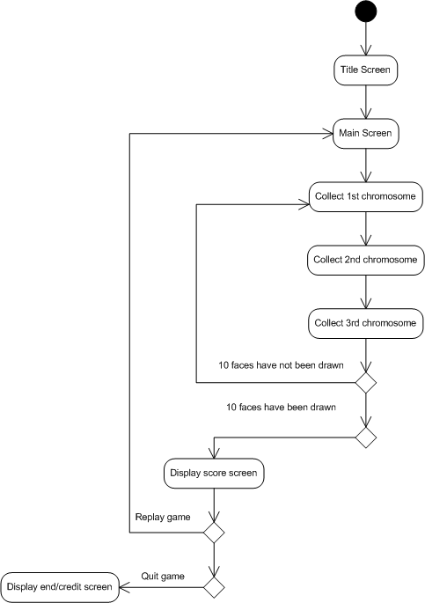

Program Flow
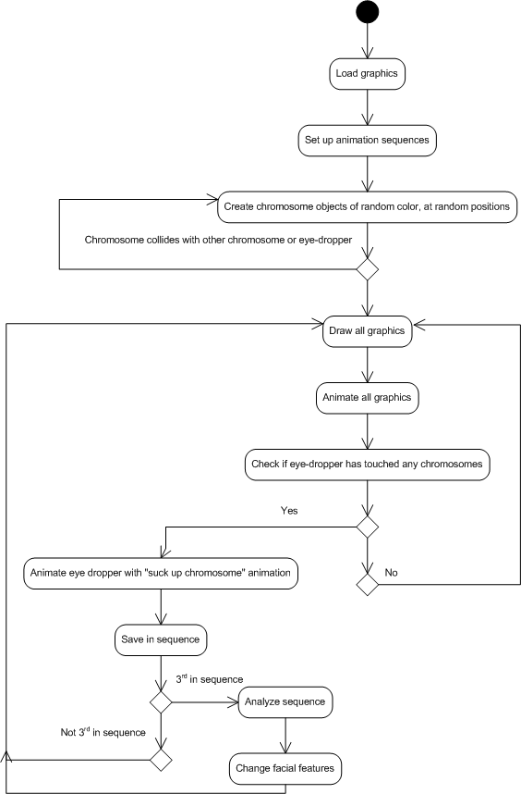
Concept Art

The eye-dropper:


The chromosomes:

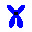

The screen divider: (vertical in game)

All of the facial features:

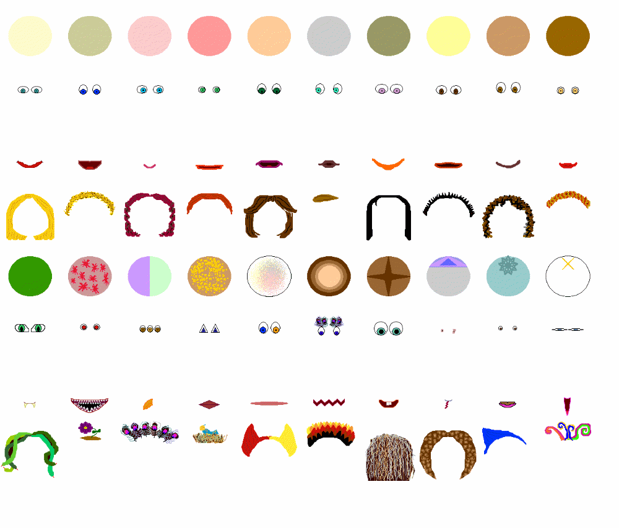

Future Improvements

This is a list of improvements I would like to make in the future:
- The game will only save the 14 highest scores. If a score is achieved that is higher than one of the scores currently in the file, the lowest score in the file is replaced.
- Levels will vary. There might be time constraints, a minimum number of points to get, a certain face to match, etc.
- More types of bonuses could be added to the system. Also, current bonuses could be edited. There are good looking combinations that aren’t getting points…and bad looking combinations that are.

Lessons Learned

I have learned these lessons (and many more that I can’t think of at the moment):
- How the main game loops work. I used this information to create my own alternate game loops that are sometimes called instead of the main game loop.
- How do draw and animate onto the back buffer, and flip the back buffer in a coordinated manner.
- How to load and display graphics properly (from a tile), so they don’t appear mutilated.
- How to use a sound editor.
- Don’t trust game engine code from other people. Especially don’t trust that it will return errors when it should. Check this, before you try to do error handling in your own code.
- I feel that I may have spent too much time on the mechanics of the game, than the actual game levels, and “purpose” of the game. I also spent a lot of time drawing graphics, and deciding facial bonuses. However, my actual intended audience (my family) is addicted to the game!

Sources

Books:
LaMothe, Andre, Tricks of the Windows Game Programming Gurus 2nd ed. Indianapolis, IN: Sams Publications, 2002.

Morris, Dave & Rollings, Andrews, Game Architecture and Design. Indianapolix, IN: New Riders Publishing, 2004.

Web:
Font for title obtained from http://www.abstractfonts.com/fonts/static_Letters/C_23.html.
created by Brian Kent, used with the following permission:
“-The font(s) in this zip file were created by me (Brian Kent). All
of my Fonts are Freeware, you can use them any way you want to
(Personal use, Commercial use, or whatever).”

