OVERVIEW

Game Story

Shinsen Gumi takes place in the city of Kyoto in Japan, covering events that span several years of Japanese history ( 1863 to 1869; the forming of the Shinsen Gumi, up to their demise). The Shinsen Gumi themselves were a special police force that patrolled the streets of Kyoto (which was at that time the capital of Japan, and home to the Shogunate) to keep them and the Shogunate safe from the rising tide of the Ishin Shishi, or the anti-Shogunate movement. The events that take place in this game are completely based around events that involved the Shinsen Gumi in actual Japanese history. Actual Shinsen Gumi member names are used for the characters.

The player controls three different Shinsen Gumi members at different points throughout the game: Captain Serizawa Kamo, and Troop Captain Saitou Hajime. In all situations in the game, the player’s mission is to kill members of the Ishin Shishi, keep the streets of Kyoto safe, and protect the Shogunate at all costs. The game is meant to tell the story of the Shinsen Gumi in a way that the player can interact with.

Development Specification

Shinsen Gumi will be developed using Microsoft Visual C++ 6.0, and the DirectX 8.1 SDK. The game will consist of four different scenarios, with completely textual story breaks in between. The artwork and animation will all be original. Sound effects will be taken from various sources on the internet, and the music will also be taken from various sources, as noted in the bibliography.

PRODUCT SPECIFICATION

Production Team Description

All programming will be done by Brian Clark. Artwork and animation will be developed by Molly Wegener.

Target Audience

The target audience for this game is age ten and above. While the game play will be uncomplicated and not cater to any particular age range, the game itself revolves around stories of very violent events. While a lot of violence will not necessarily be depicted within the game itself, the historical events themselves are of a violent nature.

Game Play

The player will control one of two members of the Shinsen Gumi in each of the four scenarios, from a side perspective. Each character’s weapon will be a sword, and the player will be expected to control this character on whatever mission the character is assigned before their scenario in the game begins.

The beginning of the game will have an introduction to the history of the Shinsen Gumi, and will introduce the first character. From there, story breaks will be featured after each mission is completed. The purpose of these will be to both fill in the player of the events that take place from one scenario to another, as well as to introduce the next character that the player will be using in detail.

Each character will have a health rating. If the player is hit by an Ishin Shishi enemy, a static amount of damage will be deducted from the player’s health rating. If the health rating drops to zero, the character will die. The health rating will not be able to be regenerated once it has dropped. To balance this out though, the player will never encounter impossible amounts of enemies at one time, nor will the scenarios be extremely long and tasking on the health rating. The goal of completing a scenario without losing all of the character’s health rating will be a very obtainable one.

In order to “win” the game, the player must complete all of the scenarios, and defeat the boss at the end of the game. The purpose of completing the game is more to see the story of the Shinsen Gumi play out, more so than winning the game to obtain any sort of item or status. The difference in the missions of the characters will be varied enough, to where the player shouldn’t feel like he or she is merely just killing Ishin Shishi as the story progresses around them. The player should feel as though, to an extent, that he or she is actually helping the member of the Shinsen Gumi that he or she is controlling to accomplish their goals.

The artwork found throughout the game will be presented in a cartoon like way. The characters are not necessarily supposed to look like actual people, but rather animated, cartoon-esque versions of real people. Every character will be depicted as wearing the actual outfit worn by the Shinsen Gumi. The music will also be a great contributor to the player’s experience, as a lot of traditional Japanese music will be featured throughout the scenarios. This should create a degree of authenticity for the player, to balance out the light hearted look of the character art.

Production Tools

The programming of this game will be done in Microsoft Visual C++ 6.0, utilizing DirectX 8.1 SDK. Artwork will be developed in Adobe Photoshop 7.0. Music will be taken in MIDI format.

GAME MECHANICS

Overview

The game will take place in Kyoto Japan, throughout various points in the seven year history of the Shinsen Gumi. Both of the Shinsen Gumi members (Captain Serizawa Kamo, and Troop Captain Saitou Hajime) will be equipped with a katana sword to dispatch any Ishin Shishi enemies that made get in their way.

The game will end when the player has completed Saitou Hajime’s scenario, and defeated the boss at the end. The ultimate fate of the Shinsen Gumi in Japanese history will then be told. This game revolves very much around making the story of the Shinsen Gumi an interesting one to the player, and unfolding the story before them as they play a part in it themselves. Traditional Japanese music will play throughout the game, in order to make the player feel as though they are taking a journey through an animated version of the streets of Kyoto back in the late 1800s, to defend Kyoto’s streets and the Shogunate.

Camera Position

The camera will be on the side the main character during action sequences, making the action part of this game a side-scrolling game. As the character moves to the right, the scenery of the game unfolds before them. Before and after each action sequence will be a screen featuring only text and music, to develop the story of the Shinsen Gumi.

User Interface Design

Shinsen Gumi features four different types of screens: the introduction screen, the game play screen, the story development screen, and the game over screen.

Introduction Screen

Here the player sees the Shinsen Gumi game logo, and can hear the theme song to the game, “natsu sae chirashi”. The player has the option to start the game by pressing the “enter” key, or quit the game by pressing the “Esc” key.

Game Play Screen

Saitou Hajime Health = 80 (Lives here)

Though there are three different scenarios with different characters, the game play screen will remain the same throughout each one. The player will have a health rating on the top middle of the screen. It will decrease each time he his hit by an Ishin Shishi. This will be the only gauge found on this screen, in an attempt to keep the game play parts of the game as simple and straightforward as possible. The player will start over from the beginning of the level if he or she dies, for up to three times. After the second time that the player dies, he or she will forced to start the game from the beginning. The name of the character that the player is currently playing as will also be displayed to the left of the health rating. On the right corner of the screen, will be a sword icon indicating how many lives the player has remaining. Three icons will represent three lives, and so on.

Story Development Screen

Here, the player will watch the story of the Shinsen Gumi unfolding before their eyes. Only text will appear on this screen, one screen full of text at a time, allowing the player to progress to the next screen at any time they would like by pressing the enter key. These screens will sometimes be quite lengthy, as the story of the Shinsen Gumi is a rich and elaborate one. This screen will appear at the beginning and ending of the game, as well as in between player controlled parts of the game. The appearance of the screen itself will be the same.

Game Over Screen

When the player’s health rating runs out twice, he or she will be shown this screen to indicate that the game has ended. They will be able to press the Enter key to return to the Title Screen, or the Escape key to quit the program.

Game Sounds

From the time the player sees the title screen, he or she will constantly have some kind of music playing in the background. Various traditional Japanese songs featuring such uniquely Japanese instruments as the koto, shamisen, and shakuhachi will be played throughout the action and story sequences of the game.

Replaying and Saving

“Shinsen Gumi” will not feature any ability for the player to save his or her game. If the player’s health rating reaches zero three times, the player will start the game from the beginning, and not have the ability to restart at any point after. The player will, however, have the ability to scroll through the story sequences so they don’t have to be retold the same story again.

Control Summary

Since this game is primarily focused on story, the game controls will not be complex whatsoever. The player will be able to move his or her character left and right across the screen with the corresponding arrow keys on the keyboard. The spacebar will also be used to make the character swing his katana blade, which is the only means of dispatching enemies.

Game Play

Shinsen Gumi will be a two dimensional side-scrolling action game. There will be three different scenarios for the player to complete, using a different character for each. Though there are three different characters present, the controls for each character will be exactly the same. The missions that the player must accomplish using each of the three characters will be slightly different for each, but all will involve having to kill Ishin Shishi.

The player will have a health rating at the top of the screen, that will only go down if attacked by an Ishin Shishi.. The health rating will refill itself for each new scenario. If this health rating is completely depleted three times within a scenario, the game will end, and the player will be forced to start from the beginning of the game.

Shinsen Gumi is primarily focused on progression of the story of the Shinsen Gumi, so the game play is completely linear. There are not multiple directions that the player can go to change how the story will play out. The only way to complete a scenario is for the player to accomplish the mission that he or she is supposed to complete.

Though the game play is linear, the story is unfolded, part by part, before the player’s eyes. He or she will get to control different types of characters who were involved with the Shinsen Gumi, of different ranks and personalities. The dissension within the group, as well as the friendships and unities within the group will be conveyed to the player.

Cut Scenes and Story Telling

Shinsen Gumi will not feature cut scenes per say. Before and after each scenario, the story development screen will appear. The story development screen will simply display screens full of text, telling the story of the Shinsen Gumi at that particular point in time. No character graphics or animations will appear on these screens.

Immediately after the game introduction screen, a story development screen will appear. It will open the setting for the time period, and explain that at this particular point, Japan was of two factions: Those who embraced the idea of the country integrating Western ways into their culture and government, and those who did not. The current government at the time, the Shogunate, was of the faction that did not. Therefore, since they were a government institution, they had to defend themselves against those who passionately believed that Japan needed westernization. The Westernization faction had immobilized a force called the Ishin Shishi, whose sole mission was to bring down the Shogunate by any means necessary. Therefore, the Shogunate needed a force to protect them from the Ishin Shishi: this is the Shinsen Gumi. In addition to protecting the Shogunate, it is the responsibility of this force to keep the streets of Japan’s capital, Kyoto, safe and orderly.

At this point the player will enter the first action scenario. After he or she completes this scenario, the game will return to the story development screen. The story will then progress to reveal that the character that the player was just controlling (Captain Serizawa Kamo) was abusing his position as a Shinsen Gumi captain. Though he was defending Kyoto against an Ishin Shishi attack, he had also killed many townspeople in the process.
The story development will continue on to set the player up to go into a scenario involving the Ikedaya Incident of 1864. The player will be told that a group of Ishin Shishi is currently staying at the Ikedaya Inn, located in Kyoto. The Shinsen Gumi have discovered that t his group plans to burn Kyoto. So naturally, they must be stopped.

Here, the player will enter the second action scenario as Serizawa Kamo. After completing this scenario, the player will once again be taken back to the story development screen. They will be told that as a result of the Ikedaya Incident, there was a surge in the number of recruits. The Shinsen Gumi was now being widely depicted as heroes by the citizens of Kyoto, instead of a group to be feared. Also, Captain Serizawa Kamo was finally assassinated from within the group as a result of his inappropriate actions.

Time will elapse in the time period that the story takes place in, and now the player will be introduced to the situation in Japan in approximately the year 1869. The Shinsen Gumi still exist, but the majority of Japan seems to have embraced the concept of letting the country become more Western influenced, and doing away with the Shogunate completely. The player reenters the story as the Shinsen Gumi is being driven out of Kyoto, by an overwhelming number of the Ishin Shishi forces. They are no longer able to protect to the government or the streets of Kyoto, so they have only once choice left: to flee for their lives.

Here, the player will enter the third and final scenario as Troop Captain Saitou Hajime. After the player makes his or her way through the scenario, he or she will have to fight a final boss. After completing the scenario and defeating the boss, the ultimate fate of the Shinsen Gumi will be revealed to the player. That fate is that all but two were killed. Beloved Commander Kondou Isami was caught and beheaded: he never made it out of Kyoto. The only surviving members were Nakagura Shinpachi, and Saitou Hajime. They would go on to integrate themselves into the changed Japanese society. Nakagura would go on to write a book on the Shinsen Gumi. Saitou Hajime would change his name to Fujita Gorou, and become a policeman. This would earn him permission by the government to continue to carry his sword. He would not reveal anything of his involvement with the Shinsen Gumi until his death.

Scenario Summary

The game will be split into three scenarios for the player to play through, with story breaks before and after each one.

Scenario One: Outside of Kyoto

In this scenario, the player will control Shinsen Gumi Captain Serizawa Kamo. The time period is 1863, shortly after the formation of the Shinsen Gumi. As Serizawa, the player will keep the Ishin Shishi forces from entering the city of Kyoto. The mission assigned to the player is to kill anyone who crossed his or her path, using Serizawa. The characters encountered here will be Ishin Shishi, who will also attempt to attack the player. As the player walks down the road leading to and from Kyoto, Ishin Shishi will come running toward the player. Once all of the Ishin Shishi are dispatched, the scenario will end.

Scenario Two: The Ikedaya Inn

The player will now again be in control of the Shinsen Gumi Captain Serizawa Kamo. The time period is 1864. At this point in the game, the Shinsen Gumi has been informed that a group of Ishin Shishi are currently at the Ikedaya Inn in Kyoto, and plan to burn the town. The player’s mission is to control Serizawa and kill all of the Ishin Shishi found inside of the Inn. As soon as the player succeeds in his or her mission, the scenario will end.

Scenario Three: Escape from Kyoto

The streets of Kyoto have been overrun by the Ishin Shishi forces, and there is no way that the Shinsen Gumi can any longer protect Kyoto or the Shogunate. A new era is violently ushering its way in. The time period is 1869. The player controls Saitou Hajime, a Shinsen Gumi Troop Captain. He has seen several of his fellow Shinsen Gumi members slaughtered in the middle of the street by the Ishin Shishi, and realizes that he must escape the city to have any hope of living. The player’s mission is to escape the streets of Kyoto, killing any Ishin Shishi that get in the way. The path through this scenario will be a straight one, and as soon as the player guides Saitou out of the city, and defeats the final boss character (a nameless Ishin Shishi Captain), this final scenario will end. If the player is killed by the Ishin Shishi before escaping, the player will die. As mentioned before, he or she will have two chances to start over before the game ends.

ARTIFICIAL INTELLIGENCE

Opponent AI

There is only one type of opponent found in this game, that being the Ishin Shishi troopers. In each level, the Ishin Shishi troopers will have pre-programmed paths that they will not deviate from. They will also move across these paths at varying speeds. Sometimes it will be easy for the player to avoid and kill the troopers, and sometimes they will be moving so fast, and directly toward the player, that it will not be an easy task to do in a timely way. The only way that the player can be damaged is by direct contact with Ishin Shishi troopers. The Ishin Shishi Captain’s AI will be similar, except that he will constantly track and come toward the player. At some point during his lifetime, he will enter an attack mode in which he will charge quite fast toward the player.

Player Detection

Upon detection of the player, damage will be dealt, and the sprites will be set back an appropriate amount to represent collision.

Collision Detection

Simple collision detection will be used. Each character in the game is enclosed in a bounded box, which is determined by the size of the bitmap image being used for the character (since all characters are approximately the same size, it should be basically the same for all characters). The box follows the movement of the character at all times, and the game loop continually checks for the following condition under which to use collision detection: Ishin Shishi contact with the player character, Ishin Shishi sword contact with player, player contact with Ishin Shishi, player’s sword contact with Ishin Shishi. If a sword is made contact with either the player character of an Ishin Shishi, damage will be deducted from whichever the sword made contact with.

Motion

All characters in the game will move at fixed speeds. If any character’s weapon collides with another, they will either disappear (to signify death), or their sprite will fall back several steps on the screen to indicate that damage has been taken..

Path Finding

All movement by all characters takes place along a single line. All enemies, as well as the character will move on the screen at fixed speeds.

Special Actions

No player characters or enemies can perform special actions of any type.

Combat

The only useable weapon in combat is a sword. Each player character will be equipped with one, as well as each Ishin Shishi warrior. If contact is made by sword on a player character or Ishin Shishi warrior, appropriate damage will be deducted. See the character bibles for specific damage point information.

Non Player Characters

There are no non player characters featured in Shinsen Gumi.

Puzzles and Traps

There are no specific puzzles or traps found in this game.

GAME ELEMENTS

Items

There are no items in Shinsen Gumi.

Character Bibles

The following are descriptions of and information regarding the characters found in Shinsen Gumi:

Captain Serizawa Kamo



Serizawa is the character that the player will control in the first and second scenarios. He is a Captain of the Shinsen Gumi, along with Kondou Isami, and Niimi Nishiki. Serizawa is a morally corrupt person, however, and uses his position in the Shinsen Gumi to bully townspeople into getting what he wants. He also is not afraid to take their lives if necessary. After the actions of Serizawa and Niimi in the first scenario, the group is feared in Kyoto, even though they are its defenders. The story will reveal that after the second scenario, Niimi will commit suicide, and Serizawa will be assassinated from within the Shinsen Gumi. This will restore some of the group’s good name.

Health: 70
Sword Damage: 8

Troop Captain Saitou Hajime



Saitou is the character that the player will control in the third and final scenarios of the game. History tells that he was one of the two survivors of the Shinsen Gumi. He will go on to blend in with the evolving Japanese society, change his name to Fujita Gorou, and become a policeman. He will hide his involvement with the Shinsen Gumi right up to the time he dies. He was considered to be one of the most deadly members of the Shinsen Gumi when it came to using his sword, so that is why his sword damage is greater than that of the other members.

Health: 80
Sword Damage: 20

Ishin Shishi Trooper



The Ishin Shishi is the group that opposes the Shinsen Gumi. Though they are looked upon as patriots in Japanese history, in this game they are the villains. They helped usher in a more modern way of life in Japan, historically known as the Meiji era. They were opposed to having a Shogun, thinking that it wasn’t an efficient or modern way to govern. They are prepared to usher in a new era of peace, even if it takes violence to bring it about.

Health: 15
Sword Damage: 6

Ishin Shishi Captain

This nameless Ishin Shishi Captain is the game’s final boss, and will have to be defeated by Saitou Hajime in the final scenario. He will be very similar in appearance to the standard Ishin Shishi warrior, with slight uniform modifications. The Captain will also, of course, be more powerful than the standard Ishin Shishi warrior is.

Health: 300
Sword Damage: 12

STORY OVERVIEW

Storyboard

The following images will provide a general idea of what each scenario and type of screen in Shinsen Gumi will look like. Often, actual images that have been digitized will be used as scenario backgrounds.

Title Screen

This is the first screen that the player will see in the game. It will simply prompt the player to continue on with the game, or quit.

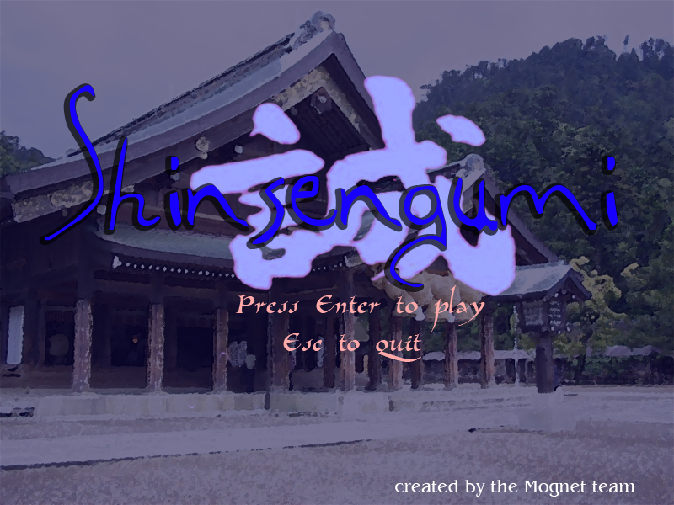

Story Development

Here, the player will see a story development screen that introduces the state of Japan in this time period, the Shinsen Gumi, and the first character that the player will play as: Serizawa Kamo.

Scenario One: Outside of Kyoto

The road leading to Kyoto is a simple country road. It’s dirt, surrounded by grass. The idea is that the player is moving Serizawa away from Kyoto, to intercept the Ishin Shishi before they reach Kyoto. Therefore, the player will be moving toward the right on the screen, and the Ishin Shishi will be coming toward him from the right. Though the idea is to move Serizawa right on the screen, the player will be able to move him left as well, though the screen will not scroll in that direction.

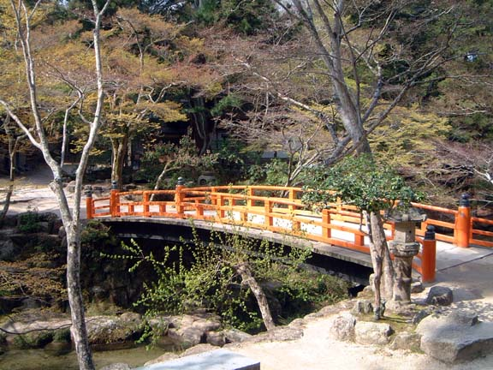

Story Development

The next story development screen that the player sees will reveal the fate of Serizawa Kamo, and the results of his actions from the first scenario. It will then introduce the next scenario.

Scenario Two: The Ikedaya Inn

The interior of the Ikedaya Inn will look like a typical old style Japanese inn. The floor will consist of wooden board, and the walls of a thin, rice paper looking material. The entire level will consist of the player controlling Serizawa to the right, down the Inn’s main hallway, to kill any Ishin Shishi he sees. The player will also be able to move Serizawa to the left. Though again, the screen will not scroll in that direction. The Ishin Shishi warriors will appear from both the right and left on the screen.

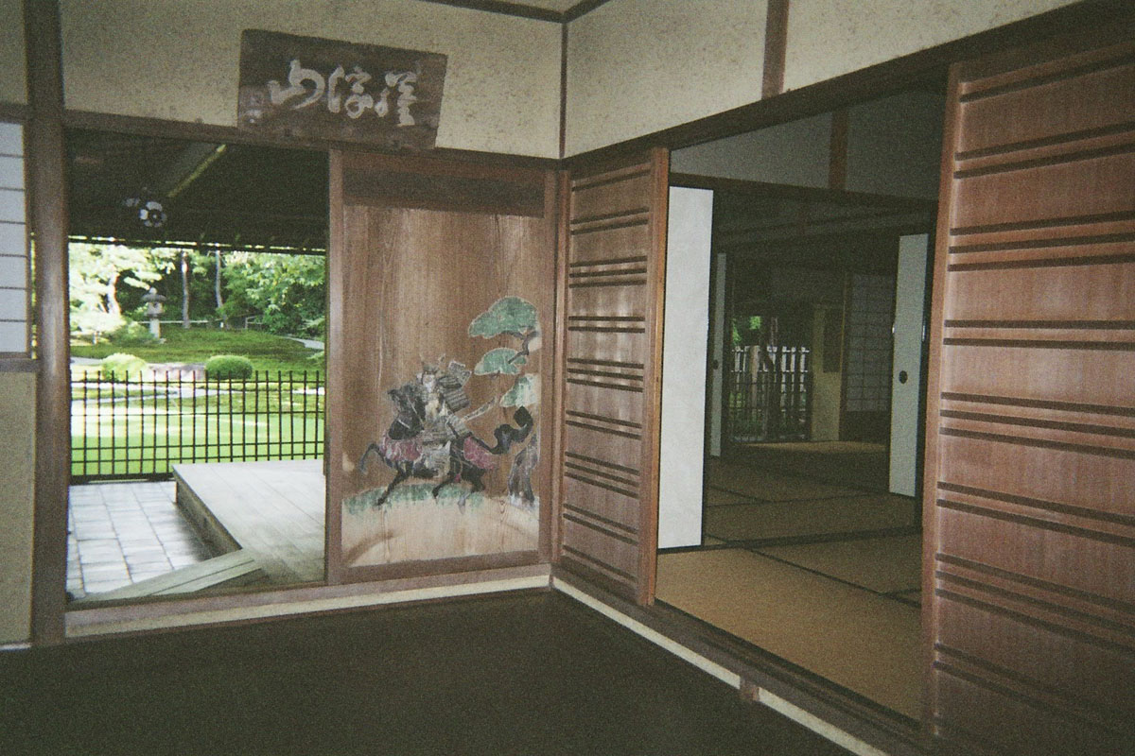

Story Development

Here, the the results of the events of the second scenario will be revealed. The time period will then be set forward several years, and the state of Japan at this time will be discussed. The player will then be introduced to the character of the third and final scenario: Saitou Hajime.

Scenario Three: Escape from Kyoto

In this scene, the player will be controlling Saitou Hajime, leading him out of the now overrun city of Kyoto. Since he is literally escaping from the city, the scenario will appear to be city-like. The background will consist of a paved stone street, with the occasional building front found in the background. The player will be controlling Saitou, moving him to the right on the screen, toward the city gate exit. As before, the player can move Saitou left, though the screen will not scroll in that direction. Ishin Shishi warriors will be coming at Saitou from both the left and right of the screen in this scenario.

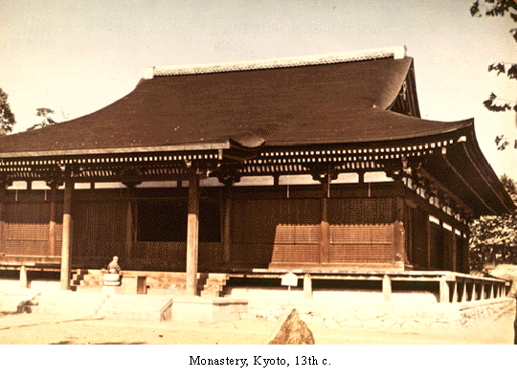

Story Development and Ending

The fate of the remaining Shinsen Gumi members will be revealed, as well as the impact of the Shinsen Gumi on the future of Japan. Here the game ends.

Background and Plot Summary

Shinsen Gumi is based on actual Japanese history, with the names and ranks of the characters, and of both opposing groups kept accurate to it. Even the personalities of the characters (which will be reflected in their individual missions) are kept as they are recorded in Japanese history. The time period in Japanese history when this will take place is 1863 to 1869. That is, the foundation of the Shinsen Gumi to their demise. The Shinsen Gumi were a special police force that patrolled the streets of Kyoto (which was at that time the capital of Japan, and home to the Shogunate) to keep them and the Shogunate safe from the rising tide of the Ishin Shishi, or the anti-Shogunate movement. This anti-Shogunate movement came about as a result to see more modern and western ways make their way into Japanese society. These beliefs entailed that there would no longer be a need for a Shogun to govern. To protect themselves against these beliefs, the Shogunate set up the Shinsen Gumi. To counter this force, the anti-Shogunate movement set up the Ishin Shishi. The Ishin Shishis mission was to assassinate the Shogun and as much of the current Japanese government as possible. The Shinsen Gumi’s mission was to prevent the Ishin Shishi from accomplishing their mission.

The player will guide various members of the Shinsen Gumi on their missions that relate to stopping the Ishin Shishi from destroying Kyoto and the Shogunate. At the end of the game, the story, like history, will reveal that the Shinsen Gumi were overpowered. It is then the player’s mission to make one of the only two surviving members escape from the Ishin Shishi.

GAME PROGRESSION

Setting

Shinsen Gumi is based on actual events that occurred in Japan from the year 1863 to the year 1869, during the time period that leads to the Meiji Revolution. A large faction of Japan wanted the country to modernize, and rid the country of their archaic system of government. The Shinsen Gumi represents the faction of Japan that fought to oppose this change, and keep the current Shogunate as the government. All scenarios will be cartoon like versions of what these places might have looked like.

Introduction

It is the year 1863, and the country of Japan is in a state of civil unrest. For quite some time now, the country has been governed by a Shogun. Japan has recently been coming under more and more western influences, hence there has been more and more pressure for the country ‘modernize’, according to western standards.

A large faction of Japanese now believes that in order to be a modern country, the Shogunate must be done away with. This, however, is not a task that can easily be accomplished simply by request. The Shogunate has been in place for a long time, and has no intention of simply disappearing. Therefore, the anti-Shogunate movement has assembled a force of warriors called the Ishin Shishi. Their mission is simple: to remove the Shogunate from power by any means necessary.

This left the Shogunate with only one decision: to form a force of warriors of their own. They need this force not only to keep themselves in power, but also to keep the streets of the capital city of Kyoto safe from being overrun by the Ishin Shishi. This force is called the Shinsen Gumi, and is made of some of Japan’s best swordsmen.

Flowchart

The following is a flowchart that represents the progression of the game:

Start
Title Screen
Exit
Story Development
Scenario One
Story Development
Scenario Two
Story Development
Scenario Three
Story Development
Game Ending
Game Over

Level and Scene Details

Scenario One: Outside of Kyoto

This scenario will take place on a road outside of the city of Kyoto. It is meant to make the player feel as though they are controlling Serizawa along a road in a country side type scenario. Ishin Shishi warriors will be traveling up the road to try to get to the city of Kyoto. The player’s mission as Serizawa is to stop the Ishin Shishi, keeping them from entering the city of Kyoto. The background will be reminiscent of what a road going through a patch of forest in Japan might have looked like in the 1800s.

Scenario Two: The Ikedaya Inn

This scenario will take place inside of the famed Ikedaya Inn, within the city of Kyoto. Ishin Shishi warriors are staying at the inn, planning to set fire to Kyoto in a short while. The player, as Captain Serizawa Kamo, must stop the Ishin Shishi from setting fire to Kyoto. The background will be reminiscent of a traditional Japanese inn, with a lot of wooden paneling and rice paper doors serving as a background.

Scenario Three: Escape from Kyoto

In the final scenario, the player will control Saitou Hajime as they lead him in his escape from the overrun city of Kyoto. The setting itself will be the streets of Kyoto, so the background will consist mostly of stone paved roads, and wooden buildings.

Scenario Four: The Final Boss

Here, the player will control Saitou Hajime to defeat the final boss: the Captain of the Ishin Shishi troopers. The setting itself will be similar to that of the streets of Kyoto.

LESSONS LEARNED

Design Teams

Even when designing a fairly small game like this, it helps to have a few people on the design team helping you out. For this project, I had someone else doing all of the art, while I did all of the programming. Even with that work divided up, we weren’t able to add as many different things to the game as we had wanted to. It’s very helpful to have several aspects of the game being worked on in parallel, if you want to finish in a timely manner.

Development Time

We could have made this game much better if we had had about twice the development time that we did. With other obligations going on concurrently to this, four weeks was just not enough to make the complete game that we thought we could.

Game Engine

Using a game engine developed by another programmer that you have no personal contact with, can be frustrating sometimes. Though Lamothe’s game engine was fairly straightforward and easy to use, it sometimes was frustrating to have to work within his constraints. Developing a game engine or at least modifying his would have been ideal, if we’d had the time.

BIBLIOGRAPHY

The game engine and libraries used for Shinsen Gumi was developed by Andre Lamothe. The files were obtained from the following book:
Tricks of the Windows Game Programming Gurus by Andre Lamothe, Sams, 2002.

All MIDI songs that were used in Shinsen Gumi are original compositions of and property of Inada-no-Umahijiri”. His homepage, containing his complete list of MIDI compositions can be found here:
http://www2a.biglobe.ne.jp/~village/zca.htm

The titles of the compositions used in Shinsen Gumi are as follows:
Title Screen – “natsu sae chirashi”
Level 1 – “akizora tegoto”
Level 2 – “aoi yama”
Level 3 – “haru saki ginuta”
Final Level – “ojisan no kuni”

The sound effect used for the sword drawing in Shinsen Gumi was obtained here:
http://www.partnersinrhyme.com/soundfx/fight.shtml

The groaning and screaming sound effects found in Shinsen Gumi were obtained here:
http://www.arcanewolf.com/wizard/sounds/

