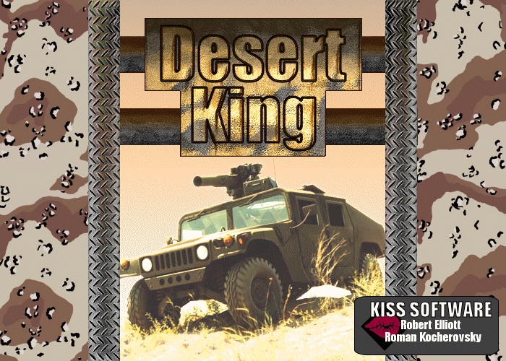

Desert King
Created By: Killer Interactive Simulation Software (KISS)

Developers:
Roman Kocherovsky
Rob Elliott

Proof of Concept Disclaimer:
The following document should be taken as design guideline, not fact.
While the core concepts will remain the same, changes may occur throughout the project.
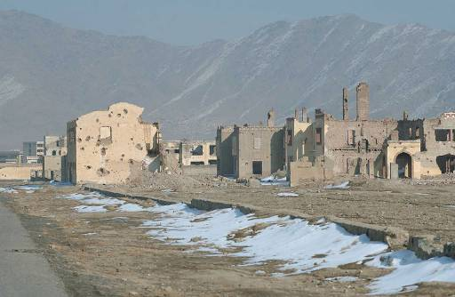

Executive Summary

Abstract of Game Story
Desert King is about a Spec-Ops Delta Force team of two brothers, Axel and Bolt, who serve their country and search for their MIA father, who they believe is still alive. To accomplish their varied and dangerous missions, they drive a special Humvee outfitted with incredible firepower. Currently the team is operating deep behind enemy lines, based out of Kandahar with the 5th SOF regiment. Their mission is to neutralize a weapons cache on the outskirts of Zabol, a town 75 miles to the east.

This weapons cache is believed to be a remnant hub of the Taliban regime and smuggled Al-Qaeda personnel. It is used by them as a source for weapons, ammo, and resources. But most importantly, there is rumor amongst the locals that the Taliban is constructing a larger bunker underneath the desert surface. Intelligence believes this bunker is being used to development a new biological weapon, more horrific than anything ever seen.

Time is against the team as the terrorists have become aware of their mission and rush to reinforce the base with troops, weapons, and defenses. If the weapon research is evacuated, or worse- completed, there is no telling what kind of domestic terror will ensue. Also amidst this chaos, shadows of the teams father abound. Might this be the link to finding him? Or will the truth be even worse than they thought…
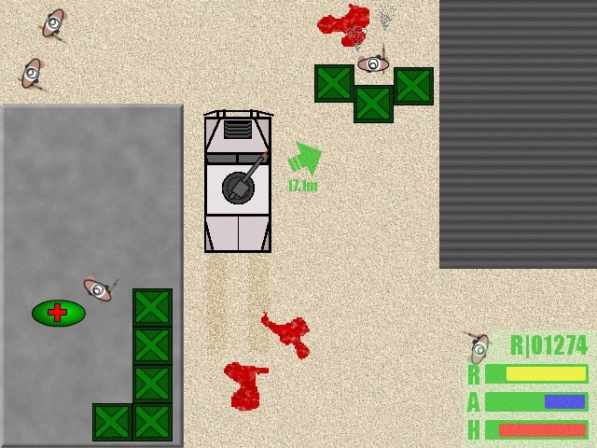
Prototype and Mockup
Game Play and Appearance

Controls
The player controls the Humvee using the up and down arrows as accelerator and break/reverse respectively. And the left and right arrows are used to turn the vehicle. The weapon on top of the Humvee is aimed using the mouse. The player will not see a target site, but will se the turret point in the direction of where he points the mouse. The left mouse button is used to fire the weapon.

HUD
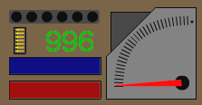
The Heads Up Display (HUD) will feature the following:
- Player Health
- Humvee Armor
- Player’s available ammo
- Player’s current weapon
- The amount of time that a player has in order to complete the mission.
- Orienteering method: lets the player know where the mission objective is even when they can’t see it

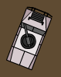
Controls
The player controls the Humvee using the up and down arrows as accelerator and break/reverse respectively. And the left and right arrows are used to turn the vehicle. You can also use the "WASD" keys to control the humvee the same as the arrows. The weapon on top of the Humvee is aimed using the mouse. The player will not see a target site, but will se the turret point in the direction of where he points the mouse. The left mouse button is used to fire the weapon.

Development Specification

Player: The player will drive the humvee. The Humvee can be tan for desert. It will have a turret on the top which will rotate. The turret can house various weapons which will be expressed in various types of ammo that the player will use.

Enemies can be shot, run over, or killed by splash damage from explosion.

Terrain: We will make use of various terrains within the game to make it more interesting to the player. Various terrain will have no alternate effects on the gameplay.

- Woman begging
  - No weapon
  - One or two frames depicting an activity
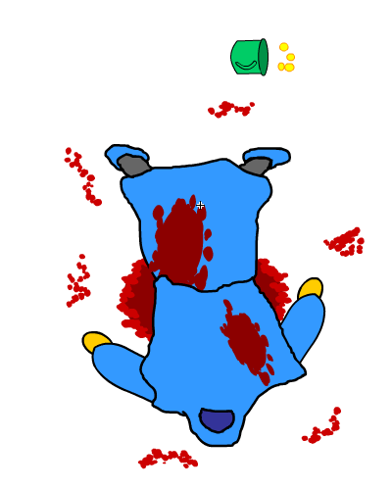
  - Begging
  - Can be killed
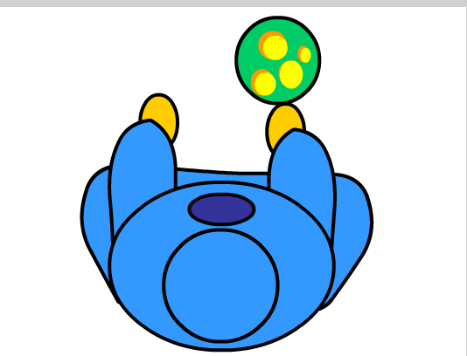
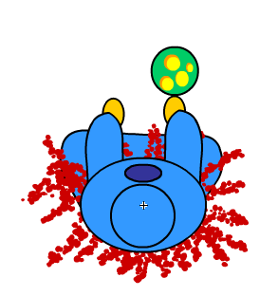

- Rifleman
  - Indigenous clothing
  - Carries AK-47 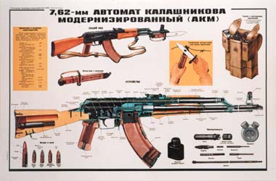
  - Shoots 3-4 round bursts at player
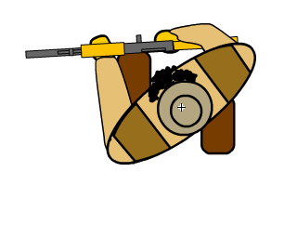
  - Walks looks around and patrols
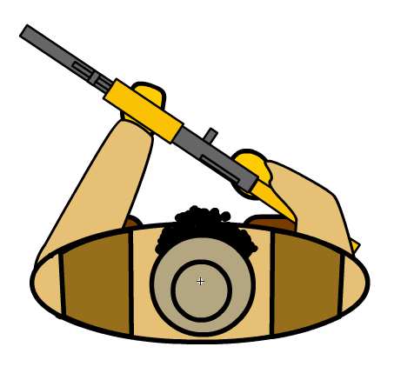
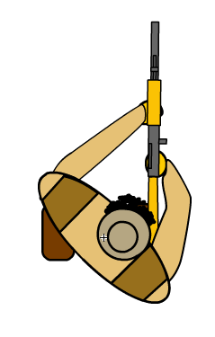

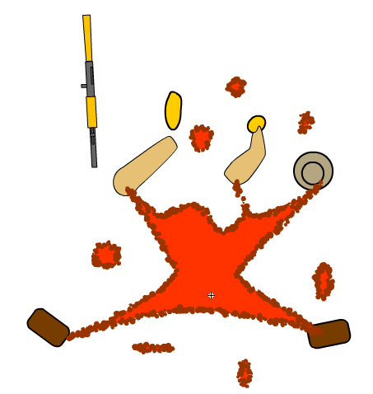

+

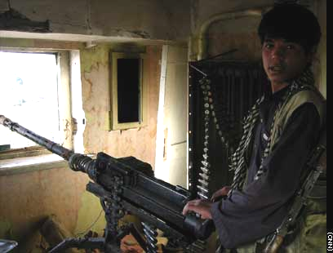
- Machinegun Nest/Bunker
  - Can have multiple guns
  - Will have cover from air
  - Will be well armored to withstand a lot of damage
  - No moving around
  - the guns can move with limited degree of freedom to aim at player

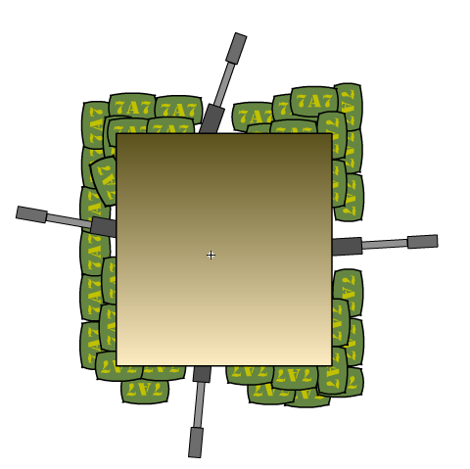
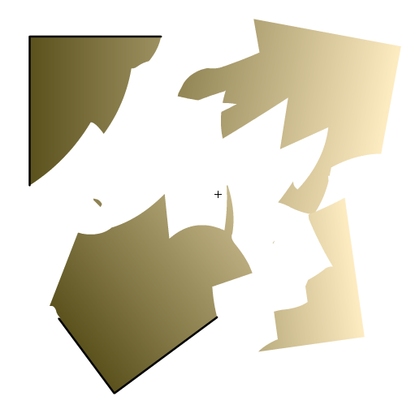

Bunker Destroyed

- Pickup Truck
  - Toyota or some such thing
  - Beat up can have machine gunner in the back
  - Can have several various personnel in the back
  - Drives around coming after player and shooting them

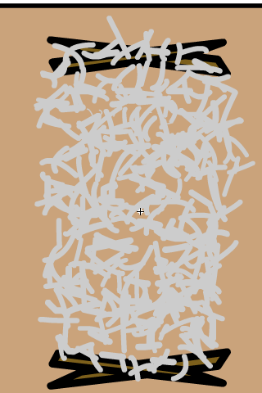
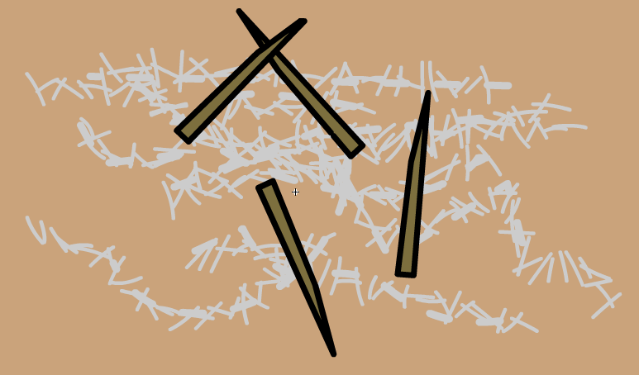
Obstacles: route/restrict player
- Barbed wire
  - Collision with player, does not allow any actor to pass through
  - Allows bullets to go through
  - Standard tool that we can use over and over again to make boundaries
  - Can be destroyed

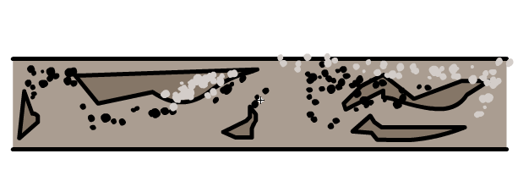
- Concrete Barricades
  - Often use by enemy on re-enforced positions
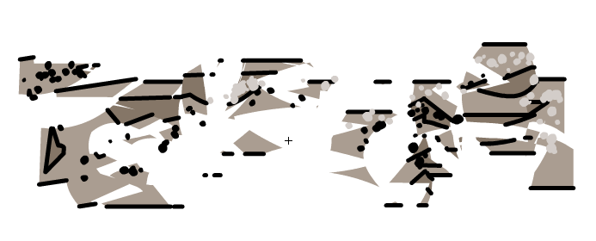
  - Solid: player can’t shoot through them or go through them
  - Can be destroyed

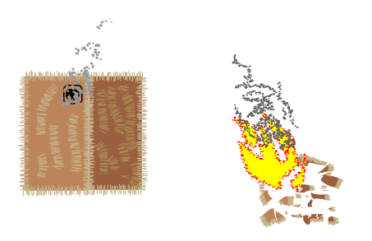

- Buildings
  - 1 story structures
  - Spawn point of enemies
  - Old mud/straw structures
  - Chimney smoke
  - When destroyed they burn

Power-ups: player sees power ups in various places on screen, they can grab them simply by running them over.
- Health
  - Gives player 10% health
- Armor
  - Gives player 10% increase in armor
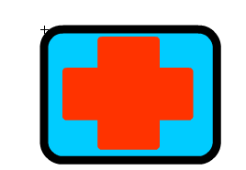
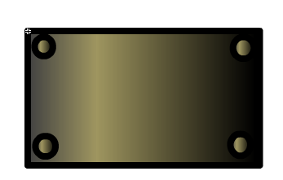
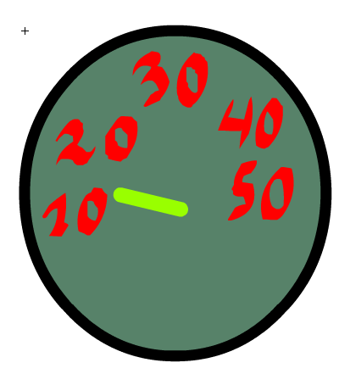
- Speed
  - player gets 10% increase in speed
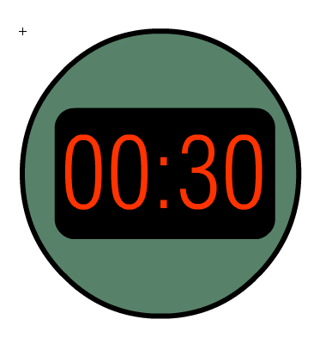
- Time bonus
  - Gives player 30 seconds longer to complete mission
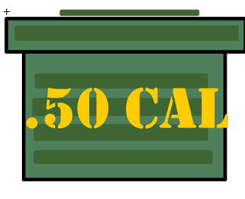
- Ammo bonus
  - 100 more rounds of ammo
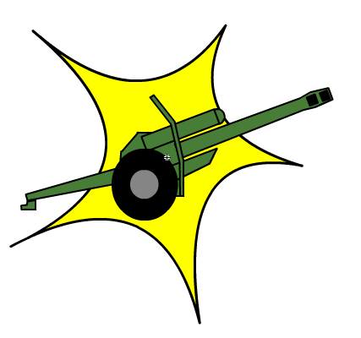
- Artillery strike
  - Kills everything on the screen besides player
- Armor Piercing Powerup
  - Kills personnel but goes through them able to kill more
Graphics
The turret of the humvee follows the mouse. The actors are animated conducting their previously described activities.

Explosions
When vehicles or buildings explode we will use explosion sequences.

Artillery Attack
The artillery attack will take place after a player has run over an artillery attack bonus. All actors accept for non combatants will be killed a uniform artillery explosion will be used on them. There will also be artillery explosions in places where there are no actors as well

Splashes: when bullets hit things
  - People: some come apart some just have blood splatter and lay down
  - Vehicles: see metal come off maybe sparks

Sound
1. Gunshots: depend on gun and ammo
  - AK-47: 1 shot
  - Humvee Gun
    - Normal .50cal
    - Armor piercing powerup
  - Explosions: one uniform sound
  - Screams:
    - Women
      - Begging: “help, help me”
      - Killed: shriek of terror
    - Gunmen
      - Killed: scream of death
- Music: Will use during cut seen and action
  - Currently sampling various Techno (Chemical Brothers), Arabic (Habibi), and Metal tracks to use in-game, as well as for briefings and title.

Platform:
We plan to implement our game in flash: Based on what we want to accomplish and a small amount of research into the various programming languages available, flash appears to be able to handle everything we need to accurately. No fuss no muss.
AI:
- All actors have preset behaviors
- Based on their role combatants will try to shoot and kill player until the player is dead. They are dead or run out of ammo and run away or surrender.

Cut scene
The cut seen will show one or 2 still frames to give the game some appeal, but then will give a menu with a background allowing the player to choose to:
- Play
a. Game loads
- Game over
- Do you want to quit?
- Progress “please wait while loading”
- Receive the Stage scene
Stage 1 - Raid!: Kill all the enemies (compund outskirts, huts, well)
Stage 2 - Breach!: Destroy Gate (watch towers, barb wire, 1 machine gun nest)
Stage 3 - Ambush!: Kill all the enemies (Base interior, concrete barracades, watch towers, 2 machine gun nests)
Stage 4 - Kill!:Destroy HQ (HQ, machine gun nests, concrete barracades)

User always has option to return to game or quit.

Sound affects on buttons of guns loading, ammo loading, engines revving, saws, punches and explosions.
If it takes time to load the level then there will be a cut scene for user to look at and a progress bar.

Target Audience:
We have picked males ages 13-25 as our target audience. This is because they are traditionally the ones driving the demand for Arcade Action shooters. Also being males ages 13-25, even if our girlfriends say we act like were 10, we are especially good at catering to this audience group.

Game Play
The game is an Arcade Action Shooter viewed from a birds eye view. It is very similar to the first installment of “Grand Theft Auto.” In this game you drive a Humvee and do not have the option of getting out.
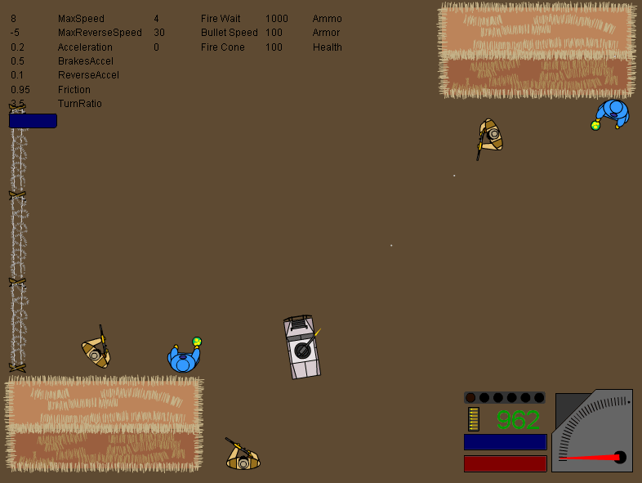
Actual Screen Shot
Production Tools
We have a few image and sound editing tools at our disposal
Image Editing: the easiest tool to handle bitmaps with is adobe Photoshop
Sound:
- Sonic foundry sound forge
- Macromedia
- Fruityloops
- sonic foundry: acid sequencer

What is it like to play the game?
Our goal is to make the game a fast paced challenge. The user will need to identify, discriminate and engage his targets, while avoiding getting hit. This is made more challenging by the time hack that the player needs to make in order to accomplish their mission.

In future additions it would be great to make the game as interactive as “Grand theft auto” allowing the player to leave the Humvee and even play multi player.
Character Bibles:

Axel and Bolt Blisken - Spec-Ops Armored Cavalry

The heroes of the story, they believe their father was kidnapped, so they now apply their military skills towards finding him, as well as kicking op-for ass. Axel is driver, he is a little more thoughtful and patient. Bolt is gunner, and wants to rush into situations guns blazing.
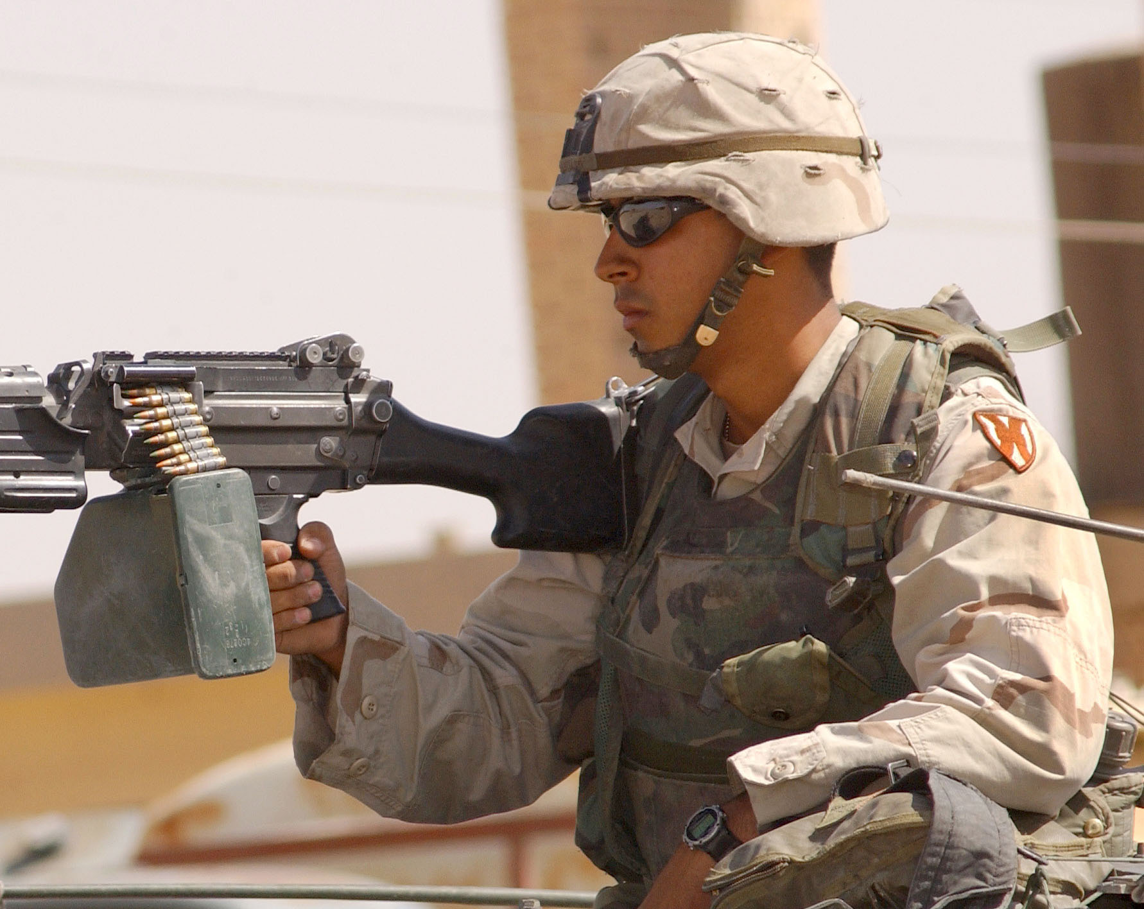
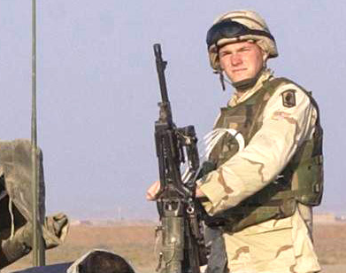
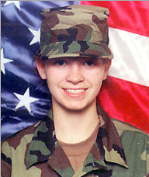
Axel
Bolt
Corporal Tara Marsh - Spec-Ops Military Intelligence

After a mysterious fatal accident in her previous unit, Marsh was transferred to Spec-Ops. She has vowed to redeem herself and has excelled ever since. She briefs the team before each mission about objectives and opposition.

Sergeant First Class Fillip Sullivan - Spec-Ops Vehicle Tech

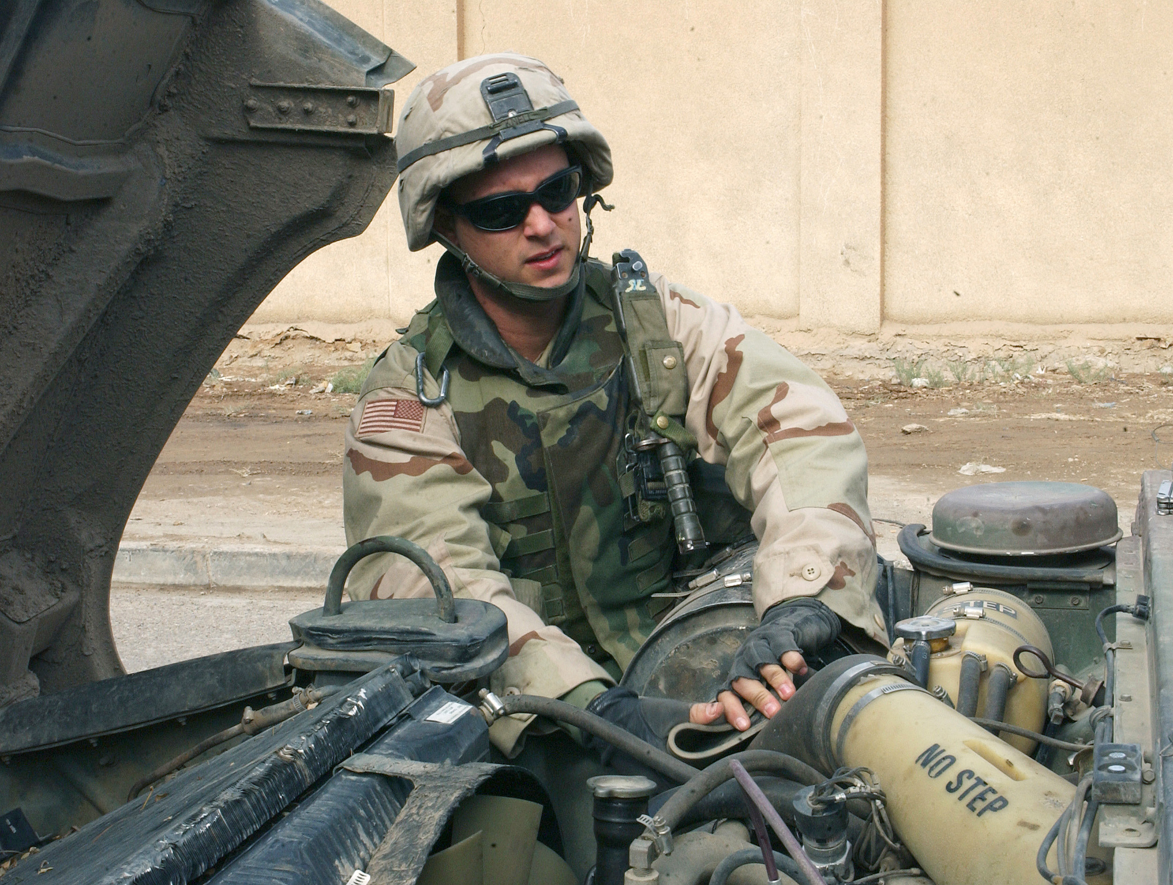
An American of Irish dissent (Sullivan…duh) he has spent 10 years in the army. He fought in panama, Grenada, and has spent the last 3 years in a secret war in Columbia. If it’s broken, Sullivan can fix it. He may also upgrade the Humvee between missions.

Commander Moudhadu Ajid - Spec-Ops Commander
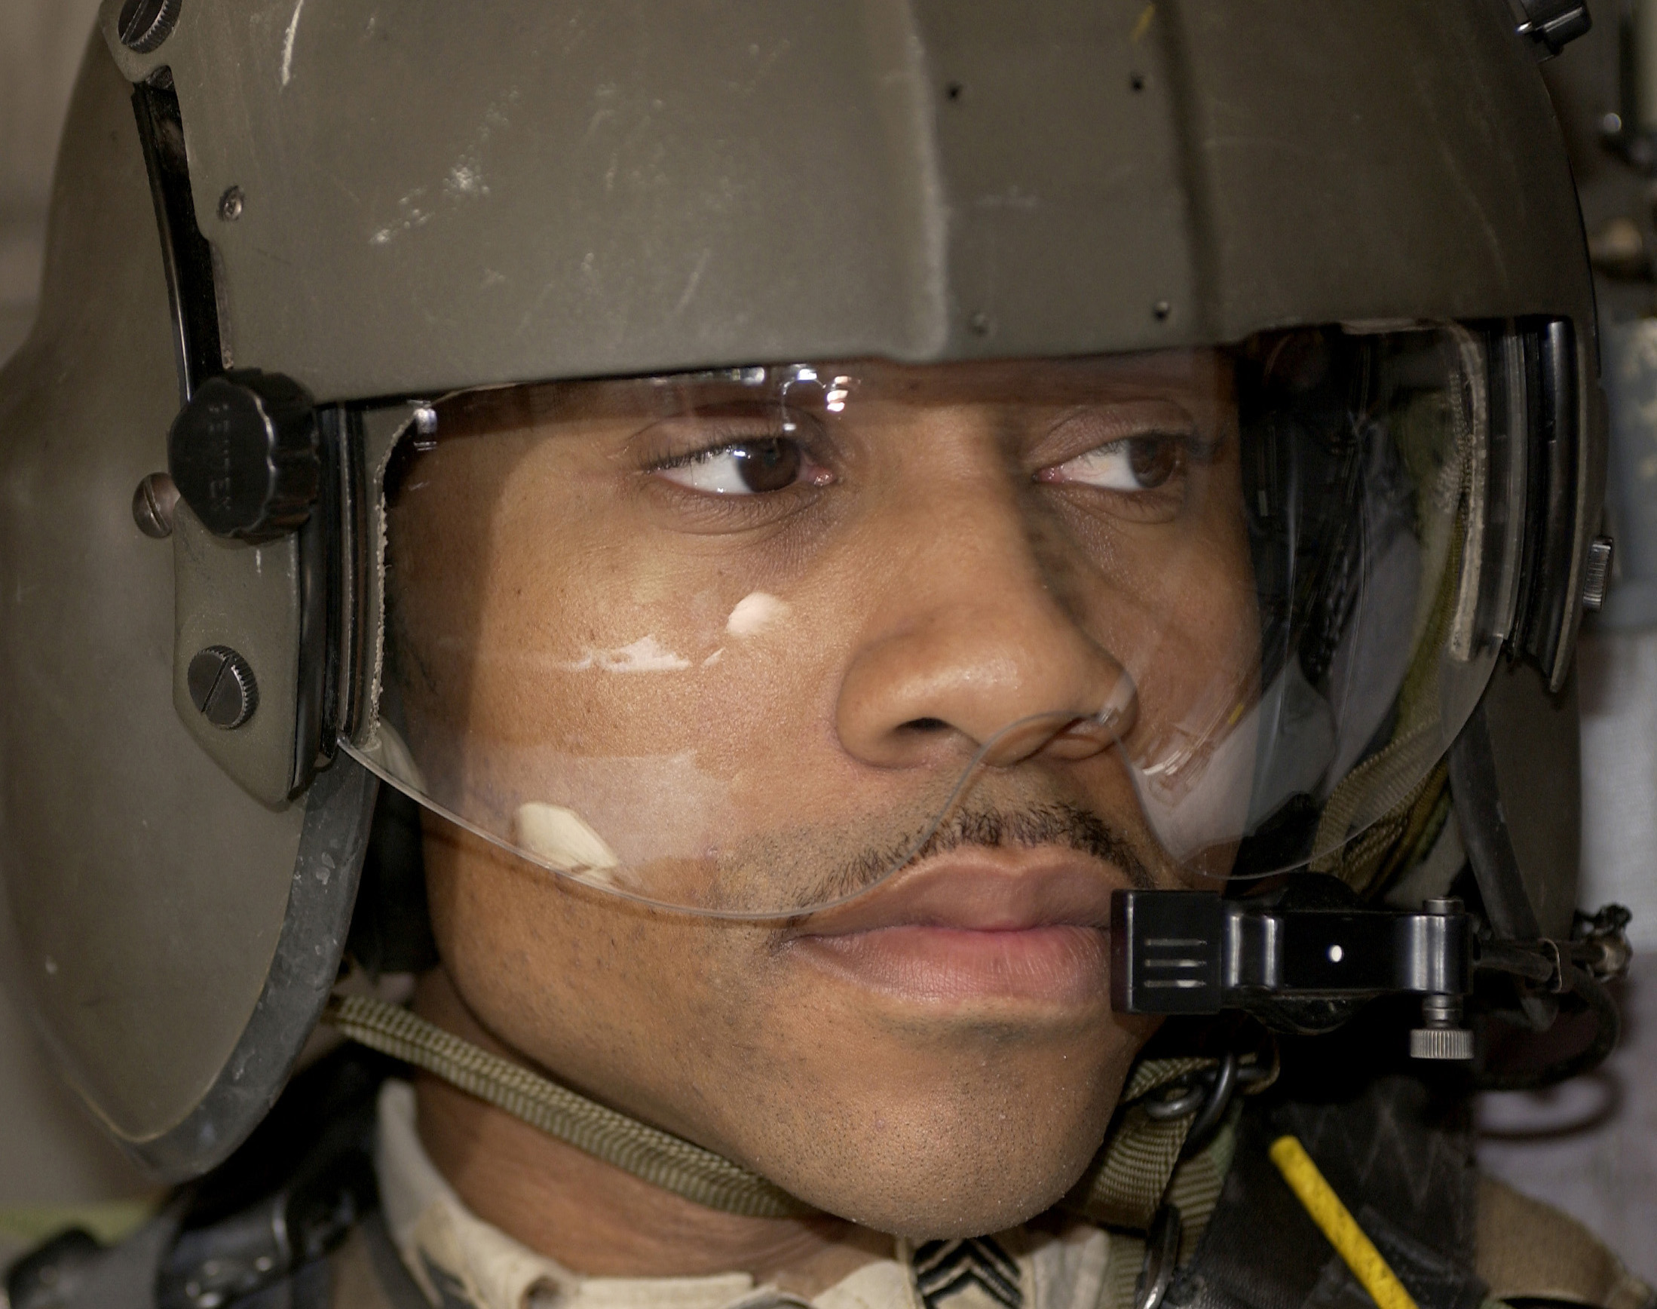
A national from Sierra Leone, he was rescued from the massacre of his village by as a teenager. He then worked as a scout with the indigenous forces lead by American Green Berets. When he turned 21, having gained the American soldiers’ trust, he was able to attain a visa to come to the United States. Upon receipt of his green card he joined the Army by special permission. In no time at all he excelled and was accepted to the Special Forces and later the Deltas. Axel and Bolt answer to him, and only him.

Clutch Blisken – MIA Military Scientist
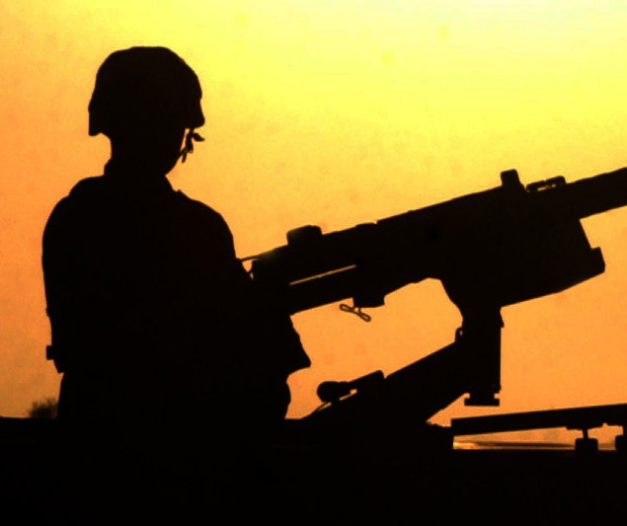
An important military scientist, Clutch went missing four years ago. It is possible he is involved against his will in the development of biological weapons. His two sons Axel and Bolt are looking for him.

Mysterious Mr. X – Evil Mastermind

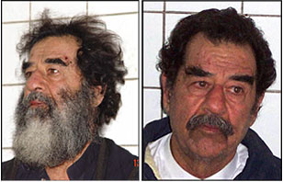

Not held enough as a child, Mr. X has developed a terrible hatred for all things nice and good. He is allying with the terrorists to fulfill his dreams of ruling over a really yucky bad evil world. A master of disguise he has been spotted using the following false identities.

And we will use this “Laser”
No, not really.
To blow up Alaska, and fry the local “polar bear” population creating an ecological crisis


