Delivery Boy – Design Document



Steve Blossom
University of Michigan – Dearborn
CIS 487

This page was intentionally left blank.

Table of Contents
Delivery Boy – Design Document 1
Table of Contents 3
Game Mechanics 5
Overview 5
Camera Position 5
Interface Design 5
Replaying and Saving 8
Game Play Details 9
Cut-Scenes 10
Storytelling 10
Artificial Intelligence 10
Opponent AI 10
Player Detection 10
Motion 10
Path finding 11
Special Actions 11
Combat 11
Non-player Characters 11
Game Elements 11
Character Bible 11
Items 11
Story Overview 12
Story board 12
Background/Plot Summary 12
Game Progression 13
Flowchart 13
Level and Scene Details 13
Bibliography 14

This page was intentionally left blank.

Game Mechanics

Overview

Game Story
The year is present day. You armed with a great master plan of obtaining massive amount of fortune have just started a job as a delivery boy for the Jimmy Johns Gourmet Subs Cooperation. Unfortunately you’ve had the luck of becoming a delivery boy at one of the stores located in Ann Arbor, Michigan (One of the most difficult cities to deliver in). Known for its bad drivers, random one way streets and of course jaywalking pedestrians that rarely look before crossing, it can be a delivery boy’s nightmare. It is your goal to keep your employment with the Jimmy Johns cooperation so you can accrue enough wealth to own the free world.

Game Play
The game is an overview 2D game. The goal is to successfully get the car to the delivery goal within the specified time period. If successful, the player earns tip money which is then added to their total savings. While out delivering the player must avoid hitting parked cars. If they happen to come in contact with a parked car it will cause damage to their car. If the player’s car gets 100% damaged they can no longer deliver subs and the game ends. If they finish their delivery without obtaining 100% damage they can apply the money they have saved or earned to fix their car. The goal of the game is to save up as much money as you can. Each level is randomly generated (everything except the map) to mimic the actual delivery environment where you have what seems to be random delivery times and random delivery locations. Because this takes place in Ann Arbor, parked cars are randomly placed on the streets to represent the way people park where every they feel like parking.

Development Specifications
The software will be developed in Visual C++ 6.0, with DirectX. The parts of DirectX will be Direct3D, DirectInputs. A digital camera will be used to capture any needed graphics for the game play. Photoshop 7.0 will be used to manipulate any of the images so a contiguous virtual world can be created.

Camera Position
The camera is located at an over head location looking downward towards the ground. The camera will remain in a relatively fixed position. When the player’s car is near a boundary of the world, the car will be moved instead of the camera to provide the illusion of an end of a world. Otherwise the car will be centered on an axis (x or y) and the background screen will be moved. The view of the camera position can be seen in the Game Play screen located in the Interface Design portion of this document.

Interface Design

The game consists of four main screens.

Intro Screen
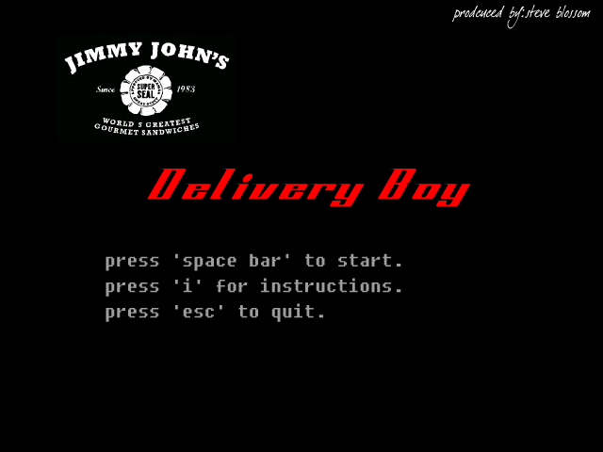
The intro screen consists of a title and a logo and the help on what keys are valid to continue on in the game. Pressing the ‘I’ key takes the user to the instructions screen. Pressing the escape key exits the game, and pressing the spacebar will take the user to the level start screen.
Instructions Screen
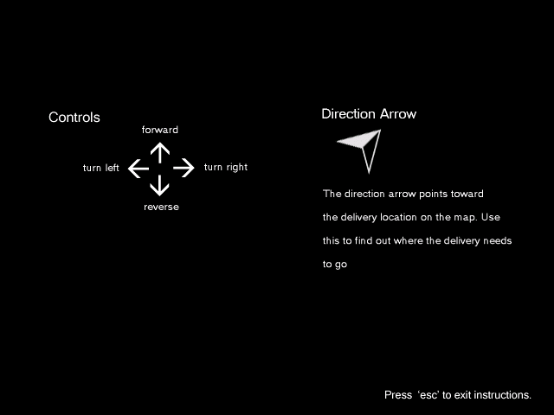
The instruction screen consists of three screens. The first 2 screens develop the story line for the player, giving a basic story outline and the goals of the game. The final screen (pictured above) shows the controls for playing the game. Pressing the ‘enter’ key will display the next instruction screen, pressing the escape key will return the user back to the intro screen.

Level Start/Level End Screen
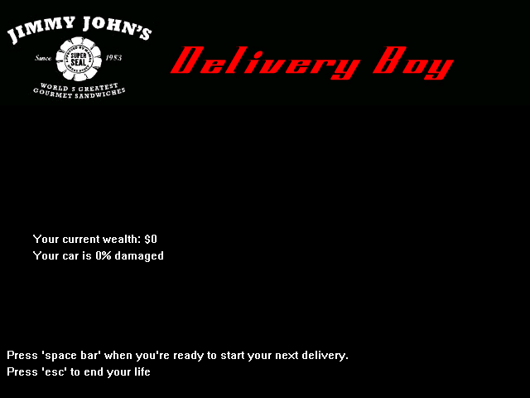
The level start/end screen consists of a header which has the Jimmy Johns logo and the game title at the top. On the screen the player’s current wealth is displayed, the amount of damage to the car. At the end of a level, the results of the level are displayed. This includes message indicating whether they completed the delivery successful or not, and the amount of tip they earned or lost accordingly.

Game play Screen
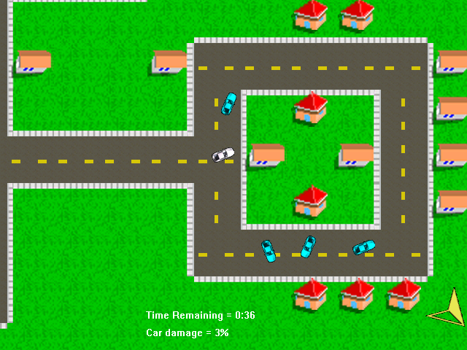
The game play screen consists of five main elements. First, is the player’s car. This is the white car in which the camera follows around. This is the object the player controls. The next are the blue cars. These cars are the parked cars that the player must avoid. These cars appear on the road through the world map. Next is the directional arrow. This is a yellow arrow that is always on the screen and located in the lower right hand corner of the screen. It represents the direction that the delivery location is from the car’s current position in the world. The next two items are the time remaining in the level and the total amount of damage the player’s car has obtained. When the remaining time is less than 15 seconds the text turns a red color to bring attention to the user. The car damage indicator also turns red when a damage rate of 80% is obtained.

Replaying and Saving
There is no mechanism for replaying or saving. Just as in real life, if you don’t make a delivery you don’t get another chance to do it again. In future revisions of the game it might be feasible to have the game play back the last level of play.

Control Summary
Intro Screen
- ‘I’ key – Displays Instructions Screen
- ‘Spacebar’ – Displays the Level Start Screen
- ‘Esc’ key – Exits the game

Instructions Screen
- ‘Enter’ key – Displays the next screen of instructions
- ‘Esc’ key – Returns player to the intro screen

Level Start Screen
- ‘Spacebar’ – Starts the game
- ‘Esc’ key – exits the game

Level End Screen
- ‘Esc’ key – exits the game

Game Play Screen
- Up Arrow – Increases the player’s speed (goes forward)
- Down Arrow – Decreases the player’s speed (goes reverse)
- Left Arrow – Turns the player’s car left
- Right Arrow – Turns the player’s car right
- ‘Esc’ key – Ends the level and returns the user to the Level End Screen

Game Play Details
The game starts up with the initial screen; see Intro Screen in the Interface Mockup section. From the Start screen the player than presses the ‘i’ key for the instructions. Instructions display the basic story line and the controls to the player. The instruction screen shows all information needed for the player to successfully play the game. If the presses the ‘spacebar’, the game is then started. The player is then given the place where the delivery needs to go and the time they need to make it in. They are then shown the Game Play Screen, as illustrated in the Interface Mockup section. After the delivery is completed or the time limit is met the player is then shown the End level screen. At this screen the player can view their current savings, the amount of money earned from the delivery, and the amount of damage to their vehicle. If they have enough money and choose to get some repairs done to their vehicle they may do so at this screen. After all this is completed, the player can then choose to start the next delivery or quit the game. The game ends when the player’s vehicle gets too damaged while out on a delivery (lose). Otherwise the game continues on until the player gets sick of the game.

The game is an overview 2D game. The goal is to successfully get the car to the delivery goal within the specified time period. If successful, the player earns tip money which is then added to their total savings. While out delivering the player must avoid hitting parked cars. If they happen to come in contact with a parked car it will cause damage to their car. If the player’s car gets 100% damaged they can no longer deliver subs and the game ends. If they finish their delivery without obtaining 100% damage they can apply the money they have saved or earned to fix their car. The goal of the game is to save up as much money as you can. Each level is randomly generated (everything except the map) to mimic the actual delivery environment where you have what seems to be random delivery times and random delivery locations. Because this takes place in Ann Arbor, parked cars are randomly placed on the streets to represent the way people park where every they feel like parking.

Cut-Scenes
Because of the scope and timeline of this project no cut scenes will be implemented.
In future revisions of the game it might be feasible to have cut scenes that illustrate the outcome of the level just completed.

Storytelling
All story telling is done in the instruction screens. It gives the basic game story and sets up the premise of the game. After that the story line is not further developed. It’s at the option of the player to imagine the future for the main character.

Level Summary
Each level is the same except for the following items:
- position of the parked cars
- delivery time limit
- delivery destination
- earned tip amount

Each of these elements are randomly generated creating the illusion of near infinite number of unique levels.

Artificial Intelligence

Opponent AI
There is no opponent AI as the game does not require it.

Player Detection
In order to successfully represent the ails of delivering subs in Ann Arbor two main aspects had to addressed. First the player’s car must stay on the road. The game is neither challenging nor real if the user can drive on top of houses. Since the world is created by placing different types of tile places, keeping the player on the street is as simple as making sure that the player does not move off a tile that is of type road. To accomplish the restriction an algorithm was developed to calculate the player’s current position and the player’s next position in the world as a grid number. That grid position is then looked up in the world map matrix. If the future tile is not a road tile the user is the not allowed to move on to that tile.

The second aspect that needed to be address was hitting parked cars. For this we simply used the Collision detection feature provided by the BOB object.

Motion
The player’s car is moved by pressing the either the up or down arrow on the keyboard. Direction is controlled by the car’s orientation which is controlled by the left and right arrow keys. The car’s direction and speed are then converted into change in x,y coordinate changes on the screen using simple trigonometry.

Path finding
The player’s path is restricted to road tiles. Since the world is created by placing different types of tile places, keeping the player on the street is as simple as making sure that the player does not move off a tile that is of type road. To accomplish this an algorithm was developed to calculate the player’s current position and the player’s next position in the world as a grid number. That grid position is then looked up in the world map matrix. If the future tile is not a road tile the user is the not allowed to move on to that tile and thus keeps the player on the correct path.

Special Actions
None

Combat
None

Non-player Characters
The non-player characters are non moving parked cars and therefore do not require any level of intelligence. They are randomly placed on road tiles, at random locations within those tiles and they are orientated a random way. If a play collides with a parked car the parked car is moved the distance equivalent to the impact speed and in the direction of the impact. Thus a car hit at speed four will move less if hit at a speed 8. Cars hit from the left side will be moved toward the right side of the screen.

Game Elements

Character Bible
There is only a single character in the game. Fave Jughes the Jimmy Johns delivery boy. This is the role the player takes on. Fave is a struggling individual who has great dreams of fortune. He has come to the conclusion that delivering subs for Jimmy Johns is the way to realize that dream.

Items
BOB items are the only complex data elements that exist in the game. They are the only elements that contain multiple items of information. They are used to deal with generating the background world, moving the player’s car around (and its orientation), the parked cars and the directional arrow.

Story Overview

Story board
- Intro screen
- Level Start screen
- Game player screen
- Level End screen

Background/Plot Summary

Game Story
Born lacking the ever desired silver spoon, you’ve grown up with a desire to make it somewhere in this world. For years you’ve relentlessly researched, plan, and scripted every detail of your eventual financial conquering of the free world. It is on this day, today, your plan goes into full affect. As today is the first day of the rest of your life. Today you are a delivery boy for Jimmy Johns Gourmet Subs.

Guided by your dreams of making it rich, your goal is to deliver subs to their intended recipients within the delivery window so that you can earn your tips and your pay. You must avoid hitting things as it will slow down your delivery time and of course cause damage to your vehicle, which requires money to fix.

Plot Summary
The player’s goal, as the delivery boy is to earn money. In order to do this they need to successfully deliver subs to the correct house within the allotted time. Doing so will earn them tips. If they damage their car they can replace it with the money they have earned/saved or not. If they choose so they of course have to spend money which goes against the end goal of the game

Game Progression

Flowchart
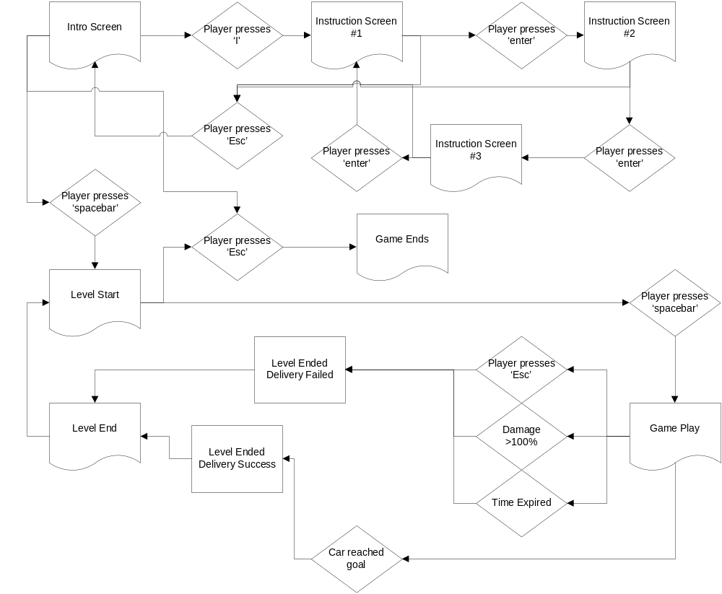

Level and Scene Details
All the levels will have the same look and feel. Each level will be created using a set of background tiles. The following are the tiles available for use:
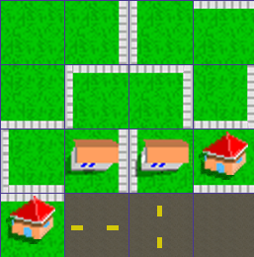

There are only three tangible objects in each level. There is the player’s car, the parked cars, and the goal delivery location.

Bibliography

Images
Background images were acquired from source on the enclosed CDROM with ‘Tricks of the Windows Game Programming Gurus’ Second Edition by Andre LaMothe.

Car images were acquired from http://www.newarabia.net/ferrari_456m_in_bahrain_part2.htm

Game Engine
Delivery Boy utilizes the game engine provided by Andre LaMothe in ‘Tricks of the Windows Game Programming Gurus’ Second Edition

