Pirate Showdown: The Game Design Document
David Nowell
CIS 587
12/17/02

I. Overview

Pirate Showdown’s story follows a pirate from the beginning of his career as a lowly cabin boy all the way to eventually becoming a pirate captain. The player begins as the lowest ranked member of a pirate crew. Through various challenges and missions, he will attempt to rise in stature, until he has become a more accomplished pirate than the Captain, at which point he will take control of the ship and win the game.

The challenges, missions, and options are all pirate-themed. There are four areas to the game:

- A boat race between the player and another pirate.
- A parrot shooting test of skill
- Raids on cargo ships
- The opportunity to interact with the crew at the bar.

Pirate Showdown is easy to play, with simple controls similar to that of basic arcade-style games, and an inuitive point-and-click menu. A thorough but concise help menu will give the beginning player instructions on how to play the games and what the goal of each is.

The game is set in a romanticized, cartoonish version of historical pirate stories. It is not intended to be historically accurate, and is more akin to a cartoon than a simulation. For instance, objects disappear when destroyed, and the physics are not rigorously modelled. There is no gore, only cartoon violence.

Due to its cartoonish feel and simple game mechanics, the most receptive audience would seem to be a pre-teenage demographic. However, since each mini-mission is designed to be completable in a fairly short length of time, an older crowd could be receptive to this as a game that can be played intermittently, perhaps as a break from a more intensive activity.

II. Game Mechanics

Overview

Pirate Showdown is a set of smaller arcade style game wrapped around a main menu and a pirate theme. It differs from just being a collection of games in that each success or victory in the smaller games affects the player’s overall rating. In addition, there is some interaction with the other pirates on the ship, making the player aware of how others feel about his character’s actions.

Camera Position

Pirate Showdown has 2 different camera angles used in the action sequences. In the boat race and cargo ship raid missions, the game is in top-down overhead view mode, with the player able to view the whole scene on the monitor. In the parrot shooting session, the player’s avatar is not visible. All the player sees is a gun-sight, like a first-person shooter. However, the player does not move himself, instead the gun is moved around the screen to aim at the targets.

User Interface Design

The main control panel for launching all the sub-missions is a very straightforward menu controlled by the mouse. The menu provides all the vital information the player needs to know. How much gold he has, his current level, health, and how the other pirates regard him. In addition, every pirate’s level is included on the main menu, so the player will know approximately how difficult the opponent is.
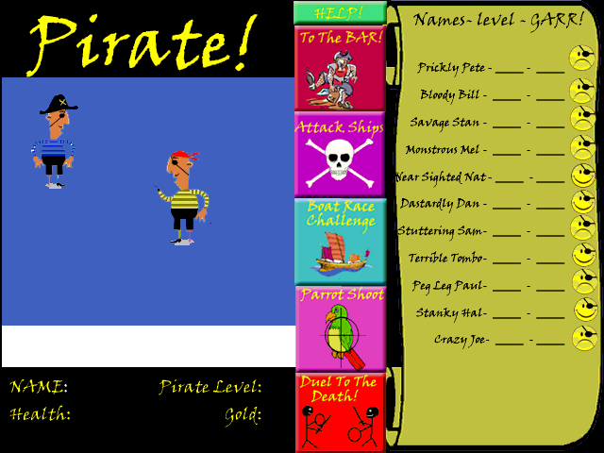

Replaying and Saving

This game does not support multiple lives, so if the player is killed, the game will end. However, at the main menu the player can save his current game, or load another game. Currently only one saved game is allowed, and saving again will overwrite the previous save. The specific state variables that need saving are the player’s level, his gold, health, and how the other pirates regard him.

Control Summary

There are different methods of control depending on the area of the game the player is in. In every section of the game, the Escape key exits. At the main menu, the mouse is used to select the next action, and opponent if applicable. In addition, here the player can hit the S key to save the game, or L to load a new game.

While shooting parrots, the controls are completely mouse driven. The target-hairs are moved with the mouse, and holding down the left mouse button fires at the parrots.

In both the boat race and cargo ship raid sequences, the arrow keys control the ship’s movements. Up accelerates the boat up to its maximum velocity, and down brakes it. Left and right turn the boat based on its facing. In addition, while raiding, the Spacebar is used to fire the cannon, and the R key will allow the player to retreat when his health drops perilously low.

Finally, the help menu and the bar scene both use the keyboard to navigate. The N key goes to the next help screen, and the Q key returns the player back to the main menu. In the bar, B buys a drink, R buys a round, and Q returns to the main menu.

Game Play Details

The main menu of Pirate Showdown has all the sub-missions available to the player. In addition, it shows your rank, gold, health, and a chart with information about all the other pirates on the ship. This chart includes their name, pirate rank, a picture, and how they feel about you, in a percentage format. This value will start off at 50% and fluctuate based on the following:

- Defeating other pirates in boat races. The defeated pirate will like you less, but it will increase the respect of others, assuming the race was truly a challenge, and not just the player defeating a lower-ranked opponent.
- Buying grog for others at the bar will improve your standing
- The player’s performance in solo missions & tests of skill, such as parrot shooting and raiding ships.

The player’s rank will start at 1, the lowest possible, with the goal being to rise in rank to a level higher than the captain, at which point the player will become the new captain and win the game. Total rank will be computed by adding base rank and adjusted rank together. Base rank is modified based on defeating other pirates, performance in parrot shooting, and raiding ships. Adjusted rank will be computed based on how much gold the player has and the overall like or dislike that other pirates have for him, weighted by pirate rank. The formula will be created to encourage balanced play, so there will be penalties to adjusted rank if the player spends all his gold trying to improve his standing with the other pirates.

In the ship raid, the player controls a small boat with a cannon on it. The target, a cargo boat, is surrounded by a variable number of escorts (1-10), of varying speeds. The number of escorts correlates to the value of the treasure aboard the cargo ship. The player needs to disable the cargo ship and dock along-side it for a few seconds to board. This is accomplished most easily by destroying the escorts, although it can also be accomplished with some alive. Some of the escort ships will concentrate on tracking down the player’s ship and attacking him, and the remaining ships will be focused on protecting the cargo ship, trying to keep themselves between the player and the cargo ship. All the escort ships have cannons and will be firing at the player’s ship. The viewpoint will be an overhead 2-D view of the ocean and all the ships. Damage sustained will be subtracted from the player’s health.

The way to challenge other pirates is a boat race. This screen will look similar to the ship raid mission. The pirate ship will be in the middle of the screen, acting as the center of the race track. Buoys will ring the outside of the track, and the player and the pirate he challenged will race 5 or 10 laps around the track, depending on the level of the competitors. There are randomly generated obstacles to make the course more challenging. The boat speed is determined by rank, but the AI will have random margins of error as it moves, so it will be possible to defeat someone of hgher rank with skillful navigating.

Another option available to the player is the parrot shooting contest. There are a 30 parrots moving across the screen, and using the mouse, the player must shoot as many as he can before time runs out. A good showing (50% or higher) will improve his rank, although every exhibition needs to be better than the previous to earn anything. Similarly, a poor showing (under 25%), will decrease the player’s rank.

The final activity the player can engage in is going to the bar. There he can spend the gold earned in ship raids. Drinking grog increases the player’s health, and buying grog for other pirates generally makes them like him more.

Cut-Scenes

There are no cut-scenes during the course of the game, however, there is a brief one at the beginning. The splash screen not only alerts the player as to what type of game this is, but gives the motivation for the player to succeed at the various missions.
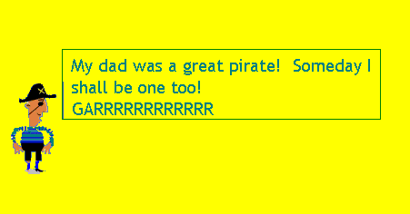

Storytelling

This is not a game with a heavily intense storyline. As it is designed to be played quickly and sporadically, a complex story would be detrimental, requiring the player to remember too many details from a previous playing session. The introductory screen will suffice to remind the player of the purpose of the game. In addition, the various environments, such as the bar, and even the help screen, which shows the player’s ship, will all add to the storyline by giving the player a sense of setting.

With these basic components in place to convey the location and style of the story, the player is free to internalize the storyline and make it specific to the events of each specific game.

Level Summary

Within each section of the game, the level settings will remain mostly static, with only the difficulty changing. The parrot shooting game is the most consistent level. Every time the player enters this game, the background is the same, there are 30 parrots, and they are all moving at the same speed. The only change is the number of parrots needed to hit. Since the player needs to perform better than his previous best, the difficulty always increases.

The cargo raid mission also has a static background. It is just set against a background of water. However, the parameters of the mission change each time it is played. There are from one to ten escort ships guarding the cargo ship each time, and the escorts all have a random speed.

The boat race is the most dynamic level. Both the player and the computer’s speed is based on the rank of each. In addition, there are crates placed in the water at random locations in the path of the racers. This ensures that each race is completely different.

III. Artificial Intelligence

Opponent AI

Most of the AI agents the player encounters will be humans in ships. These will be either pirates racing against him, or sailors defending themselves from the player. Therefore, these opponents need to appear intelligent and seem to have rational plans and actions. The other type of opponent the player will encounter is the parrots. Simple movements will suffice to mimic an animal intelligence.

Player Detection

Since this is an overhead view style of game, the player will have perfect knowledge of all activity. Therefore, it is reasonable that the opponents will also know where the player is at all times. This will enable the computer ships to track down the player and shoot at him.

Motion

All opponents will move in a believable fashion. The basic algorithms for moving the computer ships are similar to that used to navigate the player’s ship. Therefore, the computer will be moving in similar fashion and routes as the player, and subject to the same constraints. In the boat race mission, the computer opponent has a pre-determined set of waypoints that it will move through. Much like the player, who will occassionally hit a crate by accident as he moves, the computer will do the same if a crate is in his path. The waypoints zig-zag enough to give the illusion of constant navigational decisions while moving. In addition, the route is not the most optimal route available, since that would require much tighter turns that a player might not be able to make on a consistent basis.

The escort ships and cargo ship also use waypoints to move, but these are generated as the program runs. In general the cargo ship tries to move as far away from the player as possible. Some of the escort ships aim themselves directly at the player’s attack boat, while others position themselves between the cargo ship and the player.

The parrots simply move across the screen at a constant screen, flapping their wings as they fly. Every parrot comes onto the screen at a random position with a random x and y velocity. This is enough to simulate a swarm of parrots convincingly.

Pathfinding

The pathfinding routines for the computer ships are very simple. In general they select a target and plot a straight line for it. If they reach an obstacle and bounce off, they try again, with a slightly different path based on their new location. This is most noticeable to the player at slow speeds. At high speeds, the enemy boats move quickly enough that it looks like the recovery time is very quick. Future enhancements will call for better look-ahead pathfinding.

Special Actions

The majority of the AI features are based around movement and combat. The one special feature is the pirates’ responses to the players action. Feedback is given via the GARR rating, which shows how each pirate feels about the player at any given time. Specific personalities of each pirate can show through in this fashion. For instance, Bloody Bill will approve more strongly of the player for good showings in boat racing.

Combat

The AI agents only have one type of attack available to them, the cannon shot. Each successful cannon hit inflicts one point of damage on the player. The AI shoots half the time that it is within range (70 pixels). It is presumed that the other half of the time is spent reloading between shots.

The escort boats don’t worry about evading the player cannon shots. Since they are always moving toward the player, often in formation with other ships, the player generally has to be more concerned about getting out of their way. It takes ten cannon shots to disable an escort ship, and 20 to immobilize the cargo ship.

Non-player Characters

The pirates act as both the NPCs and the opponents at various times. There is no interaction with the sailors of the escort ships and cargo ships besides raiding them. However, not only does the player race against other pirates, but he interacts with them. He can buy them drinks at the bar, or just watch the GARR rating to see how his actions are influencing their opinion of him.

Puzzles and Traps

There are no puzzles or traps set for the player. A skillful player will be able to lure the computer into traps of his own however. In the ship raid mission, by using the cargo ship as a shield, it is possible to ambush the escort boats and fire at them without taking many shots. And in the boat race, careful positioning can force the opponent to run into the player, turning the opponent’s boat around and sending him flying off.

IV. Game Elements

Items

There is only one item that the player will accumulate and take with him as the game progresses. That is gold. This can be used to restore health by buying grog at the bar, or to purchase rounds of drinks for the other pirates. In addition, if the player doesn’t have enough gold, his adjusted level will decrease.

There are other objects that are either controlled by the character or the computer. In the boat race and ship raid, the player has a boat that he maneuvers around the screen. The computer also has one or more boats. And in the ship raid mission, both sides have a cannon in their boat that they can fire at each other.

The other type of objects are static objects. The only example of that in Pirate Showdown are the crates in the boat race. These are scattered about in the water, anchored down, and when a boat hits them, the boat bounces off.

Character Bibles

Player:
The main player begins play as a cabin boy, the lowest ranked pirate on the ship. His goal is to become a better pirate than any other member of the crew and take over as captain. His father was a mighty pirate, so he wants to follow in the tradition.

Prickly Pete:
Captain. Rank of 15. His approval is hardest to earn.

Bloody Bill:
First Mate. Rank of 13. Pays special attention to the parrot shooting competition.

Savage Stan:
Rank 11. Especially interested in the boat races.

Monstrous Mel:
Rank 10. Worried about being demoted. When the random encounter enhancement is implemented in the future, liable to challenge weaker pirates before they reach his level.

Near Sighted Nat:
Rank 9. Can be swayed easily by buying him grog.

Dastardly Dan:
Rank 8. Races better than his rank would indicate.

Stuttering Sam:
Rank 7. An average pirate with little ambition.

Terrible Tombo:
Rank 5. Another young pirate trying to move up the ranks.

Peg Leg Paul:
Rank 4. An exceptionally poor sword fighter.

Stanky Hal:
Rank 2. Has very few friends. Buying grog for him will win him over. However, his influence is fairly low.

Crazy Joe:
Rank 1. His feelings about the player change drastically, and often without provocation.

V. Story Overview

Storyboard

There are several different scenes and levels in Pirate Showdown. The main menu has been illustrated previously in this document. The bar scene uses the following graphic, with text on the bottom giving the various options available to the player:

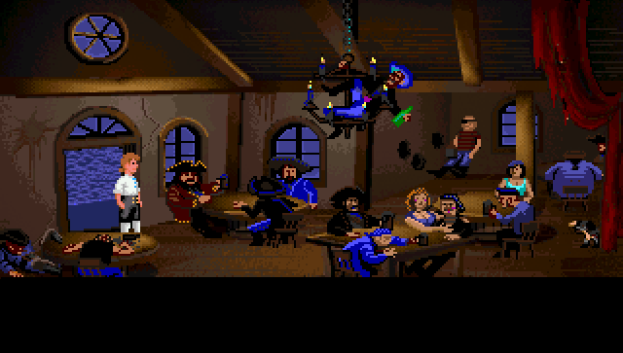

The boat race looks different every time, due to the random placement of the crates, but here is an example storyboard:
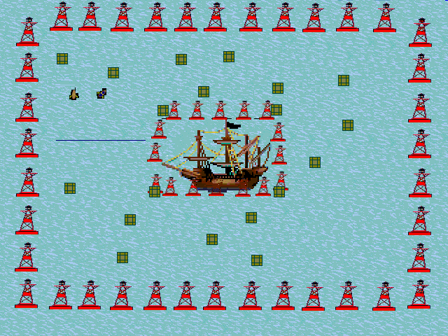

The cargo ship raid has a similar background, but with less items on the screen. Since there are so many sprites moving around, adding obstacles would just stretch out the length of the mission.

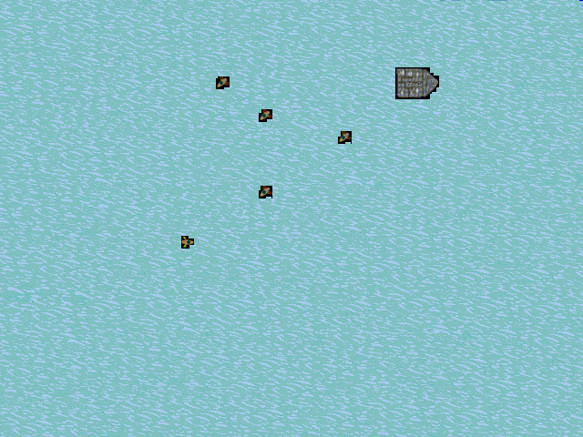

Here is an example of what the parrot shooting screen looks like. The player uses the mouse to control the cursor and left click to shoot at the parrots.
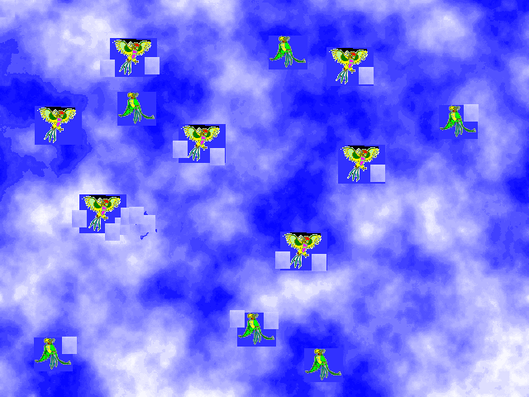

Background/Plot Summary

The player begins the game as a cabin boy, lower in rank than everyone on his ship. Demonstrating his aptitude for the pirate life by besting other pirates and performing well in demonstrations of skill, he begins to move up the ranks.

The background of the game has the player joining an established pirate ship as a new recruit. His father was a well-respected pirate, so the goal is to become as successful as him. This is accomplished by taking over as Pirate Captain.

VI. Game Progression

Setting

Pirate Showdown is set in an alternate version of the early 1700’s. The grim reality of life as a pirate is de-emphasized. Instead, the focus is on the romantic notions of life as a pirate. Drinking, sailing, raiding ships and generally having fun is what it means to be a pirate.

Introduction

The player controls the main character, an aspiring pirate. Striving to live up to his father’s legacy as a pirate, he will undertake various missions and challenges to improve his standing in the pirate community.

Flowchart

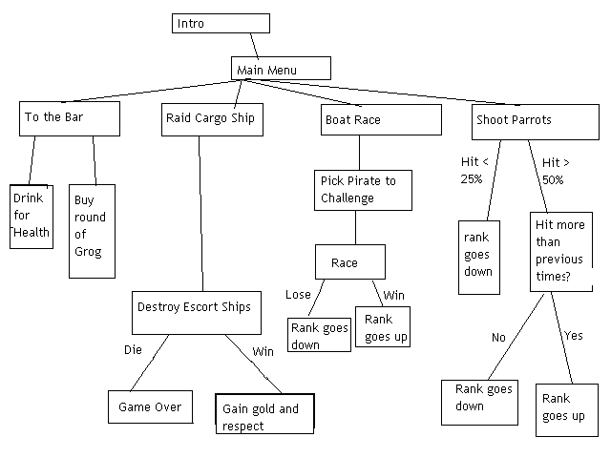

Level and Scene Details

The basic outline of each mission is detailed in the game play and storyboard sections of this document. There are some level dependent features that will be addressed here.

In the parrot shooting mission, while the parrots will not ever change speeds, the player gets no benefit from playing the mission again unless he exceeds his previous performance. In addition, a particularly poor showing (under 25 percent) will reduce his level.

The boat race challenge is also level-based. The speed for each boat is based on the level of the pirate. In this manner, a higher ranked pirate will have a better chance of victory. However, due to the random configuration of the crates, the player still has a chance to defeat a faster opponent.

The cargo ship raid will not change as the player’s level increases. His maximum speed remains the same. The escort ships have random speeds, and anywhere from one to ten ships will be present on a given mission. The more escort ships there are, the more gold will be won (20 gold per escort ship).

VII. Bibliography

LucasArts, The Secret of Monkey Island. 1990

This game was the inspiration for the setting of Pirate Showdown. While the gameplay between the two is completely different, some of the artwork and music was borrowed for Pirate Showdown. Monkey Island is a comedic pirate role-playing game, starring an inept pirate. It has spawned three sequels, each with increasingly better graphics and sound.

Elliot, Chris and Resnick, Adam. Cabin Boy. 1994

While this movie did not directly impact Pirate Showdown, it gave me the original idea of having the player start off as a cabin boy determined to become a real pirate.

LaMothe, Andre, Tricks of the Windows Game Programming Gurus. 2002

The basic game engine provided by LaMothe was used in the design and implementation of this game. This is an invaluable textbook for a first-time game designer.

