University of Michigan – Dearborn

Slime King

Edward Kallio
CIS 587
Fall 2002
Dr. Maxim M W 4:40 – 6:00
Final Project
Incomplete

Slime King 1
Overview 4
Game Mechanics 4
Camera Position 4
RPG Elements 4
Leveling up. 4
Hit Points 5
Attacking 5
Defense 5
Triple Attack 5
Heal 5
User Interface Design 6
Menus 6
Character Interaction 7
Dialog Boxes. 7
Replaying and Saving 8
Cut Scenes 8
Prologue: - Attacked by a dog 9
End of Chapter 1: Attack Tomi 10
Chapter 2: Attack the Merchant - Start: 11
Chapter 3: Kill the King - Start 12
Chapter 3: Kill the King – Good (live) 13
Chapter 3: Kill the King – Evil (die) – Game Over 14
Chapter 4: Rescue the Princess - Start: 14
Chapter 4: Rescue the Princess - End: Game Over 15
Level Summary 15
Prolog: 15
Attack the Kids: 15
Attack the Merchant: 16
Kill the King 16
Rescue the Princess: 16
Artifice Intelligence: 17
Opponent AI 17
Player Detection 17
Path Finding 17
Combat 18
Puzzles 18
Non Playing Character 19
Game Elements 20
Art Bible 20
Scenery Tiles 20
Character Tiles 25
Monster Tiles 30
Monster Bible 34
Random Encounters 34
Bosses 36
Story Overview 38
Background Story: 38
Game Progression 39
Setting 39
Flowchart 40
Level and Scene Details 41
Introduction 41
Chapter 1 41
Chapter 2 41
Chapter 3 41
Chapter 4 41
Good Ending 41
Bad Ending 41
Bibliography 42
Glossary 43

Overview

Slime King is a top down role playing game parodying Dragon Warrior, a popular Console Role Playing Game for the Nintendo Entertainment System, NES, which the game will take its look and feel. The player assumes the role of a slime in slime village. The standard “Kick Down Door, Kill Monster, Take Treasure, repeat” game formula will be used.
The Slime King will allow the player to choices, whether to save the people who he defeats, or to murder the people he defeats. If the player chooses to save people, the morally correct choice, they will be treated to a rescue the princess level, and the good ending. If the player chooses the morally incorrect path he will become king, and destroy all humans.
The user interface consists for one action button and the keypad. The keypad moves the player around, and the space bar acts as an action button, that allows the user to select an action. All menus either have a way to cancel, or one of the choices must be made. Exiting the game still requires the escape key.

Game Mechanics

Camera Position
The Camera will be positioned top down, with the level center around the player.

RPG Elements

Slimes absorb metals to gain new skills. In this game, there are four kinds of metals, Gold, Silver, Copper, and Iron. Each one is needed for a different action. Collecting (absorbing) enough gold increases attack, while absorbing copper increases defense. Iron and Silver are spell components, for healing and Triple attacking, respectively. Below are the exact methods of how each of these game objects work.

Leveling up.
Leveling up, unlike most RPGs, is just attacking and defense, no other skills are gained on each level, and attacking and defense are separate, i.e., you can level up attacking several times before you level up defense. Gold is related to attacking, and copper is related to defense. To level up, you must gain fifty times your level of the material assigned for that statistic. For example, if you have a five in attack, you must gain 50*5 or 250 gold pieces before you reach the next level in attack, and likewise for defense.

Hit Points
The Player starts out with ten hit points, and this value stay the same throughout the entire game. To take more damage, the player can increase his defense rating, which is described below.

Attacking
Unlike most RPG games, attacking always succeeds. To determine the amount of damage you do to a monster, you must use the chart below. Where + is plus, and – is a range between two numbers, i.e 1- 3 is a random number between one and three

Level | Attack
1 | 1 + 1-3 + 1-3
2 | 2 + 1-3 + 1-3
3 | 3 + 1-3 + 1-3
4 | 4 + 1-4 + 1-4
5 | 5 + 1-4 + 1-4
6 | 6 + 1-4 + 1-4
7 | 7 + 1-4 + 1-4
8 | 8 + 1-5 + 1-5
9 | 9 + 1-5 + 1-5
10 | 10 + 1-5 + 1-5
11 | 11 + 1-5 + 1-5
12+ | (level) + 1-6 + 1-6

Defense
The defense rating is directly proportional to how tough our player is. To calculate defense, take the amount of damage done by an enemy, subtracted by the number in the defense. If a player’s defense is high enough, then the enemy does no damage.

Triple Attack
Triple attack is one of the two spells in the game. This ability requires one hundred silver pieces. It allows a player to attack as if the opponent has lost two turns. This is very useful against bosses.

Heal
This ability requires one hundred iron pieces. If you have one hundred iron pieces, then this ability will allow the player to regain all their hit points back.

User Interface Design
The user interaction will include direction, Up, Down, Left, Right, and an action button, the space bar. All actions will be GUI based, either selecting a task from the GUI, during combat, or else facing a person and clicking action.

Menus

Normal Menu

Normal Menu
Look | Heal
Statistics | Cancel

Look – Gives a short description of where the player is.
Statistics – Uses a pop-up to show player information
Heal – heals the player, as long as he has enough silver pieces
Cancel – leaves this menu

Battle Menu

Battle Menu
Attack | Heal
T. Attack | Run

Attack – Attack the monster in front of the player.
T. Attack – Uses the spell triple attack
Heal – Heals the character
Run – Player tries to run from battle.

Live or Die Menu
Live DieMenu
Die
Live

Die – Kills the NPC mentioned in the text.
Live – Lets the NPC live.

Exit Menu
Exit Menu
Exit
Return

Exits – Leaves the game.
Returns – Returns to the game.

Start Menu
Start Menu
Start
Continue

Starts – This begins a new game, starting with the prologue.
Continue – The menu option continues a previously saved game.

Character Interaction

To talk to NPCs, just face the person you would like to talk to, and press the action button.

Dialog Boxes.

Small Dialog
Small Dialog
hp | xxx
sp | xxx
ip | xxx

hp – The number of Hit Points.
sp – The number of Silver Pieces.
ip – The number of Iron pieces.

xxx – the number related to the previous entry.

All of these statistics are useful to the player, so I’ve included them in a smaller pop up window. This window is displayed whenever a player has to make a choice which will require one of the items listed in the small dialog box.

Large Dialog

Large Dialog
Hit Points | xxx
Max Hit Points | xxx
Attack | xxx
Defense | xxx
Gold Pieces | xxx
Silver Pieces | xxx
Copper Pieces | xxx
Iron Pieces | xxx

Hit Points – The current amount of hit points the player has
Max Hit Points – The maximum number of hit points.
Attack – The player’s attack rating.
Defense – The player’s defense rating.
Gold Pieces – The number of gold pieces the player has.
Silver Pieces - The number of silver pieces the player has.
Copper Pieces - The number of copper pieces the player has.
Iron Pieces - The number of iron pieces the player has.

Replaying and Saving
Slime King will allow saving only in three spots, the Elder Slime, the Slime Shrine, and the Slime Throne room. This is because Dragon Warrior only allowed saving in these areas.
If a person dies, the game returns to the start menu, where the player can bring back his last save.

Cut Scenes
Cut scenes will be in-engine. The prologue, attacked by a dog, the mid cut scene, kill the king, and the final cut scene, slime saves the day, will all be animated using the game engine. Cut scenes otherwise will consist of scrolling text and dialog, and be a longer version of talking to a character.

Prologue: - Attacked by a dog

Player slime is looking around.
Text box: “

It was just an average day in the old Slime Village.
not a bad one either..
and for our one fine slime
Things were looking up

Until..

Event Battle: Attack a puppy.

Player is in front of a slime elder
Text box:
Elder: ‘I thought You were a;
Goner...
'When I was a child, Slimes
lived in Slime Valley
And Lived in Peace with
People’

Slime: 'Really?'

Slime Elder: 'Yes...The Slime King
Protected us , mostly, and
until his Betrayal, we
"slimes lived in peace’

'I've decided Here!’

Player Graphic is now wearing a cape.

Slime Elder: 'This is the Slime King's
cape. All warriors must
wear capes…

'This will protect you
From taking some damage..'

Slime: 'Why me?'

Slime Elder: 'Slimes grow stronger by
absorbing metals...

'Most slimes in Slime
Village have yet to absorb
any...Except you...'

'That Puppy...that was no
accident, more will come...'

'There is no time left'

'NOW GO AND FREE THE
SLIMES!!!! AVENGE THE SLIME
KING!!!'

Slime: 'Ummm...ok, I guess'

Slime Elder: 'If you see a Slime like me,
talk to us to heal and save'

End of Chapter 1: Attack Tomi
Textbox:
Slime:’ Please let me have
the key to the door.'

Tomi: 'You yucky slime! I will
attack you. Slime Head!!'

Slime: 'BATTLE!!!!’

Event Battle: Tomi

Textbox:

Tomi: 'I'm sorry Mr. Slimey
I'll be good to slimes, I
Promise

Allow Tomi to live or die?

Choice Live:
Slime: 'I guess I'll let
you live, I don't kill
the moronic...'

Choice Die:

Slime: 'Things like you
don't deserve to live.'

Slime: 'You will die
now!!!'

Tomi: ‘AAAAAAAAAAAAAAAAAAAAAAA'
Tomi is removed from the map.

Chapter 2: Attack the Merchant - Start:
Textbox:

Slime: 'Why are you
equipping soldiers to
attack innocent slimes?'

Merchant: 'I am just a simple
Merchant’

Slime: 'No you are not.
You don't seem to sell
anything people in this
village need, only
weapons'

Merchant: 'Warriors need swords
I provide a service.
I don't see anything
with that'

Slime: 'BATTLE!!!'

Game Event: Battle the Merchant

Merchant: 'If you let me
live, I promise to sell
groceries! I promise
Please! Please! I beg
of you!

Choose The Merchant's fate

Choose Live:
Slime: 'I guess
I'll let you live
as long as you don't
sell dog food'

Choose Die:
Slime: 'Things like you
don't deserve to live.'

Slime: 'You will die
now!!!'

Merchant: ‘AAAAAAAAAAAAAAAAAAAAAAA'
Merchant is removed from the map.

Chapter 3: Kill the King - Start

King: 'I am greatly pleased thou
hast returned...Slime King’

‘So we meet at last, the
descendant of King Slime'’

Slime: 'I'm not related
anybody special'

'Oh, I thought that’s how
these games work...'

Slime: 'I'll make you a
deal..
If you never again record
deeds on the Imperial
Scrolls of Honor, I will
refrain from attacking you'

'...'

Slime: 'BATTLE!!!'

Game Event: Battle the King

King: 'I'll never change!'

King: ‘I will always hate slimes
Slimes are GROSS!'

What should you do?

If the Player has chosen to kill Tomi and the merchant, then the script automatically jumps to kill the king (evil).

Chapter 3: Kill the King – Good (live)

Slime: 'I guess
I'll let you live

Does anyone have a
suggestion?

Graphic of Human and Elder Slime added

"Elder Slime: 'I can do
something...'

I had absorbed
mercury a while back
so I can change one human
into a slime...him!

Graphic of King changed into graphic of a slime

King: 'AAAAAAAAAHH!’

Peasant: 'Noble Slime
please save our
Princess

Slime:'huh?'

Peasant: 'Our Princess is
being held prisoner by
the dragon!'

Slime: 'Ah! Might as well
the more cliche, the
better'

Chapter 3: Kill the King – Evil (die) – Game Over

Slime: 'Things like you
don't deserve to live.'

Slime: ‘Nor any Human'

Merchant: ‘AAAAAAAAAAAAAAAAAAAAAAA'

Large Graphic of evil Slime

Human and Slimes can not
live together, never!
I will personally eliminate
The human menace!

Now begins the greatest
kingdom of the Slimes!

End

Chapter 4: Rescue the Princess - Start:
TextBox:

Dragon: ‘First, they send 1st
level warriors, now a
slime!! mwhahahaha'

Slime: 'BATTLE!!!'

Chapter 4: Rescue the Princess - End: Game Over

Princess: 'Thank you noble
slime for rescuing me'

Princess: 'As a reward,
may marry me.'

Slime: 'YESSS!’

Change scenery to slime sitting on the throne, with the princess on his side.

Human and Slimes will
live in Slime
"together

We will no longer be
enemies, but instead
consider ourselves
friend and allies

End

Level Summary

The actual story is above in Cut Scenes, this is a summery of what the player must accomplish during each level.

Prolog:
Player cannot move during prologue, it will be totally scripted. The player will learn about the story of the game, and decided to defeat the evil that lives in the world.

Attack the Kids:
Player can only move in Slime Village, and the Playground. A door will block the path to the next level, which will only be open after ending this level, by defeating the child who holds the key. The player will then have a choice, either to let the child live, and run away, or to kill the child. This will be recorded and saved for later decisions.

Attack the Merchant:
Player cannot enter the castle, because warriors with swords and shields guard it. A script is playing, where a warrior leaves the castle, goes to the town, and then returns to the castle. If a player attacks the warrior as he leaves the castle, he will be easy to defeat, and contain lots of gold, if a player attacks the warrior after he leaves the town, he will be impossible to defeat. After the player finds out the merchant is in charge of selling weapons, he attacks defeats the merchant, who vows not to sell weapons, only non weapon items, like food. The player will have a choice of letting the merchant live, or die. This will be recorded for later.

Kill the King
Now that no warriors can buy weapons, the castle is now undefended. The king is in charge of saving and loading, and his father is the reason humans have now populated slime valley. Time to take revenge. The player enters the castle, and attacks the king. After his defeat, the Slime gets a choice, to either kill the king, who vows to never forgive slimes, or find a reasonable solution. After a player chooses, a story branch occurs.
More Good then evil:
The Elder Slime enters, and turns the king into Slime. The king runs away, and is never scene again. The slime now becomes a good slime. Jump to rescue princess:

More Evil than Good
The player kills the king, and the scene fads to black. If a player chooses to save the king, but still is more evil, he will then repeat a small phrase to the effect that it’s not in his nature. The game ends with a description of the slaughter of the humans, and the image of the black slime, which represents the character. The end

Rescue the Princess:
After the defeat of the king, a player is then requested to save the princess in the dungeon below the city. The player enters the one level dungeon, and attacks a dragon, upon the dragon’s defeat; the player is shown himself and the princess in the throne room. The game repeats a small thank you, and fades out. The end.

Artifice Intelligence:

Opponent AI
Opponent AI will be based on the aggressive monster theory. All monsters are aggressive towards the player, no matter why or what. All NPC are friendly towards the player no matter what, unless they are a part of the quest.
All interaction will either use a finite state machine or a linear script. The player himself chooses to interact with a NPC, and monsters choose, by random number, to attack the player.

Player Detection
After a player steps on a tile, a percent chance for attack will be rolled. If the chance is successful, then the player must contend with some sort of attack. Before moving, the program checks to see if the player isn’t running into a wall or character, and stops him from moving.

Path Finding
No Path finding is needed. All NPC don’t move at all.

Combat
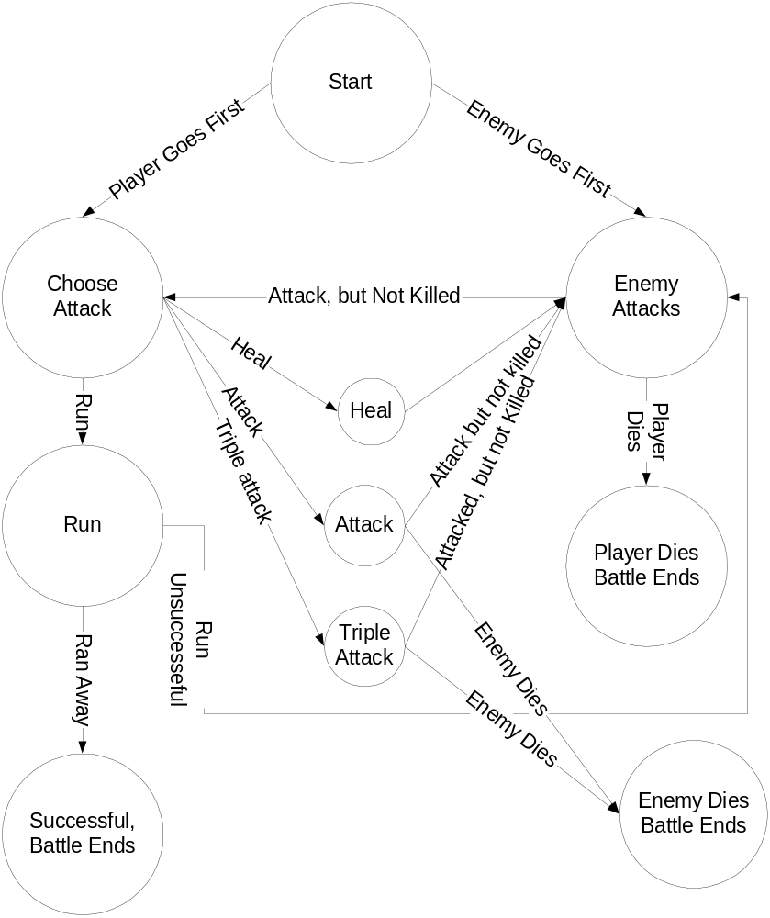

Puzzles
Each chapter requires a puzzle to be solved, and each puzzle requires the defeat of a NPC. No logic is needed for any of the puzzles in this game.

Non Playing Character
Some non-playing character information can be found in the Enemy Bible.

Elder Slimes. Elder slimes have lived in the valley for many years. They all are old enough to remember meeting King Slime. Most of them were adventurers who have absorbed certain life prolonging metals, which even they don’t know what. They are all too old to continue adventuring, but instead act as oracles to young adventures. They usually find young slimes, give them capes, and tell them to complete tasks they failed doing in their youth.

Village Slimes. These slimes are rather young, they know they are the last slimes alive in slime valley, but they don’t really care. Most of them are strong enough to leave the village on short errands, but none of them are willing to fight and save the slimes.

Oracle one and oracle two. They are directly from Dragon Warrior I, and they also make appearances in Dragon warrior III. I felt it was fitting to include them in my game. One of them heals curses, and the other tells of a place where someone can get magic keys.

Castle Knights. The Castle knights found armor that looked cool, but doesn’t do anything. They simply pretend to guard the castle, but they are really powerless.

Temp Wizard. In every dragon warrior clone, the designer must make mention of the wizard that restores hit points, since he is very useful. My version has a temp wizard that says the saying, but then doesn’t do what they should have done.

Game Elements

Art Bible
Edward Kallio edits all titles, although some were taken from sources instead of drawn by hand. Most of them contain seams, so they shouldn’t be used in other projects, unless the programmer is running out of time.

Scenery Tiles

Tile 0 - Blank
Artist: Edward Kallio



Tile 1- Grass
Credit: Edward Kallio



Tile 2 – Forest
Artist: Edward Kallio




Tile 3 – Mountains
Artist Edward Kallio



Tile 4 – Dessert
Artist: Edward Kallio



Tile 5 – Swamp
Artist: Edward Kallio



Tile 6 – Water
Source: Dragon Warrior 1 for Famcom


Tile 7 – Brick
Artist: Edward Kallio

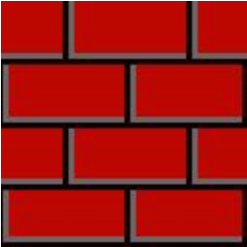

Tile 8 – Countertop / Throne
Artist: Edward Kallio



Tile 9 – Cracked Cement Block
Artist: Edward Kallio


Tile 10 – INN sign
Artist: Edward Kallio


Tile 11 – Roof Top
Artist Edward Kallio



Tile 12 – Staircase up
Source: Dragon Warror 1 for NES and Tile 7



Tile 13 – Stairs Down
Source: Dragon Warrior 1 for NES



Tile 14 – Village
Source: Dragon Warrior 1 for NES


Tile 15 – Castle
Source: Dragon Warrior 1 for NES



Tile 16 – Slime Shrine
Source Dragon Warrior 4 for PSX
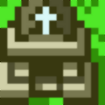

Tile 17 – Dungeon
Source: Dragon Warrior 1 for NES

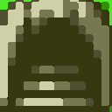

Tile 18 – PlayGround
Source: Dragon Warrior 4 for PSX

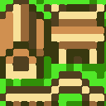

Tile 19 – Slime Village
Source: Dragon Warrior 4 for PSX and Tile 4
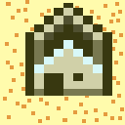

Tile 20 – Door
Source: Dragon Warrior 1 for NES, and tile 1
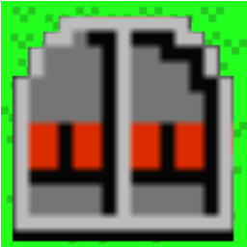

Tile 21 – Grave
Artist: Edward Kallio


Tile 22 – Sign

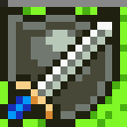

Character Tiles

Tile 49 – Red Slime
Source : Dragon Warrior 1 for NES


Tile 50 – Blue Slime
Source: Dragon Warrior 1 for NES



Tile 51 – Player Forward
Source: Dragon Warrior 4 forPSX plus cape


Tile 52 – Player Backwards
Source: Dragon Warrior 4 for PSX plus cape


Tile 53 – Player Left
Source: Dragon Warrior 4 for PSX plus cape


Tile 54 – Player Right
Source: Dragon Warrior 4 for PSX plus cape


Tile 55 – 58 – White Slime
Reserved. Was going to make you a white slime for the last quest, but decided against it due to time.

Tile 59 – Evil Player
Source: Dragon Warrior 4 for PSX


On a side note, he looks too cute to be the evil player…

Tile 60 – Slime Elder
Source: Dragon Warrior 4 for PSX


Tile 61 – King
Source: Dragon Warrior 1 for NES
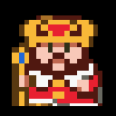

Tile 62 – Kid
Source: Dragon Warrior 1 for NES
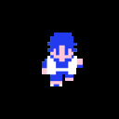

Tile 63 – Merchant
Source: Dragon Warrior 1 for NES
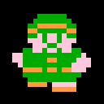

Tile 64 – Peasant Male
Source: Dragon Warrior 1 for NES


Tile 65 – Peasant Female
Source: Dragon Warrior 1 for NES


Tile 66 – Warrior front
Source: Dragon Warrior 1 for SNES
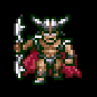

Tile 67 – Warrior back
Source: Dragon Warrior 1 for SNES

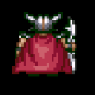

Tile 68 – Warrior Left
Source: Dragon Warrior 1 for SNES

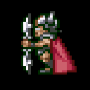

Tile 69 – Empty
The game loads 68 reversed for warrior facing right

Tile 70 – Dragon
Source: Dragon Warrior 1 for SNES

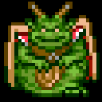

Tile 71 – Princess
Source: Dragon Warrior 1 for SNES
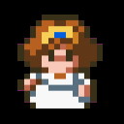

Monster Tiles

Monster 0 – Background
Source: Dragon Warrior 1 for NES
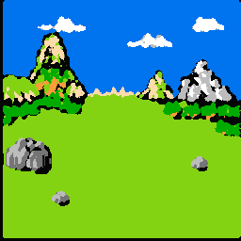

Monster 1 – Puppy
Source: Picture of my dog


Monster 2 – Kid
See tile 62

Monster 3 – Dog
Source: ClipArt
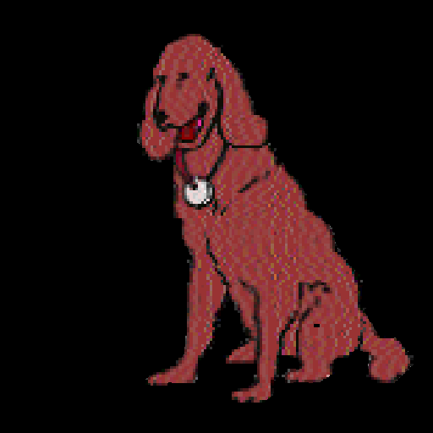

Monster 4 – Human Male
Source: Dragon Warrior 1 for SNES
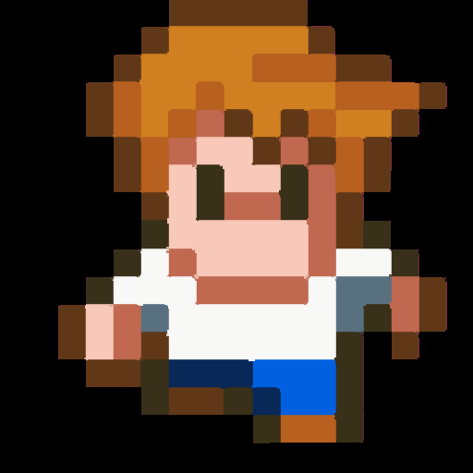

Monster 5 – Human Female
Source: Dragon Warrior 1 for SNES
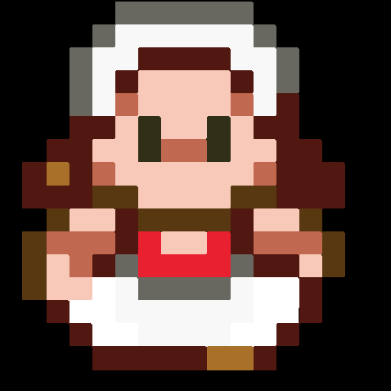

Monster 6 – Easy Warrior
Source: Dragon Warrior 1 for SNES
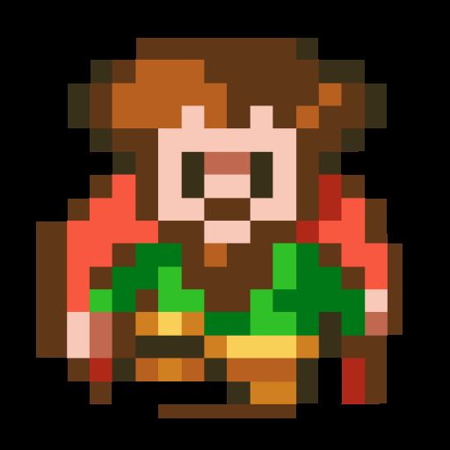

Monster 7 – Hard Warrior
Source: Dragon Warrior 1 for SNES
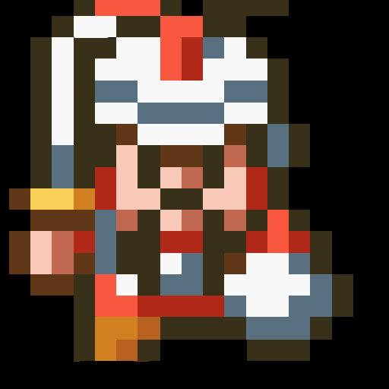

Monster 8 – Skeleton
Source: Dragon Warrior 1 for NES
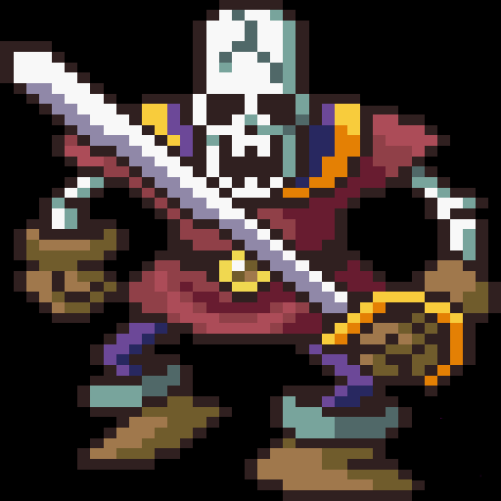

Monster 9 – Tomi
Source: http://megsplace.com


Monster 10 –Merchant
Source: Dragon Warrior 1 for SNES
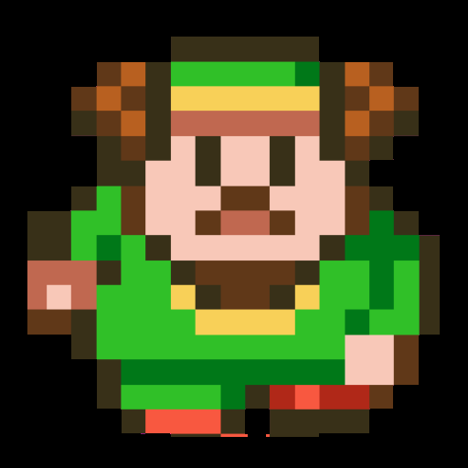

Monster 11 – King
See Tile 61

Monster 12 – Dragon
Source: Dragon Warrior 1 for SNES

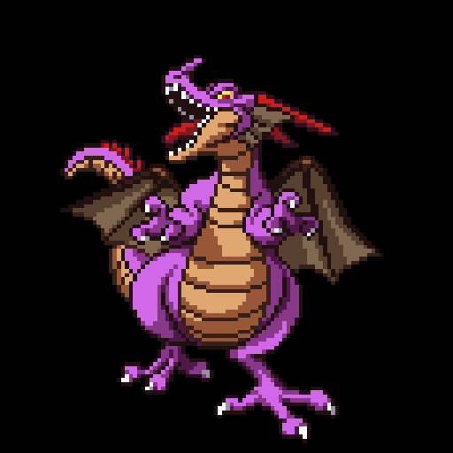

Monster Bible

Random Encounters
A chance for these to occur happens every time a player steps on a tile

Puppy
Description: a very small and loveable dog, allowed to roam free by a forgetful child. The dog has decided to terrorize our player
HP: 8
AT: 3-4
Chance to Run Away: 20%
Treasure:
Gold Pieces 5 – 10
Copper Pieces 5– 10
Iron Pieces 0 – 10
Silver Pieces 0- 5

Kid
Description: A Child who has decided to attack the player for fun.
HP: 16
AT: 7-11
Chance to Run Away: 80%
Treasure:
Gold Pieces 15 – 25
Copper Pieces15 – 25
Iron Pieces 0 – 10
Silver Pieces 0- 5

Dog
Description: An Adult stray dog, which has decided to attack the player for a food source.
HP: 12
AT: -5-8
Chance to Run Away: 20%
Treasure:
Gold Pieces 15 – 25
Copper Pieces 15 – 25
Iron Pieces 0 – 10
Silver Pieces 0- 5

Human Male
Description: A town folk who has decided to attack the slime on moral grounds.
HP: 18
AT: -7-12
Chance to Run Away: 70%
Treasure:
Gold Pieces 25 – 35
Copper Pieces 25 – 35
Iron Pieces 0 – 10
Silver Pieces 0- 5

Human Female
Description A town folk who has decided to attack the slime on moral grounds.
HP: 16
AT: -6 - 11
Chance to Run Away: 70%
Treasure:
Gold Pieces 20 – 30
Copper Pieces 20 – 30
Iron Pieces 0 – 10
Silver Pieces 0- 5

First Level Warrior Easy
Description: A Warrior whom has left the king in order to obtain weapons, he is weak because he fights with his hands. Since he does not have armor, he is harder to run away from.
HP: 22
AT: 7- 9
Chance to Run Away: 40%
Treasure:
Gold Pieces 30 – 40
Copper Pieces 30 – 40
Iron Pieces 0 – 10
Silver Pieces 0- 5

First Level Warrior Hard
Description: An Warrior whom has obtained weapons from the merchant, and is trying to level up. His armor makes him easy to run away from.
HP: 36
AT: -14-20
Chance to Run Away: 90%
Treasure:
Gold Pieces 30 – 40
Copper Pieces 30 – 40
Iron Pieces 0 – 10
Silver Pieces 0- 5

Skeleton
Description: An evil Skeleton, guarding the dragon. The dragon animated these skeletons because he was tired of fighting first level warriors himself.
HP: 36
AT: -14-22
Chance to Run Away: 50%
Treasure:
Gold Pieces 35 – 50
Copper Pieces 35 – 50
Iron Pieces 0 – 10
Silver Pieces 0- 5

Bosses

Tomi, the child
Description: Tomi holds the key to the door, which allows humans to return home from the playground. He is the gatekeeper for the children. He also hates slimes, because his sister hates slimes.
HP: 32
AT: -5 + 1-3 + 1-3
Treasure:
Gold Pieces 50
Copper Pieces 50
Iron Pieces 0 – 10
Silver Pieces 0- 5

Merchant
Description: The Merchant, who sells swords to first level warriors, must be stopped at all costs. Destroying him will limit the number of first level warriors guarding the castle.
HP: 52
AT:7 + 1-4 + 1 -4
Treasure:
Gold Pieces 100
Copper Pieces 100
Iron Pieces 0 – 10
Silver Pieces 0- 5

King
Description: The descendent of Kane, the first evil Warrior who enslaved the slimes. He continues to create first level warriors, hoping one of them will become experienced enough to rescue the princess in the dragon’s cave.
HP: 65
AT: 11 + 1 – 5 + 1 - 5
Treasure:
Gold Pieces 200
Copper Pieces 200
Iron Pieces 0 – 10
Silver Pieces 0- 5

Dragon
Description: Final Boss, the evil dragon, the holder of the princess. There really isn’t a story behind why the dragon is here, nor why he holds the princess, but he does.
HP: 85
AT: 16 + 1 – 5 + 1 - 5
Treasure: None, last guy.

Story Overview

Background Story:

The Great Slime, King Slime, was the first slime in slime valley. After slithering down the mountains, he could not make it back up, so he decided to settle slime valley, creating slime village. Soon, as news spread of a vast slime empire, first level warriors would wander into slime valley to gain experience, only to be greeted by King Slime. This act would usually result in the death of the player, however, sometimes King Slime would free a warrior if he felt that warrior was noble, and was just trying to gain experience for a greater goal.
One day, a hero wandered into slime valley, named Kane. King Slime took pity on the young hero, and allowed him to leave slime valley unharmed. Kane returned the next night with tenth and twelve level warriors he tricked into coming into the valley. The warriors made short work of King Slime, and then went into the dragon’s lair, never to be seen again.
Years past, and Kane’s descendants now occupy the valley, making the slimes prisoners of Slime Village, and allowing their children and pets to pester the slimes. To make matters worse, a dragon has moved into a cave nearby the castle, and, like most dragons do, has taken the princess. The king has decided to recruit and knight warriors in order to deal with the problem. The warriors have been attacking slimes more and more, trying to gain experience to attack the dragon, which no warrior yet has succeeded. The slimes are few in the valley, and if something isn’t done, the slimes will ultimately be wiped out of slime valley.

Game Progression

Setting
Slime King is set in a medieval world with swords, monsters and humans. The player is trapped inside a valley, which contains a human village, a human castle, a shrine, a slime village, and a dragon’s lair. No magic is involved in the game, but several elements in the game suggest that there is magic available to humans, but none of them seem to posses it, and we can assume none of them do.
Small villages, towns and castles have been erected in Slime Valley, suggesting that the population has been established for a few centuries. The Slime population has diminished, because of human influence, but since slimes reproduce rather quickly, and asexually, it has yet to reach the point where there is no chance the slime population will regain itself.
The slimes need water to reproduce, which is what is so important about the slime shrine, but the king, to prevent the slimes from using it, has cordoned it off. The king does not know the importance of the Slime Shrine; he simply does not want slimes getting near him, since he is somewhat a neat freak.

Flowchart
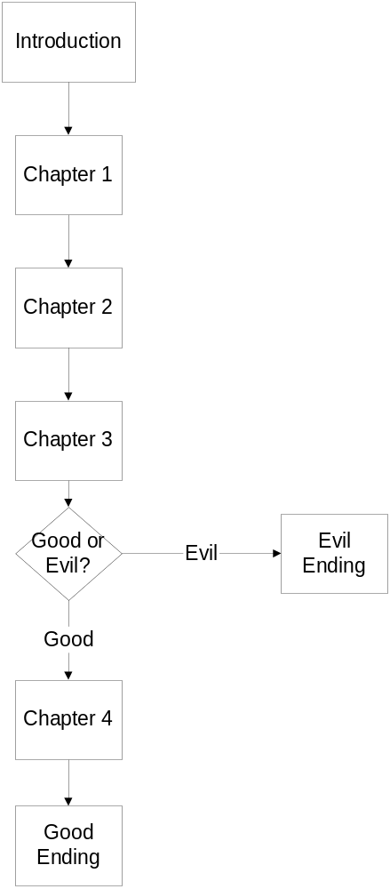

Level and Scene Details

Introduction
A cut scene plays, which leads directly into chapter 1

Chapter 1
This chapter, the slime must open a door, by finding Tomi and asking him for the key, which of course he won’t give up without a fight. The player starts out this level pretty weak, and must build experience fighting puppies and children until they are powerful enough to reach the first boss, Tomi, at about level four or five. A slime elder is in the Slime Village, for players to save and load. After the player kills Tomi, we go directly to chapter two.

Chapter 2
This chapter, the player must attack the merchant who is selling weapons to the warriors. A group of guards guard the castle, and inform the player that they got this way because of the merchant. The player is too weak to attack the merchant, but he can gain experience fighting men, women, and easy warriors.
When the player has reached the eighth level, he should be able to attack the Merchant, which leads to chapter three. A slime elder in the slime shrine will be conveniently placed to allow a player to save his game.

Chapter 3
During this chapter, a player must confront the king, and attack him. A player should be able to defeat every random encounter in the game. The player should reach level 12 before attacking the king.
After attacking the king, the player’s moral choices are weighted, and either the bad ending or chapter four is selected.

Chapter 4
A slime elder appears in the castle, giving the player an opportunity to save and heal. The player should achieve a level between sixteen and seventeen before attacking the dragon. The Skeletons in the dragon’s layer give the most experience and a player should concentration on attacking them.
The Dragon is very difficult, but not impossible, especially if a player has saved up enough silver and iron. After defeating the dragon, the game goes into the good ending, where slimes and people live together peacefully.

Good Ending
A cut scene plays, the end

Bad Ending
A cut scene plays, the end

Bibliography

Enix, Dragon Warrior I, Dragon Warrior I Remix, and Dragon Warrior IV for PSX. 1989, Dec 1993, Nov 2001, respectively.

Gray, James. Dragon Warrior dot com, December 31, 2002. http://www.dragon-warrior.com

Kim, Richards, The Classical Man. Canada, Masters Publishing 1982

Rouse, Richard III, Game Design Theory and Practice. Plano Texas: Wordware Publishing.

Musashi, Miyamoto. Book of Five Rings 15th century Japan

Tyler, Royall, Japanese Tales, Pantheon Fairy Tales and Folklore Library. New York: Random House 1987

Glossary

NES: Nintendo Entertainment System: An 8-bit console game system made by Nintendo.

NPC: Non-Playing Character. Any character in a game that is not controlled by the player. Typically this refers to game-world characters that are not hostile to the player.

PSX: PlayStation One, a 32-bit console game system made by Sony.

RPG: Role Paying Game: A game based on the type of GamePlay established by pencil and paper role-playing games, such as GURPS. Those original non-computer games were so titled because in them players took the roles of characters of their own creation, and guided them through a fantasy world.

SNES: Super Nintendo Entertainment System. A 16-bit console game system made by Nintendo

