CIS 587 – Assignment #3

Dr. Maxim



Scott Stella
sstella@umich.edu
367-04-5849
December 19, 2001

1.0 EXECUTIVE SUMMARY 3
1.1 Game Information 3
1.2 Abstract of Game Story 3
1.3 Game Play and Appearance 3
1.4 Development Specification 4
2.0 PRODUCT SPECIFICATION 5
2.1 Production Team 5
2.2 Production Tools 5
2.3 Target Audience 6
2.4 Game Play Time 6
3.0 GAME SPECIFICATION 6
3.1 Gameplay Experience 6
3.2 Interface Mockup 7
3.3 Summary of Story Line 7
3.4 Storyboards 7
3.5 Character Bibliographies 7
3.6 Flowchart 8
3.7 Level Outlines 8
4.0 User Guide 8
4.1 How to Install the Game 8
4.2 How to Play the Game 8
5.0 Design Specification 9
5.1 Implementation Details/Development Environment 9
5.2 Data structures and Interface Definitions 9
5.3 Pseudocode for Algorithms 10
Appendix A – Screen Shots 12
Start of Level 12
Combat 12
End of Level Boss 13
Defeat! 13
Appendix B – Source Code 14

1.0 EXECUTIVE SUMMARY

1.1 Game Information

Game Title – Scott Fu ©2001
Developed by – Scott Stella
Genre – Side scrollers/fighting

1.2 Abstract of Game Story

In Scott Fu, you play the role of Scott, a computer programmer whose wife has been kidnapped by Dr. X in order to blackmail him into writing a computer virus. Dr. X intends to use the virus to take over the world by causing all of the world's computers to crash, thereby destroying all financial, governmental, and personal records. You must help Scott save the world by defeating Dr. X's henchmen, retrieving the virus, and saving his wife.

1.3 Game Play and Appearance

ScottFu is a traditional "side-scroller" fighting style game. It resembles such classics as Kung Fu (Nintendo), Ninja-Gaiden (Super Nintendo), Streets of Rage (Sega), as well as many other classic video games.

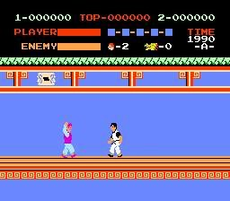
[Kung Fu for NES]

Your role is to walk the hero through the city, encountering enemies along the way. You must fight the enemies by kicking, punching, and maneuvering. Eventually, with some luck and skill, you will destroy all of the bad guys trying to thwart your advances. You will eventually locate your wife, the disk, and the infamous Dr. X. You must defeat Dr. X to claim victory and live happily ever after.

1.4 Development Specification

Basic keyboard movement:
Left key - move hero to the left
Right key - move her to the right
Ctrl - punch
Shift - kick

Health:
All characters hold their health in alterable value A
Hero: A=8
Thug: A=3
Boss: A=10

Upon picking up a health pack,
Hero gains 1 health point

Upon health of hero reaching 0 or less,
Hero will die; game restarts (defeat)

Upon health of thug reaching 0 or less,
Thug will collapse for increasing periods of time
Collapse 1 = 300
Collapse 2 = 300 + 200
Collapse 3 = 300 + 200 + 200 …

Upon health of boss reaching 0 or less,
Boss will collapse; game restarts (victory)

Damage:
Hero
Punch: 1 hit point
Kick: 2 hit points
Thug
Punch: 1 hit point
Kick: 2 hit points
Boss
Punch: 2 hit points

Inflicting Damage:
Be performing a punch or kick animation
The animation must be in the correct frame
The attacker must be facing the defender
The attacker must be overlapping the defender
The defender must not be falling down, getting hit, or in the process of standing up

Sound and Graphics:
Suitable action music should be played in the background
Propeller Heads – Spybreak! (Lobby scene from The Matrix)
Due to limitations with the game engine, additional sound effects have been removed
All characters should be animated

Character animations:
Hero
Standing (1 frame, loop)
Walking (9 frames, speed 35, loop)
Punching (5 frames, speed 25, execute once)
Kicking (7 frames, speed 25, execute once)
Getting Hit (3 frames, speed 25, execute once)
Falling (5 frames, speed 25, loop indefinitely at frame 5)
Thug
Standing (1 frame, loop)
Walking (6 frames, speed 20, loop)
Punching (5 frames, speed 70, execute once)
Getting Hit (3frames, speed 20, execute once)
Falling (5 frames, speed 20, loop indefinitely at frame 5)

Boss
Standing (1 frame, loop)
Punching (5 frames, speed 25, execute once)
Getting Hit (1 frames, loop 7 times at frame 1)
Falling (5 frames, speed 25, loop indefinitely at frame 5)
Maiden
Standing (1 frame, loop)

2.0 PRODUCT SPECIFICATION

2.1 Production Team

ScottFu was written and developed by Scott Stella for CIS 587. Scott developed the game as well as all of the artwork and animations. Scott's wife Malgosia helped with photographing the animation sequences and play testing. The following actors were used in producing the game (with my many thanks!):

Scott Scott Stella
Thug Brian Stella
Dr. X Jim Happell
Malgosia Malgosia Stella

2.2 Production Tools

The following tools were used extensively to develop ScottFu:

The Games Factory (TGF) by ClickTeam: A visual game engine and IDE that can be used to create games of almost any type or genre (side scrollers, racing games, shooting games, RTS games, etc). TGF focuses on defining various object types, and then the events/interactions between those object types. TGF takes a very different approach to coding style: instead of writing hundreds of lines of code, the developer essentially fills out what amounts to be a glorified spreadsheet. Across the top row are all of the game objects. Running down the first column are the events and triggers. The major advantage to The Games Factory is that it handles many of the common functions needed to create most games such as animation, sprite movement, and collision detection. It allows developers to focus on game content, and not the tedious task of implementing all the low-level functions required to play the game. Another advantage is that games created by TGF can be embedded as executables in web pages. Therefore, anyone visiting your web page can play your game in their web browser. Of course, games can also be saved as straight exe's as well.


Paint Shop Pro 5 by JASC: A graphics editing tool used to prepare the background images and character animations.


Logitech QuickCam software: Camera and video software used to capture character animations.

2.3 Target Audience

ScottFu is targeted at people in the CIS 587 class and friends of Scott, the author. However it is suitable for a general audience - males and females ages 8+. While it does contain some mild violence, there is no blood or gore.

2.4 Game Play Time

ScottFu has a playtime of several minutes. It's meant as a "distraction" type game - one you can play to take a break from your work or to relieve stress (by beating up bad guys). The game duration can easily be extended using the level editor included with TGF. For additional levels, one could re-use the character sprites and AI, and would most likely only need to provide artwork for the background of the new level.

3.0 GAME SPECIFICATION

3.1 Gameplay Experience

ScottFu is a heart pounding, fast paced fighting game. Enemies constantly attack the hero, which keeps the player on his/her toes. ScottFu was meant to be the type of game that anyone can play during a short break. Therefore, the controls of the game are simple and easy to grasp (there are no Mortal Kombat style combos or anything like that), keeping the learning curve to a minimal.

3.2 Interface Mockup

The interface of ScottFu is very simple and straightforward. There are no on-screen interface controls. Movement and fighting are controlled through the keyboard. The following commands are available:
Left Arrow – move left
Rigth Arrow – move right
Shift – punch
Ctrl - kick

3.3 Summary of Story Line

In ScottFu, you play the role of Scott - a very talented, mild-mannered computer programmer living in the suburbs with his lovely wife Malgosia. One day, Scott comes home to find his wife missing. He immediately receives a phone call from a mysterious individual known only as Dr. X. Dr. X says that he has kidnapped Malgosia, and is demanding that Scott write for him a virus capable of bringing the world's computers to their knees. He wants to use this virus as part of his evil plot to take over the world by destroying all the data that allows society to function – legal records, banking/finance records, etc. Scott, not wanting any harm to come to his wife, agrees to write the virus for Dr. X. However, upon completing the program, Dr. X snatches the diskette and dashes off. Scott now realizes that his only hope for rescuing his wife - and saving the world, is to take matters into his own hands. He only hopes that it is not too late...

3.4 Storyboards

Typical Level Progression Player Health


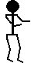
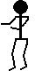



Hero Enemies Extra Health End

3.5 Character Bibliographies

Scott - The hero of the game. He's the programmer turned kung-fu master out to save the world.


Malgosia - Scott's wife who’s been kidnapped by Dr. X


Dr. X - Scott's evil nemesis. He wants to take over the world by spreading a virus that will destroy the information stored on every computer – banking records, legal records, personal information, etc.


Evil Henchmen - Dr. X's thug…willing to do anything to protect his boss.

3.6 Flowchart

Title Screen
Level 1
Win Screen

…Level N
Loose
Screen

3.7 Level Outlines

Level 1 - The Neighborhood
This is the only level currently in the game. Dr. X has run down the street and it is up to you to catch him.

4.0 User Guide

4.1 How to Install the Game

Installation of ScottFu is quite easy. Simply run d:\Install Files\setup.exe. The setup program will copy all of the files necessary to play the game to your computer. One note on installation: I noticed that the installer defaults the directory to c:\WinNT\. I would recommend changing the directory to something more appropriate such as c:\games\ScottFu or something similar.

4.2 How to Play the Game

ScottFu was designed to be simple to play. The controls are basic and straightforward. The left and right arrow keys move Scott right and left, respectably. The shift key will cause Scott to punch, and the control key will cause him to kick. That’s it.

The objective of the game is to progress through the level, taking out the thugs that rush you and eventually defeating the boss at the end.

5.0 Design Specification

5.1 Implementation Details/Development Environment

As mentioned earlier, ScottFu was developed using “The Games Factory” by ClickTeam. This environment was very well suited for a game of this type because it handles most of the low-level gaming functionality such as animation, collision detection, displaying text, playing music, user input, and basic game “concepts” (number of lives, score, etc). While it did take some time to code and refine, most of the work went into producing the graphics. All of the graphics – character animations, backgrounds, and game objects are original works (except the trees – they were stolen from another game). The character animations were taken frame-by-frame using Logitech QuickCam software and Paint Shop Pro 5.

5.2 Data structures and Interface Definitions

The Games Factory doesn’t allow for complex data structures and interface definitions. It’s more of an “object-based” visual environment. One defines active objects and background objects, and then modifies their built-in properties. The objects are not extendible, and the programmer is limited to what can already be modified. As an example, I’ll look at the main character Scott. The major elements of the object are shown in bold.

Movement – There are many types of movements allowed. For example, there is “mouse controlled,” “8-direction,” “path,” etc. For Scott, I needed 8-directional. I further modified the movement to be restricted to right-left only.

View – Is similar to “view order” functionality in many Microsoft products. It basically defines the order in which the 2-D objects are rendered. I set Scott to be “to the front” meaning that he will appear closer than all the other objects.

Object Preferences – Miscellaneous properties possessed by the object.
Group – Groups include bullets bonus, collectibles, good guys, bad guys, etc. Group distinction allows the programmer to refer to many objects collectively through one reference value. Scott belongs only to group “good guys.”
Scrollings – Specify that the object should follow the playfield and be destroyed if it finds itself far from the playfield. Both of these options are checked for the Scott object.

Animations – This is where all of the animation frames are stored and assembled. TGF has built-in animation types such as standing, walking, falling, etc. They also include some custom animation sequences should you have a unique need. Along with storing the actual graphics, you can specify the speed of the sequence and the looping properties. The “kicking” animation for the Scott object is shown below:

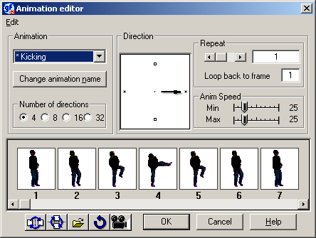

Name and Icon – This is basic identification information used when coding. The name (“Scott”) is used for mouse-over events in the code editor. However, being a visual environment, TGF uses a small graphical representation of the object (In most cases, the first frame of the “stopped” sequence).

Alterable Values – This is a very limited way of giving you object custom variables. Unfortunately, the programmer is limited to 3 values: A, B, and C. These values cannot be renamed, which sometimes causes confusion persons reading the code. For the Scott object, I use only alterable value A. It is initialized to 8 and represents Scott’s health.

5.3 Pseudocode for Algorithms

Since TGF is not a procedural or functional programming language, it is difficult to define the algorithms used. The game is written using events, and groups of events. The main groups are as follows:

Start of Level – Actions that occur when a level is first loaded. Some actions in this group include:
- Activating and De-Activating other “groups”
- Playing background music
- Setting number of lives
- Initializing alterable values
- Erasing object that shouldn’t be displayed right away

Start of Game – Actions that occur when the game is first started. Some actions in this group include:
- Activating the Game Actions group
- Showing an initial message to the player (such as “Ready?”)

Game Actions – Actions that occur while the player is playing the game. Examples are:
- Center camera on hero
- Detect defeat condition – and then activate the correct group
- Detect victory condition – and then activate the correct group
- Handle user input
  - Moving
  - Fighting
- Collision Detection
- Enemy AI
  - Moving
  - Fighting
  - Injury
End of Game Actions – Defeat – Actions that occur to handle the player’s demise.
- Show defeat message
- Activate restart goup

End of Game Actions – Victory – Actions that occur to handle the players victory.
- Show victory message
- Activate restart group

Restart – Actions that allow the game to be played again.
- Show restart message
- Restart game

The ordering of the groups is as follows:
- Start of Level
- Start of Game
- Game Actions
- End of Game Actions –Defeat / End of Game Actions – Victory
- Restart

The only part of the game I would consider to have an “algorithm” would be the enemy intelligence. So, I’ll spend a little bit of time discussing how that was implemented through a combination of event detection functions. The thug basically waits for one of two things to happen: 1) The hero is within visual range, or 2) The hero is within striking distance.
Thug
Hero
Do nothing
Walk towards
hero
Punch or Kick
X
X+320
X+75

So based on the diagram above, the detection formula for the right side is something like this:

Move – When X(Thug) > X(Hero)+75 && X(Thug) < X(Scott) + 320

Strike – When X(Thug) > X(Hero) && X(Thug) < X(Hero)+75

The AI for punching and kicking is very straightforward if the thug is within range. I simply get a random number between 1 and 20 at regular intervals. If the number is 0, have the thug punch. If the number is 1, have him kick.

Appendix A – Screen Shots

Start of Level

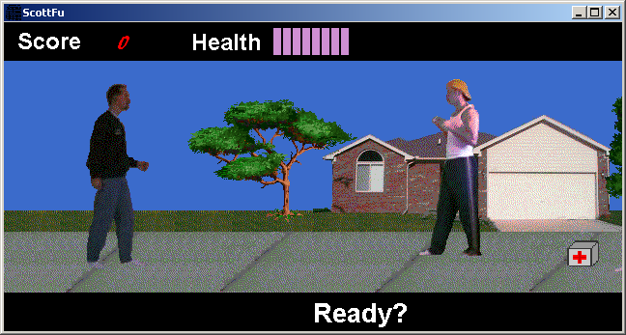

Combat

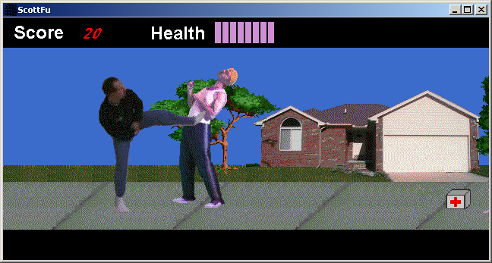

End of Level Boss

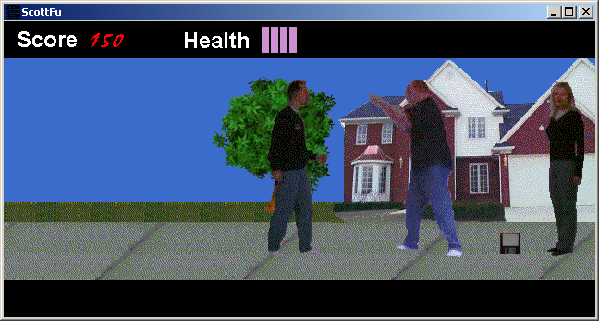

Defeat!

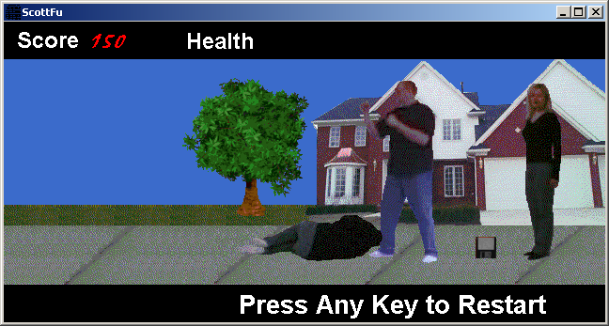

Appendix B – Source Code

The following listings are screen prints from the spreadsheet-like code editor in TGF. Unfortunately, getting quality printouts of source code is not possible with the tool.

Across the top row of the listing are the game objects such as Scott, Thug, Health Pack, etc. Then, going down the first column, are the events that trigger actions. The actions are represented by dots at the intersection of the event and the object affected by it.

Comments can be seen throughout the listing. My standards are very straightforward regarding style. Blue and yellow remarks represent major header comments. Grey and black comments are more low-level explanations of the rows that follow.

The “dots” or statements that result from the triggering event are not listed, as there was no good way to show them. However, in most cases, the statements can be inferred by the preceding comment. Most of them are not more than 3 lines anyway.



