

Fall 2015

CIS-587-002- Game Design and Implementation I

Assignment 4

3D Game Design Document Draft

Maze I Version 1.0

Presented by Jaime Cedillo

# Contents

1. Contents 2

1. Section I - Game Overview 7

1.1. Game Concept 7

1.2. Feature Set 7

1.3. Genre 7

1.4. Target Audience 7

1.5. Game Flow Summary 7

1.6. Look and Feel 7

1.7. Project Scope 8

1.7.1. Number of locations 8

1.7.2. Number of levels 8

1.7.3. Number of NPC’s 8

1.7.4. Number of weapons 8

2. Section II - Gameplay and Mechanics 9

3.1. Gameplay 9

3.1.1. Game Progression 9

3.1.2. Mission/challenge Structure 9

3.1.3. Puzzle Structure 9

3.1.4. Objectives 9

3.1.5. Play Flow 9

3.2. Mechanics 9

3.2.1. Physics 9

3.2.2. Movement 10

3.2.3. Objects 10

3.2.4. Actions 10

3.2.5. Combat 10

3.2.6. Economy 10

3.3. Screen Flow 11

3.3.1. Screen Flow Chart 11

3.3.2. Screen Descriptions 12

3.4. Game Options 12

3.5. Replaying and Saving 12

Not available. 12

3.6. Cheats and Easter Eggs 12

4. Section III – Story, Setting and Character 13

4.1. Story and Narrative 13

4.1.1. Back story 13

4.1.2. Plot Elements 13

4.1.3. Game Progression 13

4.1.4. License Considerations 13

4.1.5. Cut Scenes 13

4.1.6. Game World 15

4.1.7. General look and feel of world 15

4.2. Characters 15

4.2.1. Character #1 15

4.2.2. Character #2 16

5. Section IV – Levels 18

5.1. Level #1 18

5.1.1. Synopsis 18

5.1.2. Introductory Material (Cut scene? Mission briefing?) 18

5.1.3. Objectives 18

5.1.4. Physical Description 18

5.1.5. Map 18

5.2. Critical Path 18

5.2.1. Encounters 18

5.2.2. Level Walkthrough 18

5.2.3. Closing Material 18

5.3. Level #2 18

5.3.1. Synopsis 18

5.4. Training Level 18

6. Section V - Interface 19

6.1. Visual System 19

6.1.1. HUD 19

6.1.2. Menus 19

6.1.3. Rendering System 19

6.1.4. Camera 19

6.1.5. Lighting Models 19

6.2. Control System 19

6.3. Audio 19

6.4. Music 19

6.5. Sound Effects 19

6.6. Help System 19

7. Section VI – Artificial Intelligence 20

8. Algorithms 20

8.1. Maze Generation 20

9. Section VII – Technical 21

9.1. Target Hardware 21

9.2. Development hardware and software 21

9.3. Development procedures and standards 21

9.4. Game Engine 21

9.5. Network 21

9.6. Scripting Language 21

10. Section VIII – Game Art 22

10.1. Concept Art 22

10.2. Style Guides 22

10.3. Characters 22

10.4. Environments 22

10.5. Equipment 22

10.6. Cut scenes 23

10.7. Miscellaneous 23

11. Section IX - Secondary Software 24

11.1. Editor 24

11.2. Installer 24

11.3. Update software 24

12. Section X - Management 25

12.1. Detailed Schedule 25

12.2. Budget 25

12.3. Risk Analysis 25

12.4. Localization Plan 25

12.5. Test Plan 25

13. Appendices 26

13.1. Asset List 26

13.1.1. Art 26

13.1.2. Sound 26

13.1.3. Music 27

13.1.4. Voice 27

Design History

|  |  |  |
| --- | --- | --- |
| Author | Revision | Date |
| Jaime Cedillo | 1.0 | 11/21/2015 |
| Jaime Cedillo | 1.1 | 11/30/2015 |

# Section I - Game Overview

## Game Concept

3D version of Maze I is a game that consists of a Maze where the player can take shortcuts and reach a goal. Three levels of difficulty are available. Whenever the player finds a shortcut it can be used to shorten the time to arrive to the goal. The player can use the arrow keys to move an avatar horizontally and vertically until the goal is found.

## Feature Set

* Three levels of difficulty
* Mazes consists of one or more floors
* Holes on floors and walls
* With or without external walls
* Avatar selection

## Genre

Maze game

## Target Audience

All ages

## Game Flow Summary

Three levels of difficulty are provided. Every time that the player reaches a goal, the next maze is displayed.

## Look and Feel

The following picture is a sample of a maze.

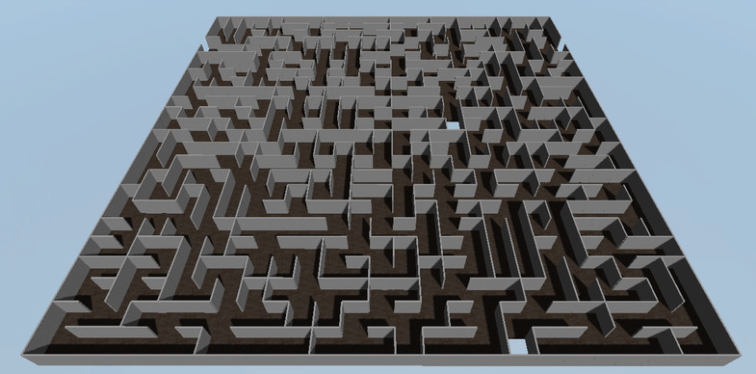

## Project Scope

### Number of locations

Each maze consists of one location.

### Number of levels

Three levels of difficulty.

### Number of NPC’s

Not applicable

### Number of weapons

Not applicable

# Section II - Gameplay and Mechanics



## Gameplay

### Game Progression

Every time that the player reaches a goal, the next level or maze is displayed.

### Mission/challenge Structure

The mission is to go from the maze entrance to the exit in the shortest time. The player can find holes on the floor and in walls that can be used as shortcuts.

### Puzzle Structure

Not applicable

### Objectives

The main objective is that the player needs to reach the exit of the maze in order to continue playing.

### Play Flow

The player goes through the maze and avoids collisions against the walls.

## Mechanics

The player can use the WASD keys to move horizontally, vertically, forwards and backwards. Whenever the player collides against the walls of the maze, it slows its pace and takes a maneuver to align its direction again.

### Physics

As soon as the player enters the maze, he/she cannot exit using the same door. The walls of the maze are solid and cannot be moved or destroyed by the player. Nevertheless, there are predefined holes on the floor and in the walls that can be used by the player as shortcuts.

### Movement

#### General Movement

Arrow keys and WASD keys can be used to move horizontally, vertically, forwards and backwards.

#### Other Movement

No jumps are possible.

### Objects

#### Picking up Objects

Not applicable.

#### Moving Objects

No other moving objects but the player.

### Actions

#### Switches and Buttons

Arrow keys and WASD keys.

#### Picking Up, Carrying and Dropping

Not applicable.

#### Talking

Dialogs at the beginning and end of the maze are planned.

#### Reading

Not applicable.

### Combat

Not applicable.

### Economy

The faster the player reaches the goal the better. The clan is waiting for him/her, and time is a precious asset.

## Screen Flow

### Screen Flow Chart

Start

Maze 1

Maze exit reached?

no

yes

Maze 2

no

Maze exit reached?

yes

Maze 3

no

Maze exit reached?

yes

Abort

End

### Screen Descriptions

Three main screens will be designed. Each screen consists of a Maze, a sample of the look and feel of one screen can be seen in section 1.6 Look and Feel.

#### Main Menu Screen

Avatar selection is available from the Main Menu screen.

#### Options Screen

The screen resolution can be selected via Unity start screen.

## Game Options

The player can only choose one from two different Avatars. The story and game mechanics are the same.

## Replaying and Saving

## Not available.

## Cheats and Easter Eggs

Not available.

# Section III – Story, Setting and Character

## Story and Narrative

The main character of the game is an explorer that needs to go through a maze to find the path that will allow his/her clan to continue its way to a valley where a new town is going to be built. The maze is the only way to go through the mountains therefore the clan decides that one of them should be sent first and then come back to guide the whole group.

### Back story

The maze was built by a wizard that wanted to prevent foreigners from entering his territory and worked as a trap from where no one had escaped before.

### Plot Elements

As the explorer goes through the paths in the maze, he/she encounters several obstacles like holes on the floor and shortcuts in the walls that can be used at his/her own risk.

### Game Progression

Every time that the explorer reaches what he thought was the exit of the maze he/she realizes that a new set of walls has to be explored in order to continue his/her path. Three different levels need to be explored to find the exit of the wizard′s trap.

### License Considerations

3D Maze Generator assets published by Mageiros studios are going to be used in this game.

### Cut Scenes

#### Cut scene #1

See section 5.1

* + - * 1. Actors
* Explorer (player)
* Wizard (NPC)
  + - * 1. Description
* The explorer is the main character. His/her objective is to find a path within the Maze to guide his/her clan.
* The Wizard built the maze centuries ago to prevent foreigners from entering his territory.
  + - * 1. Storyboard

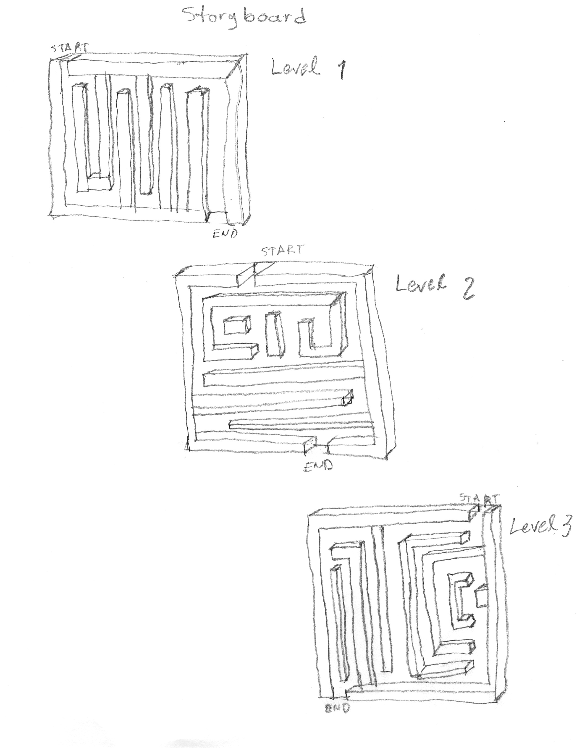

* + - * 1. Script

Not available.

#### Cut scene #2 and #3

See section 5.3

Different maze, same actors and story.



### Game World

### General look and feel of world

See section 1.6

## Characters

### Character #1

#### Back story

The explorer is the main character. His/her objective is to find a path within the Maze to guide his/her clan.

#### Personality

Goal oriented, perceptive, objective.

#### Look

* + - * 1. Physical characteristics

Asset published by Ironwool.

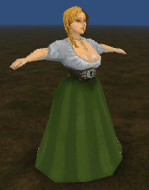

Asset published by L3D Entertainment

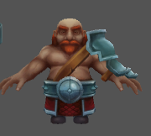

* + - * 1. Animations

Walk, run and idle animations are available.

#### Special Abilities

None.

#### Relevance to game story

Main character.

#### Relationship to other characters

The only playable character.

#### Statistics

Not applicable.

### Character #2

#### Back story

The wizard is the villain of the story. Non Playable Character.

#### Personality

Knowledgeable, territorial.

#### Look

* + - * 1. Physical characteristics

Asset published by blarumyrran@gmail.com.

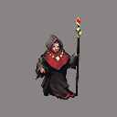

# Section IV – Levels

## Level #1

### Synopsis

See section 4.1.5.1

### Introductory Material

### Objectives

Find the exit of the maze.

### Physical Description

See section 1.6

### Map

See section 1.6

## Critical Path

### Encounters

No encounters are planned.

### Level Walkthrough

Not applicable.

### Closing Material

Not applicable.

## Level #2

### Synopsis

See section 4.1.5.2

## Training Level

Not applicable.

# Section V - Interface

## Visual System

### HUD

Not applicable

### Menus

Unity start menu to choose resolution and avatar selection menu are available.

### Rendering System

Unity graphics engine.

### Camera

To be defined.

### Lighting Models

To be defined.

## Control System

The player can use the WASD keys to move horizontally, vertically, forwards and backwards. Whenever the player collides against the walls of the maze, it slows its pace and takes a maneuver to align its direction again.

## Audio

See section 13.1.3

## Music

See section 13.1.3

## Sound Effects

See section 13.1.3

## Help System

To be defined.

# Section VI – Artificial Intelligence

# Algorithms

## Maze Generation

Kruskal’s algorithm is used to generate the maze. It is a minimum-spanning-tree algorithm which finds an edge of the least possible weight that connects any two trees in the forest.

# Section VII – Technical

## Target Hardware

No special hardware is required. The game was deployed in a computer with Windows 10, Intel Core i7 and NVIDIA GEFORCE graphic controller.

## Development hardware and software

The game is developed using Unity 5.2.1, 2D configuration and standard assets downloaded from Unity Asset Store are going to be used.

## Development procedures and standards

Agile Software Development.

## Game Engine

Unity 3D engine will be used to develop Maze I 3D

## Network

Off-line game.

## Scripting Language

C# programming Language and MonoDevelop integrated development environment are going to be used.

# Section VIII – Game Art

## Concept Art

All art is provided by third party assets.

## Style Guides

Not applicable.

## Characters

Asset published by Ironwool.



Asset published by L3D Entertainment



## Environments

See section 1.6

## Equipment

No special hardware is required. The game will be deployed in a computer with Windows 10, Intel Core i7-47000MQ CPU @2.40GHz, 8 GB of RAM and NVIDIA GEFORCE graphic controller. No benchmark testing is planned.

## Cut scenes

See section 4.1.5.1 and 4.1.5.2

## Miscellaneous

Not applicable.

# Section IX - Secondary Software

## Editor

MonoDevelop Integrated Development Environment supplied with Unity

## Installer

Unity Application Builder for Windows

## Update software

Not applicable

# Section X - Management

## Detailed Schedule

|  |  |  |
| --- | --- | --- |
| **Activity** | **Date Init** | **Date End** |
| Game Design Document | 11/20/2015 | 11/30/2015 |
| Game Implementation | 11/30/2015 | 12/10/2015 |
| Game Tests | 12/11/2015 | 12/15/2015 |
| Game Presentation | 12/16/2015 | 12/16/2015 |
|  |  |  |

## Budget

Small budget to buy assets to speed game development $100

## Risk Analysis

Short schedule and limited resources (one developer performing several roles) could lead to poor quality and/or incomplete requirement implementation.

## Localization Plan

Not applicable

## Test Plan

Start tests in early development phase.

# Appendices

## Asset List

The following assets are published by Mageiros studios***.***

### Art

#### Model and Texture List

Floor

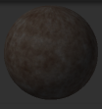

Wall

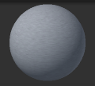

#### Animation List

To be defined

#### Effects List

To be defined

#### Interface Art List

To be defined

#### Cut scene List

See section 4.1.5.1 and 4.1.5.2

### Sound

#### Environmental Sounds

See section 13.1.3.1

#### Weapon Sounds

Not applicable

#### Interface Sounds

Not applicable

### Music

#### Ambient

Asset Store: Fantasy Music Collection by Charge Studios

#### “Action”

To be defined

#### Victory

To be defined

#### Defeat

To be defined

### Voice

#### Actor #1 lines

Not applicable

#### Actor #2 lines

Not applicable