3D Game Design Document

**“Maze Escape”**

Reza Sanatgar

David Shaw

Drew Allen

Margaret Nazelli

Version 1.1

11/11/2015

**Table of Contents**

|  |  |
| --- | --- |
| Section | Page # |
| Title Page | 1 |
| Table of Contents | 2 |
| Design History | 2 |
| Section 1: Game Overview | 3 |
| Section 2: Gameplay and Mechanics | 4 |
| Section 3: Story, Setting, and Character | 6 |
| Section 4: Levels | 8 |
| Section 5: Interface | 10 |
| Section 6: Artificial Intelligence | 12 |
| Section 7: Technical | 12 |
| Section 8: Appendices | 12 |

**Design History**

|  |  |  |
| --- | --- | --- |
| Version # | Version Date | Version Changes |
| 1.0 | 11/24/15 | Initial document completed |
| 1.1 | 11/30/15 | Target audience revised, end user requirements revised, page numbers revised, input revised, lessons learned added |

**Production Team:**

* Reza Sanatgar
* Drew Allen
* David Shaw
* Margaret Nazelli

**Executive Summary:**

Our team is looking to make a 3D puzzle/platformer/action game for our 3D game design project. This game features the player character trapped in a dream they are having, finding themselves in a room unable to escape. To get out of the dream and be able to wake up, the player must unlock the locked door that stands in their way. This must be done by collecting three keys in the different rooms surrounding the locked door. Each one will have different puzzle/platforming challenges for the player, and will contain one of the three keys. The player must collect the keys and escape within the time limit before they are trapped in the void of their dream forever.

**Section 1: Game Overview**

* **Game Concept:** The concept of the game is simple. The player must navigate several rooms and collect keys from them to unlock the door in the middle of the maze and escape. This must be done within a time limit.
* **Genre:** Action, Platformer
* **Target Audience:** We feel that players who enjoy platforming games, such as Super Mario 64 will enjoy our game. With a time limit implemented and a high score based on time remaining, players who enjoy optimizing the completion of a stage will find enjoyment in finding the fastest way to escape the maze. Definitely an E for everyone game, no mature content here.
* **Game Flow Summary:** The player will start in the middle of a maze with a locked door in front of them. To their right, left, and behind, there are three separate rooms, each containing a key needed to unlock the door to escape. After navigating their way through a room, a key will be picked up, and they will have to go back through the room to the starting point, and collect the other keys from the remaining rooms. Once all three are collected, the door to escape will be unlocked.
* **Look and Feel:** Our game will have a minimalist art style, similar to the one featured in the game Antichamber. In a relatively monochromatic environment, key items will stand out clearly to the player in color. The rooms will also be identifiable by colored lights in each room, so you know what room you are in and which you have already visited. The game will feature smooth platforming controls through the Unity physics engine, and should be very easy for anyone to pick up and play.
* **Project Scope:**
  + **Number of locations:** There will be 4 locations in our game. Those being the main room, and each of the 3 puzzle rooms.
  + **Number of NPCs:** The player will not encounter NPCs in this world, as this environment is a dream that the player is stuck in, as will be explained later.
  + **Number of weapons:** The player character will not be fighting any enemies in this game, so weapons will not be necessary.

**Section 2: Gameplay and Mechanics**

* **Gameplay:**
  + **Game progression:** The game progression is simple. Each room you successfully navigate means another key collected, and that means you are one step closer each time to escaping the maze in time.
  + **Challenge structure:** Each of the 3 rooms containing a key will be a challenge that the player must overcome. With different gaming elements in each one and an overall time limit to collect all of the keys, the player must be able to move quickly but carefully to escape the maze in time.
  + **Puzzle structure:** The puzzle structure of our game is mainly focused on how the player will navigate the rooms to reach the key at the end. With the time limit in mind, will the player haphazardly attempt to rush through the room with the high chance of falling and dying in the void? Or will the player try their best to keep the time limit in mind and try to move carefully and precisely?
  + **Objectives:** The main objective for the player is to navigate the rooms and collect the keys needed to unlock the door and escape the maze within the time limit. The secondary objective is to attempt to optimize your completion of the rooms and go for the fastest completion time.
* **Mechanics:**
  + **Physics:** Physics in our game will be handled by the Unity 3D physics engine.
  + **Movement:** As expected of a platforming game, the player will be able to move forward, backwards, left, and right with the WASD keys, and jump with SPACE. The mouse is used to move the camera around.
  + **Objects:** The primary objects of interest in our game are the keys located in each of the rooms. They will be brightly colored to stand out against the mostly monochromatic room. Collecting them will be necessary to unlock the door object in the main room where the player starts.
  + **Actions:** The player will engage in several actions when playing:
    - Jumping from platform to platform to navigate the rooms.
    - Falling into a pitfall by missing a jump, resulting in a game over.
    - Activate pause menu, from which the player can resume, exit, or restart.
* **Screenflow:**
  + **Screen descriptions:**
    - **Main menu screen:** The main screen is the first screen that will be loaded up when the game is launched. It will feature the game’s title, and buttons to start and exit the game. The high score will also be displayed here.
    - **Pause screen:** The pause screen will darken the screen and display buttons to resume, exit the game, return to the main menu, or restart the game.
* **Replaying and saving:** Since this is a simple maze game with only 4 rooms and a relatively short time limit, progress saving won’t be necessary for this game. Replayability is found in optimizing the completion of the rooms and achieving a record completion time.
* **Flowchart:**

Untitled Diagram.png

**Section 3: Story, Setting and Character**

* **Story and Narrative**
  + **Backstory:** The player character in our game is stuck in a dream realm. They begin this dream presented with a locked door. They must unlock this door in order to escape their dream and be able to wake up. They can only navigate the dream realm for a short time before they are trapped forever.
  + **Plot Elements:** The desire to be able to wake up from the dream and not be trapped in the maze of the dream realm forever will be the main motivation of the player to successfully escape.
  + **Game world:**
    - **General look and feel of the world:** As stated above, in a relatively monochromatic environment, key items will stand out clearly to the player in color. The rooms will also be identifiable by colored lights in each room, so you know what room you are in and which you have already visited. The world will definitely feel like an enclosed space, giving the impression that unlocking the door is the only hope of escape.
  + **Characters:**
    - **Player Character Bible:**
      * **Backstory:** The player character, as stated above, finds themselves trapped in a maze of their dream realm, and needs to escape before being trapped in the void forever.
      * **Personality:** The character will not talk, so it is mostly up to the player to imagine the personality of the character based on the appearance of their dream realm and the actions they take.
      * **Look:**
        + **Physical animations:** Since this is the main character in a first person platforming game, the player character will not have any animations.
        + **Animations:** See above.
        + **Special abilities:** None.
        + **Relevance to game story:** The main character of the story, who the player controls.
        + **Statistics:** Possesses standard platforming game capabilities, such as running and jumping.
* **Storyboard:**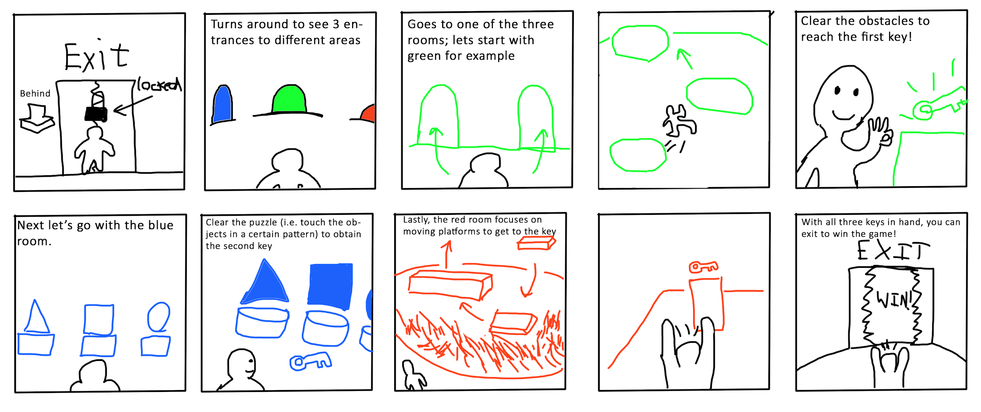

**Section 4: Levels**

* **Level outlines:**

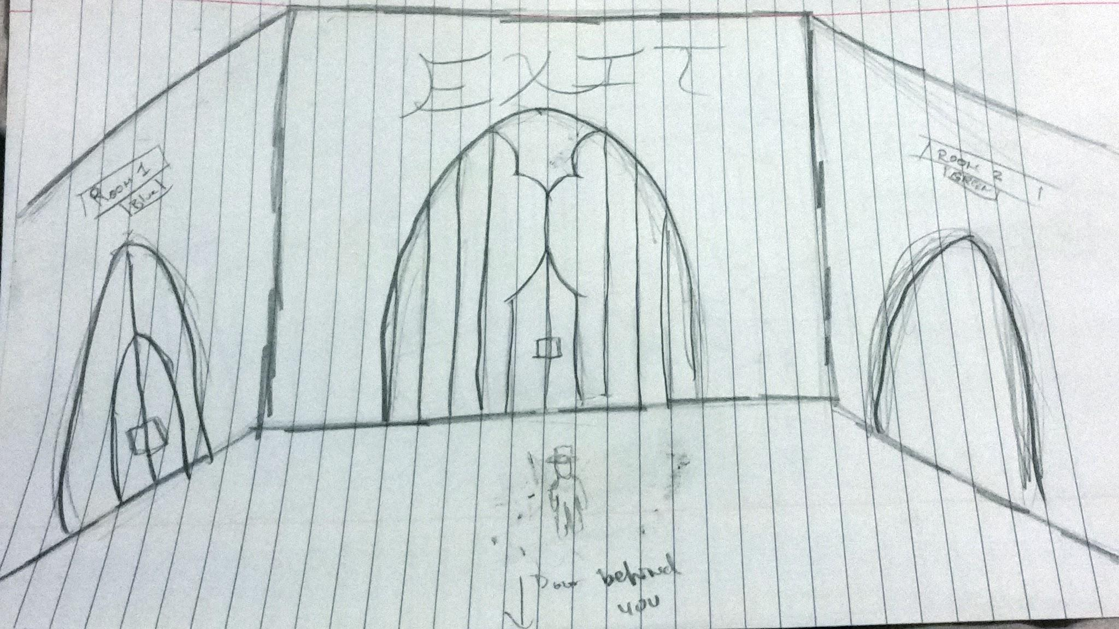

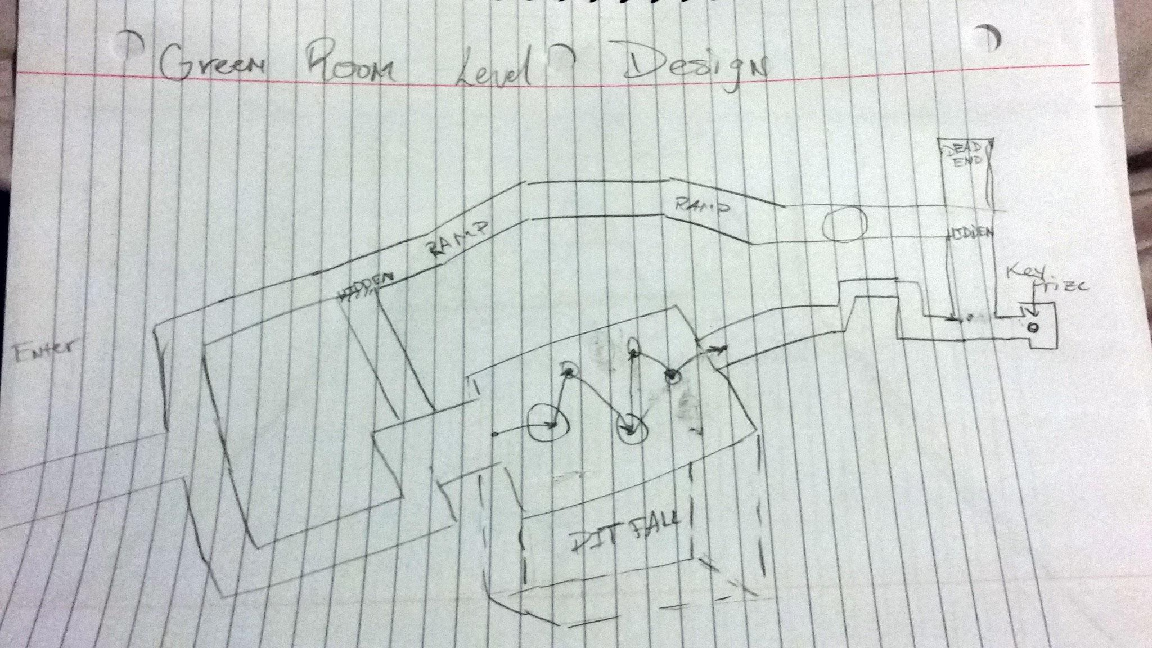

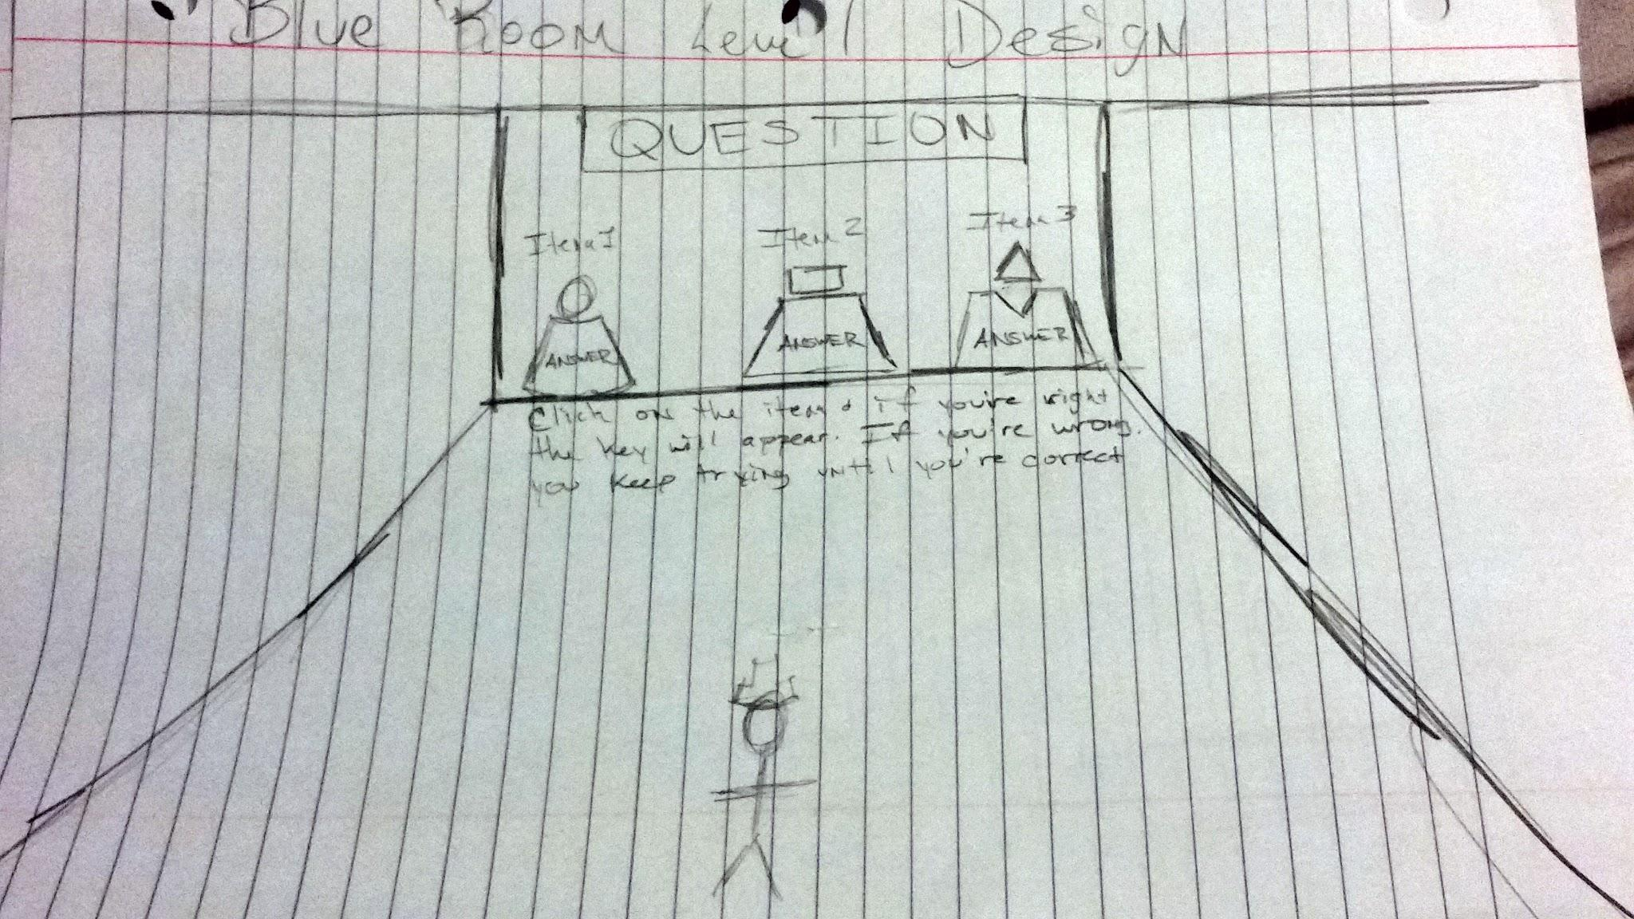

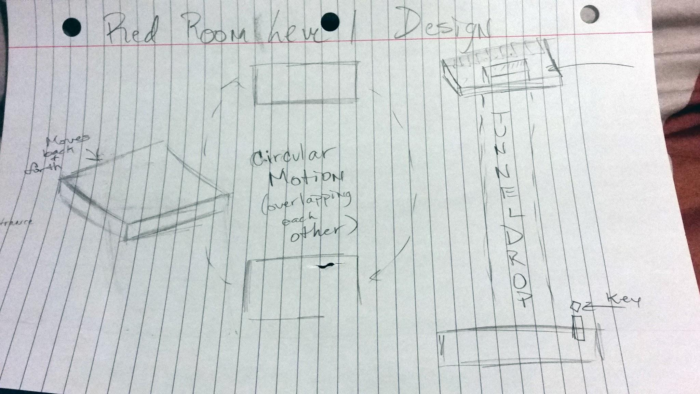

**Section 5: Interface**

* **Visual system:**
  + **HUD:** The hud will display the time remaining and indicate the keys already collected and those remaining.
  + **Menus:** The main menu as described above will be shown at startup, and the pause menu as described above will activate in game once the pause key is pressed.
  + **Rendering system:** The game world will be rendered through the view of the main camera, which will follow the player entity.
  + **Camera:** The camera will follow right in front of the player entity, to give the player a first person view of the world.
  + **Lighting models:** Standard lights in the Unity engine of various sizes and colors will be used to illuminate the environment.
* **Control system:**
  + **WASD:**  Walk/run
  + **Space:** Jump
  + **Shift:** Toggle run on and off
  + **Enter:** Pause/resume
  + **Mouse:** Move camera around
  + **R Key:** Restart
* **Audio:**
  + Footsteps of the player
  + Audio cue when key picked up
  + Ambient music
* **Music:**
  + Calm ambient music will be played in the game world.
* **Help system:** Main menu will display game controls and player objective.
* **Interface Mockup:**

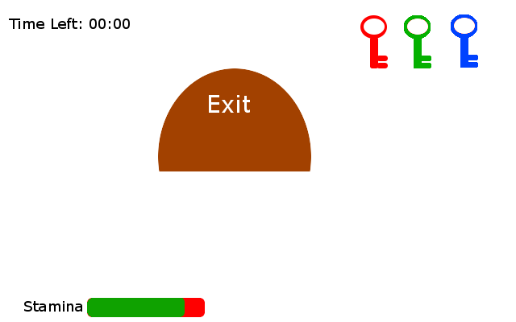

**______________________________________________________________________**

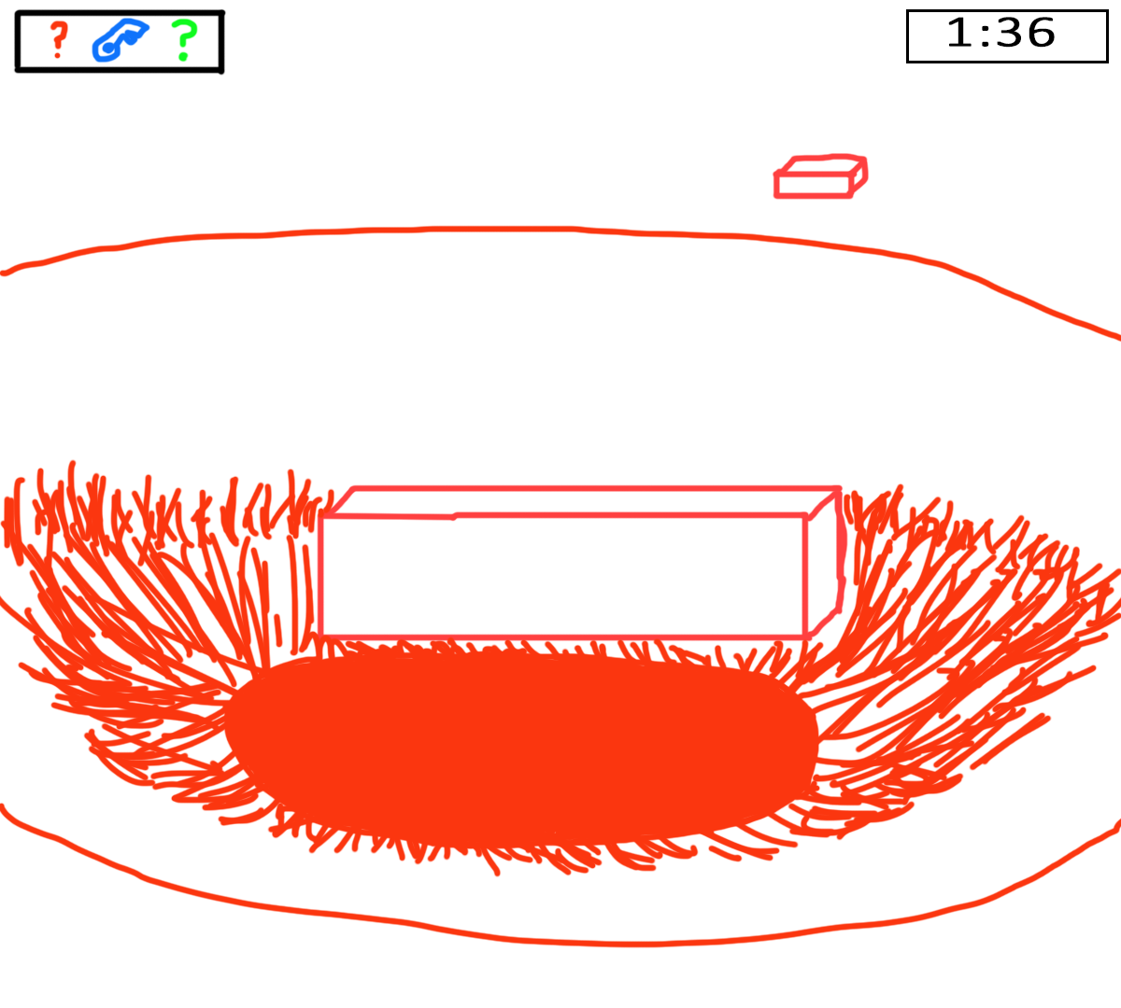

**Section 6: Artificial Intelligence**

* **Support AI:**
  + **Player and collision detection:** 
    - Player collision with they keys in the world will destroy the key object in the game world and add it to the player’s inventory.
    - Collision with the player and the door game object will not result in the victory screen unless all three keys are in the player’s inventory.
    - Collision with the player and the killzone below platforms will result in the game over screen being displayed.
    - Player collision with platforms must be checked every frame so that the player does not fall through a platform or become stuck in one.
    - Player collision with question orbs in the blue room will toggle different effects based on whether they are correct or wrong. Colliding with the correct answer orb will destroy the cage around the blue key whereas colliding with a wrong answer orb will result in time being deducted. The orbs will be destroyed on contact.

**Section 7: Technical**

* **Target Hardware:** PC
* **Development hardware and software:**
  + **Hardware:** PC
  + **Software:** Unity
* **Game engine:** Unity
* **Scripting language:** C#
* **User system specs:**
  + Nothing extreme necessary. Will not be graphically intensive, so most modern computers will be able to play this without any issues.

**Section 8: Appendices**

* **Resource list:**
  + Unity 3D standard first-person controller asset.
  + Scripts for pause menu, main menu, killzones, game over screens, scene fade in and out, and time limit/high score from David and Reza’s 2D game.
  + Unity 3D standard stage building objects, such as cubes, ramps, platforms, etc.
* **Lessons learned:**
  + Keeping design documents accurate, up to date, and organized will be a big help as we work on putting our game together.
  + Re-using bits of code from past projects can dramatically reduce production time. No need to reinvent the wheel.
  + Proposing a reasonable game scope according to the time we have to complete our project will keep us focused on making sure the key elements we plan to have working actually work properly.
  + Worrying about art assets early on is not worth the time. Focus should be put on core gameplay first and foremost.