Hostage Run
A Futuristic RTS Game

1.2. Copyright Information: We wish to designate this as free software under a license such as the GNU General Public License created by the Free Software foundation.
1.3. Version Control

Version Number: | Authors: | Date:
1.0 | Lauren Gaber,  Ryan McNichol,  Robert Nimmo,  Allison Scherr | 11/30/15

2. Table of Contents
3. Design History -------------------------------------------------------------------------------------------- 7
4. Game Overview ------------------------------------------------------------------------------------------ 8
4.1. Game Concept ------------------------------------------------------------------------------------
4.2. Genre ------------------------------------------------------------------------------------------------
4.3. Target Audience -----------------------------------------------------------------------------------
4.4. Game Flow Summary ---------------------------------------------------------------------------
4.5. Look and Feel -------------------------------------------------------------------------------------
4.6. Project Scope ------------------------------------------------------------------------------------- 9
4.6.1. Number of locations -----------------------------------------------------------------
4.6.2. Number of levels ----------------------------------------------------------------------
4.6.3. Number of NPC’s ---------------------------------------------------------------------
5. Gameplay and Mechanics ----------------------------------------------------------------------------
5.1. Gameplay ------------------------------------------------------------------------------------------
5.1.1. Game Progression -------------------------------------------------------------------
5.1.2. Mission/challenge Structure -------------------------------------------------------
5.1.3. Puzzle Structure ---------------------------------------------------------------------
5.1.4. Objectives ----------------------------------------------------------------------------- 10
5.1.5. Play Flow -------------------------------------------------------------------------------
5.1.6. Use Cases -----------------------------------------------------------------------------
5.2. Mechanics -----------------------------------------------------------------------------------------
5.2.1. Physics ---------------------------------------------------------------------------------
5.2.2. Movement ------------------------------------------------------------------------------
5.2.3. Objects --------------------------------------------------------------------------------- 11
5.2.3.1.Picking Up Objects ---------------------------------------------------------
5.2.3.2.Moving Objects --------------------------------------------------------------
5.2.4. Actions ---------------------------------------------------------------------------------
5.2.5. Combat ---------------------------------------------------------------------------------
5.2.6. Economy ------------------------------------------------------------------------------ 12
5.3. Screenflow ----------------------------------------------------------------------------------------
5.3.1. Screen Flow Chart / State Transitions-------------------------------------------
5.3.2. Screen Descriptions ----------------------------------------------------------------
5.3.2.1.Main Menu Screen ---------------------------------------------------------
5.3.2.2.Options Screen -------------------------------------------------------------
5.3.2.3.Etc. ----------------------------------------------------------------------------
5.4. Game Options -----------------------------------------------------------------------------------
5.5. Replaying and Saving ------------------------------------------------------------------------- 13
6. Story, Setting and Character ------------------------------------------------------------------------
6.1. Story and Narrative ----------------------------------------------------------------------------
6.1.1. Backstory ----------------------------------------------------------------------------
6.1.2. Plot Elements ----------------------------------------------------------------------- 14
6.1.3. Game Progression ----------------------------------------------------------------
6.1.4. Story Board --------------------------------------------------------------------------
6.2. Game World ------------------------------------------------------------------------------------- 15
6.2.1. General look and feel of world ---------------------------------------------------
6.2.2. Alliance Home Base ---------------------------------------------------------------
6.2.2.1. General Description -----------------------------------------------------
6.2.2.2. Physical Characteristics -----------------------------------------------
6.2.2.3. Levels that use area -----------------------------------------------------
6.2.2.4.Connections to other areas ---------------------------------------------
6.2.3. Resistance Stronghold ------------------------------------------------------------
6.2.3.1. General Description ------------------------------------------------------
6.2.3.2. Physical Characteristics ------------------------------------------------
6.2.3.3. Levels that use area ----------------------------------------------------- 16
6.2.3.4.Connections to other areas ---------------------------------------------
6.3. Character Bible --------------------------------------------------------------------------------- 17
7. Levels ---------------------------------------------------------------------------------------------------- 18
7.1. Level #1 ------------------------------------------------------------------------------------------
7.1.1. Synopsis -----------------------------------------------------------------------------
7.1.2. Introductory Material ---------------------------------------------------------------
7.1.3. Objectives ----------------------------------------------------------------------------
7.1.4. Physical Description ---------------------------------------------------------------
7.1.5. Map ------------------------------------------------------------------------------------
7.1.6. Critical Path -------------------------------------------------------------------------
7.1.7. Encounters ---------------------------------------------------------------------------
7.1.8. Level Walkthrough ------------------------------------------------------------------
7.1.9. Closing Material ----------------------------------------------------------------------
7.2. Level #2 -------------------------------------------------------------------------------------------
7.2.1. Synopsis ------------------------------------------------------------------------------
7.2.2. Introductory Material ---------------------------------------------------------------- 19
7.2.3. Objectives ----------------------------------------------------------------------------
7.2.4. Physical Description ----------------------------------------------------------------
7.2.5. Map ----------------------------------------------------------------------------------
7.2.6. Critical Path ------------------------------------------------------------------------
7.2.7. Encounters -------------------------------------------------------------------------
7.2.8. Level Walkthrough ----------------------------------------------------------------
7.2.9. Closing Material -------------------------------------------------------------------
7.3. Training Level ---------------------------------------------------------------------------------
8. Interface -----------------------------------------------------------------------------------------------
8.1 User Interface Design Rules --------------------------------------------------------------
8.2. Visual System -------------------------------------------------------------------------------- 20
8.2.1. HUD --------------------------------------------------------------------------------
8.2.2. Menus ------------------------------------------------------------------------------
8.2.3. Rendering System --------------------------------------------------------------
8.2.4. Camera ----------------------------------------------------------------------------
8.2.5. Lighting Models ------------------------------------------------------------------
8.3. Control System ------------------------------------------------------------------------------ 21
8.4. Audio -------------------------------------------------------------------------------------------
8.4.1. Music ------------------------------------------------------------------------------
8.4.2. Sound Effects --------------------------------------------------------------------
9. Artificial Intelligence --------------------------------------------------------------------------------
9.1. Enemy A.I. -----------------------------------------------------------------------------------
9.2. Friendly Characters ------------------------------------------------------------------------ 22
9.3. Support AI ------------------------------------------------------------------------------------
9.3.1. Player and Collision Detection -----------------------------------------------
9.3.2. Pathfinding -----------------------------------------------------------------------
10. Technical ------------------------------------------------------------------------------------------------
10.1. Target Hardware -------------------------------------------------------------------------
10.2. Development hardware and software ------------------------------------------------
10.3. Development procedures and standards --------------------------------------------
10.4. Game Engine ------------------------------------------------------------------------------ 23
10.5. Network -------------------------------------------------------------------------------------
10.6. Scripting Language -----------------------------------------------------------------------
11. Game Art -------------------------------------------------------------------------------------------------
11.1. Concept Art --------------------------------------------------------------------------------
11.1.1 Interface Mock Up ---------------------------------------------------------------
11.2. Style Guides ------------------------------------------------------------------------------- 24
11.3. Characters --------------------------------------------------------------------------------
11.4. Environments ------------------------------------------------------------------------------
12. Management --------------------------------------------------------------------------------------------
12.1. Schedule ----------------------------------------------------------------------------------
12.2. Budget ------------------------------------------------------------------------------------- 25
12.3. Risk Analysis ---------------------------------------------------------------------------- 26
12.4. Test Plan ----------------------------------------------------------------------------------
12.5. Lessons learned ------------------------------------------------------------------------
13. Appendices ---------------------------------------------------------------------------------------------
13.1. Asset List ----------------------------------------------------------------------------------
13.1.1. Art --------------------------------------------------------------------------------
13.1.1.1. Model and Texture List ---------------------------------------
13.1.1.2. Animation List ------------------------------------------------- 27
13.1.1.3. Effects List -----------------------------------------------------
13.1.1.4. Interface Art List ----------------------------------------------
13.1.2. Sound ---------------------------------------------------------------------------
13.1.2.1. Environmental Sounds ---------------------------------------
13.1.2.2. Weapon Sounds ----------------------------------------------
13.1.2.3. Interface Sounds ----------------------------------------------
13.1.3. Music -----------------------------------------------------------------------------
13.1.3.1. Ambient ---------------------------------------------------------
13.1.3.2. “Action” ---------------------------------------------------------
13.1.3.3. Victory ---------------------------------------------------------- 28
13.1.3.4. Defeat ----------------------------------------------------------

3. Design History

Version | Changes
1.0 | Updated document from one we presented in class

4. Game Overview
4.1. Game Concept
Hostage Run is a futuristic real-time strategy game focused on commanding your army of spaceships on the battlefield. The player is tasked with rescuing several allied ships throughout different missions (located on planets in the varying regions of space) which have been taken hostage by The Resistance. The player will command varying types of spaceships in battles to defeat the enemy forces and rescue the hostages.
4.2. Genre
Hostage Run is a Real Time Strategy (RTS) game.
4.3. Target Audience
The target audience for this game will be people who enjoy space and real-time strategy (RTS) games. Due to mild complexity of game controls and the presence of (non-graphic) fighting, the target age range is 8 and up. It is recommended that players be at least familiar with basic real-time strategy concepts, though it is not necessary.
4.4. Game Flow Summary
The basic game flow of Hostage Run is that the player starts in The Alliance Home Base, builds up an army, and mobilizes the army to attack The Resistance. Essentially, the player will have to traverse the terrain of the planet to reach The Resistance’s stronghold, where The Resistance’s army will surely be waiting.
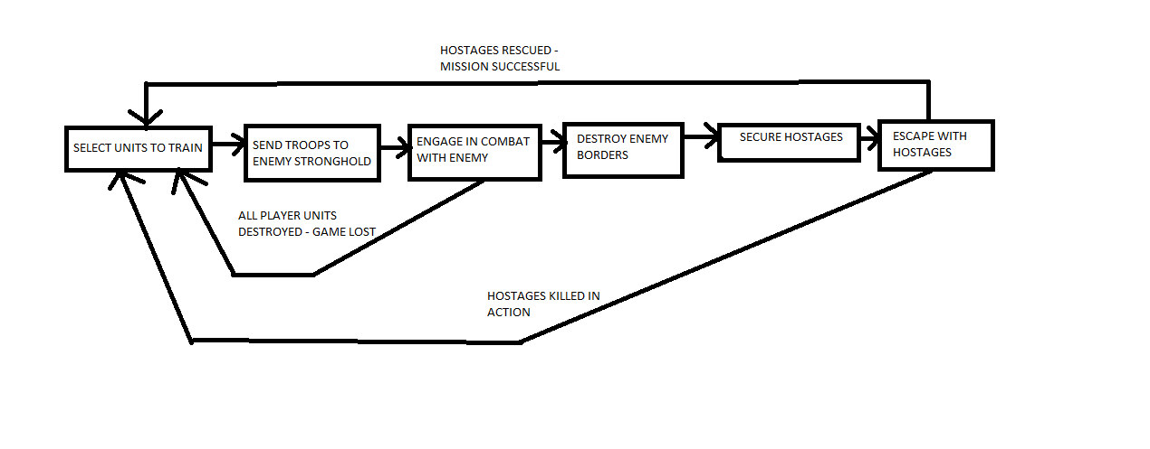

4.5. Look and Feel
The theme is a futuristic space fighting game. All characters are space ships, each with a different variation of attack or special ability. All fighting takes place on planets that include differing types of terrain and biomes. During gameplay, the player will view the battlefield through a heads-up display (HUD) that gives them information about the currently selected units. Additionally, it will provide GUI elements to command the currently selected unit. In the middle of the HUD will be the window to the battlefield. In this window, the player will see all the units, terrain, projectiles, etc., that are visible at the location the player is currently viewing. The units are styled appropriately for the setting; each is a hovering spacecraft, flying above varying planetary terrains.
4.6. Project Scope
4.6.1. Number of locations
- Player Home Base
- Enemy Home Base
- Battlefield
4.6.2. Number of levels
There are 3 levels, consisting of a tutorial level and 2 main hostage situation levels.
4.6.3. Number of NPC’s
All NPC’s are controlled by the enemy(The Resistance). So the number of NPC’s on the map is determined by how many units the enemy can produce. This number is not static, changes from level to level, and is largely determined by the time it takes to complete the missions.
5. Gameplay and Mechanics
5.1. Gameplay
5.1.1. Game Progression
The player progresses through the game by completing each distinct mission, wherein they defeat the Resistance units and rescue the hostage ship. Upon completion of each level, they will be taken to the next planet to rescue the hostages held there.
5.1.2. Mission/challenge Structure
The player’s mission in each level is to rescue the captured hostages. In each mission, the player will be tasked with infiltrating the enemy base and destroying their units (the layout of which will change on a per-level basis). After locating and picking up the hostage ship, the player will then have to escort the hostage ship to the player’s starting base, upon which they will complete the level.
5.1.3. Puzzle Structure
The type and location of enemies will provide a unique puzzle to the player with each level. As certain types of ships counter other ships, the purchasing choices that a player makes will become a puzzle challenge to solve. Additionally, the layout of the level and position of enemy ships will provide multiple methods of tackling combat, potentially involving distracting groups of enemies with small squads.
5.1.4. Objectives
The objective of the game is to rescue the hostage ships from every planet in each respective mission. This entails choosing units to purchase at the beginning of each level, commanding them to fight and defeat the enemy Resistance forces and finally escorting the hostage ship from the enemy base to the player’s starting base.
5.1.5. Play Flow
Typical play flow will follow what is outlined in section 4.4 - Game Flow Summary, where players will purchase ships, then command ships to defeat the enemies, and rescue hostage ships. In the case where player ships are all destroyed, the player will
5.1.6. Use Cases
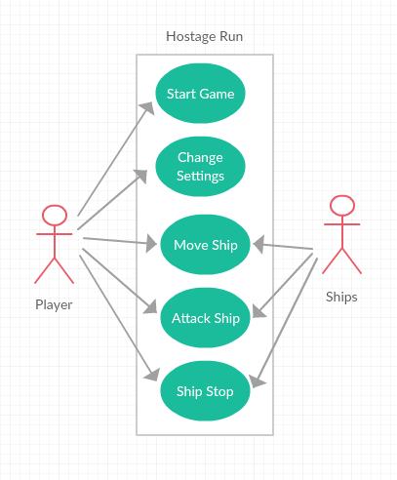
5.2. Mechanics
5.2.1. Physics
Entities in Hostage Run will be Unity GameObjects. These entities (primarily ships) will be subject to the physical laws that Unity enforces, after constraints have been fixed appropriately. This includes velocities, gravity, particles, etc.
5.2.2. Movement
Each player (the human and computer) will have the ability to select their units and select a location for the ship to move to. Once a destination has been set (via a right-click for the player, and automatically for the A.I.), the units will automatically move forward toward their destination during every frame of runtime, based on the unit’s movement speed. Each unit’s general default movement speed is outlined below in the character bible. Projectiles from attacks will follow a similar movement style, except rather than a position as a destination, they will move towards the location of their target
5.2.3. Objects
5.2.3.1.Picking Up Objects
The hostage ship in each level will have a rescue point. When an allied ship enters the region and there are no enemy ships within a certain radius around the rescue point, the hostage ship will be converted into a game unit under the player’s control like the rest of the ships in the game.
5.2.3.2.Moving Objects
Once the hostage ship has been picked up, it may be moved through the user interface in an identical manner to the other ships under your control, and will be subject to the same limitations.
5.2.4. Actions
Every ship in the game has the following actions available to them:
- Move
- Attack
- Stop
Additionally, some ships have special manually-activated abilities (hereafter referred to as “active abilities”) which are outlined in the character bible below. These basic actions as well as the active abilities will have keyboard shortcuts associated with each of them, and combined with the mouse will serve as the method of commanding units to perform these actions.
5.2.5. Combat
Each ship will have the following basic combat data associated with it: damage, cooldown, health. When a ship performs an attack, it will create a projectile with its respective damage, and the ship’s weapons will begin a timed period in which they cannot attack again, known as a cooldown. In general, when a projectile hits its target it will deal its damage to the target (subtracting the damage dealt from the target’s current health). In some cases, additional active or passive abilities may modify how this damage is dealt. When ships reach zero health, they die and are removed from the game.

5.2.6. Economy
The game’s economy comes in the form of the resources that each unit costs. Stronger units have a higher associated cost, as well as more complex ships with powerful custom abilities. At the start of each level, the player will be given access to a pool of resources to purchase their army with.
5.3. Screenflow
5.3.1. Screen Flow Chart / State Transitions
Home Screen
Options
Unit Selection
Gameplay Screen
Level
Selection
Victory
Defeat
5.3.2. Screen Descriptions – What is the purpose of each screen?
5.3.2.1. Home Screen
Provides the user with a menu to select either options or begin playing the game and proceed to level selection.
5.3.2.2.Options Screen
Provides the player with the options to change audiovisual or hotkey settings.
5.3.2.3. Level Selection
Lets the player select between available missions. They player will only have access to the most recent level reached.
5.3.2.4 Unit Selection
Gives the player UI elements to select and purchase their army for the chosen mission
5.3.2.5 Gameplay Screen
The standard user interface, outlined in the user interface section. Gives the player all controls for main gameplay, combat, etc.
5.4. Game Options
Game options for Hostage Run include various audiovisual settings (resolution, volume levels, etc.) as well as hotkey assignment for the various unit orders that can be given.

5.5. Replaying and Saving
Replayability will be available through the defeat or victory screens, whereupon the player may select to restart the level from the beginning. Features to save games are not intended to be within the scope of the current project, but may be added if time permits.
6. Story, Setting and Character
6.1. Story and Narrative
6.1.1. Backstory
The Alliance are the keepers of humanity. After the technology for mass space exploration had reached safe levels, humans spread out all over the galaxy. Each region has its own traits and culture; one such region is known for being masters of pyrokinetic technology, another region known for being masters of harnessing electrical warfare, etc. Now, The Alliance acts as the central hub and maintains the culture and technology of these many distant factions of humans, and also manages diplomacy between them for peace. Supporters of The Alliance and their agenda believe that the incredible diversity of the technology of different regions should be shared, to strengthen and grow knowledge across the galaxy for all of humanity.
Every few years The Alliance sends out military personnel with some Alliance Ambassadors to these distant regions of the galaxy to work on diplomatic agreements to maintain galactic peace. As The Alliance had been going to each region and contacting the other local humans, they had started to hear rumblings of revolution and dissatisfaction. They had heard that some of these foreign humans had not agreed to The Alliance’s terms of shared knowledge. These dissonant voices, with roots in many of the different regions, believed that The Alliance should not be spreading the technology of their cultures with the other factions of humanity. They were disgusted that their culture and identity were being taken from them. Little by little these rumblings had built up, and unknowingly to The Alliance, a new group was being formed by a small group foreign humans composed of all different regions of the galaxy: The Resistance.
On a fateful day in the year 3035, when The Alliance sent all their embassies out to the distant planetary systems, The Resistance executed a coordinated attack, and took hostage each of The Alliance’s ambassadors, and declared war upon The Alliance. Our story starts here, and it is our job as the military commander of the rescue mission to travel throughout the galaxy to the different regions and suppress The Resistance, saving the Ambassador hostages and protecting humanity’s cumulative knowledge.
6.1.2. Plot Elements
Conflict - The Resistance does not agree with The Alliance’s motivation to share human knowledge, and devises a hostage capturing of several Alliance ambassadors.
Climax - The Alliance engages with The Resistance to rescue the hostages.
Conclusion - The Alliance rescues the ambassadors
6.1.3. Game Progression
The game progression features levels in the game that progress the storyline, where the last level features the president as the hostage that was captured by The Resistance. There may also be a tutorial level to introduce the game mechanics to the player.
6.1.4. Story Board
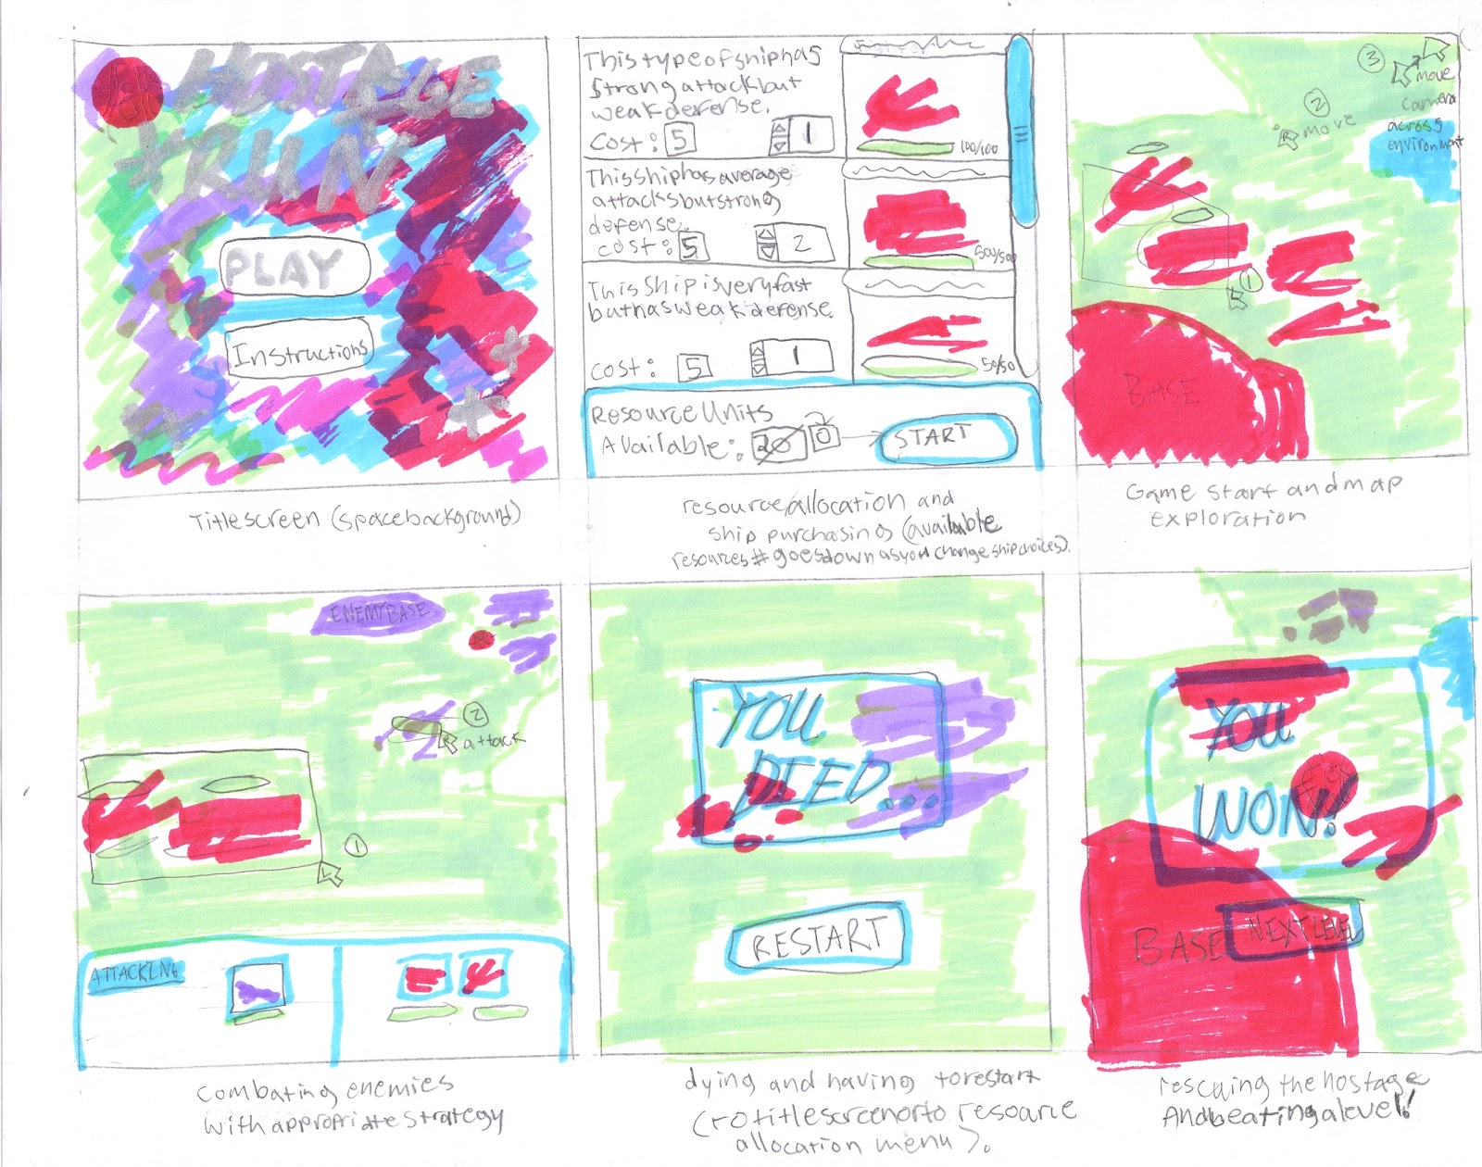

6.2. Game World
6.2.1. General look and feel of world
The theme is a futuristic space fighting game. All characters are space ships, each with a different variation of attack or special ability. All fighting takes place on planets that include differing types of terrain and biomes. During gameplay, the player will view the battlefield through a heads-up display (HUD) that gives them information about the currently selected units. Additionally, it will provide GUI elements to command the currently selected unit. In the middle of the HUD will be the window to the battlefield. In this window, the player will see all the units, terrain, projectiles, etc., that are visible at the location the player is currently viewing. The units are styled appropriately for the setting; each is a hovering spacecraft, flying above varying planetary terrains.
6.2.2. Alliance Home Base
6.2.2.1. General Description
This is the base of operations for the player. The player can build an army by constructing units. Each unit requires a certain amount of resource to construct.
6.2.2.2. Physical Characteristics
The base consists of a few buildings:
- Command Center
- Engineering Factory
- Supply Depot
6.2.2.3. Levels that use area
Every level uses this area
6.2.2.4.Connections to other areas
This area is connected to the battlefield, and is opposite of The Resistance Stronghold
6.2.3. Resistance Stronghold
6.2.3.1. General Description
This is the base of operations for The Resistance. The opposition can build an army by constructing units. Each unit requires a certain amount of resource to construct.
6.2.3.2. Physical Characteristics
The base consists of a few buildings:
- Command Center
- Engineering Factory
- Supply Depot
6.2.3.3. Levels that use area
Every level uses this area
6.2.3.4.Connections to other areas
This area is connected to the battlefield, and is opposite of The Alliance Home Base
6.3. Character Bible (time permitting determines the number of ships we actually get to create)

Picture | Damage | Fire  Rate | Health | Move  Speed | Resource Cost | Special
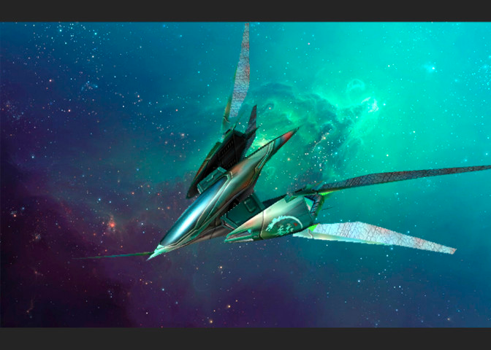 | Low | Moderate | Low | Moderate | Very Low | None
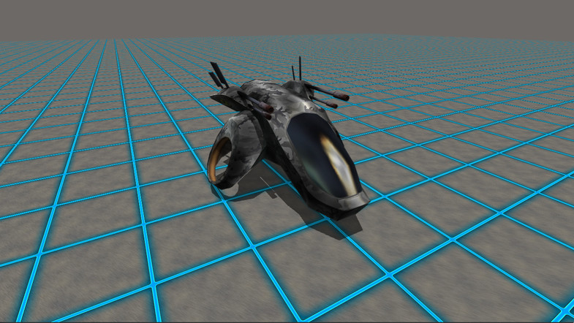 | Moderate | Low | Moderate | Moderate | Low | None
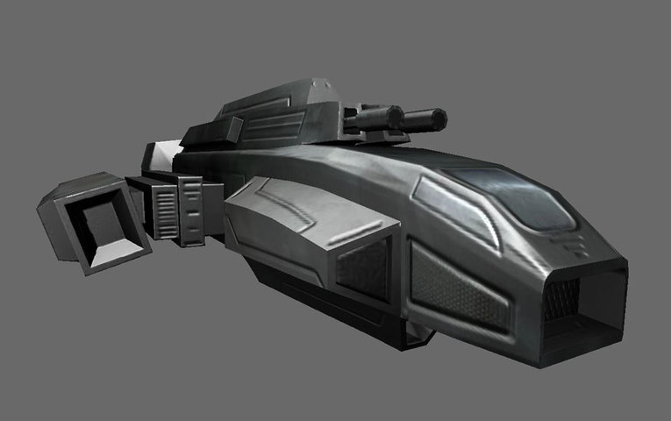 | Very Low | High | Low | Very High | Low | Active: Speed Boost
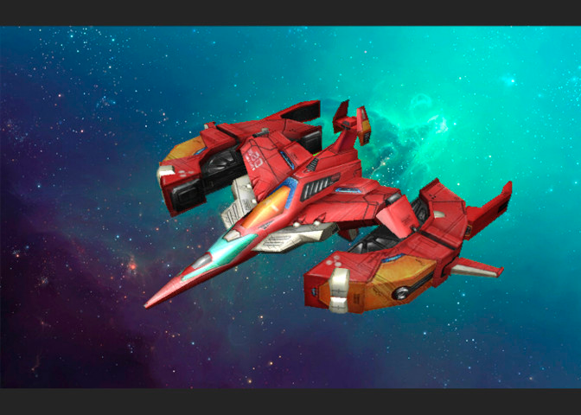 | Very Low | Very High | Moderate | Moderate | Moderate | Passive: Applies a burn effect to targets
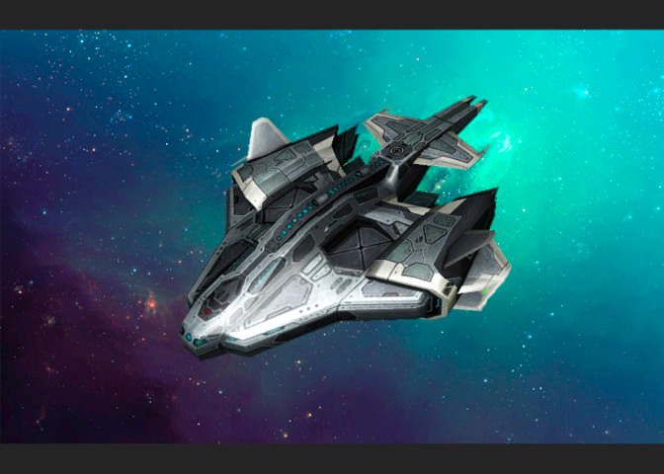 | Moderate | Low | Very High | Low | Moderate | Passive: Incoming damage reduced by flat amount
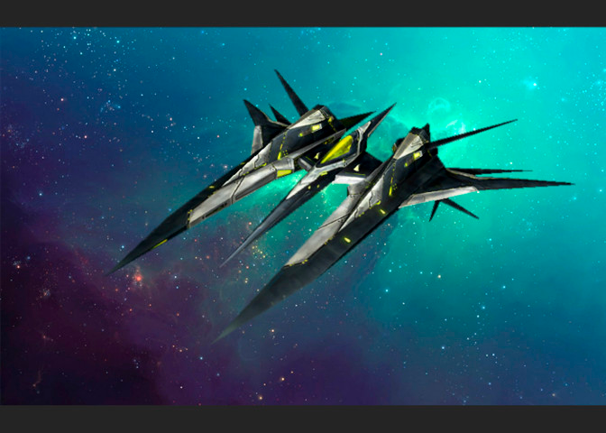 | Moderate | Moderate | Low | High | Moderate | Passive: Chance to evade attacks
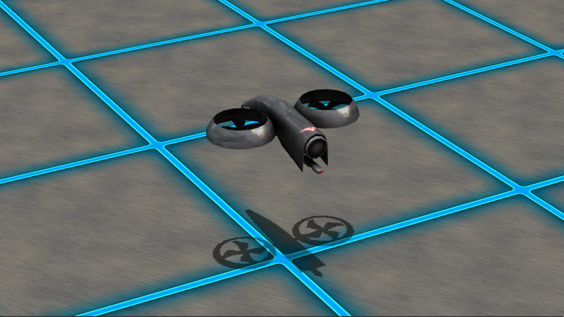 | None | None | Low | Moderate | Moderate | Active: Repair
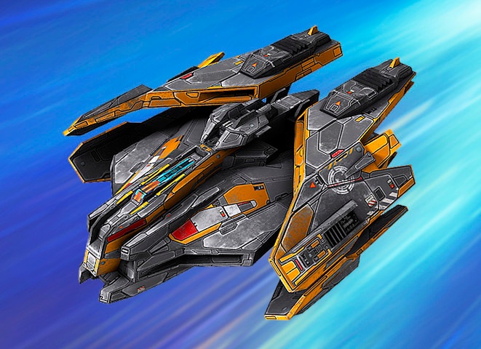 | High | Moderate | High | Moderate | High | None
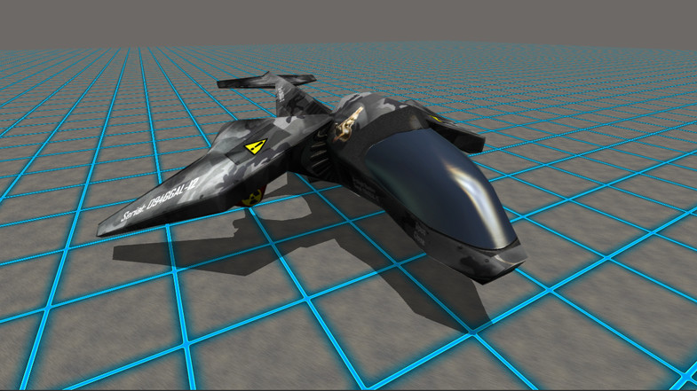 | Very High | Low | Moderate | Low | High | Passive: Area of Effect Damage
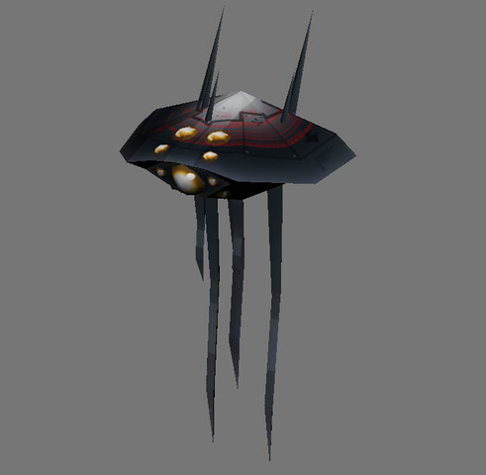 | None | None | Moderate | Very Low | Very High | Passive: Spawns spiderbots (shown below)
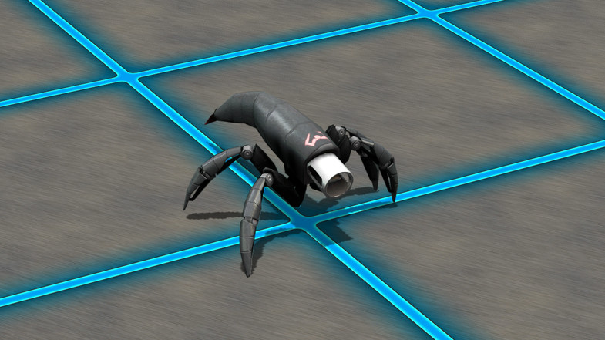 | Very Low | High | Very Low | High | N/A | (Spawned from Hive)
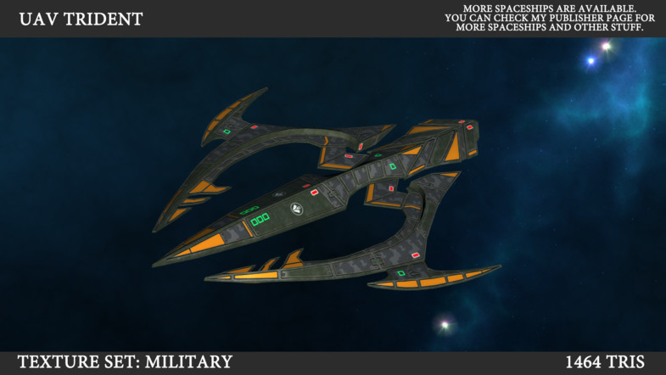 | Very High | Low | Moderate | Moderate | Very High | Passive: Chain Lightning
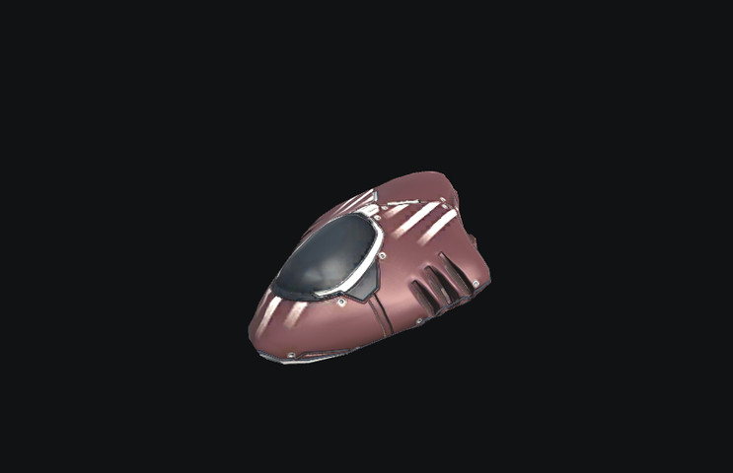 | None | None | Very Low | Very Low | N/A | Note: Hostage Ship must survive

7. Levels
7.1. Level #1
7.1.1. Synopsis
You are rescuing the hostages using your spaceship units. The strong and fast spaceships don’t cost a lot more than the other ones, and the enemy is somewhat strong. This level takes place on a relatively flat sandy terrain.
7.1.2. Introductory Material
The mission is to rescue the hostages and take as little damage as possible, as too much damage will result in a loss. This will be briefed in the intro message when first starting the game.
7.1.3. Objectives
Rescue the ally hostages from The Resistance.
7.1.4. Physical Description
You are controlling several spaceship units (selection based on spending resources) and traveling into enemy territory. There are enemy spaceships that you will fight against. Level 1 consists of mainly flat terrain that will be sandy, such as a desert.
7.1.5. Map
The map will consist of the terrain mentioned above and the ally and enemy ships.
7.1.6. Critical Path
This path is getting to the enemy base and rescuing the hostages. Arrival to this base is necessary. You must also survive the trip back.
7.1.7. Encounters
You will encounter enemy ships that will fight you and you must battle through them.
7.1.8. Level Walkthrough
All levels will have the same gameplay and mechanics. Strategically take your ships and fight to the enemy base, rescue the hostages and arrive back safely.
7.1.9. Closing Material
There will be a congratulatory message as well as encouragement to play the next level.
7.2. Level #2
7.2.1. Synopsis - The enemies see how easily you defeated them in level 1 and this time they have brought better, stronger ships and have convinced the shop clerk to limit the resources you can spend on ships for this level in an attempt to make the second rescue more difficult for you.
7.2.2. Introductory Material
The changes to the enemy and cost will be briefed in an intro message to the second level.
7.2.3. Objectives
Rescue the ally hostages from The Resistance.
7.2.4. Physical Description
You are controlling several spaceship units (selection based on spending resources) and traveling into enemy territory. There are enemy spaceships that you will fight against. Level 2 consists of a more rocky terrain, with the same objective of getting across to the enemy base and back.
7.2.5. Map
The map will consist of the terrain mentioned above and the ally and enemy ships.
7.2.6. Critical Path
This path is getting to the enemy base and rescuing the hostages. Arrival to this base is necessary. You must also survive the trip back.
7.2.7. Encounters
You will encounter enemy ships that will fight you and you must battle through them.
7.2.8. Level Walkthrough
All levels will have the same gameplay and mechanics. Strategically take your ships and fight to the enemy base, rescue the hostages and arrive back safely.
7.2.9. Closing Material
There will be a congratulatory message as well as encouragement.
7.3. Training Level - (time permitting)
This level will be a mostly flat terrain that lets you practice moving your units together or separately.
8. Interface
8.1 User Interface Design Rules
The user interface design rules follow the basic rules of RTS design and consist of the following:
- The player can select any number of their characters and see their stats and command them all to do one task together. The UI will consist of unit highlighting and a HUD for statistics on each selected unit.
- The player can select any number of their characters already performing a task in a group and assign them to do another task instead. Only one task can be performed at a time for any unit. Units can move, attack, and pick up the hostage only. Your units cannot attack each other. you should also be able to see an enemy’s stats by selecting them and the HUD should display some statistics on them as well.
- While battling, HUD and character health bar graphics should be updated with the changing values of each character’s health.
- All actions are performed with the mouse in terms of issuing commands to units. The camera is zoomed in and out or moved around with the mouse as well. The menu for quitting or restarting should be able to be pulled up with a key press like Esc.
8.2. Visual System
8.2.1. HUD
The Heads Up Display appears whenever a character or characters are selected in order to display their stats and number to you. These characters can be enemy characters, but you cannot command the enemy in any way. If both enemy and player characters have been selected, any commands will only be performed by your characters.
8.2.2. Menus
There is a start menu consisting of a story background, instructions, and a start button which sends you to a resource units allocation menu that looks like the one shown in the second storyboard panel, the HUD appears on and off during game play, and the restart/continue screens display when you lose or wish to restart or have beaten a level and you would like to continue on to the next level or the end of the game.
8.2.3. Rendering System
The rendering system we will be using is built into Unity, and we do not plan to do anything particularly special with it unless a level design calls for it.
8.2.4. Camera
The camera will not automatically follow the player’s characters around the map, and will be limited to the confines of the level’s environment layout. The camera can be moved up, down, left, right, and zoomed in and out in a limited range as to reduce confusion and always maintain decent visibility.
8.2.5. Lighting Models
The lighting models we will be using are built into Unity, and we do not plan to do anything special with them unless a level environment design calls for it.
8.3. Control System
As mentioned previously, the player will be controlling the game chiefly through the mouse. A few buttons such as [Esc] will be reserved to pull up menus which they then interact and dismiss with the mouse. The actions the player performs in-game are outlined below:
- Zooming the camera in and out - mouse scroll wheel up (zoom in) and down (zoom out).
- Tracking the camera up/down/left/right or any direction - mouse hovered in the corner or edge of the screen where they want the camera to go and it will slowly start to move that way and speed up the longer it is hovered in that spot, and stop at the edge of the map if reached.
- Selecting characters to see stats on or command - click and drag a box over the characters you want to examine or command on screen with the left mouse button.
- Commanding a character or characters to move - while they are selected, click on screen with the right mouse button the place on the map you want them to move.
- Commanding a character or characters to attack - while they are selected, click on screen with the right mouse button the enemy character on the map you want them to attack.
- Pulling up the in-game menu - [Esc] button, and you interact with the options by clicking the buttons with the mouse.
8.4. Audio
8.4.1. Music
All music will be ambient, and appropriately themed to the space setting. There will only be one or two public domain tracks looped most likely, either one for all levels or one for each level (see music appendix).
8.4.2. Sound Effects
Sound effects might include things like spaceship fire when attacks happen, triumphant effects played when a goal is reached or a level won, and failure effects when a level is lost (see sound appendix).
9. Artificial Intelligence
9.1. Enemy A.I.
The intelligence of the enemy army will be left to logic dictated on a per-unit basis. Enemy units will select their target from a weighted sum of several factions. Firstly, they will each keep track of aggression levels to help determine which of the The Allied Forces’ units they will attack. Whenever an enemy unit receives damage, it will hold a reference to the source of the damage (a unit under allied control) and increment a counter for that reference proportional to the damage dealt. The value of this counter decays over time, and is continually incremented as it receives more damage. Therefore, The Resistance units will use information on which of The Alliance units have been dealing the most damage to it recently as a weighted coefficient for selecting a target. Additionally, the A.I. will factor in the remaining health of The Alliance units that are in-range, prioritizing units that are more injured. This adds combat efficiency to the A.I., as killing off weakened enemies reduces the damage output of that team. Finally, a stronger weight will be added to units that are further into the base – that is to say that the A.I. will also attempt to prioritize units that are making their way to the hostages versus units that are simply fighting further away.
9.2. Friendly Characters
Friendly characters will simply automatically fire at their targets until the target has died. When the friendly character has no active target, it will acquire one within range at random automatically.
9.3. Support AI
9.3.1. Player and Collision Detection
Collision detection will be performed via Unity’s built-in physics engine, using colliders. Ships will be given a sphere collider to represent the exclusive regions of space that they occupy, such that no other ships may clip inside those bounds.
9.3.2. Pathfinding
Pathfinding will be handled using an A* algorithm. The landscape will be preliminarily discretized into a grid-like structure, and then an A* algorithm will determine the path along this grid to the destination location. Straight lines will then be constructed from the grid tiles to be traversed.
10. Technical
10.1. Target Hardware
We will be creating our game for a Windows system with hardware capable of running Windows XP or higher.
10.2. Development hardware and software
We will be developing with Unity 3D using Windows laptop computers.
10.3. Development procedures and standards
Variables will be lower camelcase, classes will be upper camel case. We will be working on separate sections of the project and dating and documenting the work and changes we have done in a separate text file. We will be using google drive to upload and share the unity files.
10.4. Game Engine
Unity 3D
10.5. Network
No network required
10.6. Scripting Language
C#
11. Game Art
11.1. Concept Art
11.1.1 Interface Mock Up
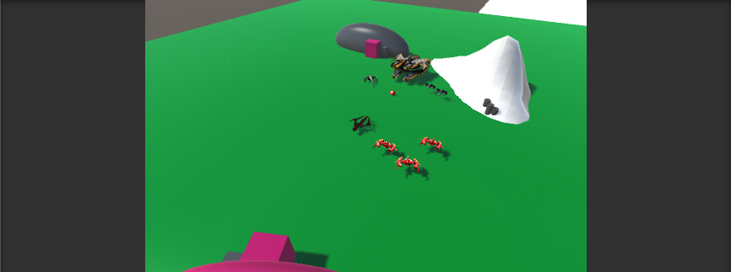
Mockup 1: The world’s camera zoomed out using the scroll wheel (limited range)
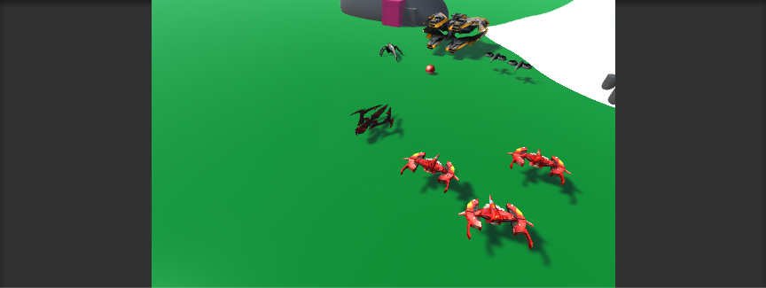
Mockup 2: The standard view
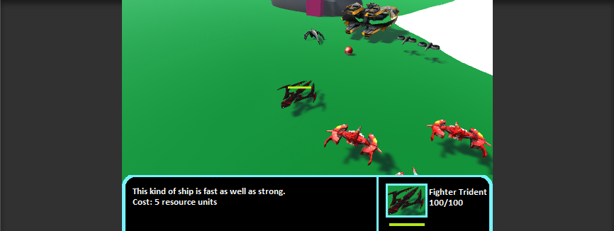
Mockup 3: Ship selection with HUD/UI specifying the ship’s health and strength information
11.2. Style Guides
The style guidelines for the project are pretty loose, but in general every model that we make or use should look like it belongs in the same world as the ships, and every ship should be about the same size if they are not a special or particularly powerful kind of ship. The environment also has to be proportional to the ship characters. Lastly, we have also agreed that we should colorcode the ships as much as we can to make team groupings as clear as possible for the player. The HUD and menus should be designed to look futuristic and space-y, which aligns with our story background and setting.
11.3. Characters
See interface mockups and the character bible for character art.
11.4. Environments
See interface mockups and level descriptions.
12. Management
12.1. Schedule

Date | Task | Who is Responsible
Tuesday Dec 1st | Upload camera tracking unity project to drive with notes | Ryan
Wednesday Dec 2nd
Thursday Dec 3rd | UI stuff - selection and generation of ships on map  Upload environmental design work and notes (adding on to Ryan’s work) | Lauren
Friday Dec 4th
Saturday Dec 5th | Meeting at noon | everyone
Sunday Dec 6th
Monday Dec 7th | selected units move when instructed and attack target | allison (& anyone who wants to help)
Tuesday Dec 8th
Wednesday Dec 9th | AI - and selected units can now attack as well and pick up the hostage | Ryan and Robert
Thursday Dec 10th | Achievable game states (finished game, failed game that needs to be restarted)
Friday Dec 11th | GOAL: have level 1 done | everyone
Saturday Dec 12th | Meeting at noon | everyone
Sunday Dec 13th
Monday Dec 14th
Tuesday Dec 15th | GOAL: Have level 2 done | everyone
Wednesday Dec 16th | GOAL: level 3 done, game completely finished

12.2. Budget
As this is a university project, there is no allocated budget. All assets will be acquired through free mediums, and developers will not be financially compensated.

12.3. Risk Analysis

Risk | Probability (0<p<1) | Severity (0-10) | Total Impact
Team member doesn’t do assigned work | 0.05 | 7 | 0.35
Loss of team member | 0.05 | 9 | 0.45
Project scope overestimated | 0.3 | 6 | 1.8
Schedule approximations miscalculated | 0.5 | 4 | 2.0

12.4. Test Plan
We will use equivalence class testing to meet all expected styles of inputs for unit testing, as well as black box system testing to ensure game quality.
12.5. Lessons learned
The following were issues that occurred in our 2D Game Project, and thus are lessons to be learned in avoiding the same problems:
- Project scope overestimated for 2D Game Project
- Concurrent redundant work performed on same sections of code
- Procrastination of game implementation
13. Appendices
13.1. Asset List
13.1.1. Art
13.1.1.1. Model and Texture List
https://www.assetstore.unity3d.com/en/#!/content/49472 Accessed November 25th, 2015.
https://www.assetstore.unity3d.com/en/#!/content/15159 Accessed November 25th, 2015.
https://www.assetstore.unity3d.com/en/#!/content/11711 Accessed November 25th, 2015.
https://www.assetstore.unity3d.com/en/#!/content/46128 Accessed November 25th, 2015.
13.1.1.2. Animation List
None to provide at the moment.
13.1.1.3. Effects List
None to provide at the moment.
13.1.1.4. Interface Art List
Storyboard:
http://www.robertkohr.com/wp-content/gallery/doras-pyramid-board/dora-pyramid-storyboard01.jpg Accessed November 25th, 2015.
Camera positioning for mockups:
http://unity3d.com/learn/tutorials/projects/roll-ball-tutorial Accessed November 25th, 2015.
13.1.2. Sound
13.1.2.1. Environmental Sounds
http://soundbible.com/147-UFO-Landing.html Accessed November 29th, 2015.
13.1.2.2. Weapon Sounds
http://soundbible.com/1949-Pew-Pew.html Accessed November 29th, 2015.
http://soundbible.com/1564-Strange-Static.html Accessed November 29th, 2015.
13.1.2.3. Interface Sounds
http://soundbible.com/1639-Power-Up.html Accessed November 29th, 2015.
13.1.3. Music
13.1.3.1. Ambient
http://www.freesound.org/people/MrPork/sounds/271866/ Accessed November 29th, 2015.
http://www.freesound.org/people/alaupas/sounds/176685/ Accessed November 29th, 2015.
http://www.freesound.org/people/fons/sounds/98627/ Accessed November 29th, 2015.
13.1.3.2. “Action”
http://www.freesound.org/people/keinzweiter/sounds/151815/ Accessed November 29th, 2015.
13.1.3.3. Victory
http://www.freesound.org/people/fisch12345/sounds/325112/ Accessed November 29th, 2015.
http://www.freesound.org/people/fins/sounds/171670/ Accessed November 29th, 2015.
http://www.freesound.org/people/fins/sounds/171671/ Accessed November 29th, 2015.
13.1.3.4. Defeat
http://www.freesound.org/people/fins/sounds/171672/ Accessed November 29th, 2015.
http://www.freesound.org/people/fins/sounds/171673/ Accessed November 29th, 2015.

