Game Design Document Outline

Title Page

Game Name
    - Hacken

Version Number, Author(s), Date
    - Version 1.3
    - Eric Anderson, James Nelson, Alexander Rebain, Kyle Stevens
    - December 16th, 2015

Table of Contents

Title Page
Game Name
Version Number, Author(s), Date
Table of Contents
Version Control
Design Specifications
Section I - Game Overview
Game Concept
Feature Set
Genre
Target Audience
Game Flow Summary
Look & Feel
Project Scope
Number of Locations
Number of Levels
Number of NPCs
Number of Weapons
Other planned additions
Section II - Gameplay & Mechanics
Gameplay
Game Progression
Mission/Challenge Structure
Puzzle Structure
Objectives
Play Flow
Mechanics
Physics
Movement
Objects
Picking up objects
Moving objects
Actions
Switches & Buttons
Picking up, Carrying, & Dropping
Talking
Reading
Combat
Economy
Screen Flow
Screen Flow Chart
Screen Descriptions
Main Menu Screen
Gameplay Screen
Pause Screen
Inventory Screen
Stat Screen
Equipment Screen
Game Options
Replaying & Saving
Cheats & Easter Eggs
Section III - Story, Setting, & Character
Story & Narrative
Back Story
Game Progression
Storyboard
Game World
Generic look & feel of world
Area 1
General Description
Physical Characteristics
Levels that use this area
Connections to other areas
Area 2
General Description
Physical Characteristics
Levels that use this area
Connections to other areas
Characters
Main Character
Back story
Personality
Look
Physical characteristics
Animations
Special Abilities
Relevance to game story
Relationship to other characters
Statistics
Section IV - Levels
Level 1
Synopsis
Objectives
Physical Description
Map
Critical Path
Encounters
Level Walk-through
Level 2
Synopsis
Objectives
Physical Description
Map
Critical Path
Encounters
Level Walk-through
Training Level
Section V - Interface
Visual System
HUD
Interface Mock-up
Main Menu
Pause Menu
How To Screen
Rendering System
Camera
Lighting Models
Control System
Audio
Music
Sound Effects
Help System
Section VI - Artificial Intelligence
Enemy AI
Archer
Fencer
Commander
Non-combat Characters
Friendly Characters
Support AI
Player and Collision Detection
Pathfinding
Section VII - Technical
Target Hardware
Development Hardware & Software
Hardware
Eric
James
Alex
Kyle
Software
Game Engine
Scripting Language
Section VIII - Game Art
Characters
Environments
Equipment
Section X - Management
Detailed Schedule
Budget
Risk Analysis
Localization Plan
Test Plan
Alex
Kyle
Eric Anderson
James Nelson
Section XI - Appendices
Asset List
Art
Model and Texture List
Animation List
Interface Art List
Sound
Environmental Sounds
Weapon Sounds
Interface Sounds
Lessons Learned
Eric Anderson
What Went Wrong?
What Went Right?
What Lessons Did You Learn?
James Nelson
What Went Wrong?
What Went Right?
What Lessons Did You Learn?
Alexander Rebain
What Went Wrong?
What Went Right?
What Lessons Did You Learn?
Kyle Stevens
What Went Wrong?
What Went Right?
What Lessons Did You Learn?
Bibliography
Inventory System
Artificial Intelligence System
Character Rigs
Item Models
Sound
Textures
Paintings

Version Control

Name | Version | Date | Description of Change
Alex Rebain | v0.1 | 11/19/15 | Added Skeleton, Filled out sections 4,5,8,9, and 10
Eric Anderson | v0.2 | 11/20/15 | Added version control, corrected several sections
Kyle Stevens | v0.3 | 11/22/15 | Reformatted document for clarity as well as to automatically generate Table of Contents
Alex Rebain | v0.4 | 11/25/15 | Completed more sections (level, story, character)
Eric Anderson | v1.0 | 11/27/15 | Updated several sections with new info. Added and edited the game back story. Added the player back story. Added second level information.
Eric Anderson | v1.1 | 11/27/15 | Added lessons learned and bibliography sections. Updated formatting to properly display in the table of contents. Added personal lessons learned info.
Eric Anderson | v1.2 | 12/6/15 | Updated the AI section to include a more comprehensive outline of the AI behaviors. Added the enemy rigs to the game art section. Added Storyboard to the story section. Updated the interface section with the new menus, and added screenshots of each menu/interface. Updated the screen flow chart.
Eric Anderson | v1.3 | 12/16/15 | Updated the bibliography section to include all the outside sources used in the project.

Design Specifications

Section I - Game Overview

Game Concept
      - A fantasy 3rd person hack and slash RPG

Feature Set
      - 3 Different Types of Weapons (heavy, balanced, quick)
      - 4 Special abilities (focus fire, area burst, energy weapon, energy shield)
      - Upgradable stats
      - Leveling system
      - Inventory system
      - Equipment system
      - Different types of enemies using different types of weapons

Genre
      - 3rd person Action RPG

Target Audience
      - Fans of RPG games of all ages

Game Flow Summary
      - The player moves through each level killing enemies in his/her own way. Each level will have a specific objective the player must accomplish

Look & Feel
      - The game uses semi-realistic models in a somewhat medieval fantasy setting. The game looks and feels dark with Gothic and medieval overtones

Project Scope

Number of Locations
        - 2 different locations planned

Number of Levels
        - 2 different levels planned (1 per location)

Number of NPCs
        - Only planned NPCs are enemies. At least 2 different types of enemies planned

Number of Weapons
        - There are 3 weapon types planned (heavy, balanced, and quick) with a couple different actual weapons for each type

Other planned additions
        - Upgradeable skills
        - Leveling system
        - Enemy strength is tied to player’s character level

Section II - Gameplay & Mechanics

Gameplay

Game Progression
        - Player will progress through the game by completing an objective in each area

Mission/Challenge Structure
        - The mission structure is one or two per area that must be completed to move on to the next level. Enemy levels will be tied to the character’s level so the game doesn’t get too easy

Puzzle Structure
        - There are no puzzles planned for the game

Objectives
        - The objectives will range from killing a certain amount of enemies to completing certain tasks like getting a key that unlocks a door to the next level

Play Flow
        - The player plays through each level completing the tasks given to them

Mechanics

Physics
        - The physics system is based of semi real world physics using the built in physics in the Unity Engine

Movement
        - The player moves around using the WASD keys like a typical 3rd person game. The player will be able to look around using the mouse and attack and defend using the mouse

Objects

Picking up objects
          - The player will pick up objects using the E key and they will be added to his/her inventory

Moving objects
          - There are currently no plans for movable objects yet

Actions

Switches & Buttons
          - Switches and buttons will be used using the left mouse button

Picking up, Carrying, & Dropping
          - The player can pick up items with the E key. Items being carried will be displayed in the players inventory window. When an item is dragged outside of the inventory window (dropped), a 3d version of the item is added to the game to represent the drop.

Talking
          - There are currently no plans for dialogue in the game

Reading
          - There are currently no plans for reading in the game

Combat
        - Combat in the game is of a hack and slash nature. Basically, just attack away at the enemy and be aware of your health. Stats will affect the amount of damage you do as well as how much damage you can take. Your shield will have a chance to block or absorb some damage from an enemy attack

Economy
        - There is currently no plan for an economy in the game

Screen Flow

Screen Flow Chart
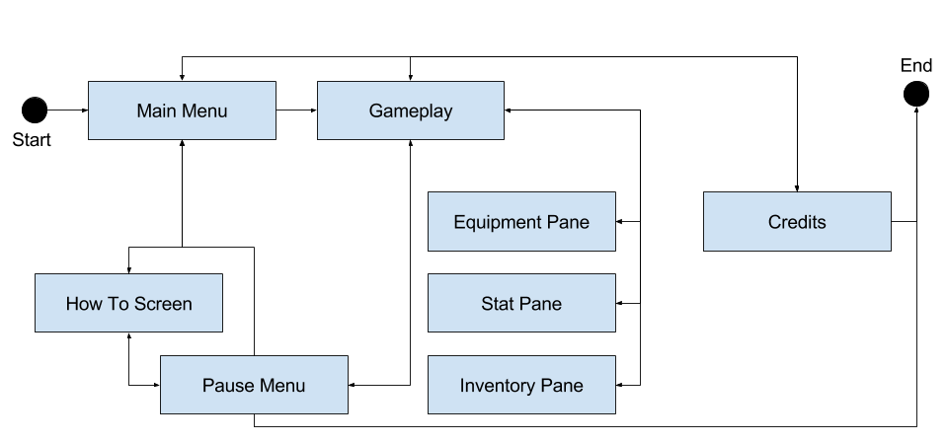

Screen Descriptions

Main Menu Screen
          - Lets the player play the game or quit the game

Gameplay Screen
          - Everything displayed while currently playing the game, including HUD

Pause Screen
          - Pauses the game. Allows the player to quit the game or go back to the main menu. Allows the player to access the inventory and stat screens

Inventory Screen
          - Gives the player access to his/her equipment and other items obtained while playing

Stat Screen
          - Allows the player to upgrade his/her base statistics and learn or upgrade special abilities

Equipment Screen
          - Allows the player to equip inventory items

Game Options
      - The player has control over his/her own statistics when leveling up. In this way, the player has a large amount of control over how his/her character evolves to accomplish the game’s tasks. It is important that the player makes good choices when deciding how to level up. The enemies will scale in difficulty with the player and it will be assumed that the player is making intelligent decisions

Replaying & Saving
      - The player can replay the game anytime they want, they will also have the option to continue playing endlessly by simply repeating the same levels but with the already accrued experience and equipment. There are currently no plans for a save system

Cheats & Easter Eggs
      - There are currently no plans for Cheats or Easter Eggs in the game

Section III - Story, Setting, & Character

Story & Narrative

Back Story
- Our story begins in the far away kingdom of Tumerria. Ruled by the peaceful Enlightened Court, these select few were known for their use of Essence. Essence, the very force that embodies the soul and allows anyone touched by the ethereal guardians, Nephalim, to channel it into pure energy.

- Tumerria is the longest reigning and furthest reaching of any Human Empire ever known, although it was not always as such. Long before the Court, the land was filled with horrendous beasts and creatures of all manner and form collectively called the “Deemin”. Leading these legions was an evil being known only as Tar’Soon, whose tyranny was only matched by his brutality.

- Enslaved by the Deemin hordes where our ancient ancestors, bound in chains and forced to toil in all manner of servitude. For decades our ancestors were oppressed, failing in many rebellions against the iron fist of Tar’Soon.

- Soon after the last rebellion, Tar’Soon ordered the execution of any Human that had not given their Essence to their masters. Seeking salvation from this eternity of despair, the Seraphim, ascended beings beyond comprehension, heard our pleas.

- The Seraphim gave unto the chosen of our ancestors the art of channeling Essence. Empowered with this new ability our ancestors were finally able to break their chains and throw off the oppression of the Deemin.

- Even with this new power victory came at a great cost, with hundreds of thousands dying in the ensuing war. Near the end of the war, Tar’Soon saw that his defeat was imminent. He gathered the last of the Deemin and fled to the north, into the swamp lands of Darmund, swearing he would return.

- For centuries the newly formed kingdom pushed forth, with the decedents of the Seraphim’s chosen, the Nephalim, ruling through the Enlightened Court. As time passed, the story of Tar’Soon, and the powers bestowed by the Seraphim, soon passed into legend. Until one fateful night...

- A village, on the outskirts of the empire, was suddenly descended upon by Tar’Soon and a large compliment of Deemin. Tar’Soon’s forces swept through the village, capturing almost all of the villages inhabitants.

- One militia man, on the edge of death received a vision of the Seraphim. The Seraphim had granted him the once lost ability to channel Essence. With this new found power, the Chosen is tasked with stopping the forces of Tar’Soon and saving the empire.

Game Progression
- The player controls the Chosen, the morning after he is granted his new powers. The Chosen finds his village mostly intact, but all of its inhabitants are missing. In place of where his fellow villagers should be, are Deemin forces. The player must fight through the village looking for clues as to why the villagers were taken, and where he might go next to pursue Tar’Soon.

- In the midst of clearing the village of the Deemin forces, the Chosen finds a missive outlining some of Tar’Soon’s battle plans. The Chosen learns that Tar’Soon will soon be laying siege to a nearby hold. Hoping to intercept Tar’Soon, the Chosen heads through a treacherous swamp with all haste.

- More will be revealed as the Chosen hacks his way through the Deemin forces to confront Tar’Soon...

Storyboard
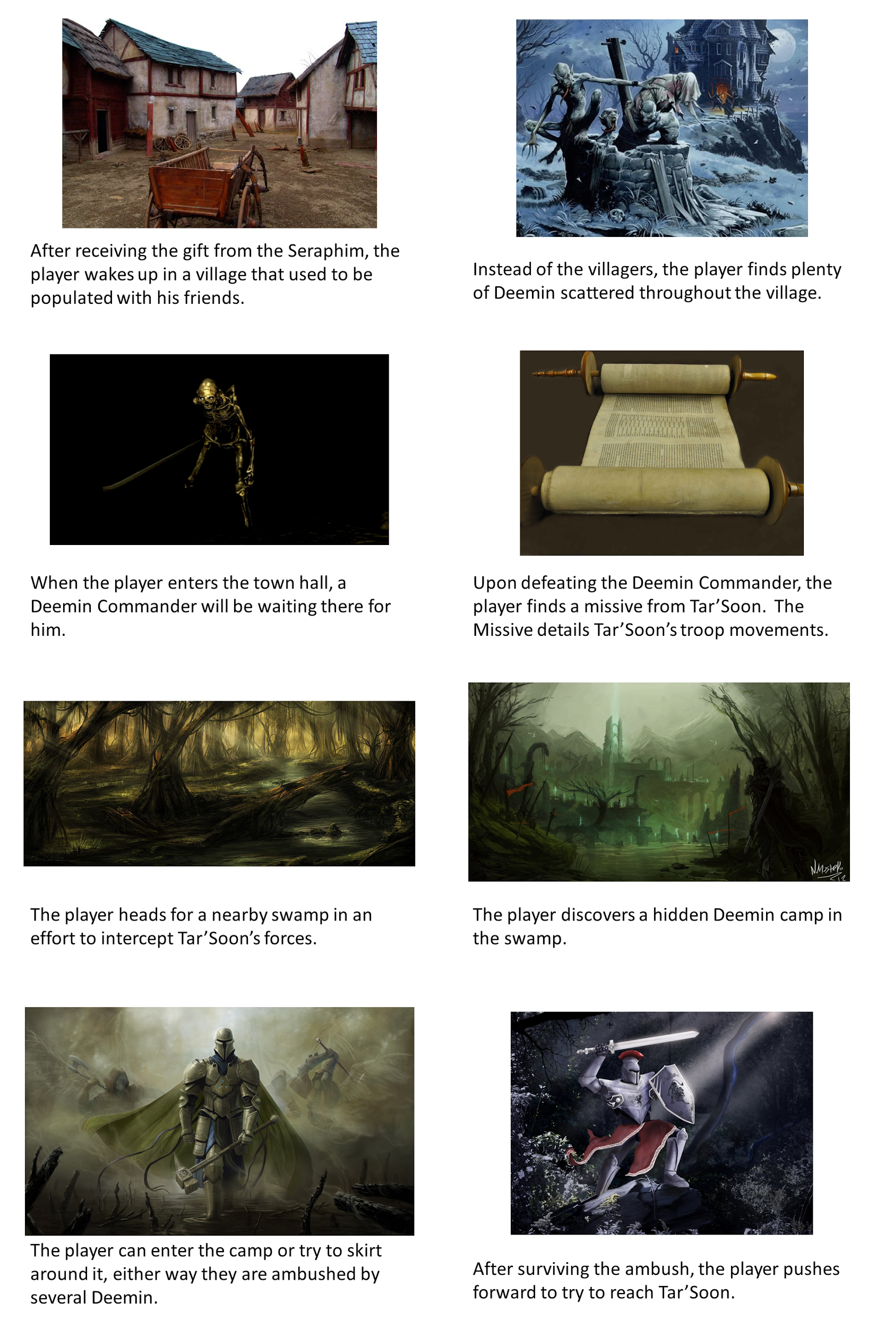

Game World

Generic look & feel of world
        - The world is a kind of medieval fantasy world. The game world is dark and lonely

Area 1

General Description
          - An abandoned village

Physical Characteristics
          - Broken down houses
          - Houses still standing
          - Abandoned church
          - Hills
          - River and waterfall

Levels that use this area
          - Level 1

Connections to other areas
          - Player must complete the area in order to get the the next area

Area 2

General Description
          - A swamp

Physical Characteristics
          - Trees
          - Small Ponds
          - Rivers

Levels that use this area
          - Level 2

Connections to other areas
          - Player must complete the first level in order to access this area

Characters

Main Character

Back story
- The protagonist has no real back story, he is a simple man who works for the militia in his village. He patrols the village at night for signs of trouble, villagers causing trouble or maybe large animals encroaching on the village’s supplies. He is unmarried, and has no children.

- From the main story: One militia man, on the edge of death received a vision of the Seraphim. The Seraphim had granted him the once lost ability to channel Essence. With this new found power, the Chosen is tasked with stopping the forces of Tar’Soon and saving the empire.

Personality
- He has a slightly imposing personality, as evidenced by his look. He desires to avoid conflict when possible, but does take some pleasure in defeating Deemin. He does feel a great desire to protect his village, and return his people to it.

Look

Physical characteristics
- Wears heavy steel plated armor and uses a variety of weapons

Animations
- Animations are fluid and include walking, running, jumping, and attacking, both with weapons and with special abilities

          - Actual Look
- See game art section

Special Abilities
- The character can learn 4 special abilities including Focus Fire, Area Blast, Energy Weapon, and Energy Shield.

Relevance to game story
- The story is focused around the main character finding out what happened to his people, and stopping Tar’Soon from destroying the empire.

Relationship to other characters
- He pursues Tar’Soon and his army, the Deemin

Statistics
- Player stats include:
  - Quick weapon mastery
  - Heavy weapon mastery
  - Balanced weapon mastery
  - Resilience
  - Agility
  - Vitality
  - Magic
  - Focus Fire
  - Area Burst
  - Energy Weapon
  - Energy Shield

Section IV - Levels

Level 1

Synopsis
- The player has just woken up in a shack on the edge of his village. He thought he was dead until receiving the vision from the Seraphim. He must search the village for evidence of what happened to his people. He will confront many Deemin in his search.

Objectives
- Search the village for evidence of what happened to his people. Eventually the player will find a missive that describes where Tar’Soon may be headed. The player can then decide to move on to the next level.

Physical Description
- It is a hilly area with a river and a water fall. A small village sits on the river. The level is a nighttime level.

Map
- See game art section

Critical Path
- Kill a Deemin in the town hall to get a missive telling where to go next. After obtaining the missive the player can exit the map to the north.

Encounters
- The player will encounter three different types of several enemies. The two main types will be sword-wielding Deemin soldiers, and Deemin archers. The third encounter will be a single Deemin commander in the town hall.

Level Walk-through
- Walk down the path and into the village. Enter the town hall, kill the Deemin commander and loot the missive.

Level 2

Synopsis
- The player has entered the swamp in the hopes of catching Tar’Soon before he reaches his destination. Tar’Soon has yet to be informed of the Chosen, but there are still somehow plenty of Deemin in the swamp. The player must cut his way through them to proceed.

Objectives
- Reach the end of the swamp path alive.

Physical Description
- It is a swamp with ponds, rivers, a lot of trees, and a few paths that wind though it.

Map
- Not yet created.

Critical Path
- Follow the large path through the swamp.

Encounters
- The player will encounter three different types of several enemies. The two main types will be sword-wielding Deemin soldiers, and Deemin archers. The third encounter will be two or three Deemin commanders in a camp near the middle of the swamp.

Level Walk-through
- Walk the swamp path to its end while not dying.

Training Level
      - There are currently no plans for a training level / tutorial.

Section V - Interface

Visual System

HUD
        - The planned HUD shows the player how much health they have, how much mana they have, and how much experience they have until their next level. It also shows the player’s current location and their currently selected special ability

Interface Mock-up
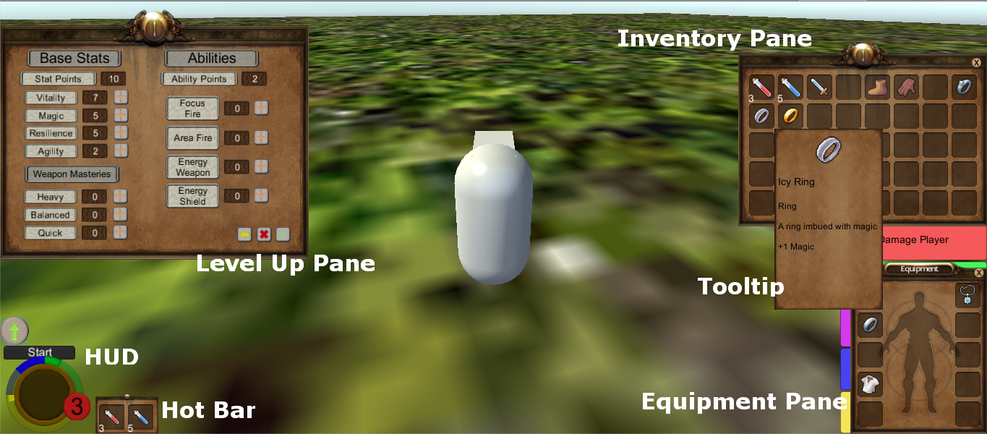

Main Menu
- The main menu will only be presented before gameplay begins or after it ends. The player can only get to the menu by exiting there current play-through.
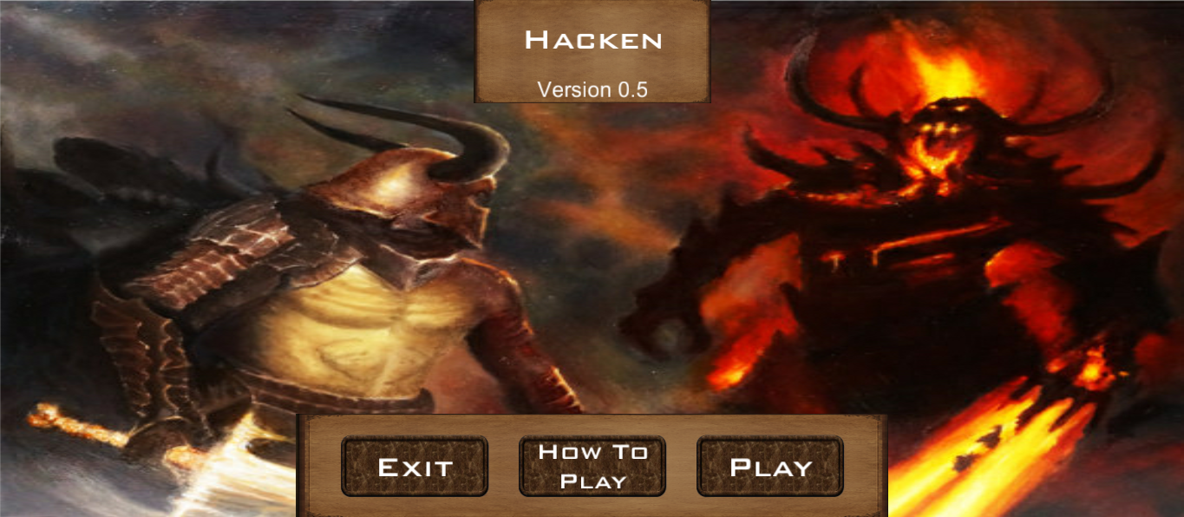

Pause Menu
- The pause menu can be reached at any time in-game by pressing the ESC key. As the name implies the game time cease to progress while the user has the pause menu active.

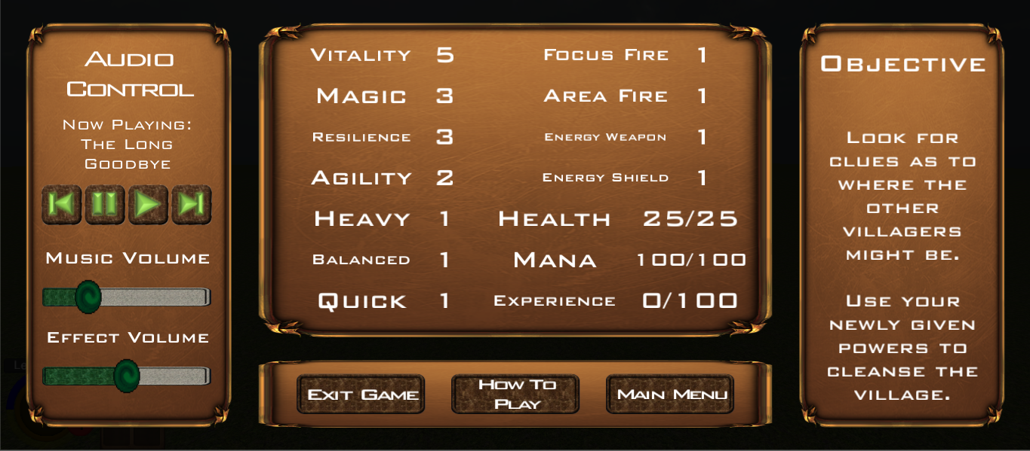

How To Screen
- The How To Screen can be accessed at any time from the pause menu. The How To Screen can also be accessed from the “how to play” button in the main menu. The user is forced to look at the How To Screen at least once when they begin a play-through.

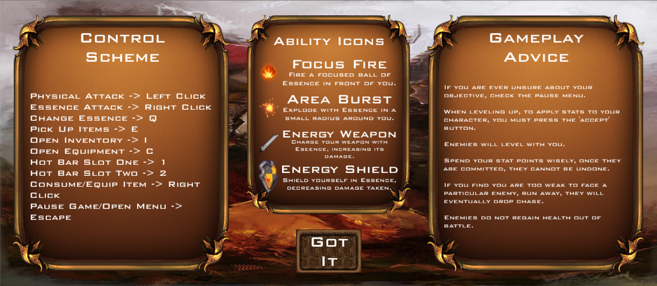

Rendering System
        - Handled by the Unity game design engine

Camera
        - The camera is in a 3rd person perspective and follows the player

Lighting Models
        - Their will be a point light high up to simulate a sun. Since the game setting is in somewhat medieval times, there will be some type of lantern scattered throughout the levels.

Control System
      - The player controls the character movement with the WASD keys and space to jump. The player can attack using left mouse button and right mouse button for a secondary attack. The player can pick up items with the E key. The player can open his/her inventory with the I key and the equipment screen with the C key.

Audio
      - Audio includes ambient sounds for the levels as well as environmental objects in the game such as waterfalls and fire

Music
      - There will be soft background music indicative of the ominous situation the player finds him/herself in.

Sound Effects
      - Player attack
      - Player take damage
      - Player dodge attack
      - Player jump
      - Enemy take damage
      - Enemy attack

Help System
      - There will be a “How to play” section in the main menu and a control scheme in the pause menu

Section VI - Artificial Intelligence

Enemy AI
- The AI will consist of three different behavior trees, implemented using the RAIN system.

Archer
- The Archer has a viewing cone of 115% left to right, centered on the character’s face.
- The Archer has two viewing ranges
  - When the player enters the Archer’s outer view range, set at 45 yards, the Archer will run towards the player.
  - When the player enters the Archer’s inner view range, set at 35 yards, the Archer will begin firing prefabricated arrows at the player every 2 seconds.
- When the Archer does not have any view of the player, he will walk between predesignated way-points. These way-points are individual to each Archer instance, and will be placed according to the actual level topographical features.

Fencer
- The Fencer has a viewing cone of 115% left to right, centered on the character’s face.
- The Fencer has three viewing ranges
  - When the player enters the Fencer’s outer view range, set at 40 yards, the Fencer will run towards the player.
  - When the player enters the Fencer’s middle view range, set at 10 yards, the Fencer will walk towards the player.
  - When the player enters the Fencer’s inner view range, set at 5 yards, the Fencer will enter a battle stance, and begin swinging his weapon at the player repeatedly with a 2 second delay.
- When the Fencer does not have any view of the player, he will walk between predesignated way-points. These way-points are individual to each Fencer instance, and will be placed according to the actual level topographical features.

Commander
- The Commander has a viewing cone of 140% left to right, centered on the character’s face.
- The Commander has two viewing ranges
  - When the player enters the Commander’s outer view range, set at 50 yards, the Commander will run towards the player.
  - When the player enters the Commander’s inner view range, set at 5 yards, the Commander will enter a battle stance, and begin swinging his weapon at the player repeatedly with a 2 second delay.
- When the Commander does not have any view of the player, he will stand in place, either dancing or idling.

Non-combat Characters
      - There are currently no plans for non-combat characters

Friendly Characters
      - There are currently no plans for friendly characters

Support AI

Player and Collision Detection
        - The enemy will detect a collision with the player and will attack the player. The player will collide with all obstacles in the game.

Pathfinding
        - There is currently no pathfinding planned for the game

Section VII - Technical

Target Hardware
      - CPU: Dual-Core @2.0 GHz or more
      - Video: Intel HD3000 integrated graphics
      - RAM: 2GB or more
      - OS: Windows 7 and up

Development Hardware & Software

Hardware

Eric
          - CPU: Intel Dual-Core 2.20 GHz
          - Video: Intel Series 4 Chip-set
          - RAM: 4GB DDR2
          - OS: Windows 7

James

Alex
          - CPU: Intel i7 4770k
          - Video: Nvidia GeForce GTX 970
          - RAM:16GB DDR3
          - OS: Windows 10

Kyle
          - CPU: Intel i7 Quad Core
          - Video: Nvidia GeForce GT 640M LE
          - RAM: 12GB
          - OS: Windows 10

Software
        - Unity 5
        - Visual Studio 2015 Community
        - Blender
        - Gimp
        - Microsoft PowerPoint
        - Google Drive
        - Google Docs

Game Engine
      - Unity 5

Scripting Language
      - C#

Section VIII - Game Art

Characters
- (left to right) Main Character, Fencer Unit, Archer Unit, Commander Unit, Boss Unit
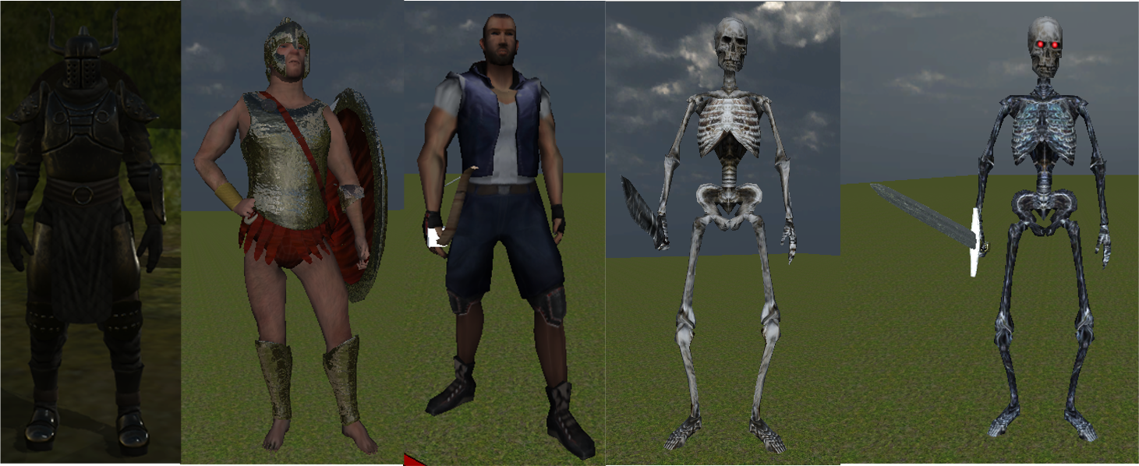

Environments
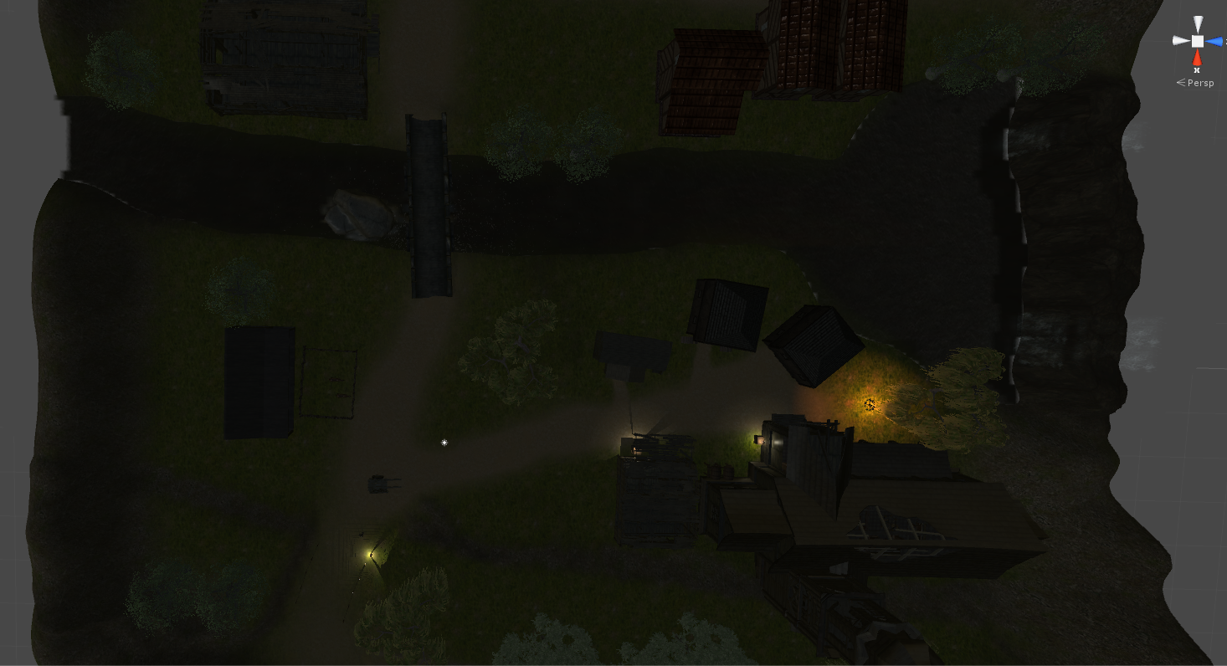
- Abandoned village

Equipment
- One handed ‘balanced’ swords/axes
- Two handed ‘heavy’ swords/axes
- One handed ‘quick’ daggers/knives
- Boots
- Gloves
- Chest Armor
- Bracelets
- Rings
- Necklace
- Helmet

Section X - Management

Detailed Schedule

Budget
      - $0.01
      - 3 Weeks time.

Risk Analysis
      - Risk 1: Not everyone has machines that can handle intensive 3D graphics. It will be difficult to find balance between game detail & performance.
      - Risk 2: Our group runs the risk of not being able to work together in person very much. Working remotely means issues revolving around project sharing & merging.

Localization Plan
      - No localization. English will be the only language supported.

Test Plan

Alex
        - Testing functionality of level (while building)
        - Testing functionality of code while coding

Kyle
        - Optimizing levels for medium performance machines.

Eric Anderson
        - User interface Structuring & Testing

James Nelson
        - Play testing

Section XI - Appendices

Asset List

Art

Model and Texture List
          - Lord (character)
          - Church
          - Abandoned building
          - Fire pit
          - Wood pile
          - Box
          - Lantern
          - Barrel
          - Horse

Animation List
- Walk
- Run
- Jump
- Attack
- equip weapons/shield
- holster weapon/shield

Interface Art List
- Player information (health, mana, experience, weapon, location)
- Skills page
- inventory
- equipment

Sound

Environmental Sounds
          - Water & Waterfall
          - Fire
          - Ambient nighttime sounds

Weapon Sounds
          - Player swing weapon
          - Weapon makes contact
          - Weapon misses
          - Enemy swings weapon
          - Enemy shoots arrow
          - Arrow makes contact
          - Arrow misses
          - Enemy dies
          - Player dies
          - Enemy takes damage
          - Player takes damage

Interface Sounds
          - Level up
          - Pick up item
          - Drop item
          - Button click

Lessons Learned

Eric Anderson

What Went Wrong?
- We had basically split the project into two sides, the player side and the enemy side. We worked collaboratively but designed separately. When it came to integrating the two halves, we did not leave enough time for adjustments.

What Went Right?
- The idea of one person making a player that can defeat a.i. and another person making a.i. that can defeat the player seemed to really amp up the difficulty level of the actual gameplay. Starting early allowed for many extra features that we were not already learned in.

What Lessons Did You Learn?
- Start as early as possible. Communicate often. Never assume modules will perfectly cooperate, no matter how much preparation is done.

James Nelson

What Went Wrong?
- When we created the story for the game we forgot to take into account that we may not be able to find similar assets that are free easily. As such, the story that was already created ended up being chopped and reassembled several times as we came across assets that we could actually use.

What Went Right?
- Once the assets and story were set, finding music and sound effects to compliment them were quite easy. Seeing that the overall color palette was of darker colors and that the story was aiming for high fantasy it was easy to image menacing and somber music accompanying it.

What Lessons Did You Learn?
- When creating a game decide at the beginning weather to create new assets or work around existing ones. If we had started working on the story as we explored what assets were available to us, we would have saved a fair amount of time.

Alexander Rebain

What Went Wrong?
- There was a learning curve to moving around the editor efficiently and animation is not as simple as it seems for complex meshes.

What Went Right?
- As a group we got a lot done early, mostly thanks to Eric. Starting early was a great plan and we’re in a good position to finish our planned game. I also found a lot of useful free meshes to help our game.

What Lessons Did You Learn?
- Always start early. Communication is key and Unity has some great tutorials.

Kyle Stevens

What Went Wrong?
- Not having a very good graphics card on my computer made running the game (inside of Unity) rather choppy and hard to edit.
- Additionally, being a beginner at using Unity means that there is always a trade off between spending a lot of time watching tutorials and learning how to do something, and actually spending time to creating something for our game.
- Sharing the game back and forth always adds issues.

What Went Right?
- The team put together a working “demo” of the game very early. This helps me since I can have a working example in front of me to explore how certain things were created.

What Lessons Did You Learn?
- Starting early definitely was a good idea.
- Having a simple concept to start with and adding more as you go along is better than coming up with an idea that is way to ambitious from the start.
- Communication with the team is key to knowing what everyone else is working on, as well as knowing what they are expecting you to produce. For example, I don’t always know exactly what I should work on, so I will ask another team member where I could help them. I think I’m better as a supporting role since I know they can create all of the new things much faster than I could.

Bibliography

  - Effects
- Water FX Pack by Unity Technologies: https://www.assetstore.unity3d.com/en/#!/content/19248
- Lens Flare by Unity Technologies: https://www.assetstore.unity3d.com/en/#!/content/5

Inventory System
- The inventory system was taken from the unity asset store under the title Inventory Master, created by Sander Buchheim: https://www.assetstore.unity3d.com/en/#!/content/26310

Artificial Intelligence System
- The artificial intelligence system was taken from the unity asset store under the title RAIN A.I. Copyright Rival Theory Inc. 2014: https://www.assetstore.unity3d.com/en/#!/content/23569

Character Rigs
- The enemy character rigs were taken from the unity asset store under the title Advanced Fantasy AI Copyright Brilliant Game Studios 2012: https://www.assetstore.unity3d.com/en/#!/content/3192
- Overlord Character model by BÜMSTRÜM: https://www.assetstore.unity3d.com/en/#!/content/48768
- Heavy attack animation taken from Warrior Pack Bundle 2 by Explosive: https://www.assetstore.unity3d.com/en/#!/content/42454
- Punch Animation taken from Fighter Pack Bundle FREE by Explosive: https://www.assetstore.unity3d.com/en/#!/content/36286
- Animated Horse by Dootsy Development: https://www.assetstore.unity3d.com/en/#!/content/16687

Item Models
- Potion models taken from Potions by Clint Bellanger: http://opengameart.org/content/potions
- Jewelry models taken from Ring Set - Precious Metals by Clint Bellanger: http://opengameart.org/content/ring-set-precious-metals
- Simple Medieval House by Achonux: https://www.assetstore.unity3d.com/en/#!/content/6623
- Woven Wood Fence by Unity Technologies: https://www.assetstore.unity3d.com/en/#!/content/19236
- Customizable Medieval Houses by Xocolatl Studio: https://www.assetstore.unity3d.com/en/#!/content/8963
- Medieval Pros by Lukáš Bobor: https://www.assetstore.unity3d.com/en/#!/content/41540
- Medieval Sword by aziz3d: http://tf3dm.com/3d-model/medieval-sword-69788.html
- Stable by kaos3d: http://tf3dm.com/3d-model/stable-54889.html
- Wooden House by kaos3d: http://tf3dm.com/3d-model/woodhouse-32132.html
- Old House by azlyirnizam: http://tf3dm.com/3d-model/old-house-45816.html
- Low Poly Cart by rafferty: http://tf3dm.com/3d-model/low-poly-cart-79545.html
- Stone Bridge by 3dregenerator: http://tf3dm.com/3d-model/stone-bridge-37857.html
- Abandoned Church by azlyirnizam: http://tf3dm.com/3d-model/abandoned-church-10615.html

Sound
- Exploring Magic (Swamp Music), and Exploring Scary (Village Music) by Andrew Isaias: https://www.assetstore.unity3d.com/en/#!/content/49914
- When Darkness Wins (Lose Screen) by Affordable Audio 4 Everyone: https://www.assetstore.unity3d.com/en/#!/content/50089
- RPG Battle Music (Battle Music) by Crick Studios: https://www.assetstore.unity3d.com/en/#!/content/4373
- With love from Vertex Studio (23) (Win Screen), With love from Vertex Studio (26) (Title Screen), With love from Vertex Studio (39) (Mountain Music), and With love from Vertex Studio (36) (Volcano Music) by Vertex Studio: https://www.assetstore.unity3d.com/en/#!/content/4883

Textures
- Yughues Free Ground Materials by Nobiax / Yughues: https://www.assetstore.unity3d.com/en/#!/content/13001

Paintings
- The Meeting Between Leo the Great and Attila - Raffaello: https://en.wikipedia.org/wiki/The_Meeting_of_Leo_the_Great_and_Attila
- Vision of Cornelius the Centurion - Gerbrand van den Eeckhout: http://www.covenantoflove.net/ethic/did-early-christians-serve-in-the-military/
- Jacob’s Dream - Gerbrand van den Eeckhout: http://agnes.queensu.ca/exhibition/artists-in-amsterdam/
- Battle Between Good and Evil - ToastedArt: http://stillsearchingforthetruth.com/2013/03/12/lifes-battle-good-vs-evil-jus-in-bello-theory/
- Soul Hunting - Songnan Li: http://forums.3dtotal.com/showthread.php?p=905543
- Epic Warrior: http://www.lyfaces.com/epic-background-pictures/epic-warrior-background-wallpaper-superhero-wallpapers.html
- Stonehold - JonasDeRo: http://jonasdero.deviantart.com/art/Stonehold-327302388
- Hell - Andreas paintangel: http://digital-art-gallery.com/picture/13415
- Heavens Battle: http://hdwpics.com/battle-hdw1251545?tegs=battle+angel&pos=13&pref=heavens-battle-angel-hdw1250547&next=noname-hdw1138428
- Breaking Chains - Jeanna Henderson: http://www.wwar.com/cgi-bin/art/artwork.cgi?artist=jeannalefay&id=10515&type=p7
- Demon Battle: https://www.walldevil.com/701339-demon-battle-wallpaper.html
- Wizards of the Coast - Thom Tenery: http://www.thomlab.com/gallery.htm
- Orzhov Guildmage - Greg Staples: http://gatherer.wizards.com/Pages/Card/Details.aspx?printed=true&name=orzhov%20guildmage

