BROs, M.D.
Design Document

CIS 587 – Game Design and Implementation

University of Michigan - Dearborn
Fall Term 2015
Francisco Sandoval

Overview

Science can now cure many diseases thanks to the pathogen destruction ball-rolling technique. Take control of the Ball Rolling Orbs (BROs) to help different patients by rolling over the pathogens in their diseased bodies.

Appearance
BROs, M.D. gives the player a top down 3-D view of the infected patient, where different diseases behave in different ways. Bright colors will help differentiate interactive objects, and the pathogens’ appearance will give visual cues to the player on how they can be destroyed.
The look of the different game items and art will match a futuristic health/infection theme.

Story Abstract
By year 2030, many viral diseases joined ranks with different cancers, AIDS, and others to the incurable disease list due to the irresponsibility of many patients. Even though they were instructed to finish their antibiotics when sick, patients stopped taking them as soon as they started to feel better. Over the year, this behavior resulted in the virus gaining resistance to the antibiotics, until medical science didn’t have medicine strong enough anymore.
Many people started dying due to previously inoffensive diseases. Even the common flu became deadly.
As the result of collaboration between different sciences, the Ball Rolling Orbs system (BROs) was created: two remote controlled orbs that can pick up an antibiotic ball (aBall), load it with different properties, and use it to destroy different viruses.
This easy to use system empowered a new breed of doctors specialized in controlling BROs, and ignited the best fighting chance humanity has ever had to stand against diseases.
Join the ranks of the world’s health system last resistance by cure the world one patient at a time, one disease at a time.

Target audience
The game is intended to be played by persons of all ages. Even though the theme may not be attractive to a younger audience, there is no sensitive material included.

Gameplay
The main goal is to heal patients (levels) by using the ORBs and aBall system to destroy every pathogen.
Even though the game is designed to be played with a gamepad, keyboard is supported as well.
The player takes control of two different orbs. By hovering an orb on top of an aBall, the orb can be captured by it. Be careful, as the orb that has control of the aBall will move slower. The aBall can then be launched towards the other orb by pressing the orb’s release button. This means each orb has its own “throw” button.
The two different orbs provide the aBall with different pathogen-destroying capabilities represented by a different color, and the aBall will remain charged until it's recharged (captured) by a different orb.
Different pathogens may have unexpected interactions with the aBall or the orbs, so a careful approach is advised.
There are different game items that will affect positively and negatively the game flow. More information on the game items in the “Game Items” section.

Development Platform
BROs, MD is to be developed using the latest stable version of Unreal Engine 4 (UE4.1.10 at the moment of creation of this document). UE4 can be hosted in both Linux and Windows environments with capabilities similar to the ones required to run the game:
- Desktop PC or Mac.
- Windows 7 64-bit or Ubuntu 14.04 or later.
- Quad-core Intel or AMD processor, 2.5 GHz or faster.
- NVIDIA GeForce 470 GTX or AMD Radeon 6870 HD series card or higher.
- 8 GB RAM.
- An Xbox 360 or equivalent gamepad controller
Only Windows 64 bit will be supported on the first release of this game.

Game Mechanics

The goal of the game is to destroy every pathogen in the level before the patient runs out of time to progress to the next one, fighting progressively more difficult diseases.
The pathogens can be destroyed by matching the color of the aBall to the color of the pathogen. There is a single aBall and two Orbs in play at all times. Both Orbs are controlled by the player at the same time.
Different game elements can negatively or positively influence the player.

User Interface Description
The UE4 widget system will be used to present the player with simple menus to select the level to be played, and options like pause, resume, or end the game.

Use Cases
Main Menu: The first screen the player sees after launching the game. A simple, sober menu is presented to the player allowing to exit the game, or transition to the level selection screen.
Loading screen: Part of the story is presented here describing the main role of the player and presenting relevant context, e.g. why am I rolling a ball between two balls? what am I destroying?
Level Selection Screen: A number of diseases (initially two) are presented here. The first and easy level will work as a tutorial with very little challenge. This disease is “Influenza”, or the common flu. The second and more challenging disease will be grayed out until the Flu level is completed.
Playing a level: The player must eliminate all the pathogens on screen, then the generator of pathogens before the time runs out. Some game items will also take part. more details in the “Game Items” section. Finish all the diseases to complete the game.

Storytelling
An introductory loading screen will provide context to the player. The different elements must fit with the theme to further convince the player of the current scenario.
On clearing a level, a screen showing that the player eradicated a disease will be overlaid, as well as the player’s progression through the game.

Level Summary
Each level is to be represented by a different disease. The difficulty will be in ascending order, and a disease name matching the level difficulty will be assigned: For example, from Flu to Brain Cancer.
At least two levels will be implemented, with more levels if time permits.

User Interface Design

The game is designed around a controller, but keyboard support is implemented as well to allow for a wider player base. Every menu navigating and game playing action must be available to both a gamepad and a keyboard.

Key Screen Images
The main visuals and effects of the game will revolve around a medical or disease theme. There must be clear visual indicators of the player’s progress like the number of pathogens, remaining time, aBall charge, and BRO type (left or right).

The following screen capture is from a very early version of the game, but the left and right BROs, as well as the aBall are depicted and functional. The art level is not developed nor implemented yet.

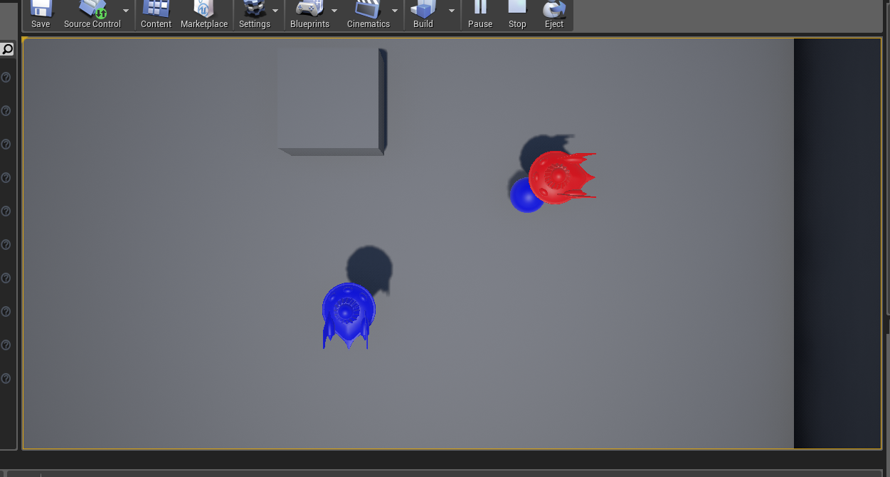
The menus and history screens will be simplistic, clean, and mostly text based.
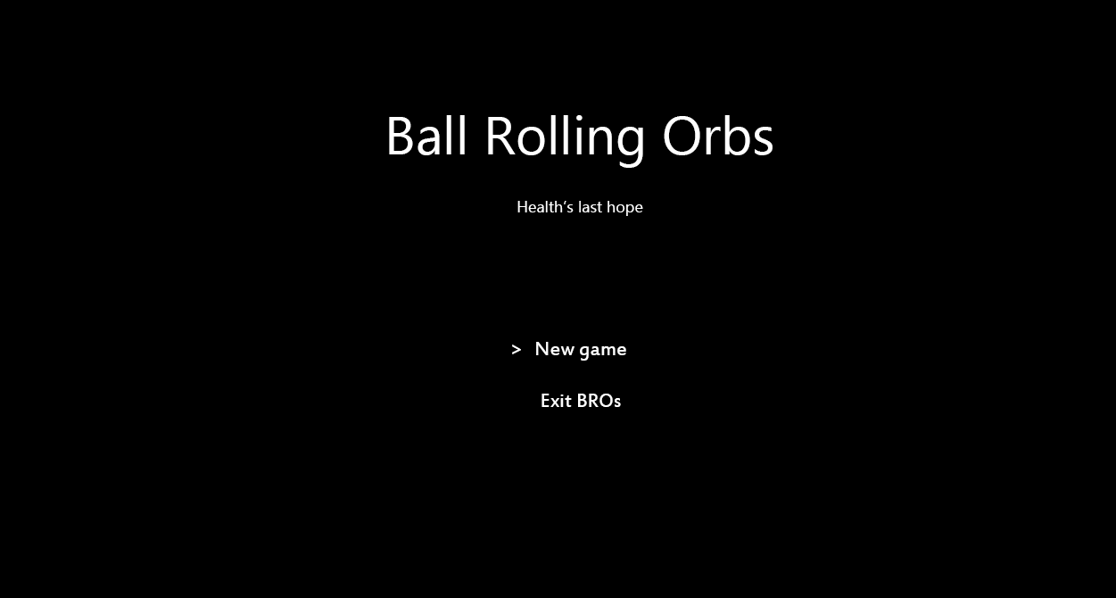
Landing menu
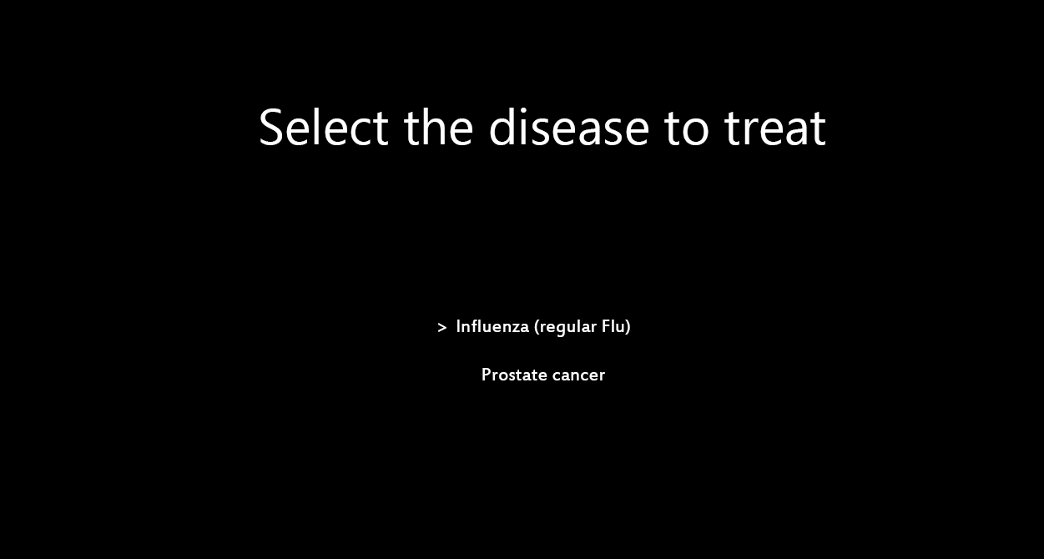
Level selection screen
Note that the previous images are very early work and intended to portray the intention and functionality, not the final look.

Control Summary
Both keyboard and gamepad are to be supported. The input controllers are as depicted in the following image:

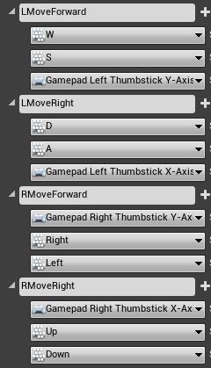 | To move the LEFT orb:  - WASD  - left stick  To move the RIGHT orb:  - keyboard arrows  - right stick
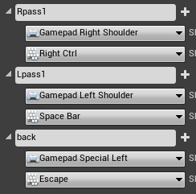 | To throw the aBall LEFT to RIGHT  - space bar  - left shoulder button  To throw the aBall RIGHT to LEFT  - right CTRL  - right shoulder button  To pause/quit game  - ESC key  - left special button (select)

State Transition Diagrams
The following diagram represents the options presented to the player during a regular BROs session.

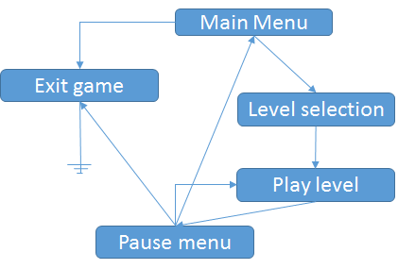

The following diagram represents the main gameplay loop during a level:
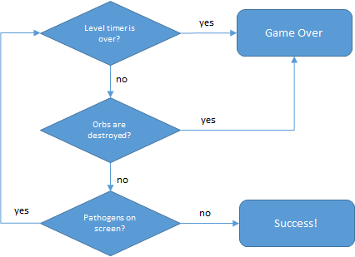

The following diagram represents the mechanics between aBall and Pathogens during a level:
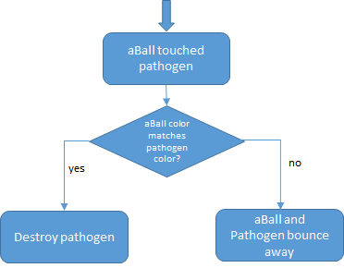
The following diagram represents the mechanics for pathogens during a level:
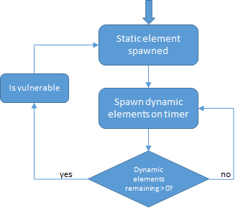

Artificial Intelligence

Opponent AI
The dynamic enemies will have predictable, physics based patterns. The difficulty will be based on sheer number, size, and speed of the pathogens.

Non Player Characters
There will be both static and dynamic non player characters. Most dynamic non player characters will be spawned by static ones. It’s up to the player to find out how to defeat the static NPCs to stop them from spawning more dynamic pathogens and finish the level.
[cancer tumor] - Static element, spawns different colors of cancer pathogens
[cancer pathogen] - Dynamic element, different colors have a different pattern behavior of movement and speed.
[Flu nucleus] - Static element, spawns different color of Flu viruses
[Flu virus] - Dynamic element, different colors have a different pattern of movement behavior and speed
NOTE on appearance: The game’s aesthetics will most likely change during development time, as the game mechanics will be developed before the art assets. For example if time permits, the NPCs will go from simple shapes with solid colors to animated blobs with better shaders.

Game Items
Besides NPCs, there will be some power ups that when collected will enhance the player’s performance:
[yellow sphere]: Increase the orb’s speed by 20%
[green sphere]: clears all damage from orb
[violet box]: every orb speed is reset to default values
[black cone]: condition critical! The player fails when an orb touches this item
The game items will be randomly spawned throughout the level.
NOTE on appearance: The game’s aesthetics will most likely change during development time, as the game mechanics will be developed before the art assets. For example if time permits, the power ups will go from simple shapes with solid colors to objects related to the desired effect, like a bomb instead of the black cone.

Story Overview

The main reason ORBs were created are due to science coming up with a cure to humanity's lack of responsibility when taking antibiotics. This spawned a new breed of doctors/engineers that have to be very capable of manipulating the ORBs to destroy all the antibiotic-resistant diseases.

Plot Summary

Once the context of the theme is established, the game will take place as the player operates the ORBs cleaning different patient diseases. Once every pathogen is cleared from a patient, the level is considered cleared and the patient healed.

Storyboard
A rough sketch of the introductory story line that will be presented to the player is included here. The story is to be presented in a “storyboard” fashion. Note that the included images only convey the idea, and are in no way representative of the final graphics to be used.
The following information is to be displayed to the user in loading screen between the “menu” and “level selection” screens.
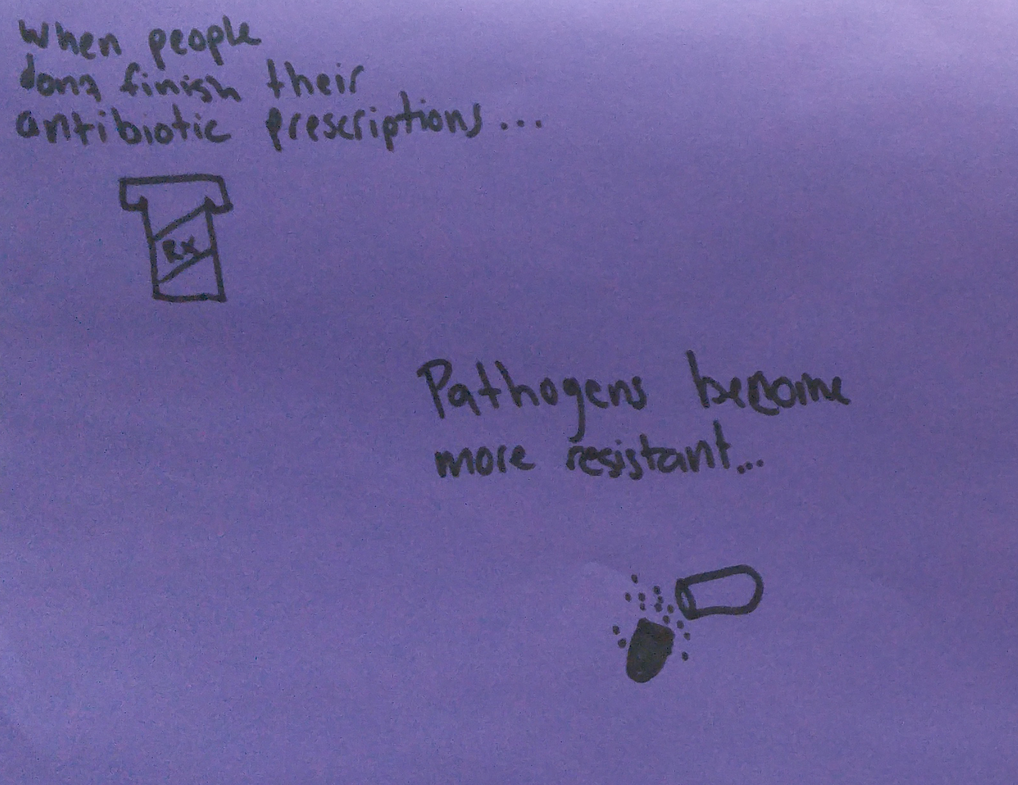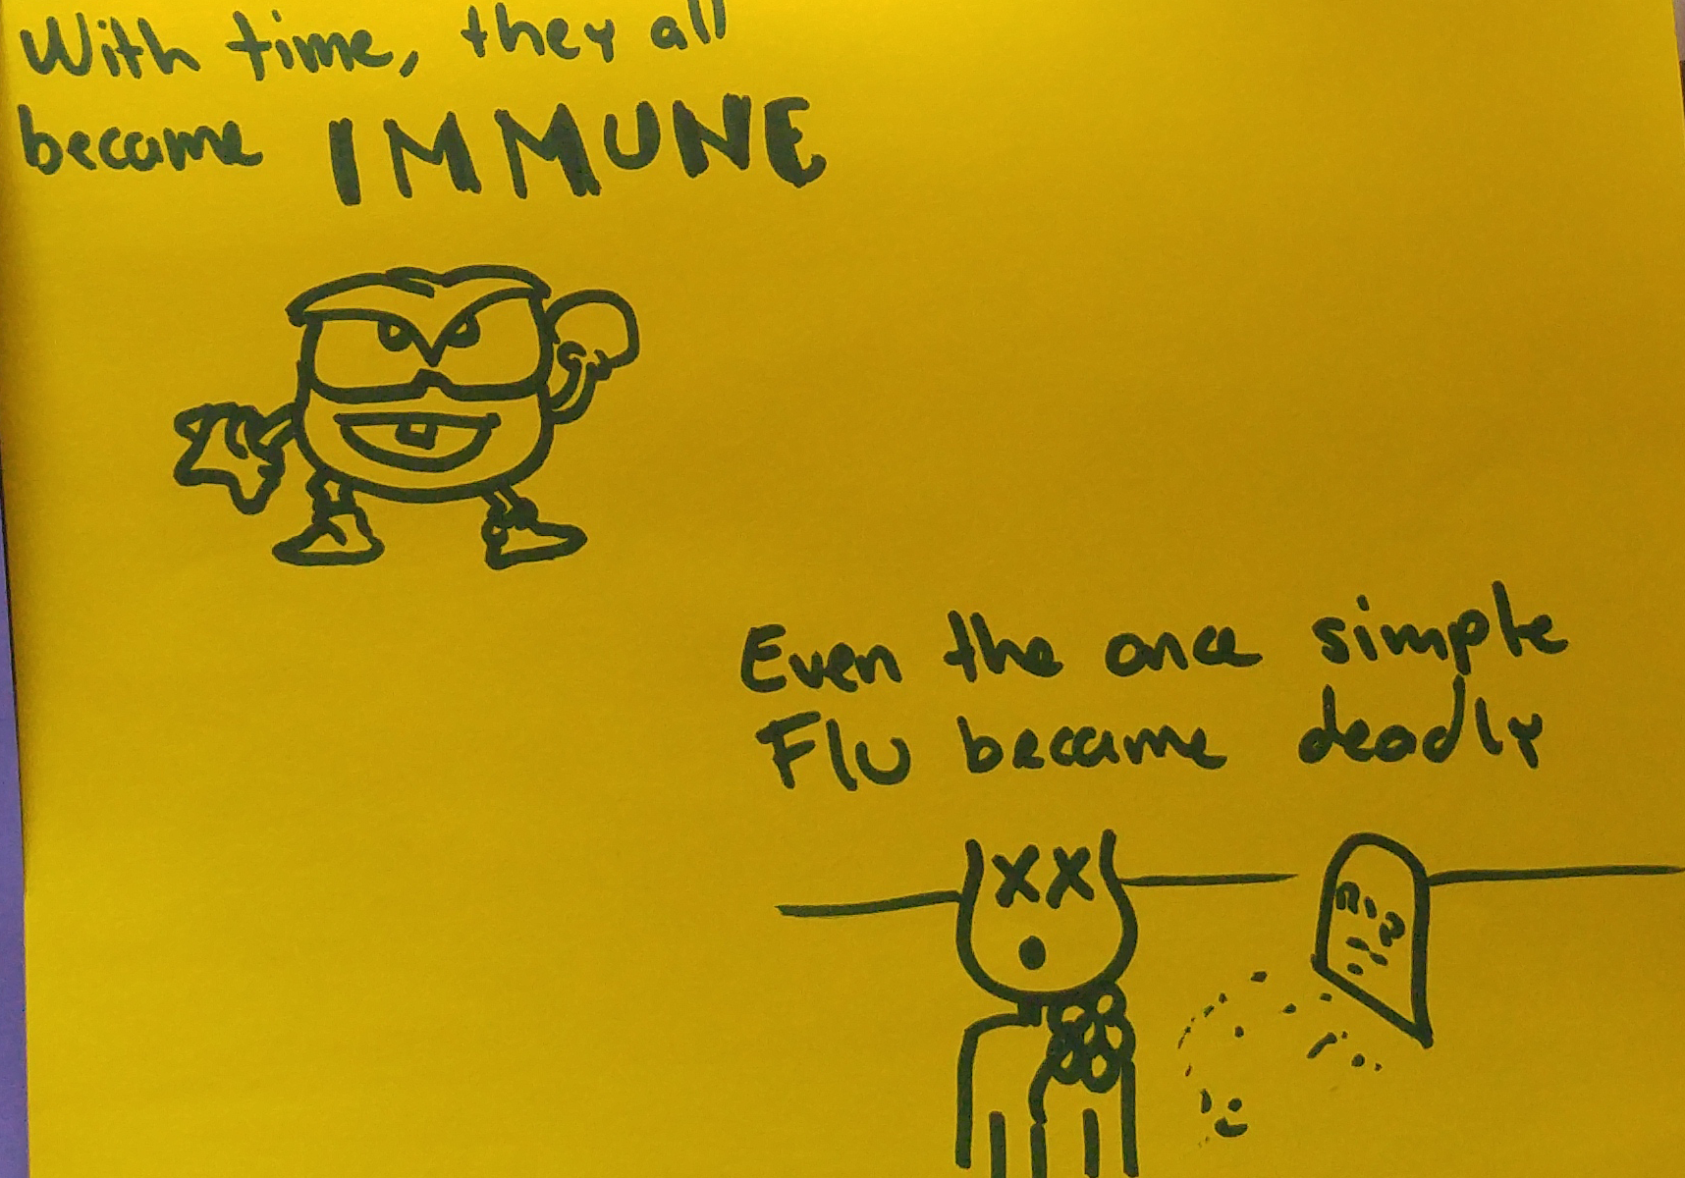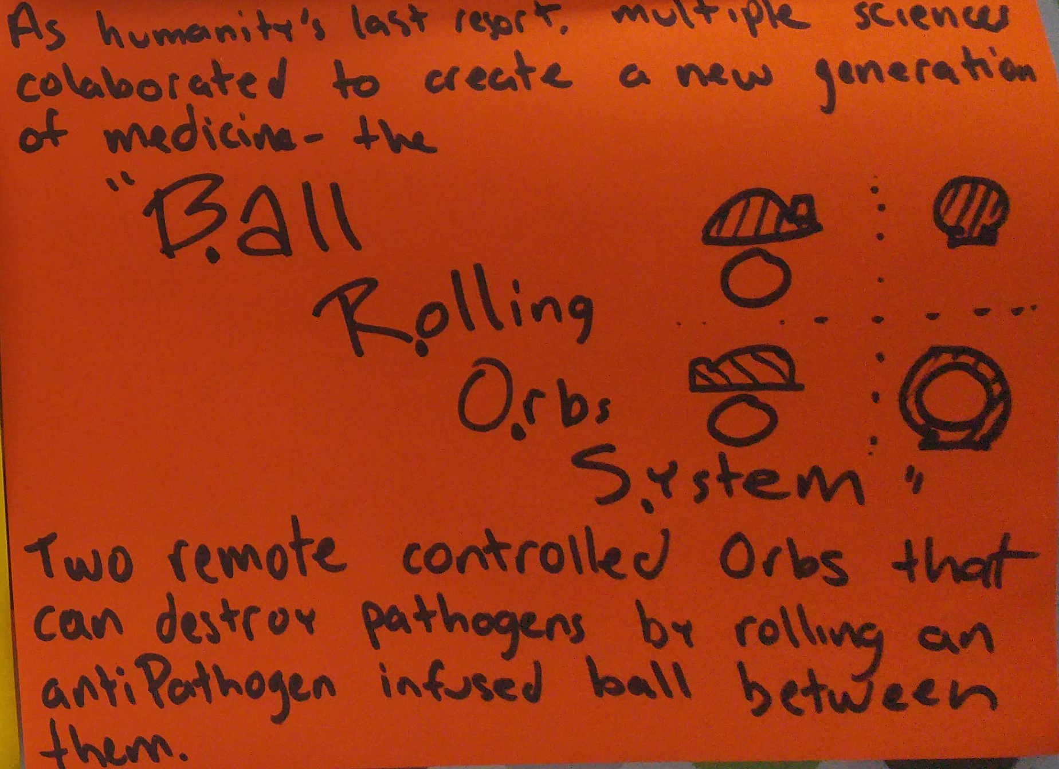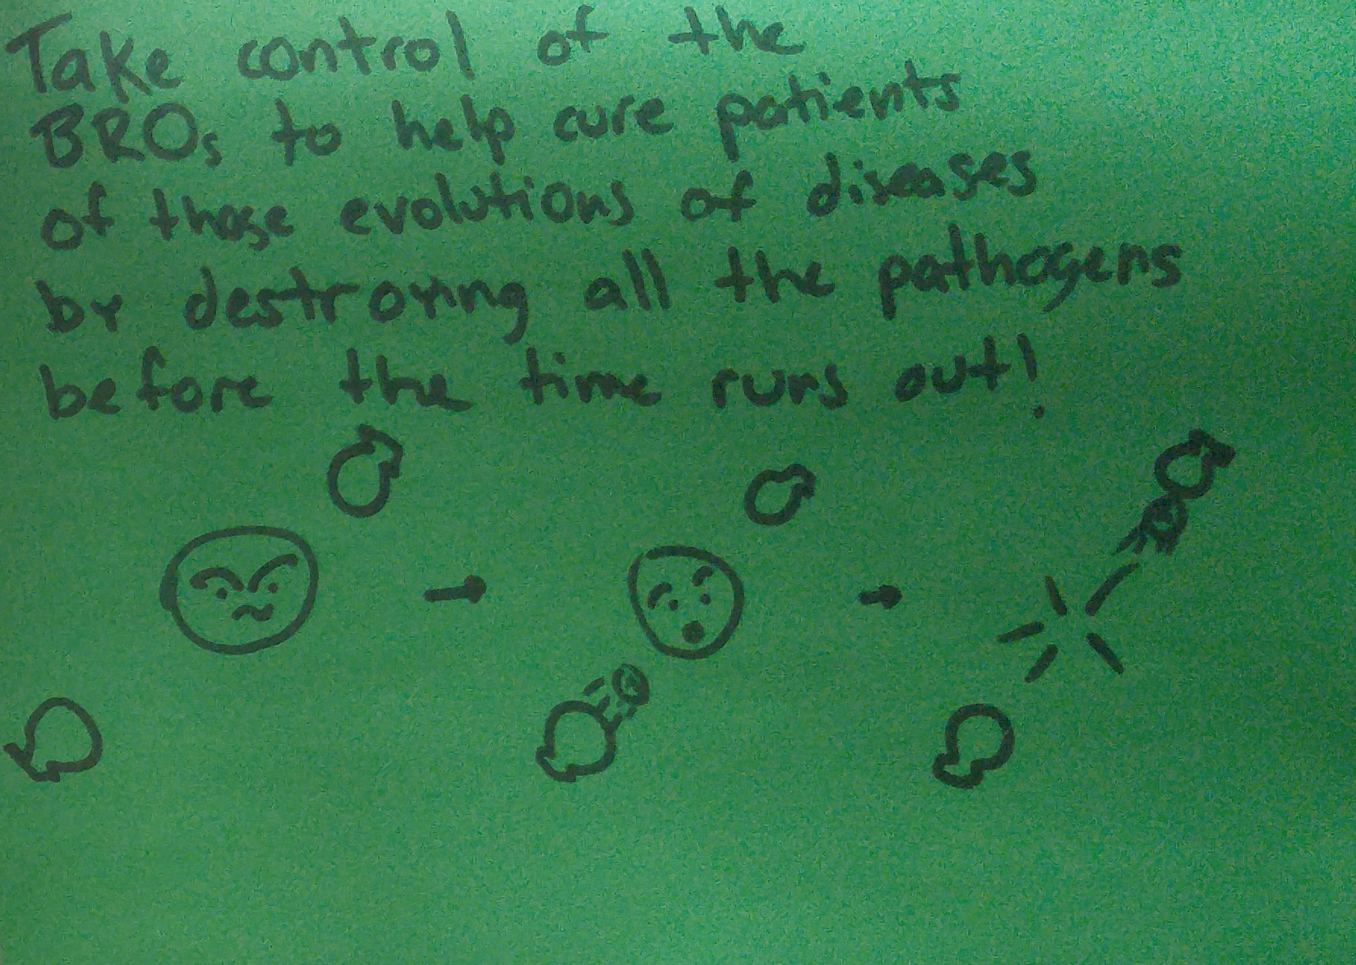

Characters
The game will not feature heroes other than suggesting that the player is an ORBs specialist, and the different diseases the player has to fight will play the role of villains.
The O.R.B.s. specialist is a breed between a Professional Gamer and an Engineer, with Medical background to understand the subtleties of each disease he faces.

Game Progression

Each level will take place in the innards of a patient.
As the game progresses, the player will get to try and heal a Flu patient and a Cancer patient. The cancer level will be significantly more difficult than the Flu patient. The intention of the first level is to serve as a tutorial to get the player used to the game mechanics, with the Cancer patient being where the player’s skills will be put to test.

Level details
Influenza (Flu) level: This level is meant to be a tutorial for the player to get used to the game mechanics. A flu nucleus sitting in the middle slowly spawning flu viruses with very predictable movement patterns. The game items will be easily attainable and the level geometry will be simple and easy to navigate.
Flu viruses will slowly damage the orbs making failure relatively hard. The player will have enough time to get a hang of the game mechanics.
Brain Cancer level: The level where the player’s skills will be put to test. If the player is not quick enough, multiple cancer tumors will spawn. Each cancer tumor will spawn multiple cancerous cells with unpredictable patterns, and the cells will be more damaging to the orbs.
The timing scheme will be more aggressive, with less time available to clear the level and more cancerous cells and tumors spawning as time progresses.

Bibliography

Unreal Engine 4 documentation: https://docs.unrealengine.com/latest/INT/
Unreal Engine 4 developers Youtube channel: https://www.youtube.com/user/UnrealDevelopmentKit
Brain Cancer and Influenza wiki pages: https://en.wikipedia.org/wiki/Influenza
https://en.wikipedia.org/wiki/Brain_tumor
Complete sources: https://github.com/peicou/BROSMD

Lessons Learned

Adjust development and game design to something feasible in the time given. Lesson learned from the design and implementation of RYP (2D game).
Difficulty curve should be smoother. Lesson learned from 2D game fest + RYP.
This section is to be extended as development takes course.

NOTE- this is a live document. This document will evolve and grow as BROs M.D. takes shape and grows into a final package.

