12-16-2015

Red Deadlicious - The Journey of Apple Arnie
Game Design Document

Samier Mukhashen, Ben Walker, Christopher Murdoch, Kyle Hicks
for CIS 487
Version 9- 12/16/15Ⓒ

DESIGN HISTORY

VERSION | DATE | WHO DID IT? | CHANGES
1 | 11/23 | Whole Team | Initial creation and skeleton
2 | 11/25 | Whole Team | Filled in bulk of document
3 | 11/30 | Samier Mukhashen & Cj Murdoch | Finalization of Initial document and turn in
4 | 12/2 | Samier Mukhashen | Converting original document into new format
5 | 12/9 | Whole Team | Filled in bulk of document
6 | 12/13 | Whole Team | Adding more based on progress of the game
7 | 12/15 | Kyle Hicks | Adding Assets found in game
8 | 12/16 | Samier Mukhashen | Cleaning up
9 | 12/16 | Whole Team | Final Read Through and finishing touches

TABLE OF CONTENTS
Game Overview
Game Concept
Gameplay/Feature Set
Game Flow Summary
Look and Feel(INSERT SCREENSHOTS)
Project Scope
Number of locations
Number of Levels
Number of Collectibles
Number of Interactables
Production Team
Target Audience
Genre
Gameplay and Mechanics
Gameplay
Game Progression
Mission/Challenge Structure
Puzzle Structure
Objectives
Play Flow
Mechanics
Physics
Movement
Use Case for Movement
Objects
Actions
Reading
Screenflow
Replaying and Saving
Story, Setting and Character
Story and Narrative
Backstory
Plot Elements
Plot Summary
Cutscenes
Game World
Characters
Levels
Level 1 - The Journey Begins
Synopsis
Introductory Material
Objectives
Physical Description
Encounters
Walkthrough
Level 2- Pandemonious Patch
Synopsis
Introductory Material
Objectives
Physical Descriptions
Encounters
Walkthrough
Interface
Visual Systems
HUD
Menus
Camera
Story Scene
User Interface Description
Control Systems
Audio
Music
Sound effects
Help Systems
Artificial Intelligence
Opponent AI
Non-Player Characters
Reactive Items
Technical
Target Hardware
Development Hardware and Software
Coding will be done in Monodevelop in C#.
Development Procedures and standards
Game Engine
Scripting Language
Game Art (PICTURES HERE)
Concept Art
Characters
Environments and Collectables
Cutscenes
Level Layouts
Management
Detailed Schedule
Budget
Risk Analysis
Test Plan
Appendices
Asset List
Art
Sound
Music

Game Overview

Game Concept
    - The player will be given a top-down look on an apple that can roll around in a space designed like a hedge maze/garden. The player will be rolling around on the ground, and will be able to roll up structures and jump over obstacles.
    - The player will be able to interact with certain portions of the environment such as switches and buttons that will manipulate obstacles. For example a button that opens a gate.
    - There will be collectible items that look like seeds and enemies that can be rolled over that look like worms. Water droplets will be pickup items that will restore time to the countdown timer.

Gameplay/Feature Set
    - It is the player’s goal to crush as many worms as possible and to gain as many apple seeds as possible before escaping the worm infested garden with your life. The sun is rising, it is getting hotter, and you have been off the branch for too long! Water will return time to the countdown timer that is at the top of the screen.
    - The game will be played as a 3rd Person Puzzle Roller.
    - Balance is a key feature to the gameplay. Many puzzles and platforming will revolve around keeping your balance.
    - Obstacles such as pistons will push Arnie into holes causing the level to restart.
    - Buttons and switches will cause certain obstacles such as gates to move out of Arnie’s way to help him progress to the end of the level.

Game Flow Summary
    - The player will start out in a green field with an obvious path laid before him.
    - Along the paths there will be various collectibles for the player to collect that will contribute to either their score or timer.
    - Stopping the player from advancing will be Gates that are controlled by near by switches or pistons that push the player.
    - The player must overcome these obstacles either by timing or interacting with the switches.
    - Once the player has overcome all the obstacles they will arrive at the end of the level which is signified by a pile of seeds.
    - Level will end with a bit of story then the next level will commence.

Look and Feel
    - The whole game will take place in a garden setting. So lots of greens and browns.
    - The game will have a confined feel at most points as you’re navigating through hedge mazes and activating switches to open up gates.
    - Logs and small bridges will help as well as hinder you on your journey.
    - Small ponds can be found throughout the level.
    - The main character Arnie will be a Red Apple.
    - He will be able to collect Blue water droplets and Brown seeds.
    - The main enemies will be pink colored worms.

Project Scope

Number of locations
      - The Garden

Number of Levels
      - 2 Levels
        - The Journey Begins-Tutorial Level
        - Pandemonious Patch- Harder level then the first

Number of Collectibles
      - Seeds, 10 per level
      - Water Droplets
      - Worms, 10 per level

Number of Interactables
      - Switches
      - Gates
      - Pistons
      - Collectibles

Production Team
    - Kyle Hicks- Art and Design
    - Samier Mukhashen-Design and Planning
    - Christopher Murdoch-Programming and Design
    - Ben Walker- Programming and Design

Target Audience
    - All ages- The look of the game will appeal to a younger audience but the mechanics will be fun enough that anyone can enjoy.

Genre
    - 3D Puzzler Platformer

Gameplay and Mechanics

Gameplay

Game Progression
      - The level will consist of a starting position and a goal. On the path to the goal there will be obstacles such as pits and various enemies in your way.
      - There will also be various puzzles the player will have to solve on their way to the goal as well. Such as buttons that control gates.
      - The level will also have many collectibles for the player to collect. Some when collected affect score like seeds and worms. Others affect the gameplay such as water droplets that adds to the game’s time limit.
      - Once the player has reached the goal, a fanfare will commence followed by a story screen and then the next level will load up.
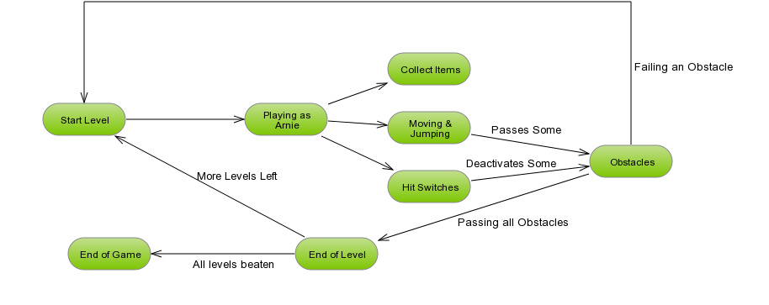

Mission/Challenge Structure
      - All levels will be structured as stated above. There will be a start point and an end point with obstacles in between
      - The challenge for each level comes from the various obstacles as well as the need for the player to want to pick up all the collectables in the game.

Puzzle Structure
      - Very thin platforms will be placed that the players will have to navigate around
      - Gates will be closed and the player must navigate to the switch in order to open them and progress.
      - Pistons will try to push the player into death pits or water pits causing them to start over. Players must time their movements correctly to get past.
      - All these obstacles will be placed across the map in a set order based on the level the player is on.
      - Easier puzzles will be earlier on while the harder ones will be saved for later.

Objectives
      - Complete the levels while overcoming all obstacles.
      - Collect all the collectables in the level for a higher score. There are 10 worms and 10 seeds on each level.
      - Complete the level in record time.

Play Flow
      - Each level will start out with a story bit.
      - Once the story bit is done the player will begin playing the level.
      - The level will try to ease the player into the mechanics by introducing a simple puzzle.
      - Once we feel the player should have mastered the mechanics we will increase the difficulty.
      - Each level will end with more story and continue in this cycle.

Mechanics

Physics
      - Arnie will have a very tight feel to him.
      - His speed will gradually increase and gradually decrease.
      - He can accumulate a boost over time that gives him a short burst of speed in his current facing direction.
      - Arnie can perform a jump that is related to his current speed. The faster he is going the more effective his jump.
      - Logs will move back and forth pushing Arnie to his demise causing the player to restart the level or the current puzzle.

Movement
      - Players control Arnie with the WASD keys. W moves forward, A moves left, S moves backwards, D moves to the left.
      - Spacebar makes Arnie jumps.
      - E key causes Arnie to boost to get past certain obstacles. Boosting shoots the player in whatever direction they are facing.
      - The apple will have a somewhat loose feel but still retain a feeling of control. The player should feel if a mistake was made it was their own fault and not one caused by the physics.

Use Case for Movement
      - This is a Use Case for Arnie. The character the player will be controlling.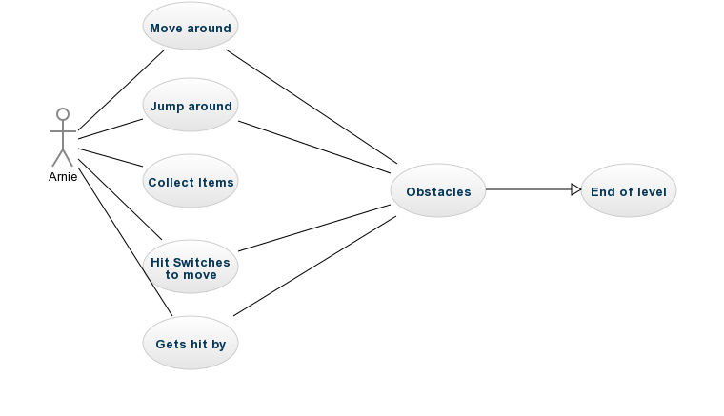
      - Move Around
        - Arnie can move around obstacles with the WASD keys
      - Jump around
        - Arnie can jump around obstacles with Spacebar
      - Collect Items
        - Arnie can collect items by touching them. Such as seeds and water. Hitting a worm also technically counts as “collecting” since they cannot harm Arnie.
      - Hit Switches
        - Arnie can hit switches to move obstacles that may be in his way
      - Gets Hit By
        - If a piston pushes Arnie then he will likely fall off the platform he is on. More than likely if Arnie falls he will hit a pit which restarts the level because he fell in and died.
      - Obstacles
        - Once Arnie has traversed all the obstacles it leads to the End of the Level.
      - End of Level
        - Once Arnie has overcome all the obstacles he has reached the end of the level and the next one will start up after the player clicks a button on the story screen. Cycle will continue.

Objects
      - Players can pick up three objects
        - Seeds-Add to the player's score
        - Worms-Add to the player’s score
        - Water Droplets- add to the players timer.

Actions
      - Switches
        - Arnie can interact with red switches which can open up gates that are in his way.

Reading
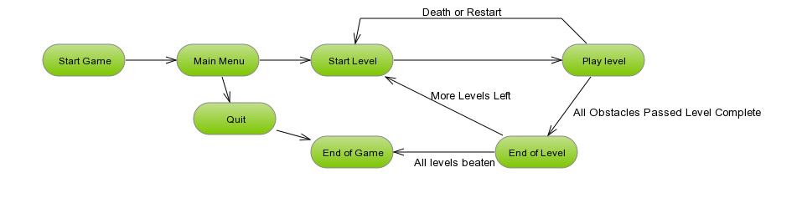
      - The player can read the story and instructions placed before each level. Describing why Arnie is on his journey and how to complete it.

Screenflow

Replaying and Saving
    - The players progress will be saved for that play session at the start of every level.
    - Exiting the game or level will cause all progress to reset. The player will have to redo any parts previously done
    - Dying or restarting on a level will cause the player to spawn back at the start of the current level.

Story, Setting and Character

Story and Narrative

Backstory
      - The apples have been eaten to bits by the worms for years. They tried to fight back, but their struggles always ended in failure. You are the one apple who will finally make a difference. You are Arnie. You have been sent from the home tree to bring as many seeds as you can out of this dangerous garden. You must crush worms, collect seeds and leave the worm ridden garden to spread your apple trees’ seeds in a safer area that does not have a worm infestation!

Plot Elements
      - Arnie will collect his brothers and sisters as he progresses through the levels.
      - Arnie will destroy all the worms infesting his home.
      - Arnie will make it out of the garden and is able to plant his family and the apple lineage will live on.

Plot Summary
      - Arnie was picked by the apple elders to leave the dying home tree. His mission is to collect the seeds left behind by his fallen companions. His friends and family were all killed by the worm infestation that has taken over the garden. He must get as many seeds as he can, squash as many worms as possible, and escape the garden to plant the seeds of his fallen friends and family.

Cutscenes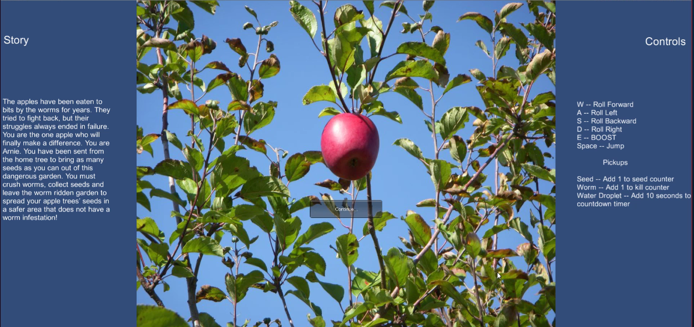

Game World
    - The world will be a garden/forest area filled with hedges, gates, flowers, logs, and puddles/ponds.
    - The world will be comprised mostly of greens, browns and blues.
    - Arnie will stand out against the world being a red apple.
    - Anything seen on the screen will tend to be believable to see in a garden. Nothing should feel too out of place.

Characters
    - Arnie the Apple - Our Hero tasked with saving his brethren.
      - Picked by the Great Elder Tree because he is the strongest and the most courageous out of the remaining apples
      - Character Model:
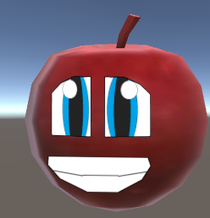
    - Evil Worms - The main villains who cause Arnie all this pain.
      - Needing apples to survive the worms ate any that happen to fall from the tree. But as the days went on less and less apples began to fall. They then decided the best course of action was to take over the tree so there would be a never ending supply of apples.
      - Character Model
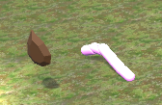

Levels

Level 1 - The Journey Begins

Synopsis
      - A Basic tutorial level showing the player everything Arnie will have to deal with throughout the game

Introductory Material
      - Level one begins with Arnie being sent from the home tree on a mission to spread the seeds of his fallen apple brothers and sisters. Apples have fallen to the ground and rotted away due to the evil worms that are destroying the garden. Arnie needs to scavenge this level for seeds and get away from the home tree that is being overrun with worms in order to let the next generation of apple trees survive.

Objectives
      - This level will be a tutorial of sorts. Guiding Arnie through the basic mechanics of the game. Such as slopes, balancing, and buttons. Seeds will be placed in a way that guide the player to follow them towards the end of the level.

Physical Description
      - It starts out with Arnie falling out of his tree. Ahead of him is a gate and logs he must overcome. He can see off in the distance a tall hill with a pile of seeds on top. He makes it his mission to make it there first.

Encounters
      - Being the tutorial level the player will be exposed to the basics of the game. The will have to deal with gates and switches, water puddles that can kill them, and pistons.
      - There will also be collectibles placed throughout the map to help guide them along their way.

Walkthrough
      - Start by moving forward to hit the switch and open the gate. Dodge the logs and go up the ramp. Go left to hit the switch to open the gate that's on the right. Once the gate opens be careful to not get hit by the logs and make your way up the hill using the bridges. Wait for the last elevator bridge to take you up to the seed pile to end the level.

Level 2- Pandemonious Patch

Synopsis
      - Level two is a more difficult level than level 1. The whole level is designed as a floating maze. There is a gate at one end of the maze that leads to the exit and a switch at the other end that opens the gate. This gate leads to another switch that opens up the end level gate.

Introductory Material
      - Level two has Arnie far enough away from the home tree that he can no longer see it. He feels alone, but he knows how important his mission is. Arnie pushes forward keeping in mind of all of his lost brothers and sisters.

Objectives
      - The player must take the left path first to open the gate then progress all the way to the right to get to the gate and complete the level.

Physical Descriptions
      - This level is based around a floating maze.
      - You start off where the last level left off on that tall hill.
      - You take some logs down into the maze and progress through it
      - Falling off the maze into the water below causes your death and the level restarts,
      - On the left of the maze is the switch to the gate that is on the right.

Encounters
      - Same encounters from the first level
      - Only new challenge is the harder platforming.

Walkthrough
      - The player must go down the ramp logs into the maze.
      - Once they are in the maze they must progress to left to hit the switch and then go to the right to exit through the gate.
      - All the while dodging logs and making sure to keep their balance.
      - Once they exit through the first gate they will encounter another switch that opens the last gate.

Interface

Visual Systems

HUD
      - Will be found at the top left of the game. In order they are the
        - Boost-How much boost they have. Boost is accumulated by just moving and can be activated using the E key.
        - Seed count- Out of 10 how many more seeds they have left
        - Worm count- Out of 10 how many more worms they have to collect.
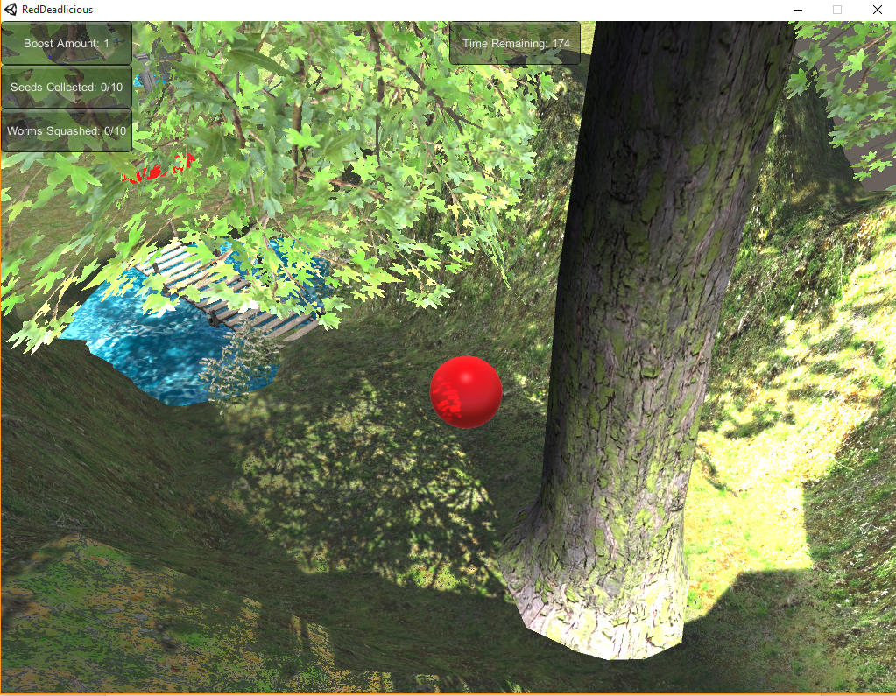

Menus
      - Main Menu- Allowing the player to start the game. Found on the Title screen
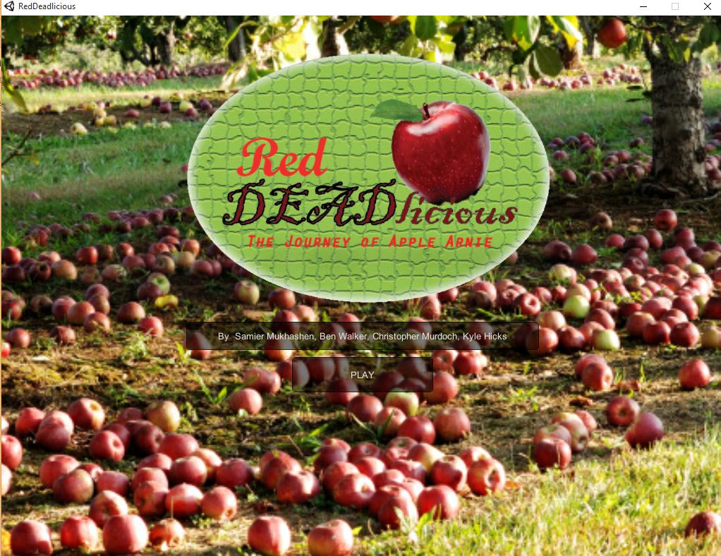

Camera
      - The camera will follow behind Arnie at a 45 degree angle. This allows the player to have a full view of what is happening around them and allow them to plan their play accordingly.
      - The camera will be static and can not be moved by the player.

Story Scene
      - In between each level will be a story screen with an image and a description of what is happening in the story. As well as the controls.

User Interface Description
    - A kill counter, seed counter, and timer will be displayed for the player to view at all times. The kill counter and seed counter will be in the top left corner of the screen and the countdown timer will be in the top middle of the screen. The counters will have the total count of seeds and worms remaining to be gathered/crushed on that particular level.
    - A main menu, pause menu, and buttons on cutscenes will be shown to the player at varying times throughout the game. A restart button will be in the pause menu for the player to use in case they get Arnie stuck somewhere in the level.

Control Systems
    - The player will control the rolling apple by using W, A, S and D. The player will be able to make the apple jump by pressing the spacebar.
    - Pressing E will give Arnie a boost in the direction he is moving.
    - The apple will have a somewhat loose feel but still retain a feeling of control. The player should feel if a mistake was made it was their own fault and not one caused by the physics.

Audio
    - Almost all interactables in the game will have a sound effect to go along with it
    - The game will have a main theme composed by Kyle Hicks
    - Arnie himself will give off sound effects based on his actions such as boosting or jumping.

Music
    - “Rolling Around” by Kyle Hicks. Main theme to Red Deadlicious.
    - “Into the Forest” By Kyle Hicks. Possible second level them to Red Deadlicious.
    - “Level Clear” and “Game Over” by Kyle Hicks. Played at the end of level and when you quit.

Sound effects
    - Sound effects were acquired from Freesound.org
    - Various computer sounding effects such as Arnie's boost was created using the program BFXR.

Help Systems
    - The story screen before each of the levels will debrief the player on their controls and any other information they may need before entering the level.

Artificial Intelligence

Opponent AI
    - Piston
      - Some sort of object will be used as a piston that will be able to push Arnie off of a path that he is balancing on. These could take the form of logs, worms, or an actual machine piston. The AI for these will be to move into the path and collide with Arnie and then to move back out of the way on a set time interval.

Non-Player Characters
    - Worms
      - We consider the worms to be NPCs since they do not harm the player even though they are evil in our story. The worms will have a script that allows them to pace/patrol around the game world in order make the player potentially go out of their way to kill them all.

Reactive Items
    - Seeds can be picked up by the player and will add to a counter shown on screen. Worms can be crushed and a count will be shown on the screen at all times. Water drops can be picked up to increase the time remaining.
    - Buttons and Switches will cause gates and doors to open and close. Allowing Arnie to pass certain obstacles.
    - Every time an item is interacted with an accompanying sound will play to signify that it has been activated.

Technical

Target Hardware
    - Any Windows PC

Development Hardware and Software
    - The game will be developed for Windows on PC using Unity 3D.

Coding will be done in Monodevelop in C#.

Development Procedures and standards
    - Everyone had to document any coding they did
    - All files had to be transferred through email to everyone on the team
    - Any changes in the document’s must be stated at the top as well as emailed to the rest of the team.

Game Engine
    - UNITY

Scripting Language
    - C#

Game Art (PICTURES HERE)

Concept Art
i. Arnie
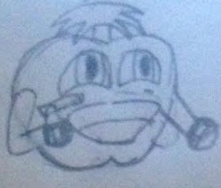

ii. Health, Kill Count, and Timer
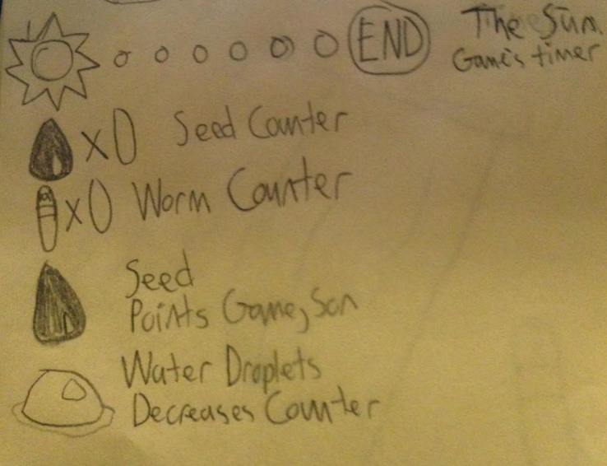

iii. Main Menu

iv. Story Scene
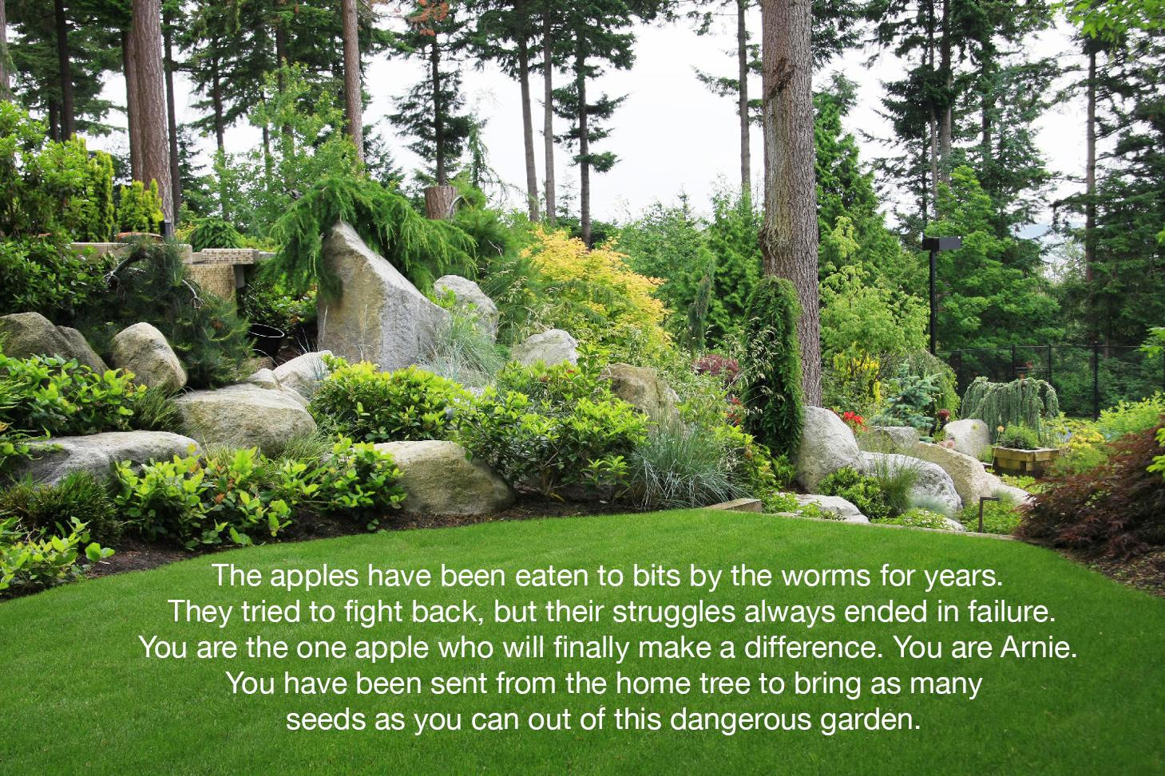

v.Storyboard
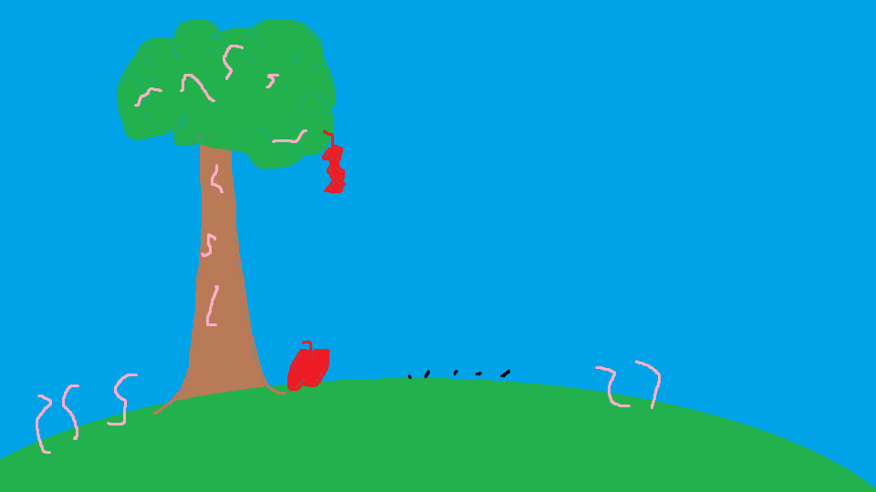
      - Arnie was picked by the apple elders to leave the dying home tree. His friends and family were all killed by the worm infestation that has taken over the garden
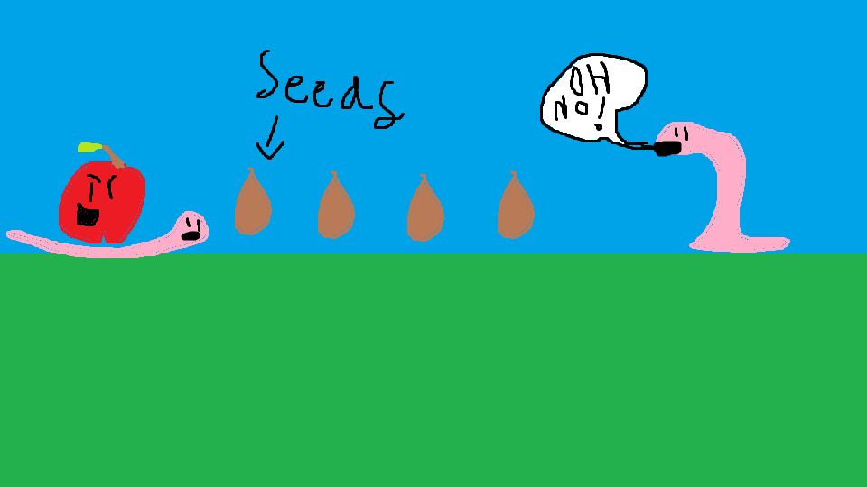
      - His mission is to collect the seeds left behind and squash any worms in his way
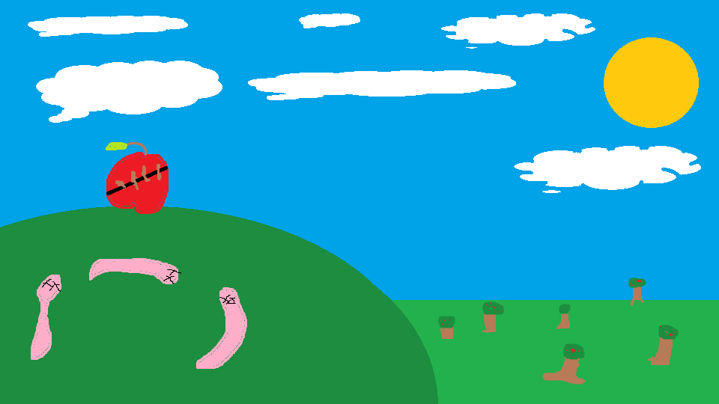
      - Once he has escaped the garden Arnie can plant the seeds and live on the legacy of his fallen comrades.

Characters
    - Arnie
    - Worms

Environments and Collectables
    - Seeds

    - Water Droplets
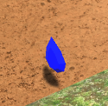
    - Garden Level
    - Logs
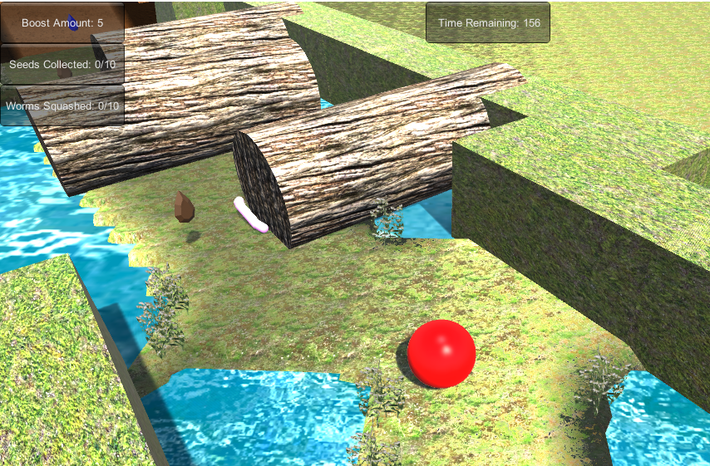

    - Gate and Switch
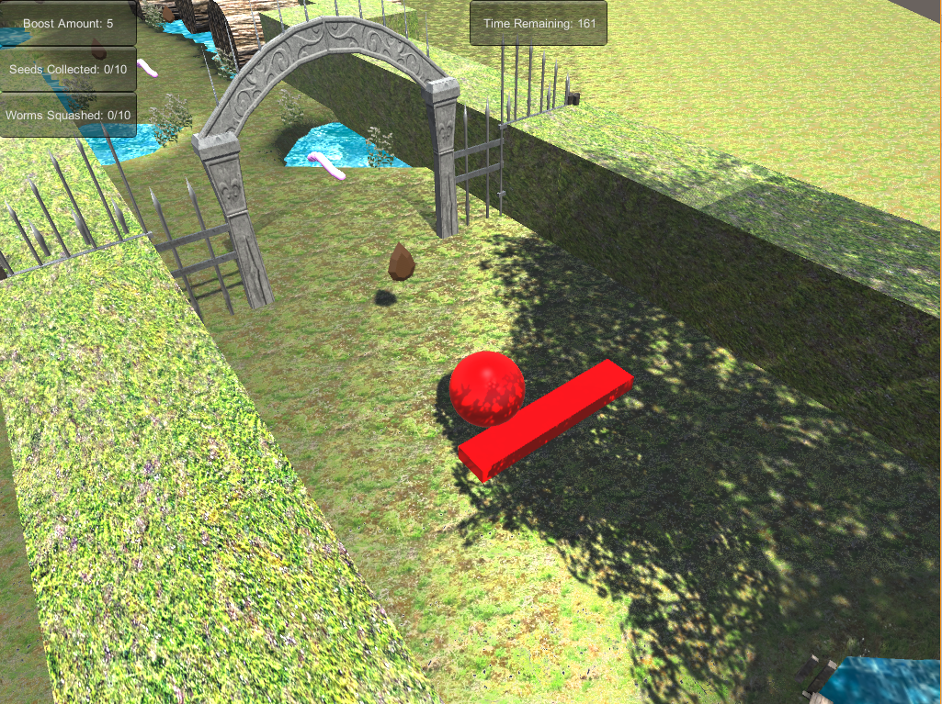
    - Water Puddles
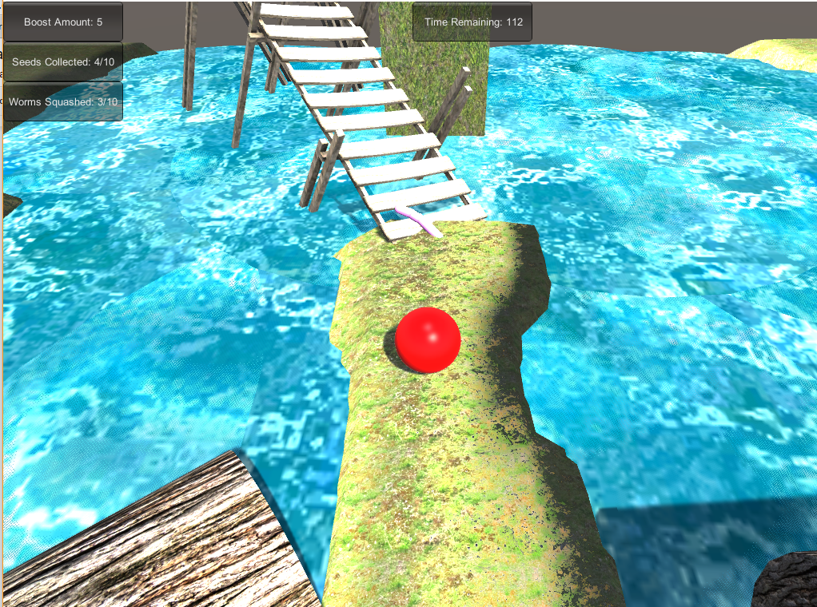
    - Ending Seed Pile
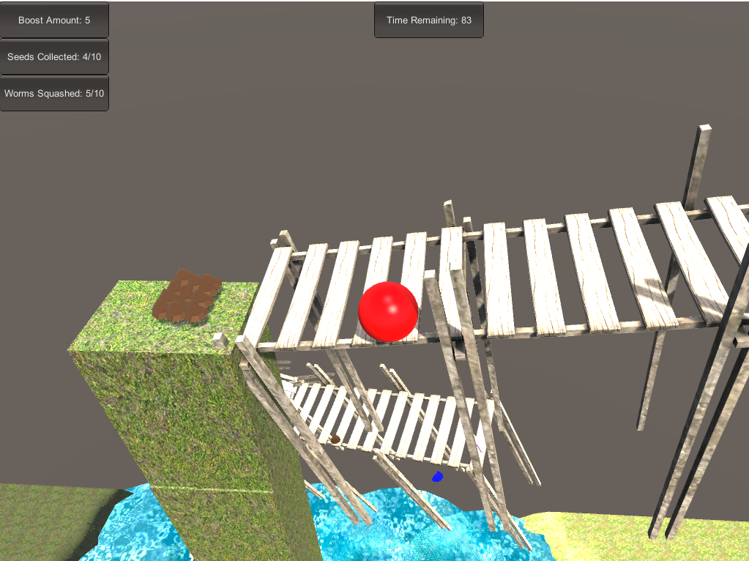

Cut scenes

Level Layouts
    - Level 1 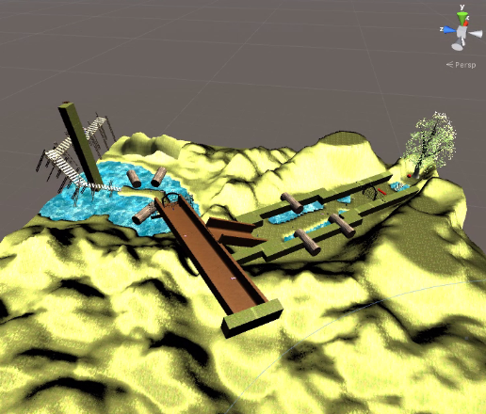

    - Level 2

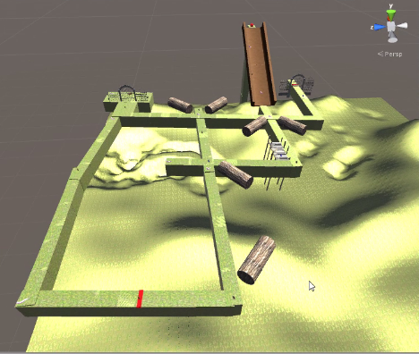

Management

Detailed Schedule
    - We as a group will meet on Wednesdays to talk about the progress that we’ve made and the direction we’d like to go in.
    - Any other free time will be used to help work on the game in any way possible. Whether that be the documentation, designing the game in Unity, or working on assets.

Budget
    - We will not be spending any money on the game
    - All assets will either be created free in house or found free online.

Risk Analysis
    - We know creating a game together can be tough but we have prepared a table of the most likely scenarios.

Description | Probability | Impact
One of us becomes sick and is unable to work | 50% | Medium
We miss our weekly  meetings | 25% | High
Game doesn’t run at all | 10% | Very high
Game isn’t fun | 50% | Very High
Other Final exams impact our ability to add finishing touches | 75% | Medium

Test Plan
    - We will design the game in a way that it will be easy to implement and test
    - First we will start out with the basic mechanics such as moving, camera placement and picking up items.
    - Then with the more advanced mechanics such as switches, gates and pistons.
    - Once all of those are working we will implement them into a level layout.
    - We will test the level bits at a time. Making sure each part works before moving on to the next.
    - Once the whole level has been done it will be tested by another developer who did not have a hand in making it to see how it feels.
    - Once we are satisfied with the level we move on to the next one and repeat the cycle.

Appendices

Asset List

Art
      - Arnie model was created by Kyle Hicks
      - Worm model was made by Ben Walker
      - Collectable water and seeds used assets on the unity store
      - All other terrain and other objects were built in unity assets.

Sound
      - All realistic sound effects provided by Freesound.org
      - Computerized sound effects were generated using the program BFXR. Sounds such as jump and collect item are an example of this.

Music
      - All music tracks were composed by Kyle Hicks.

