3D Game
Design Document
Game Title: Remnant
For CIS 487 Fall 2014
Version: 1.0

By: Kelly Katarzis, Brandon Leon, Tianyu Song, and Jacob Hasenau
Content
Design History 1
Section 1: Game Overview 2
1.1 Game Concept 2
1.2 Feature Set 2
1.3 Genre 2
1.4 Target Audience 2
1.5 Game Flow Summary 2
1.6 Look and Feel 2
1.7 Project Scope 2
1.7.1 Number of locations 2
1.7.2 Number of levels 2
1.7.3 Number of NPC’s 2
1.7.4 Number of weapons 3
Section 2: Gameplay and Mechanics 3
2.1 Gameplay 3
2.1.1 Game Progression 3
2.1.2 Mission/challenge Structure 3
2.1.3 Puzzle Structure 3
2.1.4 Objectives 3
2.1.5 Play Flow 3
2.2 Mechanics 3
2.2.1 Physics 3
2.2.2 Movement 3
2.2.3 Objects 4
2.2.4 Actions 4
2.2.5 Combat 4
2.2.6 Economy 4
2.3 Screen Flow 5
2.3.1 Screen Flow Chart 5
2.3.2 Screen Descriptions 5
2.4 Game Options 6
2.5 Replaying and Saving 6
2.6 Cheats and Easter Eggs 6
Section 3: Story, Setting, and Characters 6
3.1 Story and Narrative 6
3.1.1 Backstory 6
3.1.2 Plot Elements 7
3.1.3 Game Progression 7
3.1.4 License Considerations 7
3.1.5 Cutscenes 7
3.2 Game World 7
3.2.1 General look and feel of world 7
3.2.2 Area #1 - Ancient Ruins 8
3.2.3 Area #2 - Jungle 8
3.3 Characters 9
3.3.1 Character #1 - The Player 9
3.3.2 Character #2 - The Ruin’s Guardian 9
Section 4: Levels 10
4.1 Level #1 - Jungle 10
4.1.1 Synopsis 10
4.1.2 Introductory Material 10
4.1.3 Objectives 11
4.1.4 Physical Description 11
4.1.5 Map 11
4.1.6 Critical Path 11
4.1.7 Encounters 11
4.1.8 Level Walkthrough 11
4.1.9 Closing Material 11
4.2 Level #2 - Labyrinth 11
4.2.1 Synopsis 11
4.2.2 Introductory Material 11
4.2.3 Objectives 11
4.2.4 Physical Description 12
4.1.5 Map 12
4.1.6 Critical Path 12
4.1.7 Encounters 12
4.1.8 Level Walkthrough 12
4.1.9 Closing Material 12
Section 5: Interface 12
5.1 Visual System 12
5.1.1 HUD - What controls 12
5.1.2 Menus 12
5.1.3 Rendering System 12
5.1.4 Camera 12
5.1.5 Lighting Models 13
5.2 Control System 13
5.3 Audio 13
5.4 Music 13
5.5 Sound Effects 13
5.6 Help System 13
Section 6: Artificial Intelligence 13
6.1 Opponent AI 13
6.2 Enemy AI 13
6.3 Non-combat Characters 14
6.4 Friendly Characters 14
6.5 Support AI 14
6.5.1 Player and Collision Detection 14
6.5.2 Pathfinding 14
Section 7: Technical 14
7.1 Target Hardware 14
7.2 Development hardware and software 14
7.3 Development procedures and standards 14
7.4 Game Engine 14
7.5 Network 15
7.6 Scripting Language 15
Section 8: Game Art 15
8.1 Concept Art 15
8.2 Characters 15
8.3 Environments 16
Section 9: Secondary Software 17
9.1 Editor 17
9.2 Installer 17
9.3 Update software 17
Section 10: Management 17
10.1 Detailed Schedule 17
10.2 Budget 17
10.3 Risk Analysis 18
10.3.1 Risk table 18
10.3.2 Risk refinement 18
10.3.3 Risk mitigation, monitoring, and management 19
10.4 Localization Plan 22
10.5 Test Plan 22
Section 11: Appendices 22
11.1 Asset List 22
11.1.1 Art 22
11.1.2 Sound 23
11.1.3 Music 23
11.1.4 Voice 23

Design History

Date | Change/Addition | Author
11/22/2014 | Added and completed section 3 | Kelly
11/24/2014 | Added and completed section 2 | Kelly
11/24/2014 | Completed sections 1, and 6 | Brandon
11/26/2014 | Completed Section 4 | Jacob
11/26/2014 | Completed Sections 5, and 7 | Tianyu
12/3/2014 | Completed Risk Analysis | Kelly
12/10/2014 | Added Test Plan | Kelly
12/12/2014 | Completed Document | Kelly

Section 1: Game Overview

1.1 Game Concept
Remnant is a first-person, survival dungeon crawler that uses the Unity 3D Game engine. You are an explorer lost deep within the ruins of an ancient labyrinth in the 1600s. Armed with a torch, you must find your way out before something else does.

1.2 Feature Set
- Jungle
- A labyrinth Maze/Dungeon
- Monster/Creature
- Interesting Statue

1.3 Genre
Remnant is Survival Horror based game with a dungeon crawler feel.

1.4 Target Audience
People age 12 and up who own a PC and enjoy a good survival dungeon game with scary elements.

1.5 Game Flow Summary
There are no current plans for an interface during gameplay. The player will move through the game using keyboard and mouse controls to navigate around walls until he reaches the exit.

1.6 Look and Feel
The game has a very old look with mossy bricks, torches, and ancient artifacts. The feel of the game is claustrophobic and dark with passageways designed to stump the player into loss of direction. Possible props added to the game would enhance this feel, such as: skeletons, chains, or spider webs.

1.7 Project Scope

1.7.1 Number of locations
The current plan is for 2 locations, the dungeon and a small jungle outside.

1.7.2 Number of levels
The current dungeon plan is just one level.

1.7.3 Number of NPC’s
The current npc plan is just one enemy.

1.7.4 Number of weapons
There is no plan for weapons but there is a torch that is wielded.

Section 2: Gameplay and Mechanics

2.1 Gameplay

2.1.1 Game Progression
There is no real progression in the game. The player has one objective.

2.1.2 Mission/challenge Structure
The goal of the player is to escape the Ruins Maze before the Guardian/Monster takes their life.

2.1.3 Puzzle Structure
The puzzle to be solved by the player is to keep track of where they are within the maze. It will be easy to run in circles.

2.1.4 Objectives
Escape the maze before the monster touches you.

2.1.5 Play Flow
- Title Screen
- Story/Prologue
- Player begins in the center room of the maze and touches the artifact
- Guardian/Monster appears and the player attempts to make their way out of the maze without being caught by the monster
- Player finds the exit
- End screen displayed

2.2 Mechanics

2.2.1 Physics
Physics works as it does in the real world.

2.2.2 Movement

2.2.2.1 General Movement
The player has a first person view and can rotate their view with movement of the mouse, and can move forward, backward, and side to side with the use of a keyboard.

2.2.2.2 Other Movement
None.

2.2.3 Objects

2.2.3.1 Picking Up Objects
Currently there is only one object to interact with. This object will be the artifact that the player is placed in front of when the game starts. Interaction will occur through mousing over the object and clicking on it.

2.2.3.2 Moving Objects
None currently.

2.2.4 Actions

2.2.4.1 Switches and Buttons
None.

2.2.4.2 Picking Up, Carrying and Dropping
None.

2.2.4.3 Talking
None.

2.2.4.4 Reading
None.

2.2.5 Combat
There is no combat in this game. The goal is to simply run.

2.2.6 Economy
There is no economy in the game.

2.3 Screen Flow

2.3.1 Screen Flow Chart
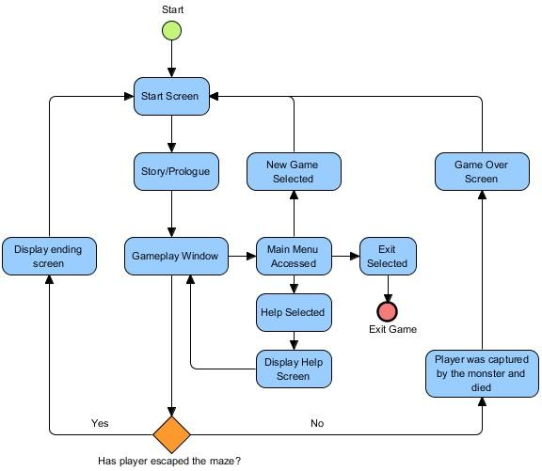

2.3.2 Screen Descriptions

2.3.2.1 Start Screen
The intro screen to the game. The player can either start the game or exit.

2.3.2.2 Story/Prologue
Displays the story to the player and gives them a background to where they are in the game.

2.3.2.3 Gameplay Window
This screen displays the game itself to the player. This where the player is able to take control and explore the game world and access the main menu.

2.3.2.4 Main Menu
Provides options to the player to do the following:
- Start a new game and reset
- Access help and review player controls and their objective
- Exit the game

2.3.2.5 Game Over Screen
Displayed when the player is caught by the enemy.

2.3.2.5 Ending Screen
Displayed when the player escapes the maze and shows that they have won the game.

2.4 Game Options
The game options will contain a very simple menu that allows the player to access the following:
- New Game - Resets the game and allows the player to start over.
- Help - Tells the player their goal, and movement controls.
- Quit - Quit and exit the game.

2.5 Replaying and Saving
None.

2.6 Cheats and Easter Eggs
None.

Section 3: Story, Setting, and Characters

3.1 Story and Narrative

3.1.1 Backstory
The player takes the role as a member of an expedition team that has set out in search of uncovering undiscovered mysteries in the jungles of South America. The year is 1612, and the team lands on a small island just off the coast of the continent. As the team makes their way into the jungle, one explorer strays from the group to search for treasure and artifacts on their own.

3.1.2 Plot Elements
The story does not contain the basic plot elements found in most stories. The climax is reached shortly after the game begins and the character must make their way out of the dungeon without being caught by the ominous creature that will trail the player throughout the entirety of the maze.
A resolution is reached by the player finding the exit of the maze, in which case they have won the game.

3.1.3 Game Progression
The backstory is given to the player to give them a general idea of their purpose of being on the island.

The player will start in the jungle and only be able to follow a narrow path leading to a cave. Inside the cave there is a statue, and once it is touched, the player is sent to the Labyrinth. The story’s climax is quickly reached when the guardian creature of the dungeon appears.
The player will then have to make their way out of the Labyrinth and find the exit to win the game.

3.1.4 License Considerations
We are to believe there are no license considerations for this story. It’s pretty generic, and overall, the gameplay itself will resemble the story of the minotaur and the labyrinth from greek mythology.

3.1.5 Cutscenes
This game will contain no cutscenes.

3.2 Game World

3.2.1 General look and feel of world
Most of the world will be within the ancient ruins, with a small section of jungle found outside of the maze.
Overall, the ruins should feel dark, eerie, and a bit claustrophobic.

3.2.2 Area #1 - Ancient Ruins

3.2.2.1 General Description
The ruins are one giant maze where the player will spend most of their time in the game.

3.2.2.2 Physical Characteristics
The ruins are built of stone. Moss covers the walls, and should obviously appear that no human has been within them for years. Random objects scatter the halls to help set the mood, and used as signs to help the player distinguish if they are running in circles.
These objects may include:
- Broken stones/bricks
- Broken pillars
- Broken barrels
- Skeletons

3.2.2.3 Levels that use area
The game will only contain one main level, and this area will be used within it.

3.2.2.4 Connections to other areas
There are no connections to other areas from this area.

3.2.3 Area #2 - Jungle

3.2.3.1 General Description
The jungle will be generic in appearance and resemble a typical tropical rainforest if free meshes can be found to do so. The forested area itself will be small compared to the area taken up by the ruins.

3.2.3.2 Physical Characteristics
The forest will contain large trees and various foliage placed amongst a bumpy terrain.

3.2.3.3 Levels that use area
The game will only contain one main level, and this area will be used within it.

3.2.3.4 Connections to other areas
There are no connections to other areas from this area.

3.3 Characters

3.3.1 Character #1 - The Player

3.3.1.1 Back story
The player will take the role of an explorer. Little back story is given about the character. It is only made evident to the player that they are an explorer in the year 1612, and currently located in an unknown area of South America.

3.3.1.2 Personality
The explorer has no personality on their own. It is simply an identity taken on by the player.

3.3.1.3 Look

3.3.1.3.1 Physical characteristics
The explorer is never viewed. The game is in a first person view, and the only viewable characteristic seen is the torch being held.

3.3.1.3.2 Animations
The torch is to move as the player moves. Particles are used for the flame. If time permits, an animation to make the torch move up and down as the player moves will be created.

3.3.1.4 Special Abilities
None.

3.3.1.5 Relevance to game story
The main protagonist.

3.3.1.6 Relationship to other characters
None.

3.3.1.7 Statistics
None.

3.3.2 Character #2 - The Ruin’s Guardian

3.3.2.1 Back story
Little is known about this character. All that can be said is it is out for blood once the artifact in The Ruins is touched.

3.3.2.2 Personality
Hostile.

3.3.2.3 Look

3.3.2.3.1 Physical characteristics
The character resembles a human with no skin. It’s much taller than an average person, and has hands comprised of three claw-like fingers. A deathly aura of black fog/smoke surrounds the character.

3.3.2.3.2 Animations
Walk animation, possible an attack animation if time permits.

3.3.2.4 Special Abilities
Swipe. Attacks the player when they come close to this character.

3.3.2.5 Relevance to game story
This is the main antagonist in the story.

3.3.2.6 Relationship to other characters
Strongly dislikes the main player for taking the artifact.

3.3.2.7 Statistics
None.

Section 4: Levels

4.1 Level #1 - Jungle

4.1.1 Synopsis
You begin by hearing the crack of a board behind you. As you turn around, you will see a chasm, with a broken board at the bottom, preventing your progress backwards. The path you are on is narrow, and the areas to your sides are blocked by trees and a slight slope. At the end of the path there is a cave that leads to a dead end with a strange statue in the middle of it. Upon touching the object, a bright white light flashes and you are taken to the next level.

4.1.2 Introductory Material
None

4.1.3 Objectives
Explore the path and see where it leads.

4.1.4 Physical Description
The jungle will be generic in appearance and resemble a typical tropical rainforest if free meshes can be found to do so. The jungle area will be small compared to the area taken up by the ruins.

4.1.5 Map
N/A

4.1.6 Critical Path
To complete this level the player must follow the path straight ahead to the cave and interact with the statue object.

4.1.7 Encounters
None

4.1.8 Level Walkthrough
Walk along the path until the cave is reached.

4.1.9 Closing Material
Screen fades to white after the player touches the statue

4.2 Level #2 - Labyrinth

4.2.1 Synopsis
You begin in the middle of the labyrinth and must make your way out. For the first few moments, nothing seems amiss, but then you notice a monster. If you try to walk into or past the monster, the monster swipes at you and prevents your progress past it while also hurting you. If you are swiped at too much by the monster, you will black out and return to the middle of the labyrinth. However, once you find the exit (which is marked by a bright light) you can try and walk out. However, if while walking out you turn around and try to look behind you, the monster will reappear behind you and block the exit, forcing you back into the labyrinth. If you escape successfully, however, you will be able to walk out and be on the jungle path again.

4.2.2 Introductory Material
None

4.2.3 Objectives
Escape the Labyrinth maze without being caught and dying by the Labyrinth Guardian.

4.2.4 Physical Description
The Labyrinth is built of stone. Moss covers the walls, and appears that no human has been within them for years. Random objects scatter the halls to help set the mood, and used as signs to help the player distinguish if they are running in circles.
These objects may include:
- Broken stones/bricks
- Broken pillars
- Broken barrels
- Chains
- Skeletons
- Spider webs

4.1.5 Map
Refer to critical path

4.1.6 Critical Path
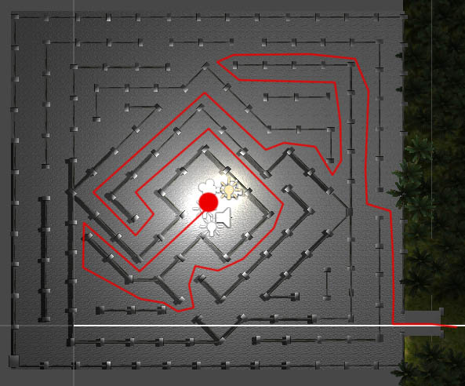

4.1.7 Encounters
Avoid the Labyrinth Guardian

4.1.8 Level Walkthrough
Refer to critical path

4.1.9 Closing Material
The player escapes the labyrinth and is out in the jungle again. A screen showing that the player has won is displayed.

Section 5: Interface

5.1 Visual System

5.1.1 HUD - What controls
Map, HP, Tools, Weapons

5.1.2 Menus
New game, Save and Quit, Help.

5.1.3 Rendering System
DirectX

5.1.4 Camera
First person

5.1.5 Lighting Models
Point light

5.2 Control System
Keyboard and Mouse
W:forward, S:back, A:left, D:right
E:investigate, F:pick up, Space:jump
Left click: attack, Right click:rotate view.

5.3 Audio
Main Character,

5.4 Music
Anguish.mp3
Oppressive Gloom.mp3
Unseen Horrors.mp3

5.5 Sound Effects
Terrified
Use some sounds in http://soundbible.com/

5.6 Help System
How to play

Section 6: Artificial Intelligence

6.1 Opponent AI
This is a single player game which has no opponent feature.

6.2 Enemy AI
The main monster will navigate through the maze while constantly finding the shortest path to the player using the built in nav mesh utility on Unity. The monster will attack the player when near.

6.3 Non-combat Characters
Not planning on any non-combat characters other than the player.

6.4 Friendly Characters
Not planning on any friendly characters.

6.5 Support AI

6.5.1 Player and Collision Detection
The player has collision detection with objects, dungeon walls, and the monster.

6.5.2 Pathfinding
The monster has pathfinding to the player.

Section 7: Technical

7.1 Target Hardware
Desktop PCs and laptops.

7.2 Development hardware and software
Hardware used to development the game varies and is dependent on each team member’s personal hardware setup.
Software:
- Unity 4.6
- Photoshop
- Blender
- Sublime 2
- Skype (for communication)

7.3 Development procedures and standards
1.Write the story line
2.Design the characters and the monsters
3.Design the movement of characters and monsters
4.Design the map system
5.Design HUD, Menus, Help

7.4 Game Engine
Unity 4.6

7.5 Network
No networking. The game will be standalone and does not require internet access.

7.6 Scripting Language
JavaScript and C#

Section 8: Game Art

8.1 Concept Art
No original concepts were created for this game. Most assets have been found online.

8.2 Characters
Labyrinth Guardian:
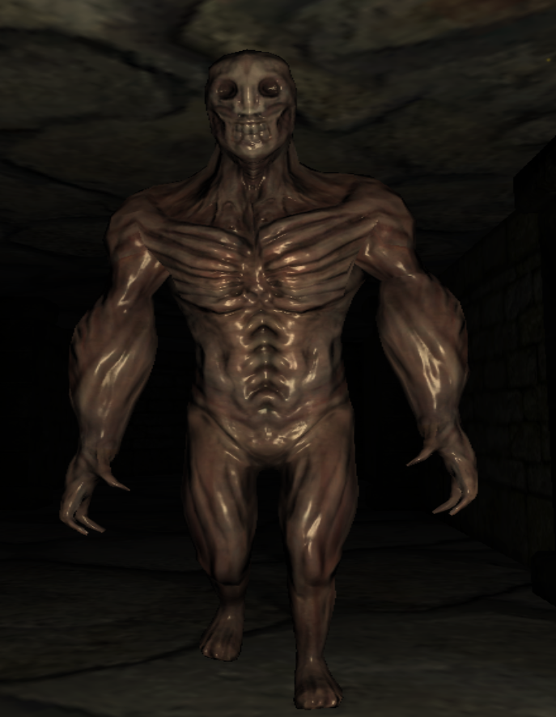

8.3 Environments
Jungle:
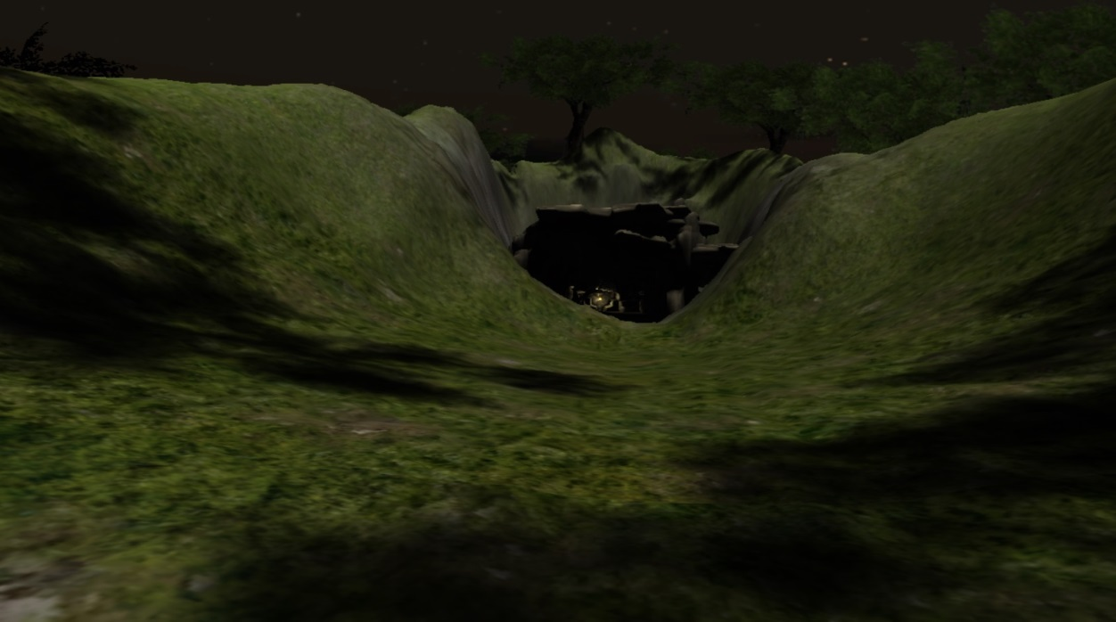
Cave:
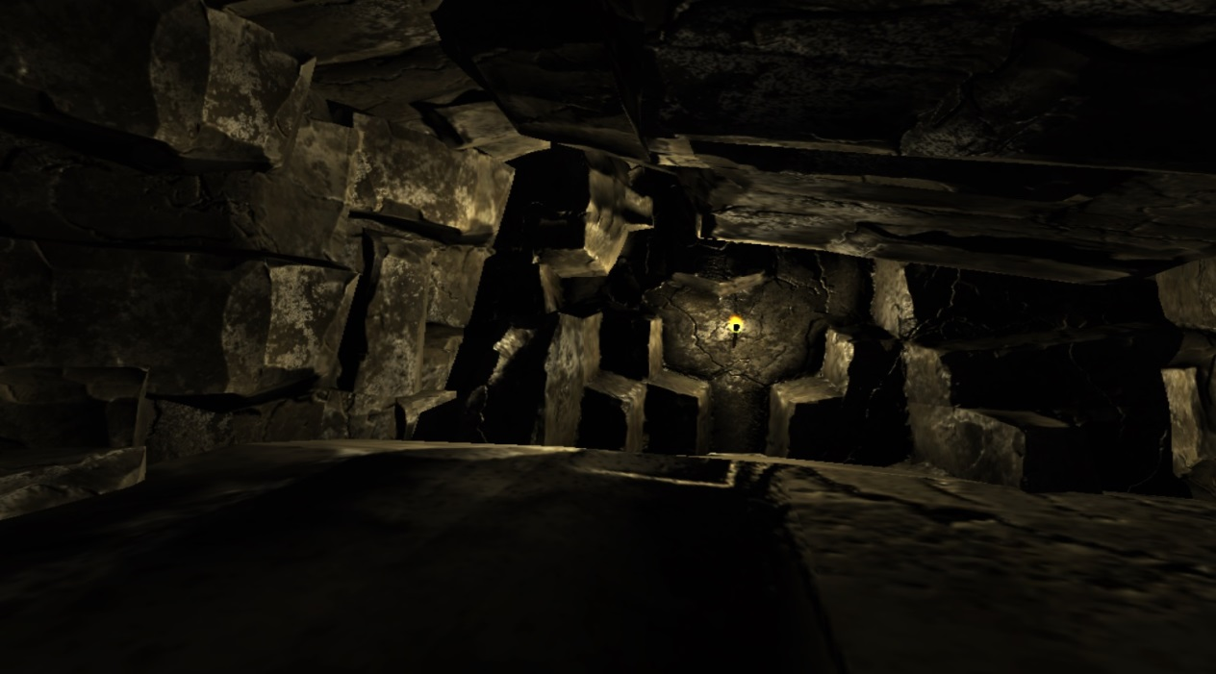

Labyrinth:
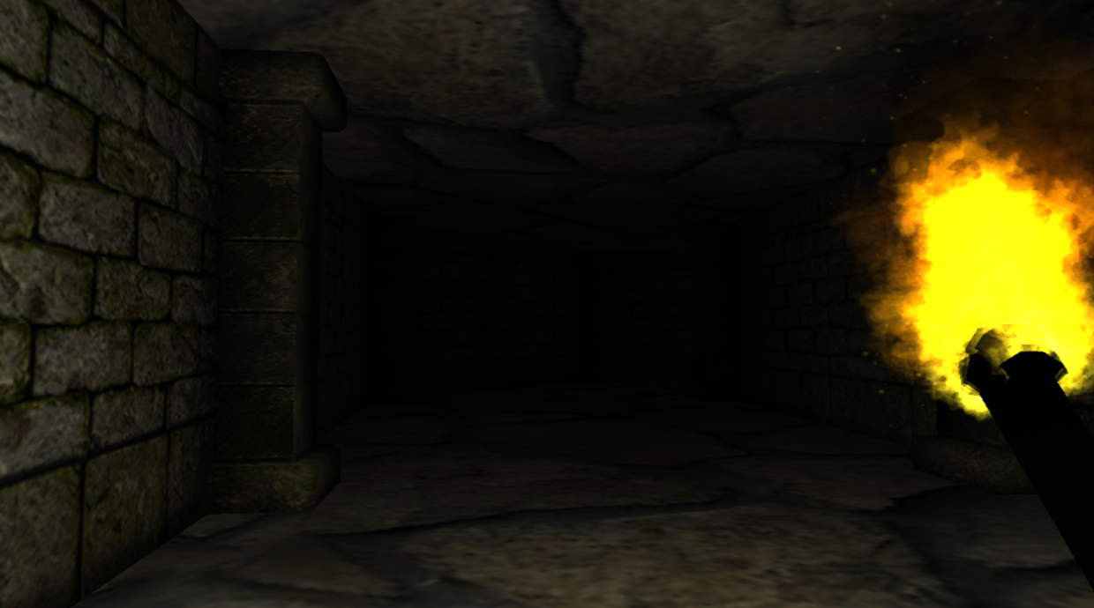

Section 9: Secondary Software

9.1 Editor
Unity 4.6

9.2 Installer
The game installation will use an executable created by Unity

9.3 Update software
None. No updates will be available.

Section 10: Management

10.1 Detailed Schedule
A detailed schedule was not developed for this project. A “Kanban” approach was taken for this project. All tasks were listed on a google drive document. As tasks were completed, they were crossed out. Individuals chose which tasks to work on when time was found to do so.
Scheduling was difficult to strictly layout due to everyone’s end of the semester plans and attempts to complete work for other classes.

10.2 Budget
Time is the only budget in the project.

10.3 Risk Analysis

10.3.1 Risk table
A presentation of all risks, probabilities and impact.

Risks | Category | Probability | Impact | RMMM
A member cannot fulfill their assignment duties | ST, PR, DE | 50% | Critical | Refer to section 10.3.3
A member cuts off communication with the rest of the team | ST, PR, DE | 50% | Critical | Refer to section 10.3.3
A member drops the course | ST, PR, DE | 10% | Critical | Refer to section 10.3.3
Limited technical skills put the team behind schedule | PS, TE, DE, ST | 10% | Critical | Refer to section 10.3.3
Hardware failure results in loss of data | TE | 5% | Negligible | Refer to section 10.3.3

Category values:
- PS – Product Size Risk
- BU – Business Impact Risk
- CU – Customer Relations Risk
- PR – Process Risk
- TE – Technology Risk
- DE – Development Environment Risk
- ST – Risk Associated with Staff Size and Experience

10.3.2 Risk refinement
High probability/high impact risks are refined using the CTC approach.

A member cannot fulfill their assignment duties:
Given that a member cannot fulfill their assignment duties then there is concern that the project will fall behind schedule.

A member cuts off communication with the rest of the team:
Given that communication is lost with a member during any phase of the project then there is concern that the project will fall behind schedule and other members could become overloaded with extra work.

A member drops the course:
Given that a member drops the course then there is concern that the project will fall behind schedule and the remaining members will become overloaded with extra work.

Limited technical skills put the team behind schedule:
Given that the team will need to acquire a new skillset to complete this project, there is concern that the learning process may take longer than anticipated and put the project behind schedule.

10.3.3 Risk mitigation, monitoring, and management
This section contains the project RMMM presented in a set of Risk Information Sheets.

Team Member Availability
Risk ID: 001 | Date: 12/3/2014 | Probability: 50% | Impact: High
Description:
Each team member has responsibilities to attend to outside of classes. This inherently causes the risk of a member being unable to fulfill their duties on this project due to becoming overwhelmed by other responsibilities.
Refinement/Context:
Subcondition 1: Another project must be prioritized, resulting in a delay for completing all other planned and scheduled tasks.
Subcondition 2: A heavy work schedule minimizes the amount of time to work on school related projects.
Subcondition 3: Traveling may result in a lack of resources to complete assigned tasks.
Mitigation/Monitoring
1. Plan ahead. Each team member should work on their assigned responsibilities in small increments. Not only will this help prevent a member from becoming overwhelmed right before a deadline, but it will also help the rest of the team pick-up what needs to be done if a member cannot complete a section.
2. Consistently communicate project progress and any events that may soon occur that could require a member to need assistance in completing their portion of the project.
3. Set deadlines earlier than assignment due dates. This allows for peer review, and allows other members to complete tasks that another member will not be able to complete.
Contingency Plan/ Management:
Develop a revised schedule and evenly divide the work that must be completed to compensate for lost time.
Current Status:
12/3/2014: Mitigation steps initiated.
Originator: Kelly Katarzis |  | Assigned: Kelly Katarzis

Loss Of Communication
Risk ID: 002 | Date: 12/3/2014 | Probability: 50% | Impact: High
Description:
A team member may stop communicating with the rest of the group without warning or reason.
Refinement/Context:
Subcondition 1: A member may drop the course and feel it not be necessary to inform the rest of the group.
Subcondition 2: A member may fall behind on their work and will attempt to avoid the group until they have caught up.
Subcondition 3: A member becomes unable to communicate due to technical difficulties and transportation issues.
Mitigation/Monitoring
1. Encourage all members to communicate. Welcome their ideas, and avoid making anyone feel excluded or inadequate in their work.
2. Each member needs to openly express if they will be unreachable for a certain period of time.
3. Each member provides several means of getting into contact with them. This includes phone numbers, emails, and Skype usernames
Contingency Plan/ Management:
Develop a revised schedule that excludes the unreachable member, and divide the remaining work evenly amongst the remaining team.
Current Status:
12/3/2014: Mitigation steps initiated.
Originator: Kelly Katarzis |  | Assigned: Kelly Katarzis

A Team Member Drops the Course
Risk ID: 004 | Date: 12/3/2014 | Probability: 10% | Impact: High
Description:
A team member may need to drop the course either due to unfortunate events in their life that restrict them from being able to put in the appropriate time needed for the class, or to avoid a poor grade appearing on their transcript.
Refinement/Context:
Subcondition 1: A member becomes ill or hospitalized and can no longer commit to their classes.
Subcondition 2: A student becomes aware that it is not possible for them to pass the course with an acceptable grade.
Subcondition 3: Personal schedules no longer allow the member to commit to the class or project.
Mitigation/Monitoring
1. Ensure that each member is engaged in the project so that they feel it is important for them to contribute. This will help teammates acquire a good grade on the project, and not have to worry about dropping the course.
2. If a team member is struggling with their assigned section, then help should be sought out from the rest of the team to gain advice on what they could do better.
3. Each member should actively provide feedback about each other’s work.
Contingency Plan/ Management:
Develop a revised schedule and divide tasks amongst the remaining team members.
Current Status:
06/13/2014: Mitigation steps initiated.
Originator: Kelly Katarzis |  | Assigned: Kelly Katarzis

Limited Technical Skills
Risk ID: 005 | Date: 12/3/2014 | Probability: 10% | Impact: High
Description:
The team’s technical knowledge and skills are not proficient to complete the expected deliverables and the learning process puts the team behind schedule.
Refinement/Context:
Subcondition 1: The team needs to take time to learn how to utilize the planned tools to complete the project. The time to learn may require more time than planned.
Mitigation/Monitoring
1. Start researching and learning about possible implementation methods as soon as possible.
2. Carefully plan the project before implementation is attempted so it is clear what needs to be learned.
3. Continue to schedule task completion ahead of due dates.
Contingency Plan/ Management:
Refine the schedule to ensure the project is completed by the project deadline, and seek out other sources for help, such as professors and other online documentation.
Current Status:
12/3/2014: Mitigation steps initiated.
Originator: Kelly Katarzis |  | Assigned: Kelly Katarzis

Data Loss Due To Hardware Failure
Risk ID: 006 | Date: 12/3/2014 | Probability: 5% | Impact: Low
Description:
All work is done on personal computers and hardware. It is possible that the hardware or software on a team member’s machine may malfunction and result in lost progress or data.
Refinement/Context:
Subcondition 1: A problem with a member’s computer occurs and prevents it from working properly.
Subcondition 2: The hardware that contains vital data is lost due to theft.
Subcondition 3: Loss of electricity prevents the hardware from being usable.
Mitigation/Monitoring
1. Save work regularly.
2. Keep backups of all documents on external storage devices such as flash drives.
3. Ensure all progress is uploaded to a shared online source (Google Drive).
Contingency Plan/ Management:
Retrieve lost data from either Google Drive, or personal secondary storage devices.
Current Status:
12/3/2014: Mitigation steps initiated.
Originator: Kelly Katarzis |  | Assigned: Kelly Katarzis

10.4 Localization Plan
This project doesn’t require any concern for localization.

10.5 Test Plan
Each component will be looked at and tested individually to ensure the game as a whole is properly working.

Black box testing will be used for unit testing. The player will perform various actions and ensure the proper response is received from either enemies or the environment.

The major components to undergo unit testing include the following:
- Start Up Screen
- Main Menu
- Interaction with the statue object
- In game menu
  - Help
  - Exit
  - Restart
- Interaction between the enemy and the player
- Environment collision flaws
- Game Over screen
- Win Screen

Section 11: Appendices

11.1 Asset List

11.1.1 Art

11.1.1.1 Model and Texture List
Tyrant_zombie.fbx
Tyrabt_d.png
Skeleton.fbx
Wall2.fbx
Standard assets imported from unity

11.1.1.2 Animation List
fadeOutBlood.anim
tyrant_zombie(animator)

11.1.1.3 Effects List
No special effects

11.1.1.4 Interface Art List
Bloodblur.png
gameOver.jpg
introScreen3.jpg
startGame.png
storyScreen2.png

11.1.2 Sound

11.1.2.1 Environmental Sounds
footstepLeft.mp3
minotaur_die.mp3

11.1.2.2 Weapon Sounds
None

11.1.2.3 Interface Sounds
None

11.1.3 Music

11.1.3.1 Ambient
OppressiveGloom.mp3
BGM1.mp3
Night.mp3

