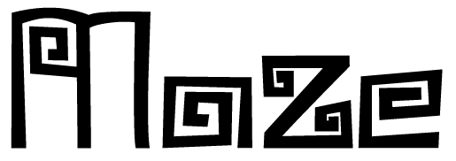

Survive the Pursuit, Escape the Maze
Version 3.0

by Alfred Kishek, Antonio Costea, Omar El-Haik, Grant Sweeney, Jonathan Hood
December 14th, 2014
Table of Contents

Design History
Version 1.0
Version 2.0
Version 3.0
Game Overview
Game Concept
Feature Set
Genre
Target Audience
Game Flow Summary
Look and Feel
Project Scope
Number of locations
Number of levels
Number of NPC’s
Number of weapons
Abilities
Gameplay and Mechanics
Gameplay
Game Progression
Mission/challenge Structure
Puzzle Structure
Objectives
Play Flow
Mechanics
Physics
Movement
General Movement
Other Movement
Objects
Actions
Switches and Buttons
Talking
Reading
Combat
Economy
Screen Flow
Screen Flow Chart
Screen Descriptions
Main Menu Screen
Options Screen
Game Options
Replaying and Saving
Cheats and Easter Eggs
Story, Setting, and Character
Story and Narrative
Backstory
Plot Elements
Game Progression
License Considerations
Some graphical elements were purchased, while others are royalty-free or creative commons. All credit is given where due. No further compensation is necessary at this time as the game is not meant to be published and sold for profit.
Game World
General Look and Feel of World
Area #1
General Description
Physical Characteristics
Levels That Use the Area
Connections to Other Areas
Characters
Main Character
Backstory
Personality
Look
Physical characteristics
Animations
Special Abilities
Relevance to Game Story
Relationship to Other Characters
Enemy Creatures
Backstory
Personality
Look
Physical characteristics
Animations
Special Abilities
Relevance to game story
Relationship to Other Characters
Levels
Level #1
Synopsis
Introductory Material
Objectives
Physical Description
Map
Encounters
Level Walkthrough
Closing Material
Interface
Visual System
HUD
Menus
Rendering System
Camera
Lighting Models
Control System
Audio
Music
Sound Effects
Help System
Artificial Intelligence
Opponent/Enemy AI
Non-combat Characters
Friendly Characters
Support AI
Player and Collision Detection
Pathfinding
Technical
Target Hardware
Development hardware and software
Development procedures and standards
Game Engine
Network
Scripting Language
Game Art
Style Guides
Characters
Environments
Equipment
Management
Detailed Schedule
Budget
Risk Analysis
Test Plan
Appendices
Asset List
Art
Model and Texture List
Animation List
Effects List
Interface Art List
Cut scene List
Sound
Character Sounds
Environmental Sounds
Weapon & Tool Sounds
Interface Sounds
Music
Ambient
Victory
Defeat

Design History

Version 1.0
The 3-D game tentatively titled Maze is in a conceptual design stage. The group has met online and communicated through email and text messaging to arrive at a concept worth pursuing. The general landscape, character, and plot of the game have been agreed upon. The concept is evolving as is the scope. Due to scheduling conflicts and some miscommunication, more progress needs to be made on the art and supplemental aspects of the game. As such, division of labor needs resolution. Unity will be utilized to power the 3-D game.

Version 2.0
Several conversations and meetings led to revisions and a narrowing of the scope of the game. Most of the progress was conceptual. Primarily, the gameplay mechanics were thoroughly refined. The team then focused on gathering assets and learning to use Unity, as well as a few supplemental tools.

Version 3.0
The game is in demo mode. Although many elements of the design have been changed, most of the elements have been implemented and the game is functional. A single level was developed for the demo. The setting of the first level was changed.

Game Overview

Game Concept
The protagonist finds himself in an unfamiliar place. The player sees his first-person perspective. The character soon learns that there are creatures roaming around and they do not appear to be friendly. The player quickly realizes that evading these creatures is essential for survival, but escaping the environment is the ultimate goal of the game. The player must navigate through a maze-like environment, searching for a way out. The main character only has defensive capabilities such as sprinting and hiding. Along the way, the protagonist encounters mysterious objects that empower him to better evade the monsters and navigate the maze, e.g., transportation portals and jump pads. If the player is killed by the monsters, the game is lost. If the player manages to reach an exit, the game is won.

Feature Set
The character can be controlled in a familiar first-person shooter method. The protagonist can move and look about in any direction. He is also able to jump. For a limited amount of time, the character may sprint. To help make his way around the dark environment, the player may activate a torch; however, doing so may attract enemies. In order to avoid being noticed by them the player may crouch, thereby moving about in a stealthy way.
Along the way, the player encounters areas where he may hide away from the monsters. Even so, the player may lose the creature by darting around corners in rapid succession. Jump pads enable the character access to alternate routes and a means of escape. The player may also teleport across the map whenever he happens upon a special gateway.

Genre
Maze is a game of suspense/horror, with action and puzzle elements.

Target Audience
The target audience is mature enough to appropriately process violence and horror elements. This player seeks suspense and challenging gameplay. Though not essential to enjoying Maze, the target audience has experience with first-person shooter games and is comfortable navigating a world in this way. Everyone from preteens to adults will enjoy Maze.

Game Flow Summary
The player starts out at a predetermined starting point in a level. A brief introduction tells the player everything needed to know in order to proceed. The player then uses various means of control to navigate the level while avoiding the antagonists - monstrous creatures. The simplest scenario would have the player walking casually from the starting point to the exit. However, it is unlikely that the beasts will never challenge the player. Therefore running, jumping, and teleportation may be necessary to advance.

Look and Feel
Maze is set in a dreary, dark environment. The visual style is fantastic realism. The antagonists are the only visible characters and are designed to appear realistic, though grotesque. Certain items, such as teleportation pads, feature incredible lighting and particle effects.

Project Scope
To begin with, the development team decided to limit the scope of the game for demonstration purposes to a single level. The number of gameplay mechanics and NPC’s were similarly restricted to narrow the scope of the demo.

Number of locations
Though each level is made up of a single map, some locations on each territory include: the starting point, several jump pads, and teleportation gates.

Number of levels
Only one level has been developed at this time. The game is designed to allow for future level add-ons.

Number of NPC’s
Multiple NPC’s are active at this time. Further development would allow for incorporation of multiple NPC types.

Number of weapons
The protagonist only has passive, defensive capabilities.

Abilities
The main character may walk, run, crouch, hide, and jump. Crouching is enhanced by hiding spots. Escape is enhanced by speed bursts.

Gameplay and Mechanics

Gameplay
Maze aims to challenge players familiar with first-person gameplay experience by compelling them to respond quickly while still having to think carefully about how to traverse an unfamiliar world. As a puzzle game at its core, Maze also tests traditional problem-solvers by forcing quick decision-making when deliberation would otherwise be preferred.

Game Progression
Traverse unfamiliar terrain on foot, searching for clues and a way out of the labyrinth, all while evading marauding monsters.

Mission/challenge Structure
The player’s mission is to guide the protagonist to an exit. The critical path is unknown, so the player must explore the environment. Though it is closed off, there are many ways to go. The challenge is to find a way out while avoiding the predators. Though the maze constrains the character’s movement, the gameplay is fairly unstructured.

Puzzle Structure
The game’s labyrinthine world provides a maze as the primary puzzle to be solved. By wandering around, the player may eventually find a way out. Maximizing the use of teleportation and jump pads, the puzzle may be more easily solved.

Objectives
The player’s primary objective is to escape the maze. This goal hinges on exploration of the world and evading the monsters. Finding and utilizing boosters is a secondary objective for the player, allowing better chances for escape when being chased by the creatures.

Play Flow
The player begins by reading the introduction and control scheme. Then the game loads and the character may move around using the keyboard and mouse. Exploration will be the player’s primary mode of play until the predatory monsters are introduced. At this point, evasion becomes essential. Frequently, the player may become engaged in a chase, where running and hiding become crucial to survival. Once a monster loses track of the protagonist, the player once again must focus on finding a way out. The level ends when the exit is finally discovered.

Mechanics
Maze is a fast-paced, suspenseful exploration game. The primary mechanics rely on normal human movement as well as a more supernatural predator’s movements about an enclosed labyrinthine environment. The game mechanics secondarily rely on enhanced and somewhat metaphysical actions the environment grants the protagonist.

Physics
Standard real-life physics apply to Maze, with the exception of teleportation gateways. Though actions may be stylized, the laws of physics are generally adhered to.

Movement
The player’s movements are generally limited to standard topographical ambulatory movement with nearly 360 degrees of visual perception.

General Movement
The protagonist may move forward and backward, as well as strafe left and right. He may look in any direction, 360 degrees, while moving or standing still. Movement occurs in the form of walking, stalking (the camera lowers to indicate crouching), and running. The player may also jump which is especially useful when interacting with jump pads. The monsters follow the same rules, though at differing speeds and without the ability to use jump pads or teleporters.

Other Movement
Though not strictly movement, transportation portals allow relocation across the maze with unexpected results. This feature is not available for the monsters. Jump pads also enhance the character’s movements by advancing the player to a higher plane of the labyrinth.

Objects
Of the various objects discussed and designed, only a few were ultimately included in the demonstration version of Maze in order to meet the demands of the scope and timeline.

Actions
The player only interacts with jump pads for a vertical boost. Though a torch may be employed, it is always available and does not have to picked up or dropped. The player may crouch to hide in the dark.

Switches and Buttons
There are no interactive switches or buttons.

Talking
There are no audible vocals in the game other than the sounds the monsters makes.

Reading
The game’s background and mission are written out for the player to read in the main menu before the game begins. The controls are also described in a brief blurb within the same menu. Some text appears on-screen at relevant times during gameplay to help the player along or to provide some exposition.

Combat
There is essentially no combat in Maze. Combat is limited to the monster's attack upon catching up to the protagonist. However, the player has no offensive capabilities, so if combat is initiated, the game is lost.

Economy
No exchange of valuables occurs in Maze, though there are virtual trade-offs to utilizing tools, e.g., using a torch to light the path will attract the creature.

Screen Flow
Maze provides a familiar screen flow structure to players, introducing them to the game and its controls before immersing them in the game.

Screen Flow Chart
The main menu screen allows the player to activate in-screen windows which display information such as the game’s background and the game’s controls. Once the player is ready to begin playing, the main menu screen transitions to the gameplay screen - a first-person perspective with limited heads-up display elements. The screen maintains this first-person view up until the player either finishes the level successfully or fails to evade the monsters. The former presents a screen with a message congratulating the player while the latter indicates to the player that the protagonist was caught by the monsters and the game is lost.

Screen Descriptions
From the title screen to the HUD elements, minimalism is the aim of the development team. The intent is to present as much information as is necessary for the player to get involved in the game with as little window dressing as possible.

Main Menu Screen
The main menu screen tells the story behind the gameplay. It also informs the player how to control the avatar.

Options Screen
No other options are available to the player as of this version.

Game Options
No other options are available to the player as of this version.

Replaying and Saving
The game may be paused, but the level is small enough that saving progress is unnecessary. The player may choose to reset the game after either a losing or successful ending.

Cheats and Easter Eggs
There is a hidden teleporter near the start where the player spawns. Hidden by a “fake” wall the player can walk through, the gateway teleports the player to the room with the exit, allowing for the maze to be escaped quickly.

Story, Setting, and Character

Story and Narrative
The story behind Maze is essentially a mystery but the plot develops by way of the gameplay, building it into a suspenseful horror. The narrative is carried out by the player’s actions, exploring the world.

Backstory
The backstory is not revealed to the player. However, it may be construed that an unknown entity has built a labyrinthine structure for unknown purposes. There is at least one set of villains the player is aware of - the monsters - but he cannot know if they too are trapped or if they were placed there with purpose. Regardless of the monsters’ background, their aggression is unmistakable.

Plot Elements
The plot is revealed to the players over time as they complete the levels. The main story is established in the first level but the player is forced to worry about survival over understanding. As such, not much of the plot is divulged early on. Substantively, a protagonist with no known backstory finds himself in the middle of a temple, manufactured in the form of a maze. Whether self-motivated or coerced, predatory creatures follows him throughout his journey. There is no other option but to seek a way out. In the meantime, the plot is gradually exposed.

Game Progression
The game progresses by the level. Each level features a different maze with new gameplay challenges and devices. One final maze bars completion of the game.

License Considerations

Some graphical elements were purchased, while others are royalty-free or creative commons. All credit is given where due. No further compensation is necessary at this time as the game is not meant to be published and sold for profit.

Game World
Maze exists in a closed-world environment whose design reveals some of the conspiracy behind the mysterious circumstances the protagonist finds himself in.

General Look and Feel of World
The world featured in Maze is based on ancient architecture. The design is generally minimalistic. The technology featured in-game is also seemingly ancient, from stone walls to flaming torches. However, some mystical and futuristic elements disrupt this aesthetic on occasions such as the smoke-like substance surrounding the monster and the particle effects emanating from the teleportation pads.
The torch-lit environments give the world a darkened, muted aesthetic. Often the stone walls may give the player a sensation of claustrophobia. Coupled with the ancient appearance of the surroundings, the setting gives off a mysterious ambiance with a tinge of dread.

Area #1
The Temple is the first maze the beleaguered protagonist must escape.

General Description
Ancient architecture makes up the temple maze the character finds himself in at the beginning of the game. Flickering torches light up the stone walls surrounding the character.

Physical Characteristics
The maze has multiple levels for the character to explore. Some parts are designated as particularly good for hiding, so that if a player needs to avoid the monster, one may do so in one of those spots. The environment is otherwise not interactive. Though the player may teleport or jump up to reach various sectors of the maze, meandering walls will block and constrain the character’s movements.

Levels That Use the Area
Each level has access to one maze and, though the mazes are connected, they are dealt with separately.

Connections to Other Areas
Upon successfully completing a level, the character transitions from the previous maze to a new one. However, backtracking from this point on is not permitted.

Characters
The beginning of the game features only one character and multiple identical enemies, though the player may surmise there is an unknown someone behind the scenes. The featured characters are the protagonist controlled by the player and the NPCs who antagonizes him.

Main Character
The main character is an enigma to the player and may in many ways serve as a container for the player’s own essence. Without additional information to flesh out the protagonist, the player engages the world of Maze as if he or she is the one trapped inside.

Backstory
The main character’s story is not known nor is it revealed to the player.

Personality
With little in the way of exposition from the protagonist, little can be derived about his personality.

Look
The main character’s appearance is not revealed to the player due to the first-person perspective which drives the game. In later levels, it is possible the player will catch a glimpse of the character in a reflective surface.

Physical characteristics
No other physical characteristics are given regarding the main character, however it may be assumed that he is an average human being.

Animations
Seeing as how the main character is not visible to the player, there are little or no animations visible either. That being said, items held by the character may be visible in the periphery.

Special Abilities
The character is a normal human being but is quite talented at hiding and running in an almost supernatural way.

Relevance to Game Story
The character’s mundane skillset puts him in direct contrast to the monster NPCs who are quite formidable. This disparity drives the thrilling nature of the chase and builds suspense throughout the course of the narrative.

Relationship to Other Characters
The main character’s relationship to any other character is not made clear at this stage of the game.

Enemy Creatures
The main antagonists are predatory monster NPCs.

Backstory
The monsters’ origin is a mystery to be discovered later in the game.

Personality
The monsters reveal little personality, if any. They appear to be driven by predatory instincts and carnivorous appetites.

Look
The monsters are humanoid in a very general sense, however disfigured and animalistic.

Physical characteristics
The monsters’ upper body is grotesquely enlarged while their legs are unusually short. They bear long, sharp teeth and claws. Their head resembles a wild dog more than any human being’s. They are branded with a red bull’s skull across its back.

Animations
The creatures’ movements are not unlike a man’s, though they are awkward looking due to their wild proportions.

Special Abilities
The monsters are quite fast and seem to move about the maze with much greater ease than the protagonist. At times, the creatures seems to materialize and dematerialize at will.

Relevance to game story
The monsters are the main adversaries to the player’s character. Though there may be a larger plot with a conspirator pulling the the monsters’ strings, all that is known is for certain is that the predators’ bloodthirsty behavior is the only thing keeping the protagonist from escaping the maze and figuring out the mystery.

Relationship to Other Characters
The monsters are likely to be the tool of some villain, though this is not confirmed within this first level in the game.

Levels

Level #1
The Temple level is the introductory level.

Synopsis
The first level is intended to introduce the player to the game mechanics and mission. As such, the difficulty of this stage is aimed at casual players. The plot is not divulged at this point, but the mystery at its core is established.

Introductory Material
Introductory material is presented primarily before the first level is loaded. Some onscreen text conveys the protagonist’s confusion to the player and otherwise “sets the stage.”

Objectives
The primary objective is the same throughout the game: escape the maze. Completing this objective requires avoiding the prowling monsters. Additionally, it behooves the player to locate teleportation fields to promote speedy getaways.

Physical Description
The meandering halls of the temple are multileveled and resemble temples of ancient times, built primarily out of stones.

Map
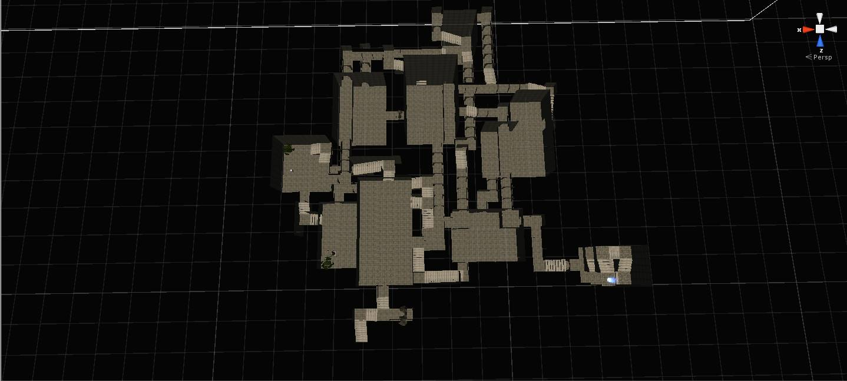

Encounters
The character will frequently encounter the villainous creatures at various locations in the level. The monsters wander the map and are a constant threat to the player.

Level Walkthrough
The level is a maze with many meandering paths. The player may try many pathways on the way to the exit, which is found as a glowing light at the end of a tall tower. The exit is positioned on the opposite side of the level from where the player spawns on a difficult to find upper path.
Precise directions are:
- Take the hallway immediately in front of the spawn point. Follow this path until you hit a large room.
- Take the door to the left and head immediately to the right.
- Follow the path until you hit the next room.
- Take a left here and follow the long path down.
- In this room, there is a larger flight of stairs to climb.
- Follow this path until you hit a split, wherein you will make a right, then another immediately afterwards.
- Follow this path and continue to walk through the rooms on the elevated points of the room.
- Eventually you will encounter a circular stairway up. At the top, is the way out.

Closing Material

Once he finds the exit, the player escapes from the maze, and beats the game.

Interface

Visual System
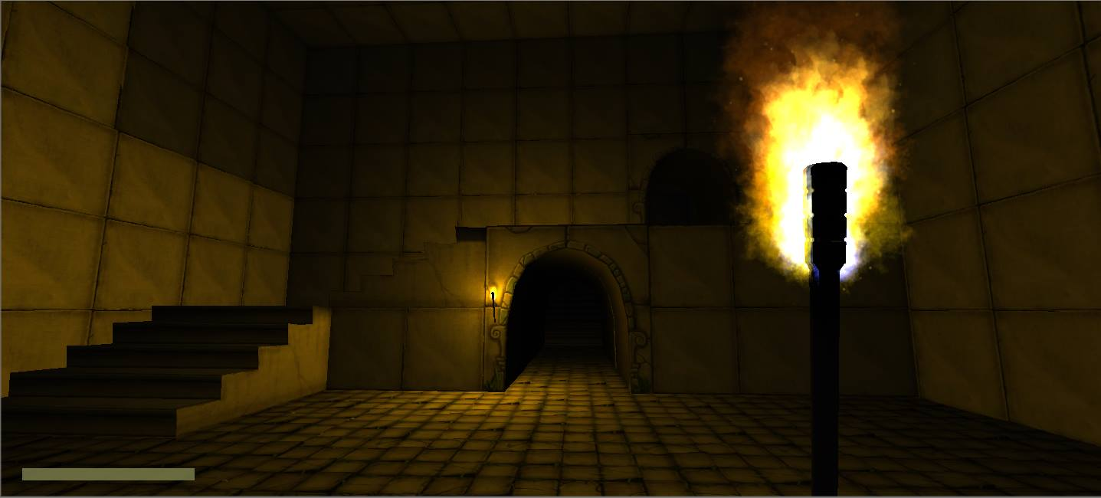

HUD
The HUD display consists of a stamina bar, as well as an equippable torch.

Menus
The menus used in the game are the start menu, the pause menu, and the game-over menu.

Rendering System
DirectX11

Camera
The camera used is a first-person camera from the protagonist’s perspective.

Lighting Models
The only lighting in the game is through torches, which are systematically placed on the walls, as well as in the player’s inventory.

Control System
Maze uses a first person perspective. The controls use WASD controls for movement, ‘Q’ to toggle torch, ‘C’ for crouch, and the ‘Esc’ key for pausing.

Audio
The game is characterized by a darker audio theme. The point of the audio is to instill a sense of isolation and suspense to the player.

Music
Ambient background music can be heard throughout the maze.

Sound Effects
Sound effects are played in response to certain cues by the player and monsters, e.g., footsteps and growls.

Help System
There is a small panel that displays the control both in the start menu and at the very start of the game.

Artificial Intelligence

Opponent/Enemy AI
The opponent AI’s are several monsters dwelling in the maze. They are able to follow the light emanating from the player’s torch. By hiding the torch, the player can hide, making it harder for the monsters to see them. The player can crouch to hide even more, reducing the detection range to ¼th it’s original value. By crouching in a bush, the player cannot be spotted at all, though he may still be killed by random encounters. When spotted, the player is chased by a monster until he is lost from its line of sight. If a monster gets close to the player, it will attack and instantly kill him with a powerful blow.

Non-combat Characters
None.

Friendly Characters
None.

Support AI
None.

Player and Collision Detection
When a Monster collides or hits the player, the player is killed.

Pathfinding
The monsters uses Unity’s built-in Navmesh system, picking points at random when “wandering” (i.e., the player is not in their line of sight). This allows the monsters to fluidly navigate the maze. When the player is spotted, the monster tracks the player’s position directly, until the player is no longer in their line of sight. Once the monsters have lost track of the player, it goes back to its “wandering” state.

Technical

Target Hardware
Graphics card: DX9 (shader model 2.0) capabilities; generally everything made since 2004 should work.
CPU: SSE2 instruction set support.

Development hardware and software
Developed on machines with the following hardware:
Processor: Intel(R) Core(TM) i7-4770 CPU @ 3.40GHz
Display adapter: NVIDIA GeForce GTX 660
RAM: 16GB
Software: Blender, VLC, Mixamo.com, Bitbucket, Google Drive & Docs, Manga Studio, and MonoDevelop.

Development Procedures and Standards
Primary development was handled by Unity and managed through Bitbucket. Some assets were created or edited using Blender, Mixamo.com, and VLC. Documentation was maintained through Google Drive and Docs. MonoDevelop is part of the Unity engine. Manga Studio was used to develop the logo.

Game Engine
Unity.

Network
None.

Scripting Language
C#.

Game Art

Style Guides
As Maze is meant to be primarily a horror game, scary elements are key. Lighting is sparse and dim. It is meant to be hard to see without the aid of a torch. The creatures are similarly nebulous, while featuring muted tones and sharp angular features.

Characters
The art for the monsters:
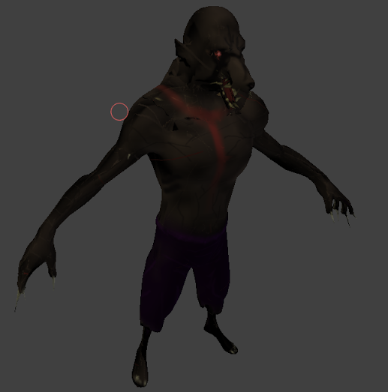
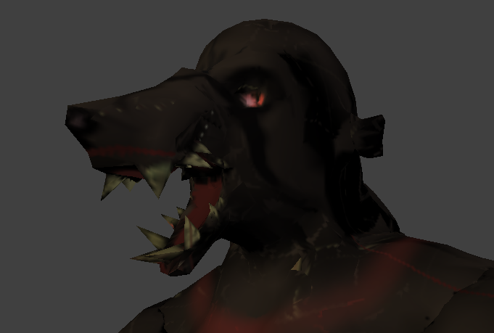
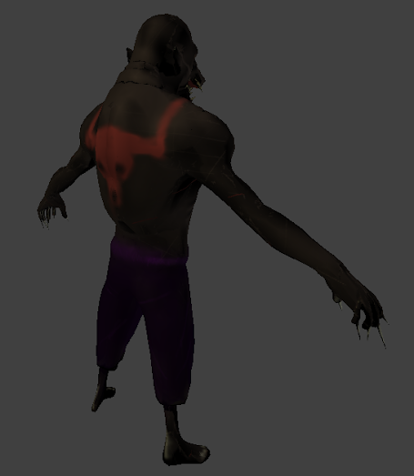

Environments
The game uses a dark temple setting to simulate a dreary and bleak mood.
Screenshot of the environment:
The assets can be found here:
https://www.assetstore.unity3d.com/en/?mkt_tok=3RkMMJWWfF9wsRogvq3AZKXonjHpfsX%2F6OsqXaOylMI%2F0ER3fOvrPUfGjI4HRcBnI%2BSLDwEYGJlv6SgFTrDHMblzybgMXhc%3D#!/content/5082

Equipment
The only equipment available to the player is the torch:
The assets can be found here:
https://www.assetstore.unity3d.com/en/?mkt_tok=3RkMMJWWfF9wsRogvq3AZKXonjHpfsX%2F6OsqXaOylMI%2F0ER3fOvrPUfGjI4HRcBnI%2BSLDwEYGJlv6SgFTrDHMblzybgMXhc%3D#!/content/7275

Management

Detailed Schedule
Week 1: Team member introductions and familiarization; pitch game ideas; investigate development needs.
Week 2: Narrow focus and scope; reach consensus; divide game pitch presentation duties; rough design; explore potential solutions; complete game pitch document; present game pitch to class.
Week 3: Learn Unity; research and acquire assets; division of labor; narrow scope.
Week 4: Begin coding; redesign level and character models; acquire assets; initialize design document.
Week 5: Complete coding; implement secondary assets; test game; apply fixes ad troubleshoot; complete design document.

Budget
$5 was budgeted to acquire some assets.

Risk Analysis
There is a risk of members not submitting functionality on time. To combat this, there are set segments of time members are needed to submit work. If they do not have it done by said time, the team would have enough time to create the functionality

Test Plan
As having the game function completely up to par is of utmost importance, we are concerned with stress testing every piece of functionality as much as possible. Any errors in play would impact the fun users would have in the game.

Appendices

Asset List
Various assets were utilized to complete the project and compensate for lack of skills or tools, e.g., audio and art elements.

Art
Some art elements were generated from scratch while others were either used to supplement existing elements or otherwise as the basis of models or behaviors.

Model and Texture List
Maze Monster NPC sculpted from Base Mesh Sculpt - a mesh by Arshlevon and a sculpt by pwnattack (http://www.blendswap.com/blends/view/74095); texture is an original work.

Animation List
Maze Monster NPC was rigged using Blender and the auto-rigging website Mixamo.com. Basic idling, walking, and running behavior animations were acquired through Unity’s Asset Store - Move Motion Free Pack v1.0 by PolygonCraft and Raw Mocap data for Mecanim v1.1 by Unity Technologies.

Interface Art List
The Maze logo was based on the ambages font from californiafonts.com.

Cut Scene List
No cut scenes were implemented for the demonstration version of the game.

Sound
All audio with the exception of the Victory music was acquired from freesound.org.

Character Sounds
Cthulu Growl by cylon8472 (249686__cylon8472__cthulhu-growl) - monster growls

Environmental Sounds
Running Hard Surface by bevangoldswain (54779__bevangoldswain__running-hard-surface) - main character runs
Footsteps Sandals on Concrete by ftpalad (119912__ftpalad__footsteps-sandals-on-concrete) - main character walks

Weapon & Tool Sounds
Fireplace by leosalom (234288__leosalom__fireplace) - torch

Interface Sounds
No interface sounds used at this time.

Music
Music is used to establish a suspenseful mood as well as to cue the player to failure or success.

Ambient
Space Organ Ambient Music by unfa (unfa__space-organ-ambient-music) - background music

Victory
Victory Fanfare (victory_fanfare) from allmusiclibrary.com - success music

Defeat
Jumper by vumseplutten1709 (208996__vumseplutten1709__jumper) - failure music

