Gravity Matrix
  - Final Document
This document is the final game document for CIS 487 – 001. Nathan Baumgartner, Nathan Bustamante, Mohamad Alhindi, Richard Morgan and Brandon Whyte
  - 11/26/2014
Contents
1.0 Overview 3
1.1 Appearance 3
1.2 Story Abstract 3
1.3 Gameplay 3
1.4 Development Platform 3
2.0 Game Mechanics 4
2.1 User Interface Description 4
2.1.1 Gravity Direction 4
2.1.2 Menu Interaction 4
2.2 Use Cases 4
2.2.1 Controls Use Case 4
2.2.2 Switch Use Case 5
2.3 Storytelling 5
2.4 Level Summary 6
3.0 User Interface Design 6
3.1 Key Screen Images 6
3.1.1 Gravity Direction Indicator 7
3.1.2 Pillars on the screen that lets the player change gravity 7
3.1.3 The level number and time taken on the level 7
3.1.4 Start Menu 7
3.1.5 Possibly a Sanity Bar 7
3.2 Control Summary 7
3.2.1 WASD - Movement 7
3.2.2 Mouse - Look around 7
3.2.3 Left Click - Ready Gravity controls 7
3.2.4 Spacebar - Jump 7
3.2.5 Enter – Pause 7
3.3 State Transition Diagrams 8
3.4 Design Rules 8
3.4.1 Naming Conventions 8
4.0 Artificial Intelligence 8
4.1 Opponent AI 8
4.2 Non-Player Characters (NPCs) 8
4.3 Reactive Items 9
4.3.1 Reactive Item List/Suggestions 9
5.0 Story Overview 10
5.1 Plot Summary 10
5.2 Storyboard 10
5.3 Character Bible 13
5.3.1 Main Character 13
5.3.2 William Tasker 13
5.3.3 Janet Tryuin 14
5.3.4 Monkey 14
6.0 Game Progression 14
6.1 Level and Scene Details 14
6.2 Level Flow Chart 14
7.0 Bibliography 15
8.0 Lessons Learned 15

1.0 Overview

1.1 Appearance
The appearance of our game will be primary focused on instilling a feeling of nostalgia in those who played older platformer-puzzle games, while introducing a new primary mechanic to solve the puzzles that players encounter. This new mechanic, the shifting of gravity, will be complimented by an alien planet, with a jungle like environment, various types of terrain and objects which will reinforce and add to the enjoyability of the gameplay.

Add screen shots!

1.2 Story Abstract
You have volunteered. At least, that is what they told you. You are not sure that you remember volunteering for this special training, but you are here, and the military would never lie to you, right?
The basic idea is that you are a freshly minted private in a future military. You wake up in what amounts to a box, with a folder sitting before you on the ground. In it is a document, with your signature, stating that for a raise in pay and rank, you agreed to be placed into this newly discovered section of alien ruins. Will you be able to escape, with your sanity intact? What will you find and discover about these long extinct aliens, that appear to have once colonized the entire galaxy?

1.3 Gameplay
The basic gameplay concept is a tried and true one; a puzzle solving platform game. That is to say the player will need to solve a puzzle, often getting from point A to point B, by utilizing different paths made available to them through various “platforms”. This concept will, in essence, remain intact throughout our game.
The major gameplay twist, however, will be that we will be utilizing a gravity-controlling mechanic. By adding in a mechanic such as this, our game quickly takes on a style of its own. The player, through a mechanic still being fine-tuned, will be able to change the directionality of gravity as it affects objects in the world. By doing this, the player can take a new approach at reaching the goal. But will the player’s ability to manipulate gravity affect in the obstacles that lay in his way? Only time will tell…

1.4 Development Platform
Our team will be utilizing the Unity development platform for the development of our game. Unity also allows for porting to multiple platforms, so our target platform for release can be variable. The team may also utilize free artistic software to develop assets.

2.0 Game Mechanics

2.1 User Interface Description
The game will be designed to run in an FPS (First Person Shooter) mode. The view will be the player character looking out of the screen and seeing the area that they are currently in. There is no part of the character that can be seen on screen. The gameplay field is very simple as described below:

2.1.1 Menu Interaction
A menu button will be on the screen, more than likely in the lower right hand corner that will open up a box onto the screen. It will pause the game and give more buttons, one that says Reset and one that says Exit. The Reset button will re load the current level the player is one. The Exit button will return the player to the home screen and they will lose all progress.

2.2 Use Cases
The following diagrams are the use cases for our game. They are basic right now since the design is still in a very early development stage.

2.2.1 Controls Use Case
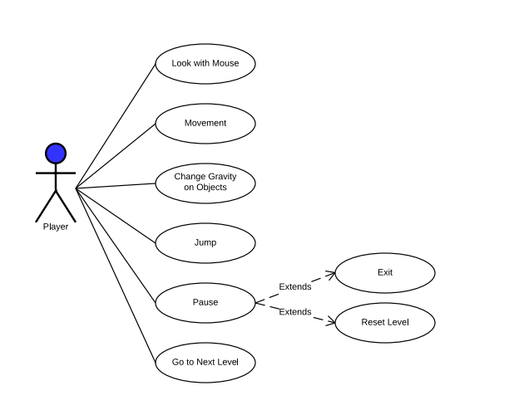
This use case describes how the player will interact with the world. There are basic movements as in most FPS games:

2.2.1.1 Character Movement
The player will use the standard WASD keys for movement.

2.2.1.2 Character Look with Mouse
The player can use the mouse to look around their environment. The mouse will not be default inverted with look.

2.2.1.3 Change Gravity Direction
There will be pillars scattered around each level. The player will interact with the pillar and this will bring up a UI showing the directions that the player can change the gravity on a particular object.

2.2.1.4 Jump
The standard FPS Shooter default for ‘Jump’, the spacebar, will be used.

2.2.1.5 Pause
The player will be able to interact with the pause menu by moving the mouse over the top of it and clicking on it. This will show the reset and exit buttons that will work as described above.

2.2.2 Switch Use Case
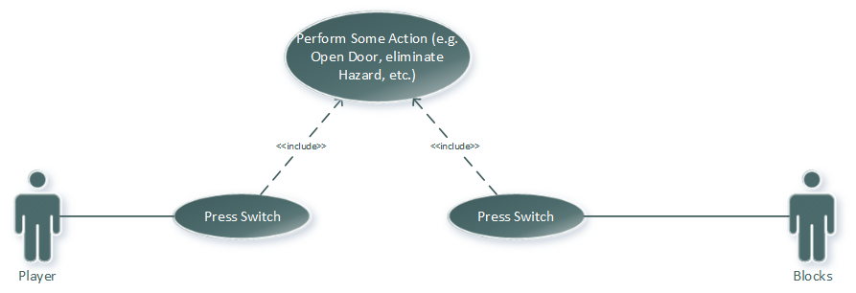
This Use Case helps to describe how the player will interact with the different objects in the game.

2.3 Storytelling
The main story is told in the opening intro scene. The scene features an alien planet growing in the distance with text appearing telling you the story. It last about one minute and leads right into the first level of the game.
As of right now, there are no NPCs planned for being in the game. The main objective of the game is to simply figure out how to get out of this place before you lose your sanity. Throughout the game, the player will also discover why they are there and what the final purpose of the ruins and the significance they played for the aliens that built them. These story points will, once again, most be told through papers the player will find as well as thought bubbles of the character’s musings, even though the player will never see the character.

2.4 Level Summary

Each level will consist of some sort of puzzle that the player must complete in order to reach the exit. Solving the puzzle will always involve changing gravity in different directions either to platform to different areas or to move blocks around that the player can jump on.

2.4.1 Level 1
The first level of the game will act as one of two tutorial type levels. It is a simple level where the user will first learn how to move around the space, look around, jump, and change gravity on an object. The user simply has to move one platform to make his way to the exit. They may also experience getting stuck in this level, by falling in a pit, and have to reset the level.

2.4.2 Level 2
The second level will act as a second tutorial type level but a little more difficult. The player will need to use the gravity pillars again, but this time there goal will be to block lasers that are in their way from escaping.

User Interface Design
The User Interface Design follows the main setup for most FPS Shooters. The main difference that will be implemented is that there will be no gun or anything to show on the screen. The attempt is to keep the game interface as simple and bare bones as possible.

Key Screen Images

3.1.2

3.1.3

3.2 Control Summary

3.2.1 WASD - Movement

3.2.2 Mouse - Look around

3.2.3 Left Click - Ready Gravity controls

3.2.4 Spacebar - Jump

3.2.5 Enter – Pause

3.3 State Transition Diagrams
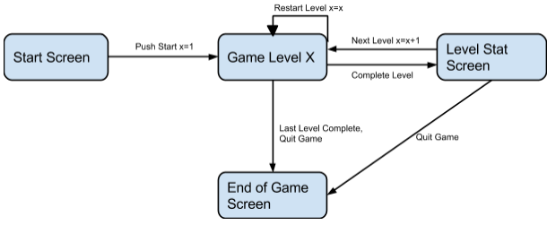
The State Diagram shows how our planned game is designed to move through the different states of the game.

3.4 Design Rules

3.4.1 Naming Conventions
We are planning on using standard CIS naming conventions for the game. We are going to capitalize our classes, variables will be camel cased and functions will also use the camel casing format.

4.0 Artificial Intelligence

4.1 Opponent AI
Our game will not be actively utilizing artificially intelligent opponents. It will, however, utilize various algorithms to create obstacles that do things such as moving or changing as the player attempts to solve the puzzles.

4.2 Non-Player Characters (NPCs)

Our game will not have any visible NPCs that will directly interact with the player. In sticking with the theme of our game, it will be the puzzle and the player going directly against each other, without much influence from outside enemies. It is possible, however, that there will be some type of indirect contact between an NPC that remains unseen and the player. This will be primarily used to introduce various new concepts and ways to solve parts of the puzzles when direction needs to be given to the player. This “voice” may be brought into the game in a more direct manner later in the game, however that will not be handled in this iteration of the game.

4.3 Reactive Items
There will be 3 major categories of reactive objects in our game. These objects will create the majority of both the obstacles in the puzzle, as well as the player’s options to solve the puzzle.
The first major category will be the various platforms and blocks that obstruct the player. These can range from a basic platform just for standing on, to a platform/block that will kill the player upon touching it. Some of these will not change at all with the rotation of gravity. Others of these will be affected in various ways as gravity is changed by the player.
The second major category will be the player’s device that is utilized to change the directionality of gravity. The main look of these devices will be alien like pillars that when approached will give the players certain options about how to change gravity. The player will interact with the object and the world in order to bring about a worldwide change in gravity. These item(s) will serve as the primary tool the player can utilize to help solve puzzles.
The third major category will be goal objects. While these objects are doors or gateways, interacting with these objects will allow the player to trigger either the next level, or the victory condition.

4.3.1 Reactive Item List/Suggestions

4.3.1.1 Block Types
- Blocks unaffected by gravity
- Blocks only affected in the y direction
- Blocks only affected in the x direction
- Blocks affected in both directions but locked in the z direction(we don’t have z directional gravity changing)

4.3.1.2 Switches
- Player operated switches (button), pillars the player interacts with

4.3.1.3 Hazards(Will come in later levels of the game)
- Lasers
- Spikes

5.0 Story Overview
The following section describes the general story overview. The game will not have a heavy story, but it will have enough to hopefully help to make the game interesting and make the player actually want to play it.

5.1 Plot Summary
The idea is that the player is a private in the future Earth’s military. Before the game began, the player ‘volunteered’ to explore some newly discovered alien ruins on a far flung planet at the edge of the galaxy. Whether or not this is true is something that the player will need to strive to discover throughout the course of the game. As the story goes along, the player’s sanity will slowly slip and slide, and eventually they will go completely insane unless they escape the facility in time.

5.2 Storyboard
You wake up, not knowing where you are. Your surroundings are a mystery to you, and there is barely enough light to see in front of you. Before you lies a folder…
Upon examining the contents of the folder, it is made clear that you, apparently, had volunteered to be on the first team to explore a newly discovered alien ruin on a distant planet. Now alone and without your gear, you take stock of your situation.
Looking around has revealed that, yep, these are some ancient ruins. There doesn’t seem to be much around other than a dusty pedestal and a lot of darkness. Might as well see what the deal with the pedestal is…
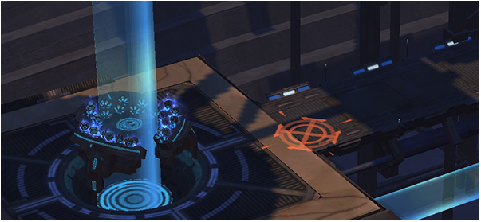
Upon reaching the old pillar, it activates and a voice begins speaking to your mind? Out loud? Both? You can’t quite tell, and you certainly don’t see anyone, but the voice has begun giving you instructions on what the pedestal can do. All you have to do is use the pedestal’s abilities to reach the exit. How hard can that be?

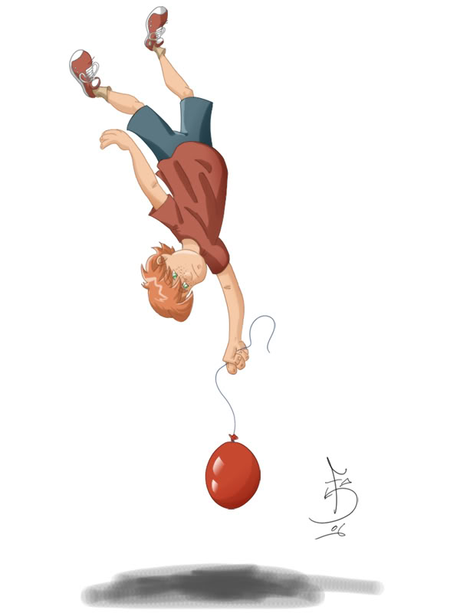
It turns out that the pedestal allows you to change the direction of gravity! That should make escaping the ruins easy enough…
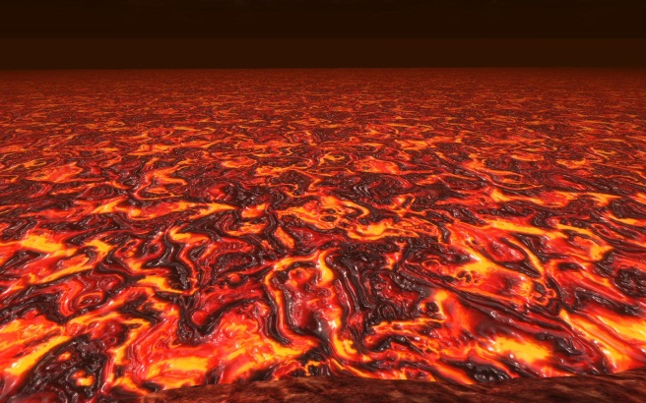
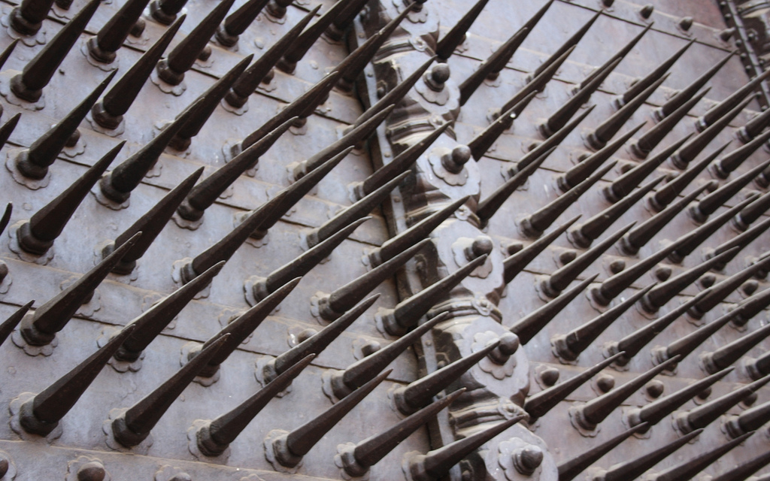
Or not. Good luck!

5.3 Character Bible

5.3.1 Main Character
The main character is the one that the player will be controlling throughout the game. He is a private in Earth’s military that supposedly volunteered for a secret mission to a set of alien ruins on the edge of the galaxy. His only goal is to survive and escape before he completely loses his sanity.

5.3.2 General William Tasker
His name and signature are on the files that the player finds when he first wakes up. Was he the one that had offered the player this promotion? What is his role in all of this? Why is he so interested in these alien ruins and what will he do with their power once he unlocks their secrets?
The general will be the main antagonist in the story aside from the ruins. The player will find different notes and orders from him, sometimes next to bodies the player finds in the ruins in various states of decay.

5.3.3 Janet Tryuin
Along with papers found next to those that the player assumes were sent in here to die with the general, the player also finds journal entries from one Janet Tryuin. The player immediately starts to find them and he realizes that she was in here not too long before he was. Another prime motivation is that the main character will want to find her because as far as he knows, she is the only other person who could possibly be alive in these horrifying ruins.

5.3.4 Monkey
A monkey like create that follows you around after you find him later in the game. He will help to offer hints of how to exit your current room.
It should be noted that this character is just an idea and will most likely not be implemented in this version of the game.

6.0 Game Progression
At the moment, the game progression is very simple. However, it is described below.

6.1 Level and Scene Details
This game is highly based on the level design. Since it is a maze game each level will progressively get more difficult. There is a possibility that we will add a time element through a “sanity” bar so that as you progress through each level you lose sanity. We don’t plan to use a lot of color and design in our levels due to time and resource constraints, in essence our level will be very plain. Our main focus in each level is that there is a challenge and that it works with the idea of changing gravity. Due to the changing gravity aspect of this game the levels will also have 6 planes that we have to design for every level.

6.2 Level Flow Chart
The diagram below is the basic level flow chart. All levels should follow this same progression with very little changes. For the moment, a way to exit the game is also going to be included after the conclusion of each level because it is still in early development. Once the game itself is implemented in its final form, this functionality will most likely be removed and the player will have to save/exit from the main game menu that can be accessed from the main UI.
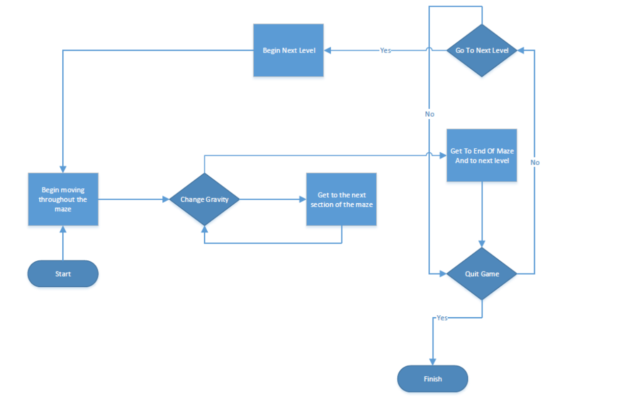

7.0 Bibliography
Not used.

8.0 Lessons Learned
For this project, we felt that we were well prepared. We had a clear plan and setup. However, due to some last minute difficulties, we were unable to complete the game with the quality that we would have liked.
In order to help fix this in the future, we would plan more ahead with more strict deadlines.
The other item that we found is that Unity is an extremely powerful development engine. Since it can do so much, a lot more research is needed in order to make all of the different parts of the game work well together. In fact, one of our final problems, namely the laser beam in the second level, could have been solved if we had known more about the development platform.
In closing, this was a good and fun project. We look forward to working more together in the future.

