--Title/Cover Page -

Chroma

1.2. Copyright Information

Developers:
Nicole Ebiware
James Polisuk
Fadi Alnabolsi
Kazi Ahmed
Lindsay Insco

2. Table of Contents

- Title Page………………………………..01  - Table Of Contents…………………..…...02  - Design History…………………………..03  - Section I - Game ………..…....04  - Game Concept………………....04  - Feature Set……………………..04  - Genre…………………………...04  - Target Audience………………..04  - Game Flow Summary………....04  - Look And Feel………………….04  - Project Scope…………………..05  - Number Of Locations....05  - Number Of Levels……..05  - Number Of NPC’s……..05  - Number Of Weapons….05  - Section II - Gameplay and Mechanics.06  - Gameplay……………………….07  - Game Progression…………….07  - Mission/Challenge Structure………………..07  - Puzzle Structure……….07  - Objectives……………...07  - Play Flow……………….07  - Mechanics……………………....07  - Physics………………….07  - Movement……………...07  - General Movement……...07  - Other Movement……...07  - Objects………………….07  - Picking Up Objects………....07  - Moving Objects..07  - Actions………………….07  - Switches and Buttons………...07  - Picking Up, Carrying, Dropping……….07  - Talking………….07  - Reading………..07 | - Combat………...07  - Economy……….07  - Screenflow…………....07  - Screenflow Chart…………...07  - Screen Descriptions…...07  - Main Menu…..07  - Options..07  5.4. Game Options………..07  5.5. Replaying and Saving.07  - Section III - Story, Setting and Character………………………..08  - Story and Narrative…....08  - Backstory……...08  - Plot Elements…..08  - Game Progression……08  - License Considerations...08  - Cutscenes…….08  - Game World…………….08  - Area 1. Morning..08  - Area 2. Dusk…...08  - Area 3. Night…...08  - Characters……………….09  - Section IV - Levels……………....10  - Section V - Interface…………….11  - Section VI - Artificial Intelligence.12  - Section VII - Technical Bible……13  - Section VIII - Game Art………….14  - Section IX - Secondary Software.15  - Section X - Management………..16  - Appendices……………………….17

3. Design History
Edition | Author | Description | Date
0.1 | Nicole Ebiware  James Polisuk  Lindsay Insco  Fadi Alnabolsi  Kazi Ahmed | First Group Discussion of Game | 11/22/14
0.2 | Lindsay Insco | Updating document | 11/23/14
0.3 | Nicole Ebiware | Additional Screenshots | 11/23/14
0.4 | James Polisuk | Edits and corrections | 11/26/2014
0.5 | James Polisuk  Fadi Alnadolsi | Final Revision | 12/16/2014

4. Section I - Game Overview
4.1. Game Concept
The concept of our game is an exploration game with three progressive is. The game will be 3D, and a plat former with a first person point of view.
4.2. Feature Set
The game will be immersive and will take advantage of both the keyboard and mouse to navigate the game, while a soundtrack runs in the background and sound effects to draw the player in.
4.3. Genre
The game will be a plat former game based on the idea of exploration.
4.4. Target Audience
We are targeting the casual gamer with a simple, yet challenging game that is quick to learn.
4.5. Game Flow Summary
The game will start in the early portion of the day, and progress to dusk, and then night. Navigation will come from the keyboard and mouse, and the ability to enter and exit buildings is also a possibility in hopes of finding the items
necessary to complete the level.

4.6. Look and Feel
As seen below, we are going for a simplistic 3D world.
This is not from our game, just a picture with a nice layout of our goal.
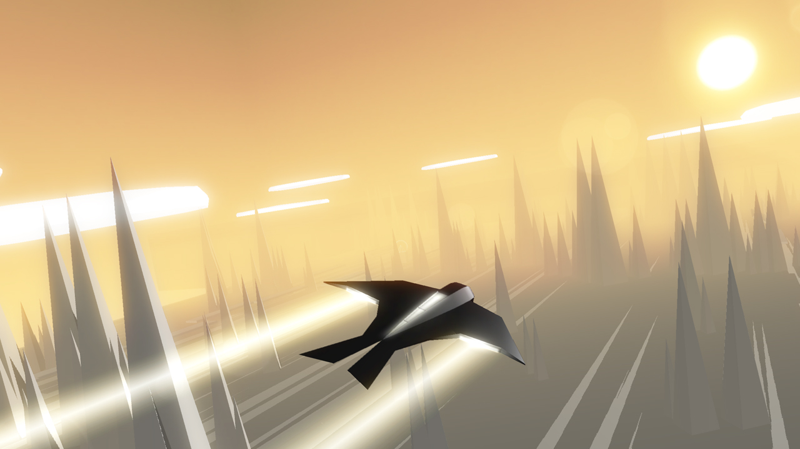
4.7. Project Scope – A summary of the scope of the game.
4.7.1. Number of locations
1
4.7.2. Number of levels
3
4.7.3. Number of NPC’s
1
4.7.4. Number of weapons
0

5. Section II - Gameplay and Mechanics
5.1. Gameplay
5.1.1. Game Progression
There will be three levels as the day progresses in the game. The game will start during the afternoon, then progress to a scene in which dusk comes about, and finally the sun will set in the final level as you play into the night.
5.1.2. Mission/challenge Structure
The challenge is to explore the environment and find 2 items. The idea is that once the first item is found, you have a set time to get the second item or you lose.
5.1.3. Puzzle Structure
Items are randomly generated on the map for the player to find. Collecting two of these items will allow the character to advance to the next level.
5.1.4. Objectives
The player must find 2 specific items required in each level to advance to the next stage. After the first item is discovered though, the player has a limited amount of time to find the next item, or you lose the game.
5.1.5. Play Flow – How does the game flow for the game player
The gamer will be actively scavenging through the level in search of specific items that’ll allow him/her to get to the next level.
5.2. Mechanics
5.2.1. Physics – How does the physical universe work?
We are going for simple physics, similar to real life.
5.2.2. Movement
5.2.2.1. General Movement
- 1st Person
- AWSD -> Directional
- Space - Jump
- Mouse - Camera Movement
5.2.2.2. Other Movement
5.2.3. Objects
5.2.3.1. Picking Up Objects
In order for the player to pick up objects, the player must run over the object.
5.2.3.2. Moving Objects
- N/A
5.2.4. Actions
5.2.4.1. Switches and Buttons
Similar to picking up objects, switches, buttons, and doors will be activated by simply running into / over the object in question.
5.2.4.2. Picking Up, Carrying and Dropping
Certain items must be gathered to progress in the game, and after the first item is picked up, the second item necessary must be picked up in a limited amount of time.
5.2.4.3. Talking
At this moment, there will be no talking or character interaction in the game.
5.2.4.4. Reading
At this moment, there will be no reading necessary beyond the introduction screen, timer, and simple instructions.
5.2.5. Combat
There is no combat in this game.
5.2.6. Economy
There is no economy in this game.
5.3. Screenflow
5.3.1. Screen Flow Chart – A graphical description of how each screen is related to every other
5.3.2. Screen Descriptions – What is the purpose of each screen?
5.3.2.1. Main Menu Screen
5.3.2.2. Options Screen
5.3.2.3. Etc.
5.4. Game Options – What are the options and how do they affect game play and mechanics?
5.5. Replaying and Saving
- No save system
- Unlimited lives

6. Section III – Story, Setting and Character Bible
6.1. Story and Narrative - Specific details like scripts and cut scenes may not be in this document but be in the Story Bible.
6.1.1. Backstory
6.1.2. Plot Elements
6.1.3. Game Progression
The player must collect medallions in order to open the door that leads to the next area. After the player completes 3 levels in one area, they must reach the exit that leads to the next area.
6.1.4. License Considerations
6.1.5. Cutscenes
6.1.5.1. Cut scene #1
6.1.5.1.1. Actors
6.1.5.1.2. Description
6.1.5.1.3. Storyboard
6.1.5.1.4. Script
6.1.5.2. Cut scene #2
6.1.5.3. etc.
6.2. Game World
6.2.1. Area #1 Morning
6.2.2.1. General Description
This is the first world of the game. It is very pure and bright.
6.2.2.2. Physical Characteristics
All elements of this level are white and the skybox is a partly cloudy blue sky. Buildings are open and the interiors are accessible by the player, but they cannot interact with anything.
6.2.2.3. Levels that use area
Level 1
6.2.2.4. Connections to other areas
There is a door that leads to level 1-2
6.2.3. Area #2 Dusk
6.2.3.1. General Description
In this level of the game, the sun is setting
6.2.3.2. Physical Characteristics
All elements of this level are white, but the sun is setting so it casts an orange glow onto the land.
6.2.3.3. Levels that use area
Level 2
6.2.3.4. Connections to other areas
There is a door that leads to level 2-2
6.2.4. Area #3 Night
6.2.4.1. General Description
This is the first world of the game. It is very pure and bright.
6.2.4.2. Physical Characteristics
All elements of this level are white and the skybox is a partly cloudy blue sky. Buildings are open and the interiors are accessible by the player, but they cannot interact with anything.
6.2.4.3. Levels that use area
Level 1
6.2.4.4. Connections to other areas
There is a door that leads to level
1-2

6.3. Characters
6.3.1. Character #1
6.3.1.1. Backstory
6.3.1.2. Personality
6.3.1.3. Look
6.3.1.3.1. Physical characteristics
6.3.1.3.2. Animations
6.3.1.4. Special Abilities
6.3.1.5. Relevance to game story
6.3.1.6. Relationship to other characters
6.3.1.7. Statistics
6.3.2. Character #2
6.3.3. etc.

7. Section IV – Levels
7.1. Level #1
7.1.1. Synopsis
7.1.2. Introductory Material (Cut scene? Mission briefing?)
7.1.3. Objectives
7.1.4. Physical Description
7.1.5. Map
7.1.6. Critical Path
7.1.7. Encounters
7.1.8. Level Walkthrough
7.1.9. Closing Material
7.2. Level #2
7.3. etc.
7.4. Training Level

8. Section V - Interface
8.1. Visual System
8.1.1. HUD - What controls
8.1.2. Menus
8.1.3. Rendering System
8.1.4. Camera
8.1.5. Lighting Models
8.2. Control System – How does the game player control the game? What are the specific commands?
8.3. Audio
8.4. Music
8.5. Sound Effects
8.6. Help System

9. Section VI - Artificial Intelligence
9.1. Opponent AI – The active opponent that plays against the game player and therefore requires strategic decision making (example, Civilization or Chess, how is it to be designed?
9.2. Enemy AI – Villains and Monsters
9.3. Non-combat Characters
9.4. Friendly Characters
9.5. Support AI
9.5.1. Player and Collision Detection
9.5.2. Pathfinding

10. Section VII – Technical – This may be abbreviated with most in the Technical Bible.
10.1. Target Hardware
- PC - Potentially HTML5 implementation?
10.2. Development hardware and software
- Hardware : PC/Mac
- Software : Unity
10.3. Development procedures and standards

10.4. Game Engine
- Unity Engine
10.5. Network
- N/A
10.6. Scripting Language
- C# / Javascript

11. Section VIII – Game Art - This may be abbreviated with most of the content in an Art Bible.
11.1. Concept Art
11.2. Style Guides
11.3. Characters
11.4. Environments
11.5. Equipment
11.6. Cutscenes
11.7. Miscellaneous

12. Section IX - Secondary Software
12.1. Editor
12.2. Installer
12.3. Update software

13. Section X - Management
13.1. Detailed Schedule
- We have 3 weeks to put this together, from design to develop to publish, so it’s frequent team meetings
13.2. Budget
- $0
13.3. Risk Analysis
13.4. Localization Plan
13.5. Test Plan

14. Appendices
14.1. Asset List
14.1.1. Art
14.1.1.1. Model and Texture List
14.1.1.2. Animation List
14.1.1.3. Effects List
14.1.1.4. Interface Art List
14.1.1.5. Cut scene List
14.1.2. Sound
14.1.2.1. Environmental Sounds
14.1.2.2. Weapon Sounds
14.1.2.3. Interface Sounds
14.1.3. Music
14.1.3.1. Ambient
14.1.3.2. “Action”
14.1.3.3. Victory
14.1.3.4. Defeat
14.1.4. Voice
14.1.4.1. Actor #1 lines
14.1.4.2. Actor #2 lines
14.1.4.3. Etc.

Bibliography

Kazi Ahmed – Better team coordination

Fadi Alnabolsi – Know team members weaknesses and strengths and plan early

Nicole Ebiware - Don’t wait last minute

Lindsay Inco – Have contingency plans

James Polisuk – Don’t have too many cooks in the kitchen. Plan accordingly, read assignment requirements beforehand.

