3D Game Design Pitch: MiniTrax

Mario Konja, Ruth Johnson, Jordan Necovski, Maher Rabah-Nasr
CIS 487/587 Fall 2013

Table of Contents
Overview
Appearance
Story Abstract
Gameplay
Development Platform
Game Mechanics
User Interface Description
Use Cases
Storytelling
Level Summary
User Interface Design
Key Screen Images
Control Summary
State Transition Diagrams
Design Rules
Artificial Intelligence
Opponent AI
Non-Player Characters
Reactive Items
Story Overview
Plot Summary
Story Board
Character Bible
Game Progression
Flowchart
Level and Scene
Bibliography
Lessons Learned

Overview

Appearance
    - Users will have a menu screen in which they will pick one of four mini games, designated by a genre of music, to partake in. Each mini game will have multiple levels in which the user attempts to achieve the goals set before them.

Story Abstract
    - You are an eager music student looking to get your foot in the door at a local music conglomerate. In order to get hired for a highly desirable summer co-op program at Rockstar Enterprises you need to do whatever the company’s Senior Music Producer tells you to do. It just so happens that this producer would liek you to assist a few friends of his. You will need to prove your proficiency through a selection of three different music genres. To beat out the other candidates you must complete the mini games in MiniTrax with the best score.

Gameplay
    - Players will engage in various mini games in an attempt to complete certain tasts before the completion of a certain song has run it’s course.
    - Activities include collecting items, traversing narrow mazes, escaping from zombies, gunning down cows, and solving the biggest puzzle of all - Accessing all three levels and the secret STORY page.
    - Players will be able to navigate through each level using WASD keys and the mouse. When a level is completed, the player will be taken to the menu screen and given the option to choose another available level.

Development Platform
    - Game Engine: Torque 3D
    - Scripting Language: TorqueScript
    - Operating System: Windows

Game Mechanics

User Interface Description
    - Menu Screen
      - Mini game choices will be displayed along with lock state. If a game has been played previously, then the last score and the high score achieved will be shown.
      - A link to mini game high scores will be available.
    - In game play
      - On the first level of each genre, a cutscene will play that describes the objectives of that set of levels.
      - User interface will be in first person view or third person view depending on the game.
      - Depending on the mini game being played the user will either be holding a gun, a spray can, or even nothing.
      - For games that require aiming at a target, a reticle will be displayed to assist the player.
      - A HUD will be displayed to show the user the current score in the game and how much time is left in the song. The time will be in the top center, and the score will be displayed in one of the corners.
      - At the start of each level, a song description will display temporarily.
    - Pause menu
      - It will display “PAUSE” in a large font along with an option to quit the game.
      - There will also be a short description of how to complete the current type of game.

Use Case
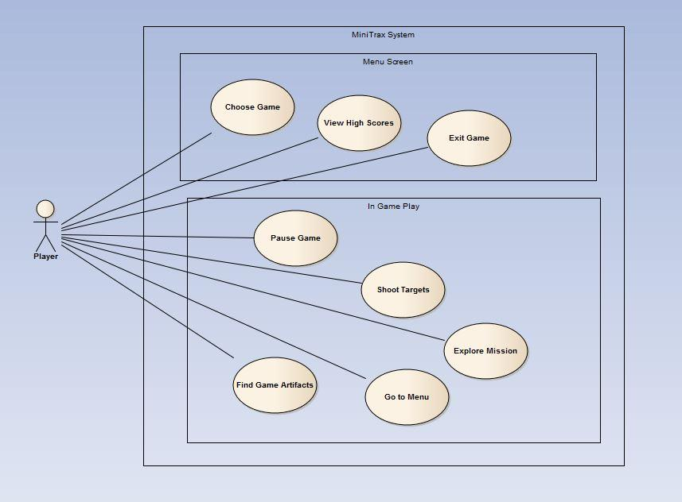

Storytelling
    - When the player chooses a mini game, a screen will display describing the objective of the game and give the user instructions for playing the game.
    - All mini games have a common theme that the player must complete as much as they can in the time that the song takes to play through completely.
    - Upon completion of all four genres, a final scene will be shown.

Level Summary
    - Each level is designed around a unique theme. The theme is dependent on the genre of music that is playing in the background of the level.
      - Country level - Sent to help out the music executives’ friends, you can choose to start with the farmer. He needs you to get rid of the cows of a rival farm, but quickly! The owners will be back by the end of just one Kenny Chesney song.
      - Rap level - Helping out someone from the music execs’ former rap group, you find yourself stranded and left for dead as the former rapper’s biological experiments have gone horribly wrong. She accidentally created ZOMBIES! Run away until the zombies understand the the Wu Tang Clan Ain’t Nothin Ta F Wit, and decide to leave you alone.
      - Punk level - “CANCELLED DUE TO A NUMBER OF VIRTUAL ARRESTS MADE WHEN OUR VIRTUAL GRAFFITI ARTISTS TRIED TO VIRTUALLY WORK*
      - Electronic level - A former war buddy of our music executive friend needs help collect the landmines he uses to protect himself from ‘charlie’. Unsurprisingly, the crazed vet lives on land that if FULL of pitfalls. To make matters worse, his strobe light defensive feature has gone haywire as well. Good luck finding those explosives in the middle of the night while something comparable to a rave is going on.

User Interface Design

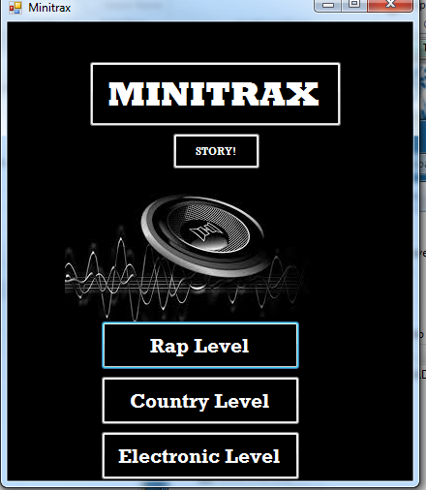

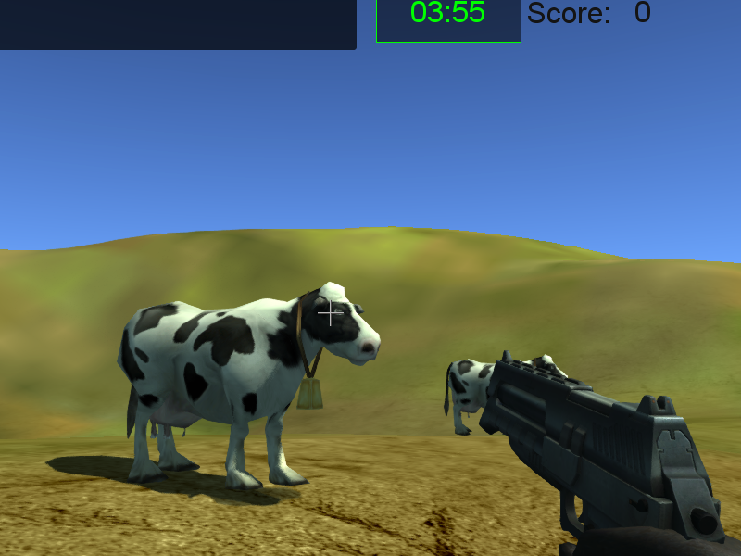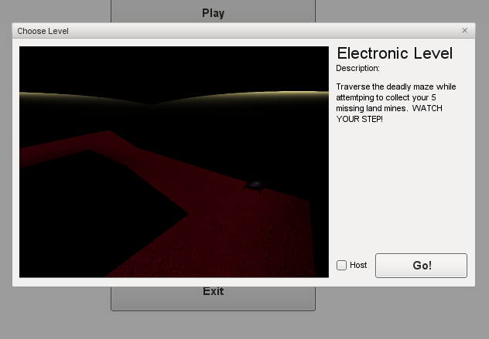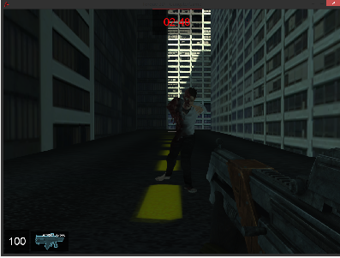

Control Summary
    - W = Forward
    - S = Backward
    - A = Strafe left
    - D = Strafe right
    - Space = jump
    - Left mouse click = interact
    - Mouse movement = Camera control
    - Esc = bring up menu/pause game

State Transition Diagram
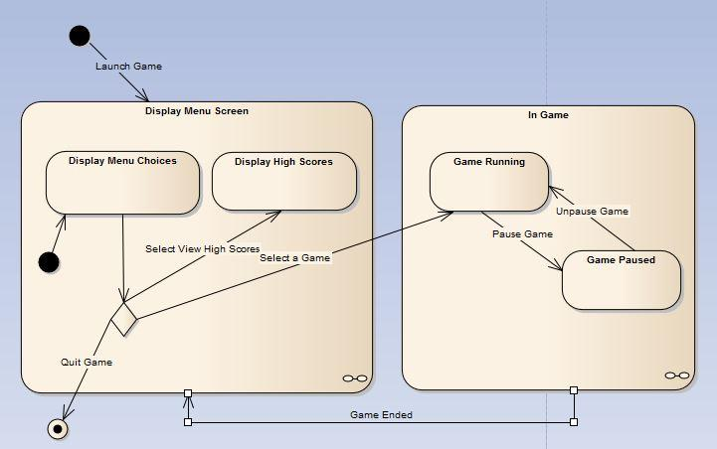

Design Rules
    - Keep in mind that the game is due in mid December.
    - Make the basic level designs
      - Make sure the game is playable
      - Make sure the player cannot get stuck
      - Make sure your environment is playable.
      - Fulfill the minimum requirements for the assignment.
    - Modify game play elements
      - Make transitions between levels
      - Add trigger points to trigger events such as new levels.
      - Change character appearance
      - Modify player functions (such as jumping height)
    - Features
      - Add multiplayer component.
      - Multiple endings
      - High score display

Artificial Intelligence

Opponent AI
    - Cows that you have to chase and kill in the country level
    - Zombies that chase you and try to arrest you in the rap level.

Non-Player Characters
    - Cow
    - Zombies

Reactive Items
    - Landmines are collectibles

Story Overview

Plot Summary
    - Whether it’s running away from zombies, shooting cows, or traversing a tricky path, you are determined to do whatever it takes to prove yourself worthy of the job. And those are the exact things that Ricardo will have the player do, as some of his friends need help with those exact tasks!

Story Board

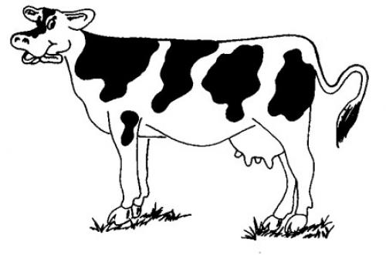
Character Bible
    - Main character
      - Name: Blue Ivy
      - Gender : Female(Turned into a male soldier in the final version. Probably had a surgery or something)
      - Age: 20
      - Parents: Beyonce and Sean Carter (Jay-Z)
      - Favorite type of music: Icelandic Death Metal
      - Her reason for going into music: Growing up in a music household it was in her blood. She has loved music her entire life. She also is A-OK with cow genocide and isn’t prone to seizures.
    - Music Industry Mogul
      - Name: Ricardo Jr. Jr.II
      - Gender: Transgendered
      - Age: 42
      - Parents: Ricardo Jr. and Ricarda
      - Favorite type of music: Country Rap
      - His reason for going into music: “It’s where the money’s at”

Game Progression

Flowchart
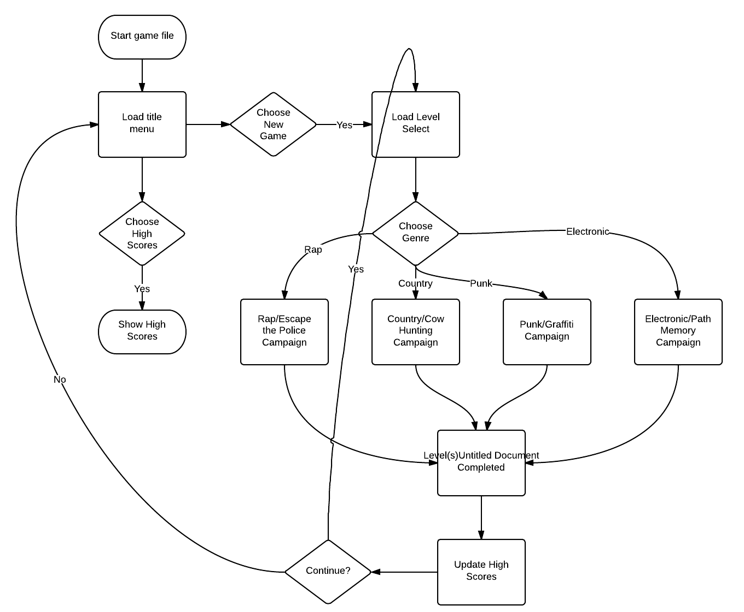

Level and Scene
    - Country level - Sent to help out the music executives’ friends, you can choose to start with the farmer. He needs you to get rid of the cows of a rival farm, but quickly! The owners will be back by the end of just one Kenny Chesney song.
    - Rap level - Helping out someone from the music execs’ former rap group, you find yourself stranded and left for dead as the former rapper’s biological experiments have gone horribly wrong. She accidentally created ZOMBIES! Run away until the zombies understand the the Wu Tang Clan Ain’t Nothin Ta F Wit, and decide to leave you alone.
    - Punk level - “CANCELLED DUE TO A NUMBER OF VIRTUAL ARRESTS MADE WHEN OUR VIRTUAL GRAFFITI ARTISTS TRIED TO VIRTUALLY WORK*
    - Electronic level - A former war buddy of our music executive friend needs help collect the landmines he uses to protect himself from ‘charlie’. Unsurprisingly, the crazed vet lives on land that if FULL of pitfalls. To make matters worse, his strobe light defensive feature has gone haywire as well. Good luck finding those explosives in the middle of the night while something comparable to a rave is going on.

Bibliography
  - Rap Level - Wu Tang Clan Ain’t Nothin Ta F Wit by the Wu Tang Clan
  - Country Level (Cow Carnage) - She Thinks My Tractor's Sexy by Kenny Chesney
  - Electronic Level - Harder, Better, Faster, Stonger by Daft Punk

Lessons Learned
  - Getting a job is a lot more work than just having the qualifications that are stated.
  - The learning curve for a new development tool is sometimes higher than you think.
  - Being creative is Job #1.
  - INTEGRATE EARLY
  - SERIOUSLY, INTEGRATE EARLY

