Day at the Museum
  - CIS 587 – Computer Game Design & Implementation
Matt Fielden
Fall 2013

Overview
Day at the Museum is a First Person Shooter (FPS) game utilizing various features and concepts prevalent throughout the FPS genre while trying to maintain an over the top storyline with extra zealous enemy guards. Using various guns and strategies, the player will attempt to repel several waves of enemies that are tracking the player down. The player will have to use the environment to their advantage to be able to defeat all of the enemies and win the game.

Appearance
Day at the Museum will incorporate many popular elements from the FPS genre such as HUD/UI information and various level design elements. The game will be set in an urban environment with various buildings and streets that can be navigated. Power-ups will be placed in specific places throughout the environment for the player. They will include additional weapons, resupply ammo, and possibly special effects like invisibility or increased armor.

Gameplay
Day at the Museum will play like a standard FPS will various additional elements. Day at the Museum will utilize a wave system for combat and enemy spawns rather than a set amount of enemies on the level to begin with. Each wave will introduce progressively larger and harder swarms of enemies. There will be a set number of waves, and if the player can survive long enough to defeat all of the enemies of each wave, they will defeat the level knowing they survived. The player will have a specified amount of lives, so that in the event of a player death they can respawn and continue eliminating enemies to try and beat the level.

Development Platform
Day at the Museum will be utilizing the Torque 3D game engine. It will be based off the sample FPS Tutorial, but will have some heavy modification or replacement of the User Interface, the game mechanics, and the level in general.

Game Mechanics

User Interface Description
The user interface will be separated into a few sections, each detailing important but different data. One section will contain weapon/item information. This will give information about what the player is currently holding, whether it is a weapon or a helpful item. There will also be a remaining section detailing some environmental and player information, such as a timer and the player’s health bar.

Storytelling
Basic story telling will be done before the level begins, and as needed throughout the level. The storytelling happening in game will be via dialogues with the character, and textual descriptions on the screen.

Level Summary
The main level of the Day at the Museum takes place in a modern city. There are various buildings, including the museum where the game starts, that the player can enter and take cover in. Additionally, there will be a large open area in the middle, housing some powerups and additional weapons/ammo. The buildings themselves can have multiple entrances and levels and could be used for various purposes such as retreating, or gaining a vantage point over the enemies.

Use Cases
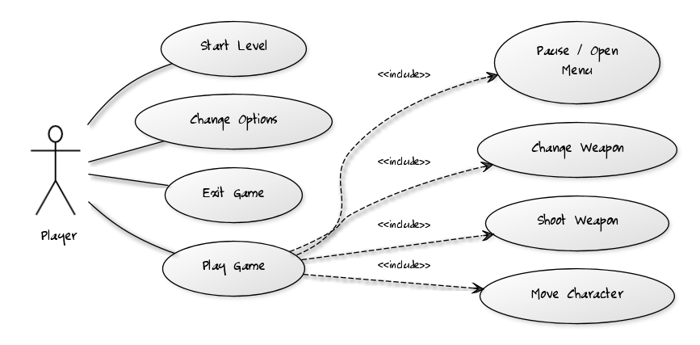

User Interface Design

Key Screen Images
(Note: Screens are simulated from the Torque3D FPS Starter Kit and are used to provide a visual representation of the game’s user interface. They are not representative of the final visual state)

Title Screen
User configurable Options
Level Start
The title screen will be a basic title screen with an image of the game scenery and environment in the background. The options for the title screen will be to start the level, go to options to change some settings, and exit to leave the game.

Heads Up Dislplay (HUD)
Mission/Wave timer
Current Weapon and magazine/total ammo display
Player health status
The heads up display (HUD) will show the player various information about their current status. Information provided will be in real-time with the intention of helping the player decide how to further execute their strategy and assess the current situation

Control Summary
The controls will be the standard FPS controls for movement, aiming, and firing. A full control list is detailed below.
Control | Description
W | Move player forward
A | Move player left
S | Move player backwards
D | Move player right
R | Reload weapon
Mouse Scroll | Cycle through weapons
Left Mouse Click | Fire Weapon
Right Mouse Click | Zoom In
Shift | Run
Ctrl | Crouch
Space | Jump

Design Rules
All of the user interface should be designed with a few usability rules in mind. All of the text should be contrasting from background colors enough that they can be easily and quickly read at any point by the player. This will be accomplished by adding an overlay behind the HUD so that the environment behind the status indicators does not interfere with this usability. Additionally, Day at the Museum will keep the user’s field of vision as clear as possible unless there is imminent danger or a change in status. This will allow the user to focus on the task at hand, surviving the enemy waves.

Artificial Intelligence (AI)

Opponent AI
Day at the Museum will consist of a few different types of enemies that will all follow the same general AI behavior pattern. At the core, the enemy AI will implement a basic pathfinding algorithm to chase down the player and when in range and visible, fire at the player. The enemy AI will not fire at the player if it does not know where the player is (I.E. the player is hidden behind some obstacle) or if the enemy is not in range to hit the current player.

Non-Player Characters (NPCs)
There will be no NPCs other than the enemy characters detailed above.

Reactive Items
There will be various reactive elements in the game such as obstacles that will stop bullets and serve as viable cover.

Story Overview
Day at the Museum is more of an action oriented game and as such lets a lot of that action tell the story itself, however there is still an underlying story behind the level and why there are hordes of enemies trying to eliminate the player.

Plot Summary
The game begins when the main character, Simon, is in a prominent local museum. Simon has had a rough life, and has a strong desire to possess some of the world’s most prominent weapons. Lucky for him, his local museum happens to have several of them on display. Simon decides to fulfill his destiny and steal the weapons. Unfortunately for Simon, the museum also happens to employ the most ruthless and persistent organization of security guards in existence, the SMG. The game centers around the actions just after Simon has stolen the weapons, including his escape from the museum. After escaping, Simon must fend off the hordes of security guards that insist on recovering the lost museum treasures. Armed with only the weapons he has just stolen, you control Simon and can beat the game by surviving the waves of security and escaping with the treasure!

Character bible

Simon
Role: Main Character – Controlled by the Player
Background: Growing up with in a troubled neighborhood, Simon has always gotten the short end of the stick when it comes to good luck. In his early teen years, Simon was alone and lonely with nobody to turn to. He turned to the only thing he was good at, crime. Decades of crime have taken Simon to several highs and lows but he has learned several invaluable lessons over time. He has also developed a very string affinity for weapons, and shooting them. Feeling empty, Simon decides that it’s time to do the big one; it’s time to combine both of his passions and pull off the ultimate heist.

Supreme Museum Guards Clansmen
Role: Main Character’s opposition – Guards of sacred antiquities
Background: The Clan of Supreme Museum Guards (SMG) is a long running organization dedicated to protecting the world’s most valuable treasures. The actual whereabouts of how the SMG got started are only known to those inside of the secret society. What we do know is that members who join are members for life and must take an oath where they vow to protect the world’s treasures at ANY cost. SMG members are known for their abilities to seemingly appear out of nowhere, and arrive en masse. When your treasures are protected by the SMG you know two things; one, you have something extremely important or valuable and two, the consequences of trying to steal the treasure will be dire.

Game Progression
The game progresses as a standard FPS with a wave spawning system progresses. The basic behavior is outlined in the flowchart below

Flowchart

Level and Scene Details
The level will be set in an urban environment with open buildings and streets with cars. The player will be able to seek shelter behind these objects and in the buildings. Additionally, there will be a large clearing on the map, much like a park. This clearing will house several power-ups, but will have the disadvantage of not having much to offer in the form of cover. Thus it will be a risk reward type of scenario where the player will be rewarded with power-ups for going to the clearing, but also risks being caught in the open with nowhere to go. Power-ups will also be scattered throughout the remainder of the map, but in a much smaller quantity.

