Undead Tower Defense 3D

F2012

Jacob Boncher
Terry Holt
Tyler Odom
Joe Shunia
Table of Contents
1.0 Overview 3
1.1 Game Concept 3
1.2 Feature Set 3
1.3 Genre 3
1.4 Target Audience 3
1.5 Game Flow Summary 3
1.6 Look and Feel 4
1.7 Project Scope 4
2.0 Game Mechanics 5
2.1 Overview 5
2.2 Camera Position 5
2.3 User Interface Design 5
2.4 Replaying and Saving 5
2.5 Control Summary 5
2.6 Game Play Details 5
2.7 Cut-Scenes 5
2.8 Storytelling 6
2.9 Level Summary 6
3.0 Artificial Intelligence 7
3.1 Opponent AI 7
3.2 Player Detection 7
3.3 Motion 7
3.4 Path Finding 7
3.5 Special Actions 7
3.6 Combat (attack, evasion, damage) 7
3.7 Non-player Characters 8
3.8 Puzzles and Traps 8
4.0 Game Elements 9
4.1 Items (e.g. data dictionary) 9
4.2 Character Bible 9
5.0 Story Overview 11
5.1 Storyboard 11
5.2 Background/Plot Summary 11
6.0 Game Progression 12
6.1 Setting 12
6.2 Flowchart 12
6.3 Level and Scene Details 12
7.0 Lessons Learned 13
8.0 Bibliography 14

1.0 Overview

1.1 Game Concept
This game is based off of Terry and Joe’s 2D game, Undead Tower Defense. The concept is to survive for as long as possible against an infinite onslaught of zombies. The player stands on top of a tower and shoots zombies to prevent them from overrunning him. The game continues until the player dies.

1.2 Feature Set
The game features a tower from which the player shoots enemies.
The tower is inside of a fences, which the zombies try to destroy, so the player takes damage when the zombies reach the fence.
It contains mainly two different types of zombies (dark slow zombie, white shirt mid-fast zombie) with a few different sub types (white shirt zombie types running, limping, slouching, and normal walking).
There are 4 different ammo types that have different effects. The grenade launcher will do radius damage and send a zombie flying through the air, also emits an explosion. The fire lurker will emit flames that can catch zombies on fire for a couple seconds (cumulative flame damage). The ice lurker will hit the zombie with ice and for a few seconds ice effect will be on zombie (cumulative frostbite damage). The last is the standard bullet which will cause blood dust effect to be emitted from the zombie, but does normal bullet damage.

1.3 Genre
First Person Shooter.
Zombie game.
Survival.
Horror.

1.4 Target Audience
The target audience is first person shooter players, as that is the main genre of the game. Because it features zombies, it may also drive in people who like zombie/horror games. The game itself, however, should probably not be played by small children.

1.5 Game Flow Summary
The game is set with the player in a tower defending himself against zombies. The progression of the game is simply by more and more zombies continuing to attack. The game will continue this cycle of more zombies and incrementing waves until the player is killed. Death or exiting is the only way to end the game.

1.6 Look and Feel
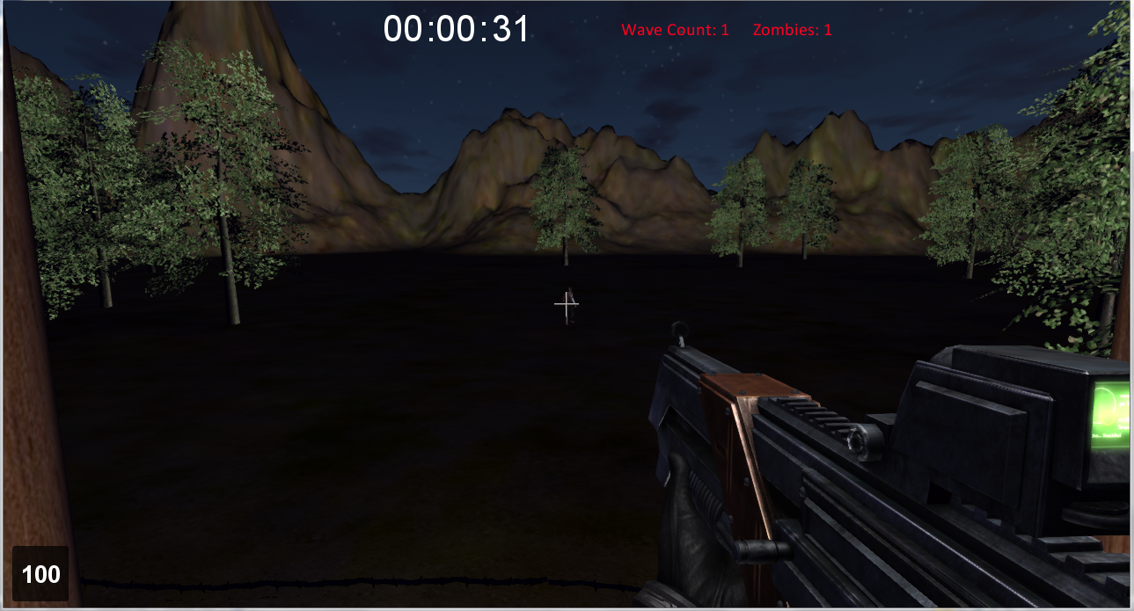

1.7 Project Scope
There is only one level in this game, as it is based off of waves of enemies attacking a stationary player rather than the player moving through the world. The only NPCs are the zombies, who vary in speed, health, and strength. The game could, in theory, last forever, as it is a survival game, so the only way to finish it is to die.

2.0 Game Mechanics

2.1 Overview
The mechanics of the game are, to the user, simple. The player clicks to fire his gun, which shoots a bullet. If the bullet collides with a zombie, it takes damage. When a zombie takes enough damage, it dies. The zombies do damage to the player by attacking the fence that separates them from the tower, and by extension the player. Since there are no additional weapons other than what the player begins with, this game should be simple and intuitive for anyone who has ever played an FPS.

2.2 Camera Position
The game uses a first person perspective for the camera position by default, however the player can press the tab button to switch to a third person view, so the camera is directly behind the player. In third person perspective, the camera will be quite close to the player, so the game will still have the FPS feel to it.

2.3 User Interface Design
The UI consists of a crosshair for aiming, a number representing health in the lower left-hand corner, the wave number, number of zombies left in current wave, and time spent in game at the top of the game, and the arms and gun of the player. These can be seen in the screenshot that shows the game’s look and feel (section 1.6).

2.4 Replaying and Saving
Replaying can be done by exiting the game and re-opening it.
There is no saving functionality.

2.5 Control Summary
Use the mouse to aim and fire. There is no other player movement required.
Tab button switches between first and third person cameras.

2.6 Game Play Details
Because of how simple the mechanics for the player are in this game, there are not any details to describe that are not covered in other parts of Section 2.

2.7 Cut-Scenes
There are no cut scenes in this game.

2.8 Storytelling
Pressing the play button from the main menu loads a screen that tells the plot of the game. The player can click anywhere to continue onto the game. From there, there is no additional story told.

2.9 Level Summary
There exists only one level in this game, as it is a survival game. It has a fenced off tower in the middle of a forest. In the background there are mountains (all this can be more clearly seen in the screenshot in section 1.6). For progression, the enemies are broken down into waves. Each wave is more difficult than the last by adding more enemies to it.

3.0 Artificial Intelligence

3.1 Opponent AI
The AI of the game is based off of most of the aiPlayer functions that came with the torque 3d fps tutorial and also based partly on the tutorial from class. How the AI works is a zombie spawns randomly on screen and enters a think process (what will it do?) Basically the only few things the zombie will do is turn toward the player (orient so the player is in view) if he is out of view, chase/pursue the player until the player dies or zombie is killed or finds another target, or attacks the player once in range.

3.2 Player Detection
Basically how the detection works is the aiZombie of class aiPlayer finds the closest player obj on screen within the zombies view radius. If nothing is in the zombies view radius it is in a do nothing state. If there is a player in the zombies view radius it will chase that player. Of course all zombies spawn within the view radius and since the player does not run away and the zombies always move toward the player the only time the zombie will enter a do nothing state is if the player dies.

3.3 Motion
If the zombie has a target the zombie will give chase. The zombie basically will chase until it dies or starts colliding with an object or player (in which case, it will still move play running animation). Zombie types move slightly differently, there are three zombies that move at different speeds one is very slow, the other is middle pace, and the last runs (strides toward the player). The zombies also have varying animations to distinguish them, there is the middle pace injured zombie, slouching zombie, slumped over zombie, upright zombie, and arms held out zombie. (Also there are different animations for the slow zombie (limp animation) and the fast zombie (run animation).

3.4 Path Finding
There isn’t really any path finding in the game. Zombies find closest player and basically chase until someone (zombie or player) dies.

3.5 Special Actions
There are no special actions the zombies are for the most part mindless zombies. Only thing they really do in the game is chase, attack (melee) and die. One feature that the game does have is that when they get hit with a bullet they have a blood particle effect. Also if they get hit with flames they catch fire or if they get hit with ice they will sparkle blue.

3.6 Combat (attack, evasion, damage)
There is no evasion. They do attack, once they are at a few feet from the fence they go into attack mode and do damage to fence (feeds back to player) each does 3 HP of damage. The zombies continue to attack until the player dies or the player kills them. The zombies will similarly take damage from the player if they are shot with a bullet.

3.7 Non-player Characters
The only non-player characters in the game are the zombie opponents, who are described further in the character Bible (section 4.2). The AI description in section 3 in general is about these zombie opponents.

3.8 Puzzles and Traps
There are no puzzles or traps in the game.

4.0 Game Elements

4.1 Items (e.g. data dictionary)
There are no items in the game other than the assault rifle that the player has at the beginning. Even though it is technically an item, it is his only weapon, so it can be thought of as more belonging to the player than a separate item.

4.2 Character Bible
- Player
The player is one of the last surviving humans in the world. He is barricaded in a tower, and defending it from zombies. When they break through the fence, he will surely die. The player has an assault rifle, with infinite ammo, with which he can shoot the zombies.
- Enemies
  - Normal Zombies
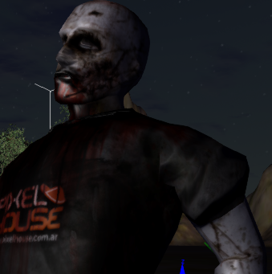
    - Description
Normal Zombies basically have black t-shirt that says “pixel House” Dark Blue shredded jeans and grey skin and cuts and lacerations.
    - Properties
Normal zombies are the slowest zombie type in the game. They limp and slowly meander toward player.
  - Disfigured zombies
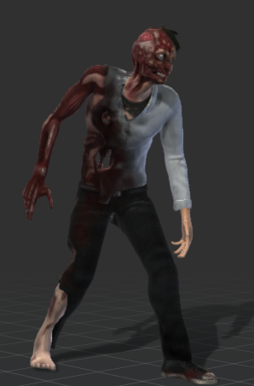
    - Description
Disfigured zombies have considerably more injuries and disfigurations than the normal zombies. They have holes in their midsections, have missing or exposed skin (look a little like to face). Basically have seen more battle (the more progressed in difficulty zombies).
    - Properties
All move faster than normal zombies, but have varying speeds and walk differently to tell make each zombie more unique.
  - Disfigured Zombie (sub enemy type) “Fast Zombie”
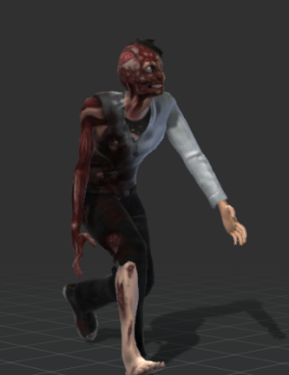
    - Description
Look the same as disfigured zombie but hunched over, with faster movements.
    - Properties
Fastest zombie in the game. Basically, is the zombie that will get you killed half of the time.

5.0 Story Overview

5.1 Storyboard
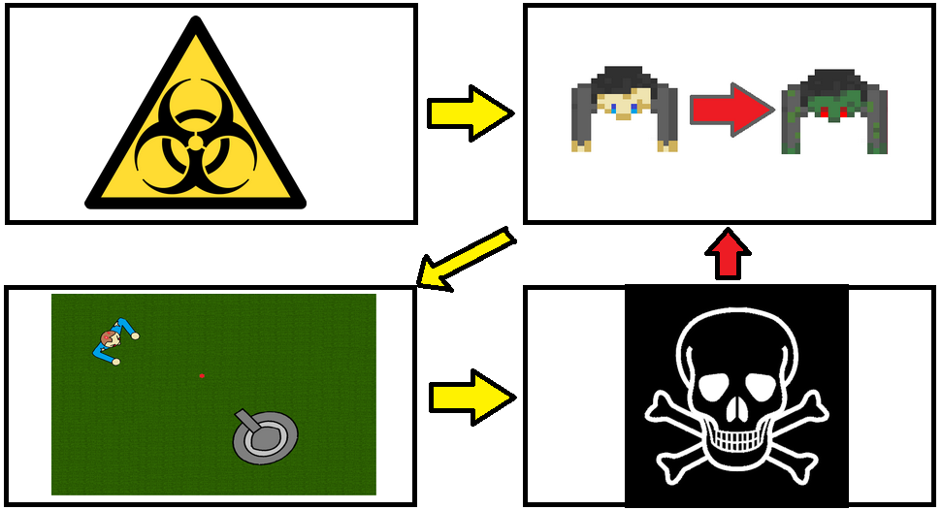

5.2 Background/Plot Summary
An infectious disease has spread across the world to the human and various animal populations. This disease kills the host transforming them into hideous creatures "the undead." These new creatures have a hunger for brains and infect anyone they come into contact with. Survivors must avoid contact with the creatures at all costs. The last remaining survivors are held up in a tower and must defend themselves from the oncoming onslaught of undead.

6.0 Game Progression

6.1 Setting
The game is set in a forest, with the player barricaded in a tower, surrounded by a fence. Zombies are attacking the tower, and the player will surely die as soon as they break through the fences.

6.2 Flowchart
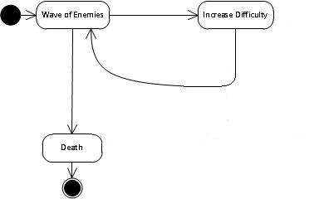

6.3 Level and Scene Details
There is only one level in the game, and only one scene within that level. This level can be seen best in the screenshot in section 1.6.

7.0 Lessons Learned
We learned, from the first game, that it is very difficult to program when you are unfamiliar with the framework in which you are working, so all of us began to work Torque early and tried programming different things in it, to become more familiar with it, in contrast to trying to learn a game engine on the fly as we both did with Charles Kelly’s 2D C++/DirectX engine. From this project, we confirmed that belief, and learned that starting early isn’t always a guarantee of success with a sufficiently complex framework.

8.0 Bibliography

Disfigured Zombie models and animations
http://www.mixamo.com/c/3d-characters/free

Normal Zombie models and animations (by pixelhouse)
http://pixelhouse.com.ar/

Zombie AI/Zombie Spawn code (Adapted from AIPlayer code provided by torque, code provided by ChrisG, and tutorial code from book)
http://www.garagegames.com/community/forums/viewthread/103503

Music by A Slip of the Knife (local artist Louis George)
Songs:
- (Menu Song) Justin Chapman is the Pervert –Album: Hamburger E.P.
http://www.last.fm/music/A+Slip+of+The+Knife?ac=a+slip+of+the+knife

- (In Game Song) Dr. Lochness – Untitled. Single
http://aslipoftheknife.bandcamp.com/

Menu Screen(briel3)
http://desktop.freewallpaper4.me/download/7322/nice-night-to-shoot-zombies

Barbed Wire Fence
http://3tdstudios.com/models.html

WatchTower(sharkie101)
http://www.turbosquid.com/FullPreview/Index.cfm/ID/500178

biohazard image from
http://en.wikipedia.org/wiki/File:Biohazard.svg

skull and crossbones from
http://en.wikipedia.org/wiki/File:Skull_and_crossbones.png

