U! zoMDie
By Haonan Du
Lorenzo Mannarino
Nicholas Mauti
Zheng Zhang

Overview
Game Mechanics

Overview – The game takes place on the UM Dearborn campus, the main focus of the first level is the CIS building. The main character is a CIS major and student of UM Dearborn.

Camera Position – First Person Shooter

User Interface Design – The interface will consist of a HUD that shows the mission objective.

Replaying and Saving – Replay is available. Hit F3 to do so.

Control Summary – Standard keyboard and mouse controls, arrow keys or W-A-S-D to move, mouse is used to aim weapon, left click to fire. Space is to jump

Game Play Details – The student will have free roam of the map, free to explore every inch of the current display. Zomdies will spawn throughout the campus. Student must protect the bottle, if zomdies touch the bottle, 3 more will spawn, if you touch the bottle, 2 more zomdie will spawn. Kill 30 zomdies faster is better. Player can challenge himself by finish the mission faster.

Cut-Scenes – A final cut-scene will be employed once the campus is free from zomdies and the students are safe.

Storytelling – The background/goal of the level and game will be displayed on the players HUD via text format. Future updates could include audio and/or video.

Level Summary – Level 1 takes place outside of the CIS building, your goal is to defend the building from the zoMDies. Once player killed 30 zomdies and no zombie exists, the CIS is building and the students inside are safe. Do it faster is better.

Artificial Intelligence

Opponent AI – Zomdies will randomly spawn throughout the map, the number of zombies spawned will depend on the difficultness the player has chosen. Zomdie AI is fairly simple, try to touch the bottle from wherever the zomdie is.

Motion – Zomdies run to the bottle from different spots of the map.

Special Actions – None exist in this current build

Combat – The player will start out with one crossbow with a limited amount of ammo. There is bunch of ammo for the player to reload, but player need to pick it up. Player does not have the ability to fight the zomdies with hand to hand combat.

Non-Player Characters – Zomdies

Puzzles & Traps – It’s a strategy for player how he wants the zomdies come.
-if you touch the bottle, 2 more zoMDie come out.
-if the zoMDie reach the bottle, 3 more zoMDie come out.
-You have the chance to win faster if more zoMDies come out at a time,
on the other hand you may lose faster in this situation too.

Game Elements

Items
- Crossbow: The students main source of offense against the zomdies, without the crossbow the student will surely not survive.
- Ammo: Bullets for the crossbow, a limited amount of ammo is available
- Bottle: The main focus of the gameplay, protect the bottle from the zomdies

Character Bibles
- The Student: the main character of the game, he is the last hope for the school. He is fighting the zomdies.
- Zomdies: Your enemy!

Story Overview

Storyboard: see graphics at end of document

Background/Plot Summary – It was an operational error made by a Chemical Engineering student, the Dearborn campus is now flooded with tons of zomdies. There is a red bottle that can save the campus someday, your task is to protect the bottle!

Game Progression

Setting – Difficulty is decided by the player.

Intro – Introduction to the game will feature a main screen where you will have the following options: start a new game, replay the recorded games and exit game. The options are detailed in the Use Case diagram below

Flowchart – At the end of the document with the other graphical items

Level & Scene Details - Only one level, the player can challenge himself by win faster.

Lessons Learned

Start the game development sooner. Familiarize with gaming/coding environment and language before game development.

Gantt Chart
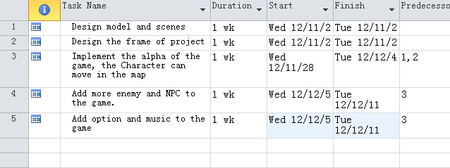

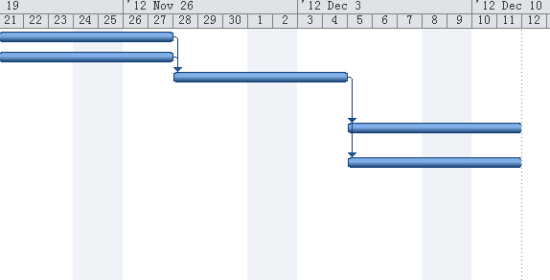

Use Case:

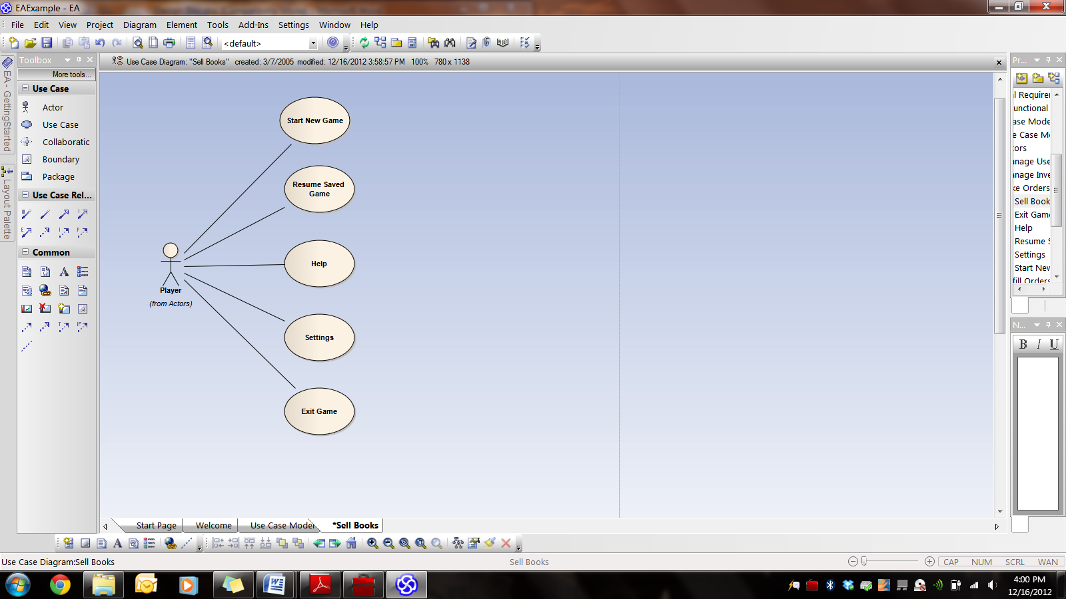

Flowchart:

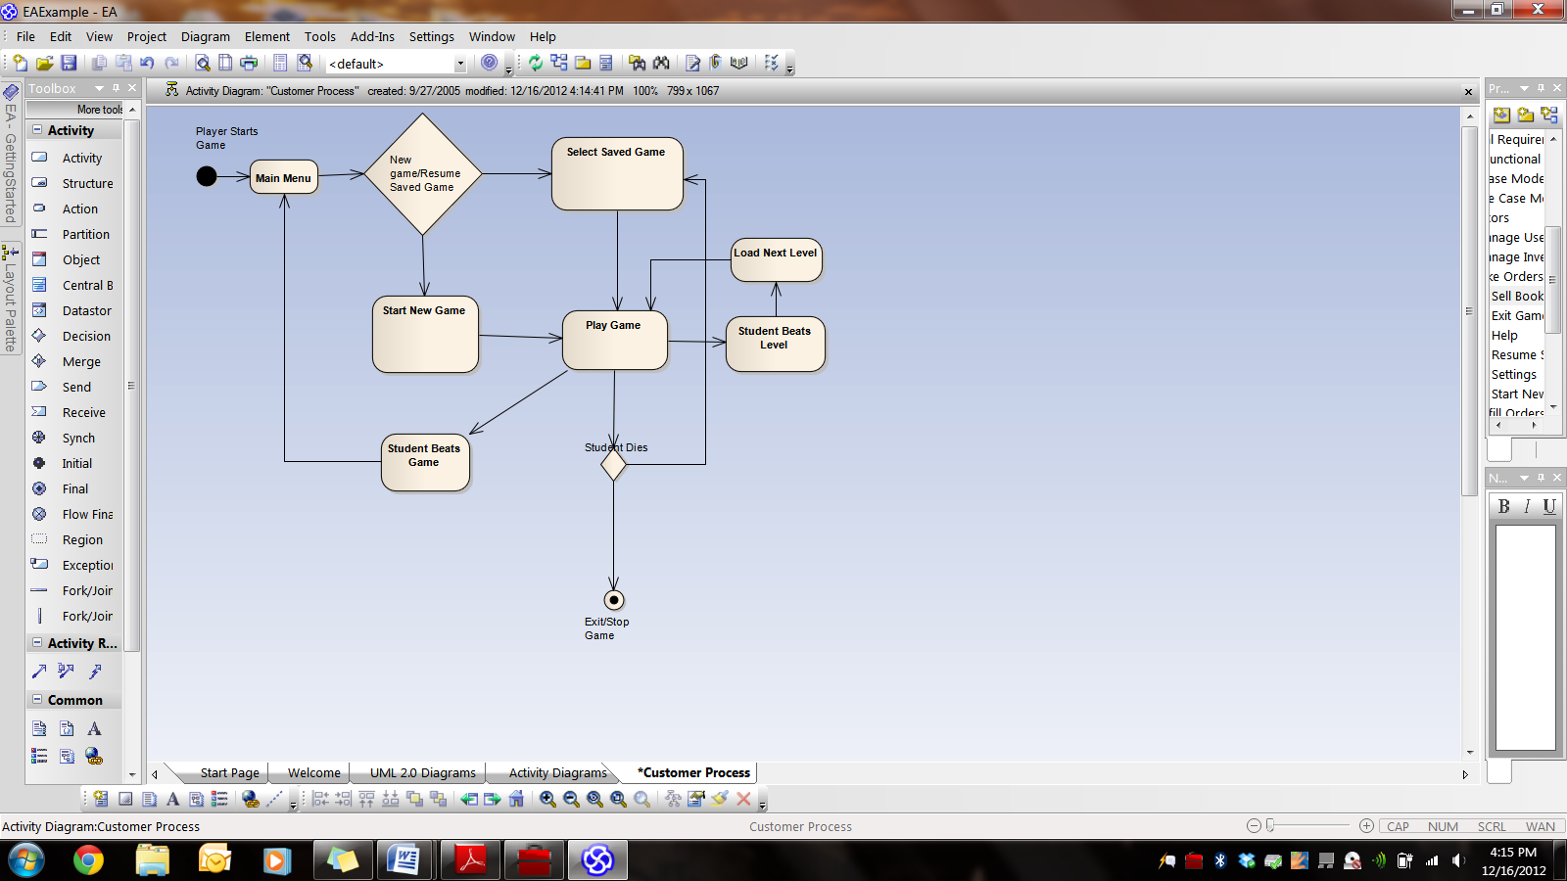

Storyboard:

