3D Game Pitch: a new day’s discovery

CIS 487  
jared Baker, michael greenleaf, Nader Khraizat, & gamal waza

# overview

## Appearance

The game will utilize art assets provided by Garage Games. As these assets are more realistic than cartoony in appearance, the game’s art style will lean towards realism. Additional 3D meshes will be obtained from sites like Turbosquid.com and modified in Blender, being retextured in some cases. The entire game plays out from the 1st person perspective. The game will take place over a full day, giving each level a unique set of lighting challenges. A heavy emphasis will be placed on particle effects and scene lighting.

**Concept Art:**

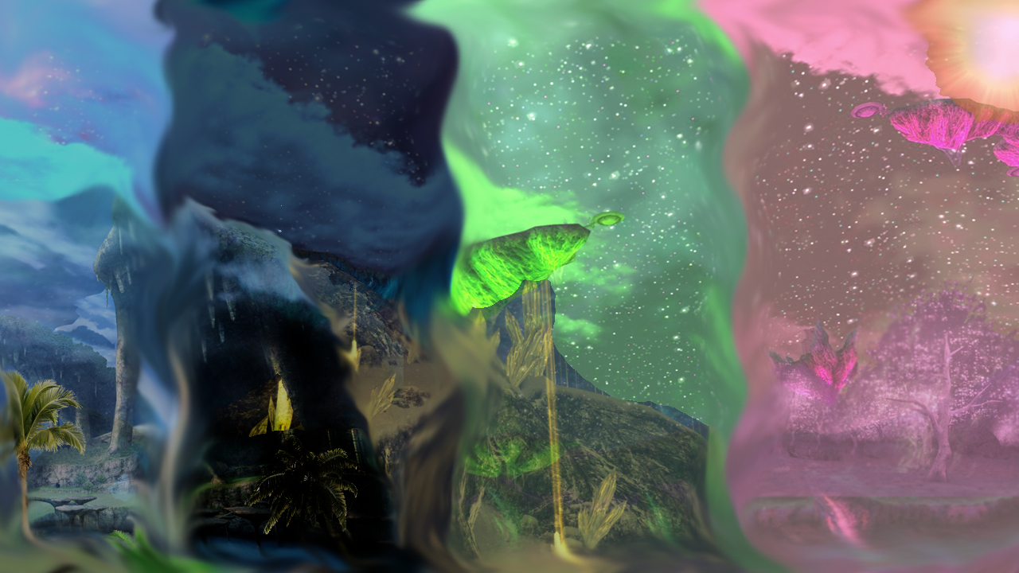

## story abstract

You awake to find yourself alone on a beach. You cannot remember who you are, or how you ended up on the sprawling island before you. The small footprints in the sand and a light in the distance are the best clues you can find that will illuminate just what is going on.

## gameplay

The gameplay is inspired by That Game Company’s *Journey* (2012). The emphasis is on exploration, navigation, and puzzle solving. Players will be able to run and jump in order to traverse the varied game levels. Progression from level to level will involve overcoming platform challenges and solving puzzles. Within a level players will search for Points of Interest (PoI), which will help develop the game’s story. An example of a POI would be a teddy bear that has been left along a path, signifying that maybe a child has been in the area.

**Update:** We were only able to implement platforming and exploration elements.

## development platform

Development will take place on the Windows (7 or later) platform using the MIT build of the Torque3D engine.

# Game mechanics

## user interface description

We will take a very minimalistic approach. All the player will have displayed for them is the number of PoI in the level. If there is time, a compass will be made that will point to the next PoI to be visited. The goal is to have as much of the game environment exposed as possible.

**Update:** The HUD did only include the PoI counter. There was not enough time to implement a PoI compass.

## use cases



## story telling

We will use an emergent storytelling style where the story is told over the course of the game. All the information the player is given at the start of the game is that they awake alone on a beach with a set of small footprints leading away from them. The player is not told who they are, or what their character’s gender is in an effort for the player to project themselves onto the main character of the game. Journeying from PoI to PoI across the four levels will slowly reveal how the main character ended up stranded, who the footprints seen at the beginning belong to, and their relationship to this person.

**Update:** This played out as planned. The small introduction is shown to the user and all other bits of the story are revealed through the PoI scattered about the levels.

## level summary

Each level is designed around a unique theme and is set at a different time of day. The opening level takes place on a tropical beach during dusk. The second level takes place in the caves under a mountain during the night. The third stage takes place outside in a snowy mountain valley during dawn. The final stage opens up to a cherry blossom field during mid-day. Essentially the player goes through settings that are reflective of summer, fall, winter, and spring over the course of the game. The levels will be united through their background music. While each stage will have its own song, they will share a melodic motif that will help link the levels together.

# User Interface design

## key screen images (**updated**)

Level 1: Tropical Beach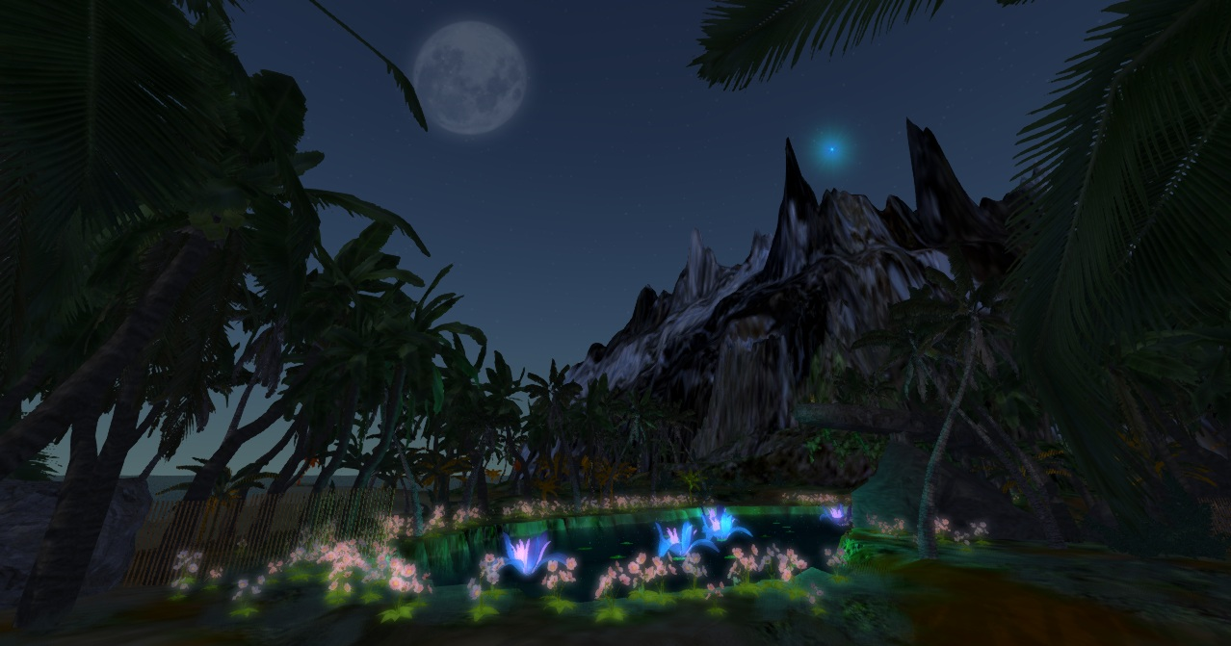

Level 2: Mountain Caves at Night

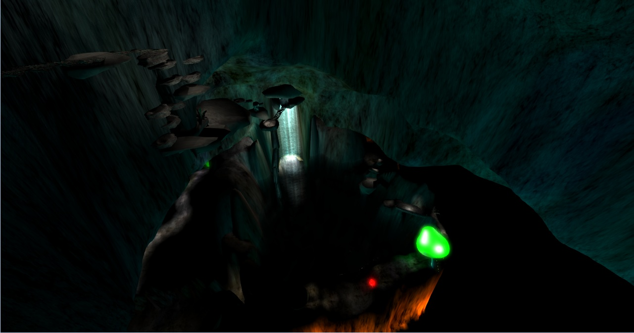

Level 3: Snow Valley at Dawn

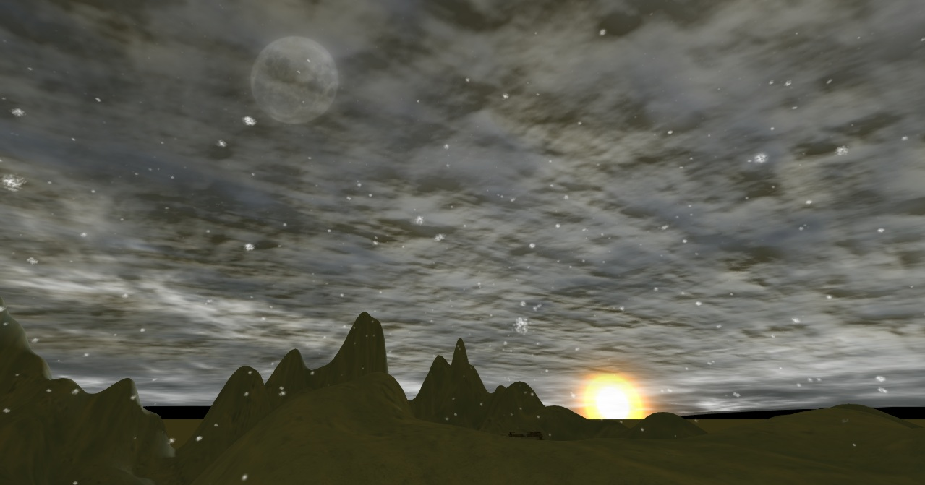

Level 4: Cherry Blossom Fields at Midday

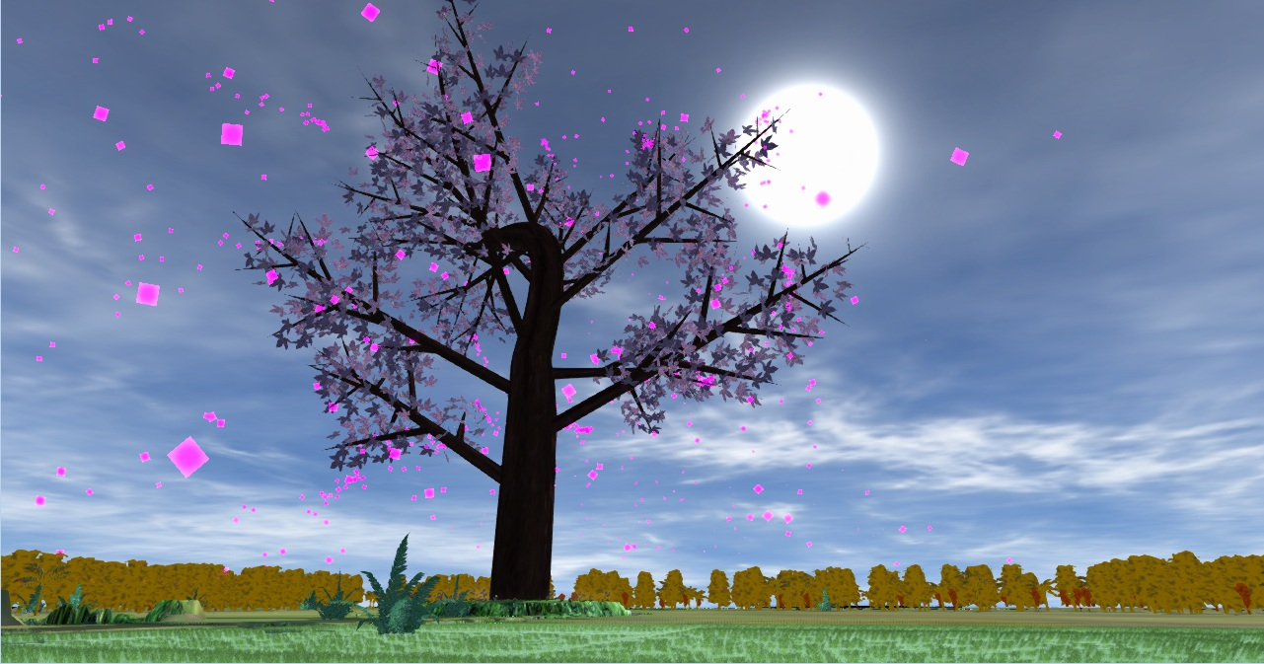

## control summary

* W = forward
* S = backwards
* A = strafe left
* D = strafe right
* Space = jump

## state transition diagrams



## design rules

For this project we will employ the KISS mentality given the time constraints: Keep It Simple Stupid. The main thing we will keep in mind while designing and building this game is that we have to develop a complete game by 12/17/2012. This means no half-implemented features. We will employ a three-tier design strategy, where working on a subsequent tier cannot begin until its predecessor is completed:

**Tier 1: Basic Level Building (Update: completed)**

* Build four compelling, unique levels.
  + Each level will contain PoI for the player to visit.
  + Each level will have its own music.
  + Each level will have unique art and lighting effects.
  + Make sure the player cannot get stuck in the environments (e.g. falling into a pit they cannot climb out of).
* Connect each level through in-game triggers (as opposed to selecting each level from a menu).

**Tier 2: Gameplay Elements (Incomplete)**

* Modify player’s jumping ability. **(Completed)**
* Add platform challenges to each level. **(Half implemented)**
* Add puzzle elements to each level. **(Not completed)**

**Tier 3: Features (did not reach tier 3)**

* Add PoI compass.
* Add traps.
* Add multiplayer component.

# Artificial intelligence

Artificial Intelligence in this game will only involve environmental triggers. For example, there will be switches to open doors and raise bridges. Also some platforms will move along scripted paths to make platforming more challenging.

**Update:**

* Triggers were implemented that allowed the player to transition from level to level without returning to the main menu.
* Moving platforms were not implemented due to time and issues with collision detection with moving objects.
* No switches for opening doors or raising bridges.
* Implemented a game ending trigger which exits the player from the game back out to the main menu.
* We did implement some interesting things regarding the way the wind emitter affected our trees. Hidden away in the Torque documentation was information that said that by texture painting trees a certain way the Torque wind emitter could make the trees bend and the leaves shake. Due to the time involved, this feature was only implemented on two trees (banana palm and skinny palm). These were modeled after existing Torque assets.

# Story overview

## plot summary

You wake up alone on an island. You notice a set of smaller footprints leading away from you. In the distance you can see an unnatural light glittering. This is all the player will know at the start of the game. Through the course of the game the player will come across visual clues that, in conjunction with the level-unique audio, will help fill in the story.

The story the player will discover goes as follows: A parent and his/her child wash ashore on a deserted island. The parent’s gender is never revealed, allowing the player to project him or herself onto the main character. The young child is awoken before the parent is, and is guided to the end game location by a whimsical spirit and his own curiosity.

The backstory is takes inspiration from the large immigration to the United States in the late 19th and early 20th century. Live was tough for the single parent and their child in their home country. The parent had to work long hours across multiple jobs just to survive. In order to escape this harsh life, the parent saved up all the money they could in order to board a ship to America, the land of opportunity. Unfortunately for this family of two, the ship they boarded was not soundly put together and was destroyed during a storm.

## storyboard

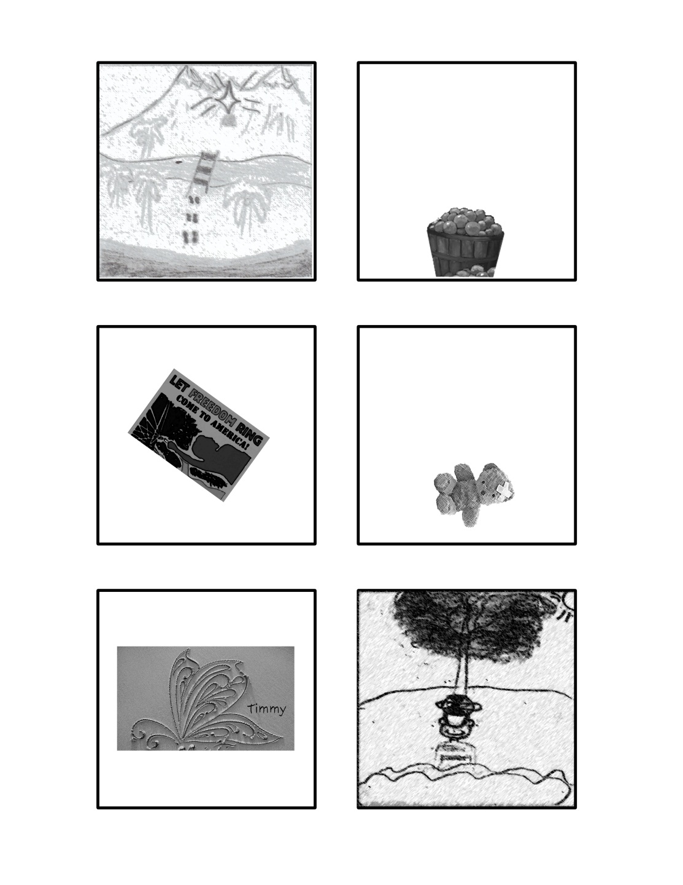

## character bible

* **Unnamed Parent (Player controlled):**
  + The main character (named Parent for this document) is not given a gender or race so the player can better project themselves onto the main character. That said Parent does have a backstory that is not as ambiguous.
  + The main character is a single parent who has a child named Timmy. Parent worked 16-hour days, splitting their time between the coal mine and the textile factory in order to raise Timmy. Facing rough times in their homeland, Parent decides to take Timmy to America, the new land of opportunity. Scrounging together what little money Parent could, Parent bought two tickets on the cheapest ship to America.
* **Little Timmy:**
  + Timmy is the seven-year-old child of Parent. He is a very happy child despite his family’s low income. Timmy generally has his head in the clouds and is a bit of a wanderer. If something catches his curiosity, one can bet he will chase after it until his curiosity is satiated.

# game progression

## Flowchart



## level and scene details

*Note: See individual level design documents for more detail*

* **Level 1: Tropical Island at Dusk**
  + There are some small footprints in the sand close to the player spawn point.
  + There is a noticeable pulsating light coming from the base of the distant mountain.
  + Puzzle and platform challenges are simple.
  + Music: Slower tempo where the melody gives off a feeling of curiosity.
* **Level 2: Mountain Caves at Night**
  + Level is mostly lit with point lights.
  + Florescent fauna and particle emitters are used to create a surreal atmosphere.
  + Puzzle and platform challenges are get slightly more complex.
  + Music: now that the initial tension has subsided, the tempo increases and joins instrumentation indicating the protagonist is starting to have fun.
* **Level 3: Snow Valley at Dawn**
  + It is snowing.
  + The early morning light gives the environment a yellowish hue.
  + Puzzle and platform challenges are get slightly more complex.
  + Music: Higher pitch that matches the falling snow.
* **Level 4: Cherry Blossom Fields at Midday**
  + There is a spring time feel.
  + Particle effects will make it look as though the cherry blossom petals are floating in the air.
  + The ambient light gives the environment a warm, rose-tinted hue (a light pink).
  + Puzzle and platform challenges are their most difficult.
  + Music: Softer instruments and a melody that signifies a resolution is near.

# bibliography

**Third party 3D assets:**

* Rope Bridge = Inkman Blender
* Fern = Sebastian Lague
* Iris = Kaisaki1342
* Bamboo Fence = Rovy Pessoa Ferreira
* Color Mushrooms = Ahmad Maad
* Realistic Rock = Eli Gershenfeld
* Boy = Dioniz
* Sack = Andi Hotz

**Music**: Kouhei Tanaka

**Reference Material:**

* *The Game Programmer’s Guide to Torque* by Maurina, Peters, 2006.
* Garage Games Torque Online Documentation: http://docs.garagegames.com/

# lessons learned

*For each team member’s specific lessons learned, see the separate post-mortem forms.

**General Lessons Learned:**

* Appreciate the work of 3D-modelling artists. This work is really tough when you want things to look nice.
* 3D sound has to be recorded in mono. It is so obvious why this is so, but during development it was problem we had to overcome.
* No matter how great the toolset before you may seem, there are always bugs. Also, it takes a while to learn a scripting language