3D Game Pitch
CIS 587
Davin Moilanen

Overview

Story Abstract
MDOT Madness! You are a mild-mannered software engineer who commutes to and from work by car. After a long day at work, your only wish is to get home as quickly as possible. However, no matter which way you turn, you run into roadwork; every road is filled with obstacles, narrowed down a single lane, or completely closed. It’s enough to drive you mad!

Target Audience
This game is mainly targeted at adults. It will not contain material that is overtly inappropriate for teenagers, but it might carry a parental warning due to the irresponsible driving style that the game could be perceived to encourage.

Appearance
The game will feature realistic physics and 3D graphics viewed in real-time from a 1st- or 3rd-person viewpoint. See Play GUI for an in-game GUI schematic. For the most part, “found” 3D models and textures will be used; these may be altered slightly to fit the game’s theme.
The game setting will be residential and business areas not completely unlike some areas in southeast MI. Since unplanned, disorganized, and ineffective roadwork is a ubiquitous part of every drive to and from any two points, the path between work and home will be littered with roadwork-themed obstacles. True to life, there will be no simple, safe path from point A to point B.
Since this game is a one-man development effort, it is unlikely that numerous, large, and/or elaborate missions will be feasible, so an attempt to maintain visual interest will make use of Torque’s existing environmental effects. Each mission will have a seasonal theme, with appropriate weather and environmental aspects.

Gameplay
This is a single player, 3D driving game. The player will use the keyboard and mouse to navigate a vehicle in a virtual environment. The object of the game is to drive from to the player’s home within a specific time limit. Colliding with some objects will add bonus points to the player’s score, while colliding with others will subtract points and/or damage the player’s car. The game will be divided into missions and each mission will conclude when the player arrives at a home base. The game ends when a mission is completed, when time runs out during a mission, or when the player’s car is destroyed.

Development Platform
The Torque Game Engine Advanced (TGEA) 1.8.0 will be used as the development platform. The TGEA Racing Starting Kit will be used as a starting point. The Torque Script language will be used to develop all game features.
MilkShape3D and Torque Constructor will be used to create some simple 3D models where appropriate “found” models are unavailable.

Game Mechanics

User Interface Description

Main UI
The main screen will display the game title and an array of buttons that invoke the following user-initiated actions:
- Start Game – Load the game and enter the play UI.
- Options – Popup the options dialog.
- About – Popup the about dialog.
- Exit – Exit the program.

Options UI
The options screen will display controls for changing game options in to following categories:
- Graphics – choose graphics card, screen resolution, texture quality, etc.
- Audio – choose sound card and configure volume levels.
- Controls – allow remapping of some keyboard commands.

Loading UI
The loading screen will display a progress bar and a description of the mission being loaded. A button will allow the user to cancel the load process and return to the main screen.

Gameplay UI
The gameplay screen will default to a 3rd-person view of the player’s vehicle in a 3D environment. The 3D view will be overlaid with various 2D heads-up display (HUD) indicators representing game progress and character status. See Play GUI for an in-game GUI schematic.

Game Over UI
The game over screen will show the player’s final score and an OK button to return to the main screen.

Use Cases
Player->Configure Options
Player->View “About”
Player->Select Level
Player->Play Game
Player->Exit Game

Storytelling
Significant story-related information will be conveyed to the user via text messages. These will include, but not necessarily be limited to:
- Text fields display the name and description of the selected mission as the mission is loading.
- A warning appears on the screen if the player misses a checkpoint.
- A message appears on the screen when the player’s vehicle is destroyed.

Level Summary
Two levels are currently planned for this game: fall and winter. The levels will each have a seasonal theme. Due to time constraints, I will use the same basic layout for both levels, each with a different seasonal theme. The winter level will feature reduced friction to present the player with a different type of challenge.

Location
The location represented will be similar to that of southeast Michigan. The terrain will have some minor elevation changes and will feature a large number of trees. Both levels will take place near the end of the workday, and the weather will be typical for the season. The fall level will have leaves swirling in the air, the sky will threaten rain, and the trees will be nearly bare. In the winter level, the sky will be overcast, snow and heavy, wet rain will fall, and the terrain will be covered in snow.
In some areas, the terrain will have more drastic elevation changes than is typical of the geographical location. This cheat will help guide the player to the expected goal. Since construction work sometimes involves digging deep, some large pits will be present throughout the levels.

Player
The player will always start at the “office” building. The goal is always to drive home as quickly as possible. The player does not have any inventory items to keep track of, and can assume that enough gas is in the car to reach the goal. Each level will start with a prompt that urges the player to drive home as quickly as possible.

Objectives
The primary objective is always the same – drive home as quickly as possible. The secondary objective is gain the highest score possible by minimizing damage to one’s vehicle, knocking over construction barrels, driving quickly to gain a time bonus, and avoiding the severe penalty for running over a construction worker.

Challenges
Each level will challenge the user by setting a minimal time limit – wasting time running into obstacles or driving slowly will lead to failure to pass the level.
Obstacles and hazards will be present throughout the level. Since the player needs to stick to the road in order to pass all checkpoints, they will be forced into encountering many of the obstacles.
Unlike many driving games, the player’s car will sustain damage after impacting most obstacles (excludes barrels). Sustaining damage will incur both a score penalty and possibly end the level if the car is completely destroyed.
The winter level will feature reduced friction to make the level more challenging. More time will be allowed, but the player will need to drive much more carefully in order to pass the level successfully.

User Interface Design

Key Screen Images

Play GUI
The Play GUI will be a set of control overlaying the rendered 3D scene.
- Score – The player’s current score.
- Checkpoint – The number of checkpoints reached over the total number of checkpoints.
- Time Remaining – The amount of the time player has remaining to complete the mission.
- Center Message – Displays an important message to the player. This control is only visible when a message is present and will disappear after a set amount of time elapses.
- Damage – The number of damage points remaining over the maximum number of damage points. The player will need to keep a watchful eye on this indicator since damage emitters are broken (see Known Issues for details).
- Speedometer – The player’s current speed.
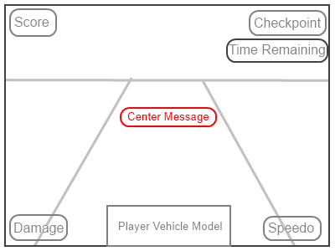

Control Summary

Gameplay Controls
Outside of gameplay interaction, the keyboard and mouse input will be interpreted as normal windowed GUI input. During gameplay, keyboard and mouse input will be captured and interpreted as player actions.

Movement
Mouse X Axis (yaw): Turn left/right
‘W’ or UP: Accelerate Forward
‘S’ OR DOWN: Apply Brakes
SPACE: Hand Brake

Other
CTRL-R: Reset car (flip it back onto its wheels, if necessary)
ESCAPE: Exit mission
TAB: Toggle 1st- and 3rd-person views
CTRL-O: Bring up options dialog
CTRL-K: Commit suicide (ends the game)

State Transition Diagrams

Design Rules
- Each mission will be seasonally themed, e.g. winter, fall, etc.
- Each mission will be fairly short in length to keep demo development time to a reasonable level – they can always be extended as time permits.
- To keep things interesting (and to leverage “found” terrains), the geography/topography of Michigan will not necessarily be respected in each level.
- “Found” object models will be preferred over custom models, again to minimize development time. Slight changes will be made to textures to keep with the game’s theme.
- The player will not be required to keep to the road surface, but each level should be designed so that keeping to the road is advantageous.
- Checkpoints will be placed along the preferred mission path to and the player can only complete the level by passing through the checkpoints in order. Since the checkpoints are invisible, the correct path will need to be clearly demarcated.
- Each level will end when the player arrives at home and parks in the driveway.

Artificial Intelligence

Opponent AI
There are no traditional “opponents” in the sense that non-player characters do not deliberately try to prevent your mission from succeeding. AI will be restricted to path-following construction workers who are just trying to do their jobs.

Non-Player Characters
Workers – These characters are either standing around doing nothing or wandering along pre-defined paths. They do not intentionally get in your way, but may be difficult to avoid since they tend to either move quickly or not at all. Avoid hitting these characters because even a moderate impact will injure or kill them – injure or kill a worker and it’s a 7500-point penalty! The player’s car will also sustain damage when impacting workers at high speed.

Reactive Items
Construction Barrels – These objects will be scattered throughout each mission. The player can score bonus points by running into as many barrels as possible. Collisions with construction barrels will not damage the player’s car. Each barrel will be worth 500 points. Collisions will send the barrels flying.
Obstacles – Each level will be filled with obstacles in the form of static objects and interiors. These obstacles will not react to impacts but will damage the player’s vehicle when impacted at high speed. The amount of damage will be proportional to the severity of the impact, and a minimum impact threshold must be exceeded before the player’s vehicle sustains any damage. Obstacles will include concrete barriers, raised manhole covers, and big metal plates covering who-knows-what in the middle of the road.

Story Overview

Plot Summary
The plot is split into days, with a mission corresponding to each day. Each mission starts with the player leaving work after a long, arduous workday. The goal is the same for each mission: get home as quickly as possible, avoiding obstacles that damage your car, and earning bonus points for taking out aggression on construction barrels.
Each mission is also themed to a different season, representing the idea that construction work seems to be present year-round. True to life, there is no end to this plot. The player can repeat each mission as many times as desired, perhaps trying to attain a higher score than the last time, but always with the knowledge that a similar challenge will be waiting on the very next day.

Storyboard

Leaving Work
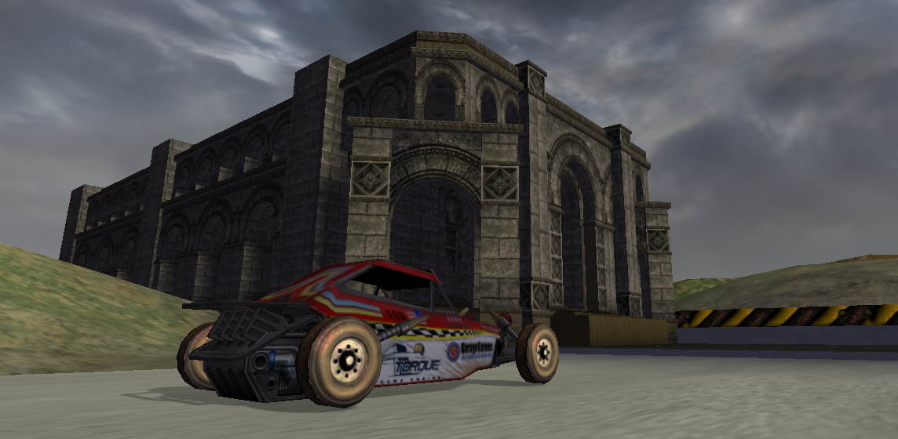

“Accidentally” Hitting Barrel
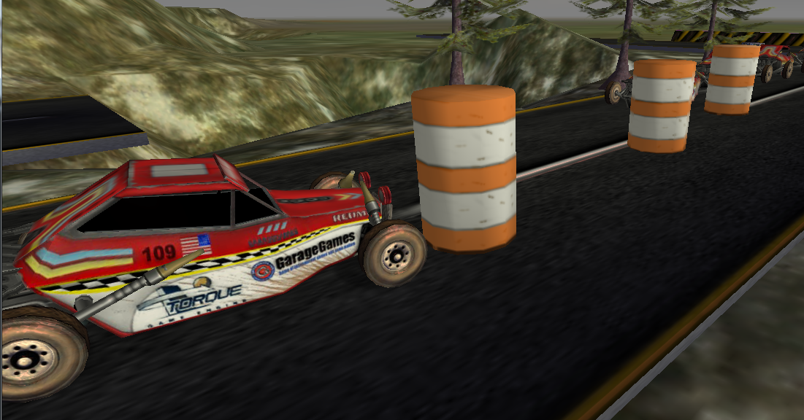

Safe at Home
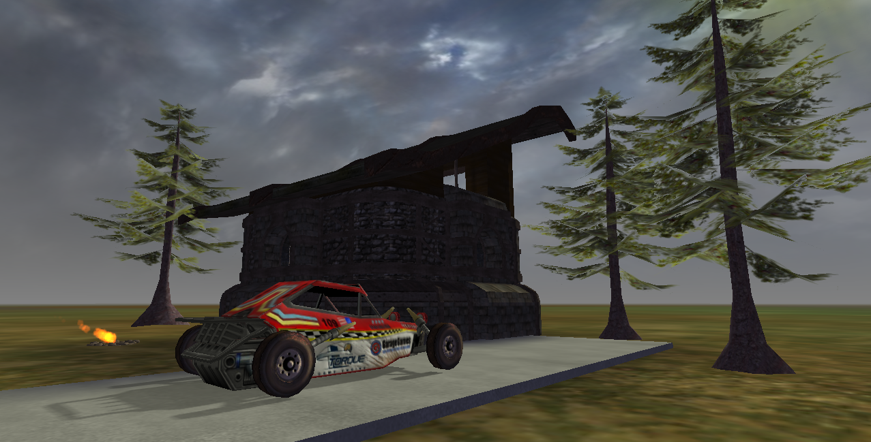

Character Bible

Player
We do not see the player directly, but rather the player’s vehicle from a 3rd- or 1st-person view. No one is quite sure why the player drives a dune buggy to and from work each day.

Construction Worker
Construction workers will be present in each level. None of them will be doing any actual work, but some will tend to move around rather quickly. Oddly enough, the workers appear vaguely orc-like. However, they are wearing bright orange vests and yellow hardhats, so they should be easy to spot.
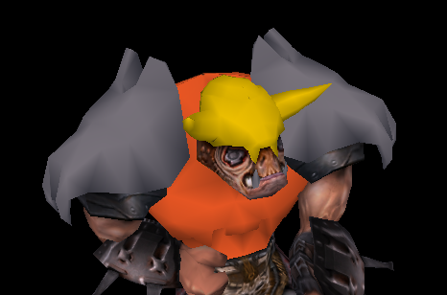

Construction Barrel
These are fun to knock down, and they are worth bonus points. Collisions with barrels will not damage the player’s car. The mass of the barrels will be set to a very low value in an attempt to prevent the car from being knocked off course too severely (See Lessons Learned for comments).
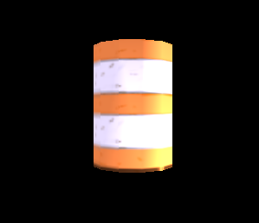

Game Progression

Flowchart

Level And Scene Details

Environment

Fall Theme
Trees will either be evergreen or deciduous with most of the leaves having fallen. Fallen leaves will swirl in the air.
The weather conditions will be partly sunny, with an ominous threat of rain.
The terrain will mainly be green grass, with brown patches suggesting the approach of winter.

Winter Theme
Trees will either be evergreen or deciduous with all the leaves having fallen.
Snow and heavy rain will fall from the overcast sky. It will be dark and gloomy at all times.
The terrain will be covered with snow and ice.

Interiors

The Office
This building marks the start of each mission.
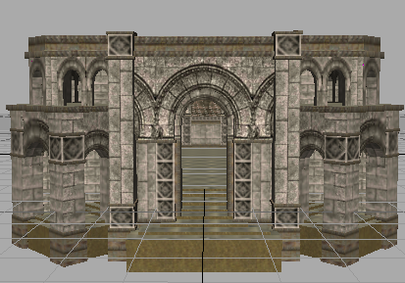

Home
This building marks the end of each mission.
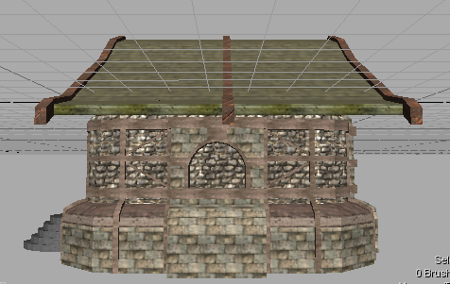

Concrete Barrier
Barriers are obstacles that can cause serious damage to the player’s vehicle. On the other hand, they are useful in that they can help the player discover the expected route to the end of the mission.
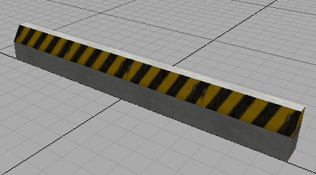

Road Section
The player should try to stick to the roads to minimize vehicle damage as well as be certain that all checkpoints are encountered.
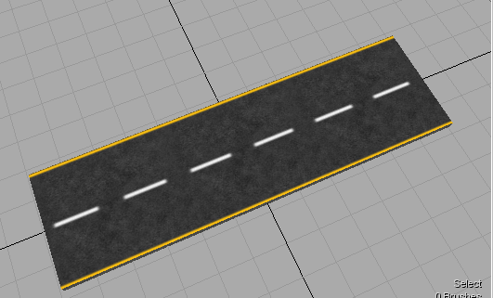

Big Metal Plate
This can do some real damage to the player’s vehicle.
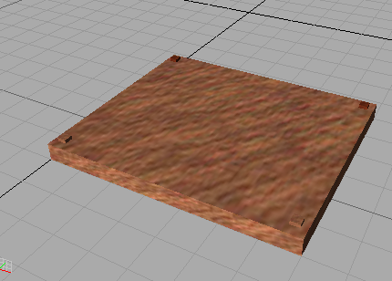

Static Objects

Raised Manhole Cover
This obstacle is less likely than the Big Metal Plate to damage the player’s vehicle, but it can still force the player off course if it is run over at a high speed.
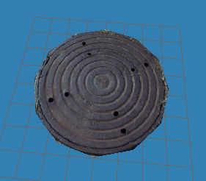

Bibliography
Finney, K. C. (2005). Advanced 3D Game Programming All In One.
TGEA Racing Starter Kit. (n.d.). Retrieved from http://3dcentral.net/downloads/torque/tgeaRace/TGEA_starter_racing.zip
Torque 3D Documentation. (n.d.). Retrieved from http://www.garagegames.com/products/torque-3d/documentation
Torque Wiki. (n.d.). Retrieved from http://tdn.garagegames.com/wiki/

Resource Listing

Main Sources
The following sources will be used for the majority of the models, sounds, and textures used in this game. Where DIF versions were incompatible, they will be re-exported from the source MAP files using the latest version of Torque Constructor. In some cases resources will be modified to fit the game’s theme.
- TGEA Racing Starter Kit
  - Models
  - Missions
  - Sounds
  - Code
- Torque Game Engine 1.5.2 Demo (bundled with Torque Constructor)
  - Models
  - Sounds
- Torque Game Engine 1.2 Demo (CD accompanying Finney’s Book)
  - Models
  - Sounds

Other Sources
- Google Image Search
  - Manhole cover texture
  - Construction cone image
- MDOT website
  - MDOT logo

Lessons Learned

Challenges
- The vehicle physics in Torque is very difficult to get right, and the default settings do not provide intuitive results. Significant modifications will need to be made to even make the vehicle drivable.
- The physics of vehicle/rigid object collisions appears to be flawed. For instance, in tests, even though the vehicle outweighs the collided object by a factor of approximately 5000:1, the vehicle still loses speed and lurches/jumps when it impacts the object. Decreasing the mass of the collided object any further causes the engine to crash. Increasing the mass of the car (even with spring adjustments) makes the car un-drivable. At this point, I do not have any ideas on how to solve this problem.
- The TGEA World Editor is extremely unstable. It crashes without warning, fails to process mouse and keyboard input correctly, deletes unselected objects, corrupts mission files, and so on. This, among other things, makes the prospect of developing expansive levels a remote possibility.

Known Issues
- When damage emitters are enabled on the player’s vehicle, the engine crashes consistently upon mission completion. When the emitters are commented out, the problem goes away. Without damage emitters to indicate that the vehicle is sustaining damage, the player will need to keep an eye on the GUI damage indicator in order to determine the vehicles damage level.
- Sounds attached to the vehicle object sometimes stop working for no apparent reason. It is usually the engine sound that eventually fails.
- The game sometimes loses mouse and keyboard input, and the vehicle stops responding to some or all input. This problem appears to be exacerbated by running in windowed mode (i.e. not full screen).
- The engine crashes inconsistently and for no apparent reason. This is true in both unmodified demos and demos containing test modifications. For example, one run will crash as soon as a mission loads, while the next time the same mission loads successfully. Baffling.

