A Gathering of Crows
3D Game Design Document v2.0
2011
Carlos Devoto
CIS 587
12/19/2011
Contents
Revision Notes 6
Overview 6
Story Abstract 6
Appearance 7
Gameplay 7
Development Platform 8
Target Audience 8
Game Mechanics 8
Camera Position 8
User Interface Description 9
Use Cases 10
Storytelling 10
Level Summary 11
User Interface Design 12
Key Screen Images 12
Main Menu Screen: 12
Options Dialog: 13
Introduction Screen 1: 16
Introduction Screen 2: 17
Start Mission Screen: 18
Join Game Server Screen: 19
Game Load Screen: 20
Play Game Screen: 22
Scoreboard Dialog: 22
Game Lost Screen: 23
Game Won Screen: 24
Replaying and Saving 25
Control Summary 25
Game Play Details 25
System State Transition Diagram 27
Design Rules 27
Artificial Intelligence 28
Opponent AI 28
Non-Player Characters 28
Reactive Items 28
Health Potions 28
Bundles of Crossbow Bolts 28
The Iron Crown 28
The Main Gate 29
Moving Outside the Fortress 29
Story Overview 29
Plot Summary 29
Storyboard 30
Cut Scenes 30
Character Bible 30
Hero – Unnamed(You) 30
Game Progression 32
Flowchart 32
Level and Scene Details 33
Attribution 33
Bibliography 33
Lessons Learned 34

Revision Notes
Feedback | Provided By | Revision
Triggers do not work properly along vertical dimension. | Bruce Maxim | Adjusted the rules for respawning items based on time lapse as opposed to zone egress. Item placement in locations where the player is made vulnerable will be used instead as a deterrent to nesting.
Players have no special inducement to acquire the Iron Crown until all other players have been killed. | Louis Devoto | When a player acquires the Iron Crown, he or she will also acquire the Leap of the Gods ability, which provides a significant enhancement to the player’s ability to maneuver between the different levels of the fortress.
The level description section lacks sufficient detail. | Bruce Maxim | More detail has been added to the appropriate sections.
The default “Query LAN Servers” functionality provided by Torque relies on UDP broadcasts, which means that you cannot test client-to-server functionality if you are not connected to a LAN. Many network administrators also disable UDP broadcasts within their networks for security reasons. | Carlos Devoto | I have modified the “Join Servers” dialog provided with the Torque demo such that, if you know the IP and port of the Torque server that you want to connect to, you can type it in directly instead of using the “Query LAN” functionality provided by Torque. This allows you to connect to a dedicated server running on your own machine when you are not attached to a LAN, and it also allows you to connect to a server running in a LAN directly without using UDP broadcasts.

Overview

Story Abstract
Sjoerd Stormcrow had accomplished much over the course of his thirty-three-year reign. Under his rule, the orcish tribes of the Moch Magore had set aside their ancient squabbles, boiling up from their ancestral dwelling places deep beneath the Fanhadon Mountains to sweep across the surface kingdoms of the humans, elves, and dwarves. Those who stood against his legions were swept aside like chaff. Those unable to resist were enslaved and sent to work in the slag pits. Through sheer force of will, Sjoerd had managed, over the course of the past thirty years, to forge a mighty orcish empire that stretched across the land from the sun-baked Barrens of Saravannon in the South to the ice-choked Sea of Shards in the North.
And now, with a single dire pronouncement from this withered crone who stood before his throne, the entire fabric of his life’s work was threatening to unravel. She had never been wrong before, this cursèd Doomsayer of the Bloodspear tribe. She had prophesied his rise to power when he was still an unblooded whelp, begging for scraps at the foot of his father’s table. Sjoerd had no choice therefore but to believe her when she foretold that he would be dead within the fortnight. His thoughts ran immediately to his many sons; how the empire would be rent asunder as they fought like crows over the leavings of his great legacy when he was gone. He could not, he WOULD not, allow this to come to pass! With the grim resolve that had characterized so much of his rule, he quickly settled on a course of action and began to bark commands to his coterie of attendants.
“Summon all of my sons to the Fortress of Zul-Jarak! Tell them that there will be a great contest, and that only the strongest among them shall live to wear the Iron Crown.”
“A Gathering of Crows” is an online multi-player first-person-shooter in which each player assumes the role of a scion of the Stormcrow clan—an orc warrior in the line of succession to inherit Sjoerd Stormcrow’s throne. By order of their father, the players have all been summoned to the Fortress of Zul-Jarak where they are sealed in and told that they must engage in a death match in order to determine who will succeed to the throne. Players are armed with crossbows and equipped quivers full of explosive bolts. The gates to the fortress have been barred from the outside, and only open when the last living player takes possession of the Iron Crown, a relic hidden somewhere on the grounds of the fortress. Also scattered throughout the fortress are additional quivers and healing potions so that players may replenish their stock of resources.

Appearance
The game takes place entirely within the abandoned orc fortress of Zul-Jarak, a spartan structure which rises up out of a fog-shrouded moor. The fortress consists of a central keep, and an enclosed bailey. The fortress walls are studded with crenellations, including parapets to allow for movement along the battlements. Rounded towers are set at intervals where different segments of the outer wall meet. Players can climb these towers using staircases that spiral upwards through the tower interior, and use them to access the wall parapets or the tower roof. The central keep consists of two stories separated by stairs, including several rooms, a fortified balcony, a fortified roof, and embrasures which are set along the walls facing the bailey. A few out-buildings also line the bailey providing additional places for the players to move around and hide in. The main goal of the fortress design is to provide the players with a three-dimensional battlefield replete with hiding places and ambush sites. A heavy fog overlays the entire setting in order to further limit visibility and create the illusion of space. A large statue of an orc champion stands in the center of the bailey in order to remind everyone that this is an orcish fortress. The entire fortress is sparsely furnished and decorated, reflecting the orcs’ militaristic disdain for affectation and the trappings of comfort. The stout, oaken gate leading into the fortress has been barred shut from the outside to prevent the sons of Sjoerd from escaping until after the death match is complete. Ammo clips, health potions, and the Iron Crown are located throughout the complex, and manifest themselves as rotating 3D objects.

Gameplay
The game is designed for two to eight players, with no provision for a single-player mode. Preferably, the game requires a dedicated server, though any one of the players may host the server. Other players may discover a server and join it. Each player must provide a name which will be used to uniquely identify the player’s character within the game. Once a player has joined the game, he or she appears at one of eight spawn locations located throughout the fortress. Players may communicate with each other via broadcast messages which are displayed using a Message HUD. The Message HUD is also used to broadcast key events to all of the players as they occur. Each player’s viewpoint defaults to a first-person perspective, but players may freely toggle between first- and third-person perspectives. Each player is armed with a crossbow and equipped with a quiver of 10 explosive bolts. Players may move around using standard key combinations, and employ the mouse to aim and fire their crossbows. Each use of the crossbow depletes the character’s stock of ammunition, which may be replenished up to the maximum capacity of 50 by gathering bundles of crossbow bolts located throughout the fortress. Crossbow bolts strike their targets with an explosive impact. Any player caught in the blast takes damage. When a player’s health reaches zero, the player is dead and out of the game. Players may replenish their health by gathering health patches located throughout the complex. Ammunition bundles and health potions re-spawn after a predetermined time interval. The objective of the game is to kill all of the other players, and to gather up the Iron Crown. Doing so will cause the gates of the fortress to open thereby allowing the victor to exit the fortress and win the game. The Iron Crown is a unique item which may be found somewhere within the fortress. The Iron Crown may be gathered up any player at any time. Once a player has taken possession of the Iron Crown, it may not be taken away from that player until the player in question is killed, at which point the Iron Crown will reappear at the location occupied by the player at the time of his death. If the player was killed by venturing out of the fortress prematurely, the Iron Crown will instead reappear at its original location.

Development Platform
The game will be developed for the Windows platform using the Torque Game Engine (TGE) version 1.5.3. In addition to meeting the system requirements for TGE v. 1.5.2, network connectivity is a must, since the game is designed to only support an online multi-player mode.
Required Hardware:
- Pentium II/400 - AMD/400 (or better), 128MB RAM, 20+GB HD
- Windows XP/Vista/2007
- AGP Radeon or GeForce class w/32MB (Radeon 8500 or GeForce3 w/64MB highly recommended)
Required Software:
- Latest drivers for Video board
- DirectX version 8.0 or later.
- OpenAL Runtime or SDK Installation

Target Audience
In this game, the players are trying to kill each other, but there are no graphic depictions of violence, so the game is appropriate for teen-agers and adults. The controls are fairly simple to master, and there are no complex mechanics for resource management or character development. This game is therefore well suited to casual gamers who have never played a first-person shooter game before, as well as more experienced gamers who enjoy the thrill of pitting themselves against fellow gamers.

Game Mechanics

Camera Position
Each player’s viewpoint defaults to a first-person perspective, but players may freely toggle between first- and third-person perspectives by pressing a key. In first-person mode, players may also press a key to zoom in on a target, thereby making it easier to aim the player’s crossbow at the target in question. A crosshair symbol is displayed in the center of the screen which also makes it easier for players to aim. When a player has another player in his crosshairs, a small bar is displayed beneath the target denoting the target’s current health. When an enemy player appears on the screen, his name is also displayed in green above the character so that players can identify each other easily.

User Interface Description
The user interface will consist of the following major screens and dialogs:
- Main Menu: This is the first screen that players see. It contains a splash screen image; the game title and credits; and three buttons (“Start Mission”, “Options”, “Quit”).
- Options Dialog: This is a pop-up dialog that players can use to set their audio, graphics, and keyboard preferences.
- Start Mission Screen: Within this screen, the player specifies his or her player name, and elects whether or not to host a new game server.
- Join Game Server Screen: This screen is displayed to players who elect not to host a new game server. It provides controls that the player may use to locate an existing game server (either on the LAN or on the Internet), and to join a game. I have modified the “Join Servers” dialog provided with the Torque demo such that, if you know the IP and port of the Torque server that you want to connect to, you can type it in directly instead of using the “Query LAN” functionality provided by Torque. This allows you to connect to a dedicated server running on your own machine when you are not attached to a LAN, and it also allows you to connect to a server running in a LAN directly without using UDP broadcasts.
- Game Load Screen: This screen is displayed to players while the game is being loaded. It provides a brief description of the primary game objective. It also describes the basic controls that are used to play the game.
- Introduction Screen: This screen is displayed to players after the game is loaded. It provides the story of Sjoerd Stormcrow and his sons as a backdrop to the game.
- Game Screen: This is the main game screen. It provides player with a 3-dimensional view of the game world. The viewpoint defaults to first-person perspective, but can be freely toggled to third-person perspective. The game screen includes three additional graphical components:
  - Message HUD: Allows players to communicate with each other via broadcast messages. Also used to broadcast system notifications to all of the players as different events occur.
  - Health HUD: Shows the amount of health that the player has remaining. When the player’s health reaches zero, the player is dead.
  - Ammo HUD: Shows the amount of ammo that the player has remaining. When the player’s ammo reaches zero, the player cannot shoot his crossbow.
- Scoreboard Dialog: This dialog may be launched from the game screen by pressing F2. It displays a list of all players together with the number of kills that each player has achieved during the current mission.
- Game Over Screen: This screen is displayed to users when the game is over. It includes a list of the game scores at the time that the player exited the screen. Depending on whether the player won or lost the game, a different message is displayed within this screen. This screen automatically transitions to the Game Load Screen when the current game ends and the game is cycled.

Use Cases

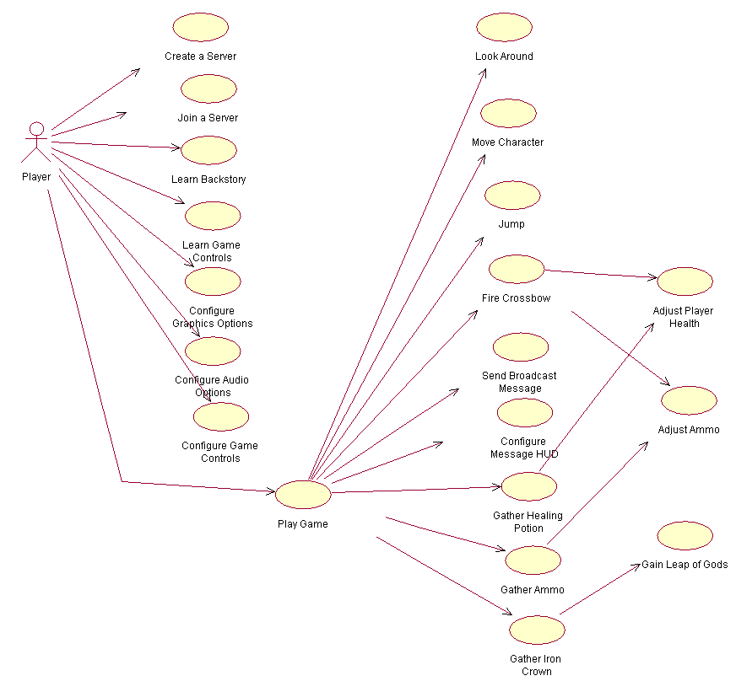

Storytelling
The story of the game is relayed to the player via two “Introduction” screens which present players with a brief textual history of Sjoerd Stormcrow’s rise to power and set the stage for the high stakes death match between his sons within the fortress of Zul-Jarak. The story is further propelled forward within the “Game Over Screen”, which describes the winning/losing player’s fate after the death match ends. Admittedly, these types of narratives would be better handled via cut scenes as opposed to text. As the only developer on this project, I did not want to over-extend myself.

Level Summary
The mission consists of navigating through a single closed environment with various zones. As such, the game is comprised of only a single level. Players are not allowed to exit the fortress until they have acquired the Iron Crown, and slain all of their opponents. Once a player has succeeded in completing both of these objectives, he or she may exit the fortress through the main gate. Players who exit the fortress without meeting all of these conditions (e.g. by leaping from the castle walls) are immediately removed from the game. A player who is killed is also immediately removed from the game.
The castle grounds are perpetually shrouded in a light fog and consist of various indoor and outdoor zones. The castle itself consists of various components, including:
- The Outer Wall – Players can reach the top of the outer wall by navigating up the spiral staircases that are located inside various towers situated where two wall segments meet.
- Towers – There are ten towers located throughout the castle. Towers provide the main means of navigating between the vertical levels of the castle. Each tower has three levels connected by a spiral staircase.
- The Gatehouse – The gatehouse provides the sole conventional means of exiting the fortress in the form of a stout oak gate. The gatehouse includes two levels plus a roof level that can be reached by climbing up spiral staircases. The first and second levels have two rooms each. Doorways allow access to the main bailey, and also provide access to the parapet that runs along the outer wall of the keep. Players may also navigate to the gatehouse roof.
- The Keep – The keep includes two levels plus a roof level that can be reached by climbing up spiral staircases. The first and second levels have several rooms, including a large throne room that spans both levels and which features a galleried balcony. The Iron Crown is kept within this throne room.
Ammo bundles and health patches are located at various positions throughout the fortress, strategically positioned so that players who attempt to reach these items will be exposed to enemy fire.
All in all, the level is designed to provide players with plenty of places to hide and move about. Special care was taken to deter players from nesting in any one position. This was accomplished via item placement, but also by ensuring that there was no way for the player to cover every entrance to a given room with his crossbow.

User Interface Design

Key Screen Images

Main Menu Screen: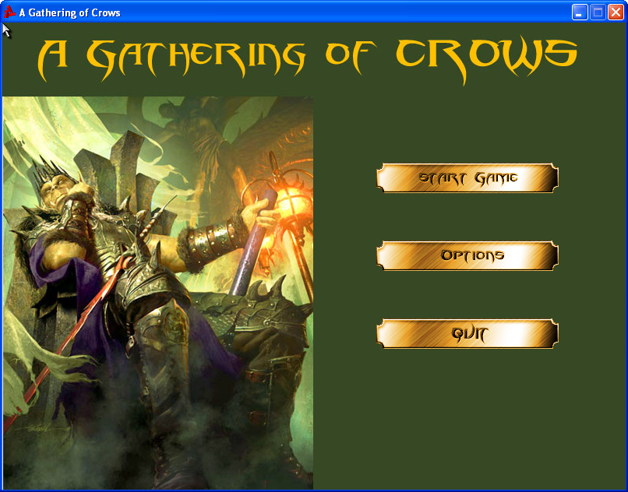

Options Dialog:
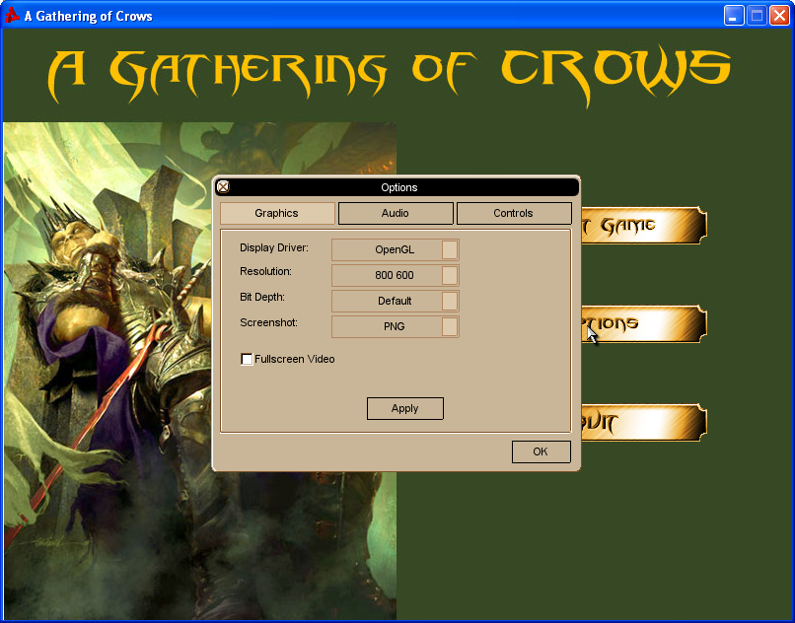
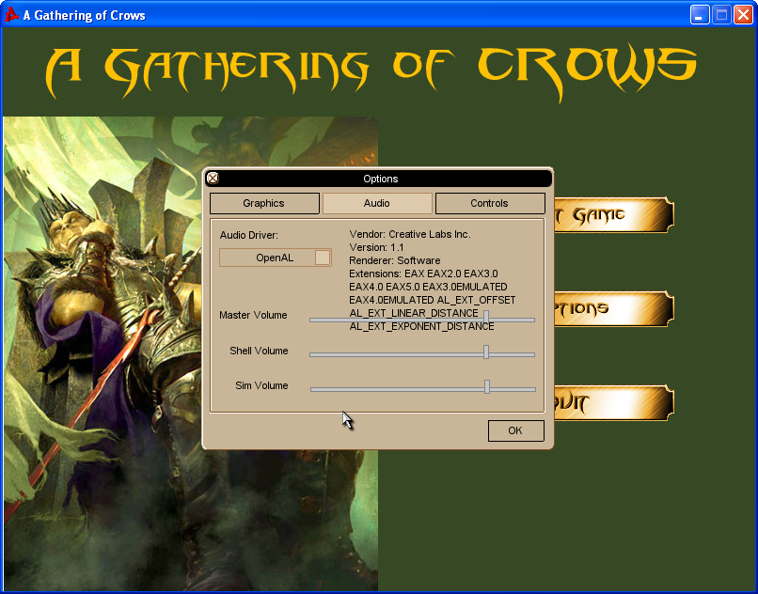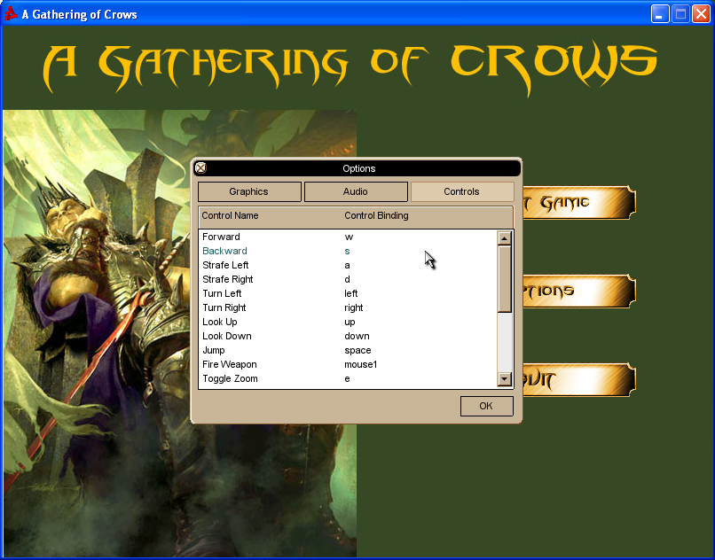

Introduction Screen 1:
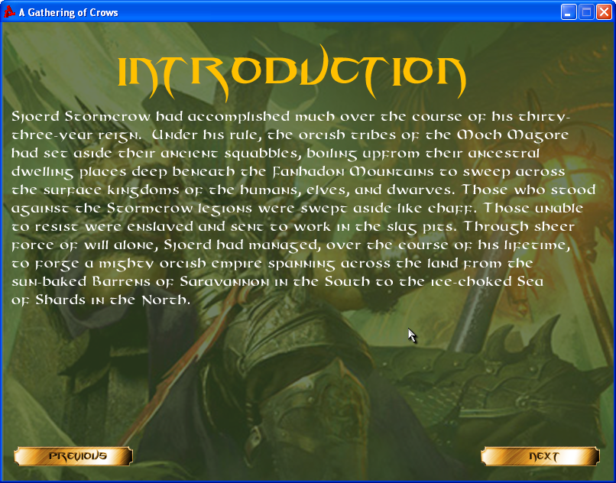

Introduction Screen 2: 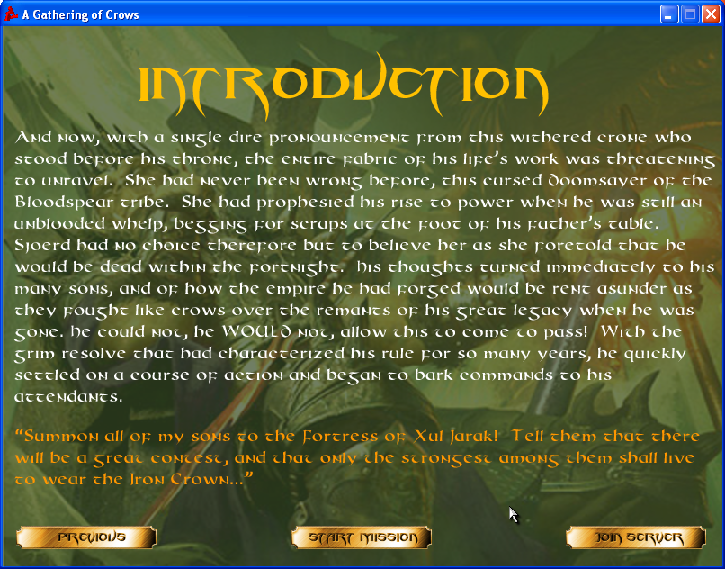

Start Mission Screen:
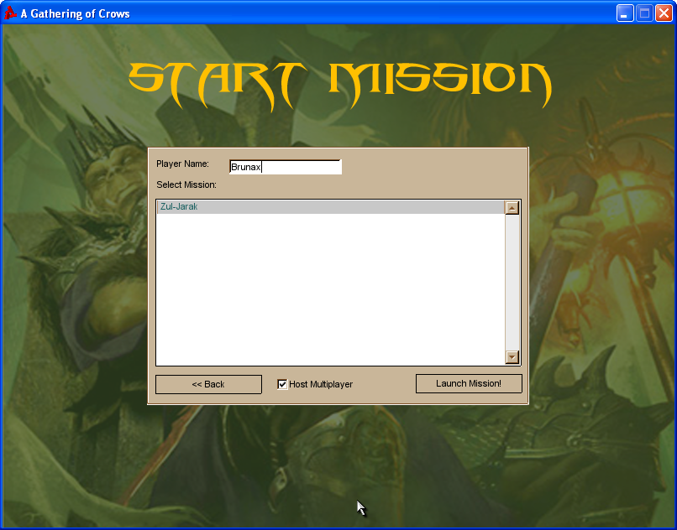

Join Game Server Screen:
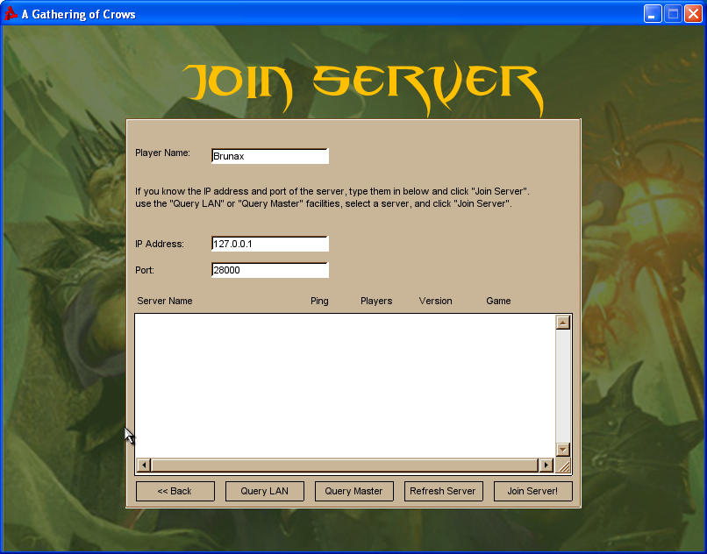

Game Load Screen:
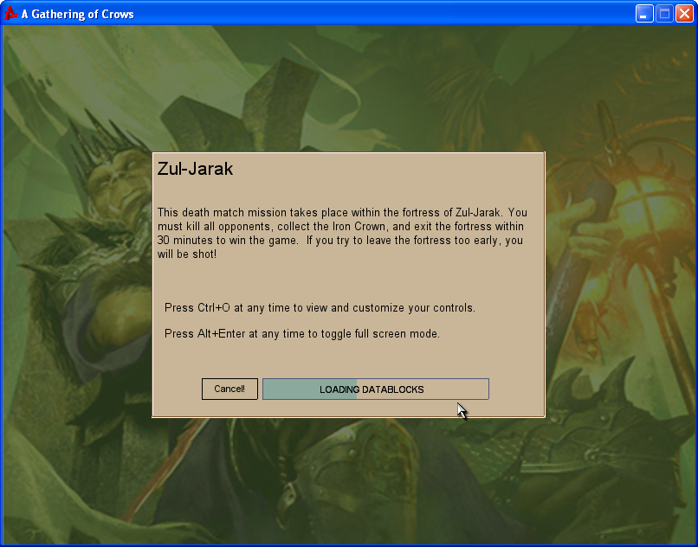

Play Game Screen:
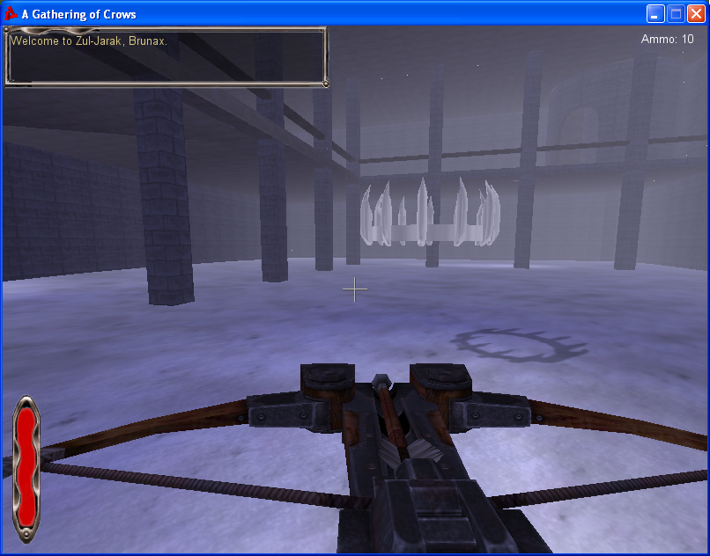

Scoreboard Dialog:

Game Lost Screen:

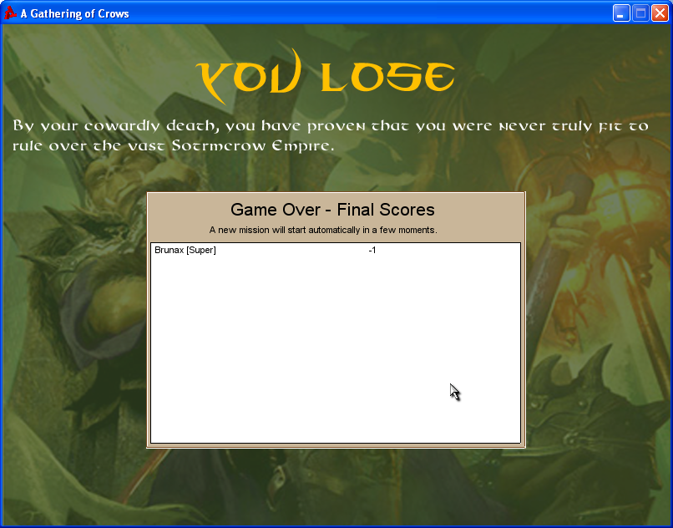

Game Won Screen:
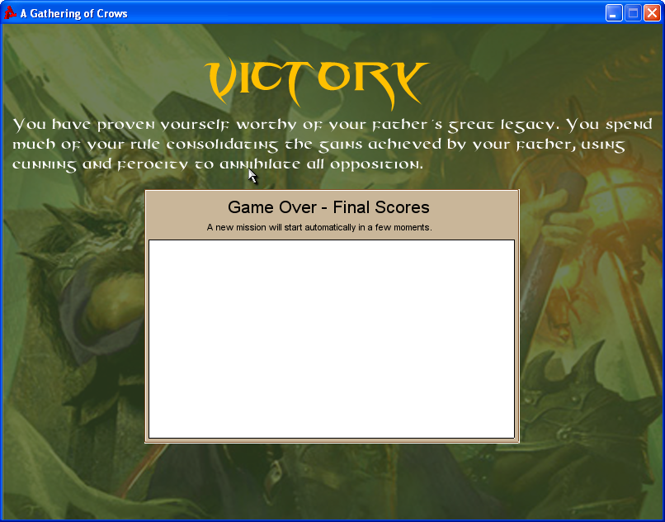

Replaying and Saving
When a player is killed or wins the game, he or she is presented with a “Game Over” screen which informs the player that a new mission will commence automatically shortly after the current mission ends. If the player simply waits, the game will cycle itself automatically a few seconds after a given mission ends, allowing players to maintain their existing connections without having to join the server again.
As a death match style game, A Gathering of Crows will not include any provisions for saving the state of the game itself. Players are, however, allowed to customize their player name, video options, audio options, and control triggers; these changes are automatically persisted to the file system.

Control Summary
The game will use the standard Torque-defined game controls where applicable, as shown in the table below.
Action | Control
Move Forward | W
Move Left | A
Move Down | S
Move Right | D
Jump | Spacebar
Rotate Camera | Mouse Movement
Fire Weapon | Left-Click Mouse
Toggle Zoom | E
Switch from first- to third-person perspective | TAB
Send Broadcast Message | U + <type a message> + ENTER
Message HUD Page Up | PAGE UP
Message HUD Page Down | PAGE DOWN
Resize Message HUD | P
Show Scores | F2
Bring up Options Dialog | Ctrl+O
Leave Game | ESC

Game Play Details
- The game requires a minimum of two players and a maximum of eight.
- When players die, they do not respawn. This means that individual players exit the game at different intervals. It is therefore best to run the game using a dedicated server. Doing so prevents a hosting player from stopping the server by closing the app as soon as he or she is killed. Players who leave the app running after they are removed from the game will automatically be reconnected to the server as soon as the current game ends (i.e. the server cycles the game automatically as soon as it ends).
- If less than two players join the game, the victory conditions cannot be met. The front gate will never open, and when the player attempts to leave the fortress, he or she will be shot. This prevents players from winning the game before other players have a chance to join.
- Once any player has been killed, the game roster is “locked”, and no other player is allowed to join. Players who attempt to do so will be told that the server is full. This prevents players who have been killed from rejoining the current mission simply by reconnecting to the server.
- When a player picks up the Iron Crown, he or she will acquire the “Leap of the Gods” ability. This ability provides a substantial increase to the player’s jump force. Because of the three-dimension nature of the level design, a player with this ability has a significant advantage in terms of being able to reach various areas of the map more quickly than other players. This ability therefore serves as a strong inducement for players to acquire the crown, and also to focus fire on the player who is currently in possession of the crown.
- To win the game:
  - At least two players must have joined the game.
  - No more than 30 minutes may have elapsed since the mission started.
  - Only one player remains alive.
  - The surviving player must have possession of the Iron Crown.
  - The surviving player must exit the fortress.

System State Transition Diagram
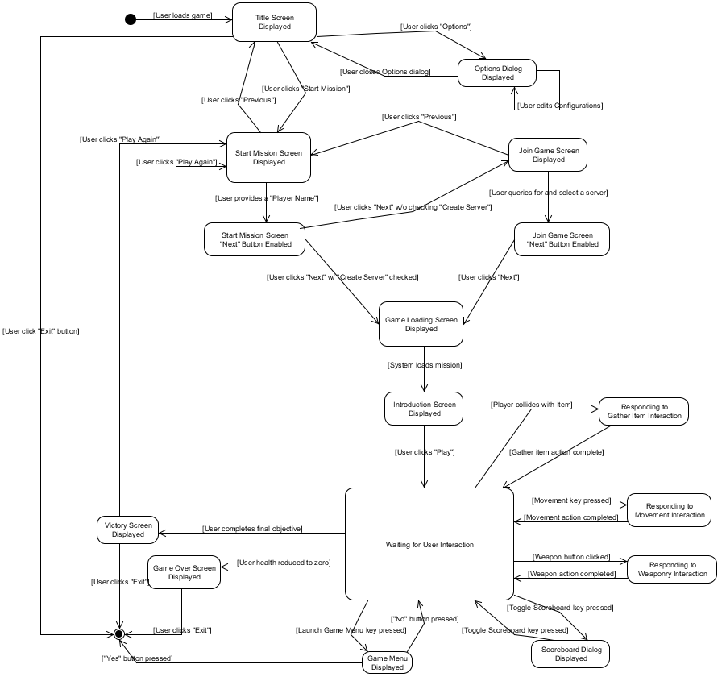

Design Rules
Game design will focus on providing intuitive and easy-to-learn user interfaces. Because this is a one-man project and because Torque is mostly terra incognita to me, the success of the project will depend on a carefully scoped project plan which relies heavily on the use of multi-media assets, framework capabilities, and pre-written demo code provided by the Finney CD and other online resources. I anticipate that a significant portion of my effort will be occupied by world design. I have set forth a fairly ambitious task for myself by designing a large 3D fortress layout in order to differentiate my game from the FPS demo. This will include leveraging the capabilities of Torque to create fog. The goal again is to create a compelling three-dimensional battlefield with plenty of ambush sites, and opportunities for ad hoc collaboration via messaging.
Special care was taken to deter players from nesting in any one position. This was accomplished via item placement, but also by ensuring that there was no way for the player to cover every entrance to a given room with his crossbow.

Artificial Intelligence

Opponent AI
All opponents will be controlled by the players themselves. In other words, the game is designed for pure PVP game play.

Non-Player Characters
The only NPC referenced within the game is Sjoerd Stormcrow, who is the father of the player characters. His role in the game is purely narrative in function, and he will not be represented during actual game play.

Reactive Items
Several types of items will exist in the game which respond to user interactions. These are described below.

Health Potions
Health potions will be located at different spots throughout the fortress. Players may imbibe a health potion simply by colliding with it, provided that the player’s health is below 100%. Colliding with a health potion when the player’s health is below 100% will cause the player’s health to be replenished by a fixed amount, but never above 100%. The potion will also disappear and will not re-spawn until a predetermined time interval has elapsed. To prevent players from “nesting”, health potions will only be placed in locations where the player will be vulnerable to enemy fire. If the player’s health is at 100%, the player will pass right through any health potions that he collides with, and the potions in question will not disappear.

Bundles of Crossbow Bolts
Bundles of crossbow bolts will be located at different spots throughout the fortress. Players may gather up a bundle simply by colliding with it, provided that the player’s stock of ammunition is currently below 100%. Colliding with a bundle of crossbow bolts when the player’s health is below 100% will cause the player’s stock of ammunition to be replenished by a fixed amount, but never above 100%. The bundle will also disappear and will not re-spawn until a predetermined time interval has elapsed. To prevent players from “nesting”, bundles will generally only be placed in locations where the player will be vulnerable to enemy fire. If the player’s stock of ammunition is at 100%, the player will pass right through any bundles that he collides with, and the bundles in question will not disappear.

The Iron Crown
The Iron Crown is a unique item located somewhere within the fortress. A player may gather the Iron Crown simply by colliding with it. Once a player has taken possession of the Iron Crown, it may not be taken away from that player until the player in question is killed, at which point the Iron Crown will reappear at the location occupied by the player at the time of his death. If the player was killed because he or she attempted to leave the fortress prematurely, the Iron Crown will instead respawn at its original location. This prevents the Iron Crown from appearing at a location outside of the fortress, which would make it impossible for players to retrieve without dying. When a given player has collected the Iron Crown, a message will be broadcast to all players including the player’s identity. The player will also acquire the “Leap of the Gods” ability, which manifests itself as a significant increase in the player’s jump force.

The Main Gate
While the mission is going on, the Main Gate of Zul-Jarak is closed and cannot be opened by the players. Once there is only one player left in the game, and once that player has taken possession of the Iron Crown, the Main Gate of Zul-Jarak will swing open, allowing the player to exit the fortress. Successfully passing through the Main Gate will cause the game to end and the Victory Screen to be displayed. When the gate opens a message is broadcast to the remaining player indicating that victory is at hand.

Moving Outside the Fortress
If any player exits the fortress by any means before the victory conditions have been met, the player in question is immediately killed, and the Game Over screen is displayed to that player. It is presumed that there are armed orcish soldiers positioned around the fortress waiting to dispose of such craven dogs. If such a player was in possession of the Iron Crown upon exiting, the crown will re-spawn back in its original location.

Story Overview

Plot Summary
Sjoerd Stormcrow is an orc warlord who has spent a lifetime building up a vast continent-spanning empire, and he’ll be damned if he plans to allow his squabbling sons to dismantle his life’s work after he has died. Accordingly, when Sjoerd learns of his own impending death, he decides to settle the matter neatly by summoning all of his sons to the abandoned fortress of Zul-Jarak and ordering them to fight each other to the death. The last survivor will be granted the right of ascension to Sjoerd’s throne upon his death.

Storyboard
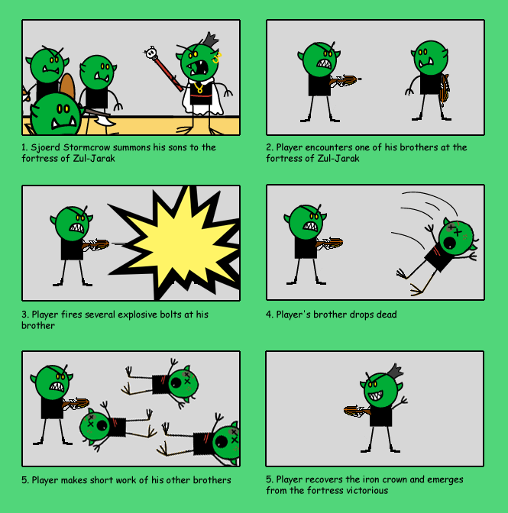

Cut Scenes
The game does not include any cut scenes, but instead relies on textual narratives in order to elaborate the game’s plot.

Character Bible

Hero – Unnamed(You)
Description: For years you have suffered countless indignities at the hands of your father, forced to beg and steal things that should be yours by right of might. For years you have stayed your hand against the mutton-headed oafs who call themselves your brothers, fearing your father’s wrath should you act upon your god-given impulses. Now at last, you are presented with the opportunity that you have always dreamed of: a contest to the death against all of your brothers, with the throne of the Stormcrow Empire as the prize. What could be better? You pinch yourself to see if you are still awake…

Abilities: Can wield a crossbow with explosive bolts. Awesome physical health and stamina; can fall from great heights without sustaining injury; can take enough punishment to fell an ox, and still remain standing.

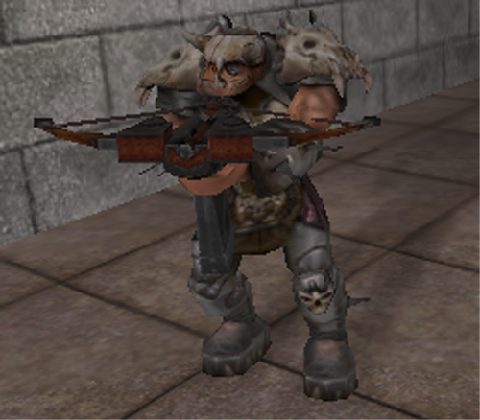

Game Progression

Flowchart

Level and Scene Details
As stated in the level summary above, the castle grounds are perpetually shrouded in a light fog and consist of various indoor and outdoor zones. The images shown below provides a 3D representation of the game map:

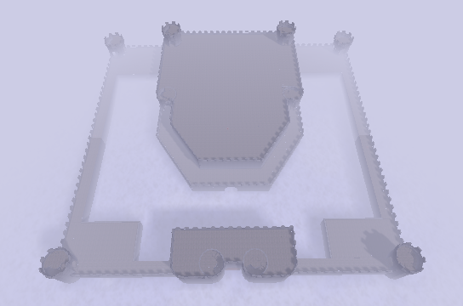
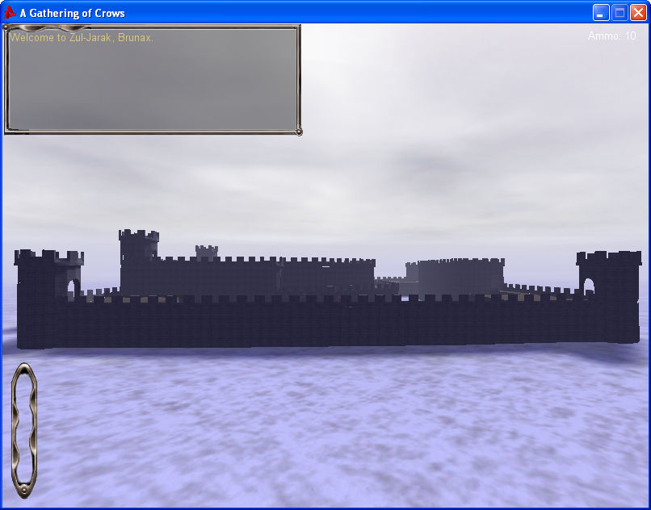

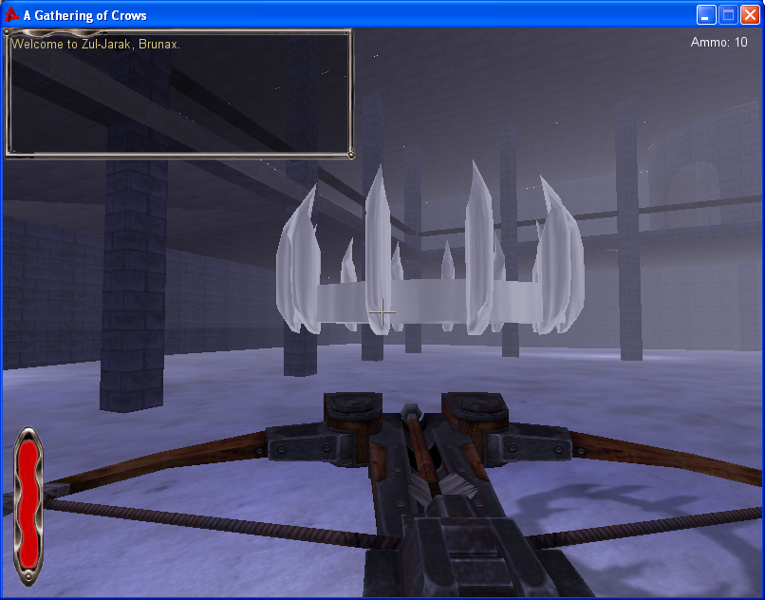
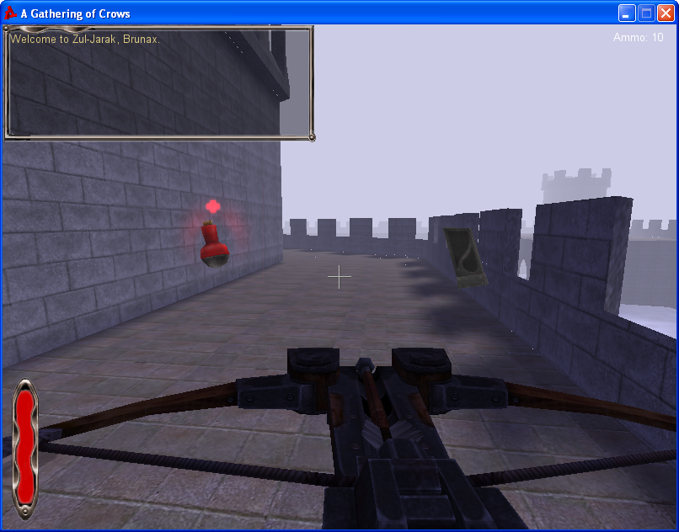

Attribution
This game is built entirely on the chassis provided by the starter.fps Torque demo application developed by Garage Games. The demo app was tweaked extensively to support the various customizations described in this document, but it still provides much of the “heavy lifting” for the game.

Bibliography
Finney, K. C. (2007). 3D Game Programming All in One. Boston: Course Technology.
Finney, K. C. (2005). Advanced 3D Game Programming All In One. Boston: Thomson Course Technology PTR.

Lessons Learned
It is extremely difficult to design a software program when you are as yet unfamiliar with the capabilities of the framework that you are planning to use. In particular, it is not entirely clear which features of the design will prove to be infeasible given the actual time constraints and technology constraints. As such, I have tried to err on the side of conservatism as much as possible in an effort to properly manage stakeholder expectations. I may extend the scope of the design as the project progresses if time allows and if certain implementation tasks prove easier to accomplish than I currently anticipate given my lack of experience with the technologies. For projects in which there are a lot of unknowns, iterative design is by far superior to a waterfall approach.

