Picasso: After the Cubist Era by Kenneth Chung
Overview
- Appearance:
A 3D game featuring a box. It will be 3D. It will not look realistic.
- Story Abstract:
After the cubist movement died away, the dejected Picasso was left with only one option: to destroy humanity. Utilizing the power of hideous art, Picasso’s mastery of cubism allowed him to impregnate himself and he spawned a cube-shaped man-eating masterpiece. It was an unnamed piece as the act of bearing children killed Picasso because he is male.
- Gameplay:
The player is a cube who must sneak behind people (or something) and consume them unnoticed. If a person (or something) sees the cube moving, the person will attack the cube. The cube may gain some attribute as he consumes a number of certain people.
- Development Platform:
Visual Studio IDE, some kind of Torque base, and 3DMaxStudio for the graphics.
Game Mechanics
- User Interface Description:
Numerical health, people consumed, maybe some kind of radar.
Use Cases: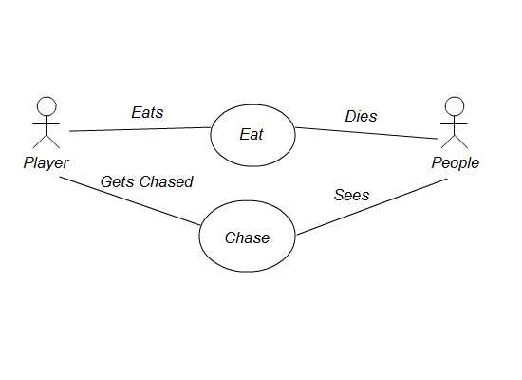
- Story Telling:
Cube will eat through increasingly difficult stages until the world ends.
- Level Summary:
Cube initiates at some part of the level. Depending on the stage, architecture, objective, number and type of enemies will differ.
User Interface Design:
- Key Screen Images: 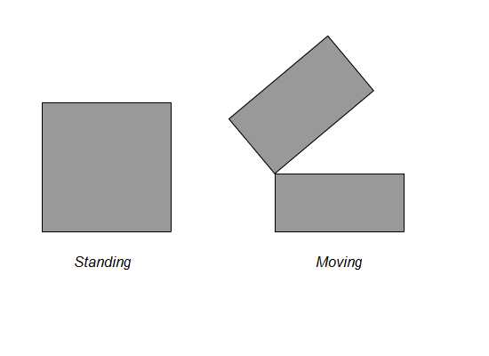
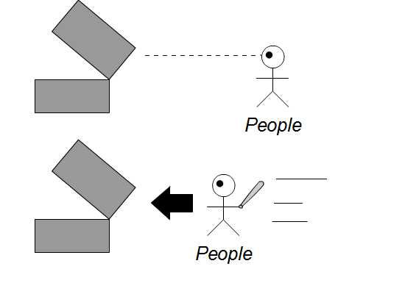
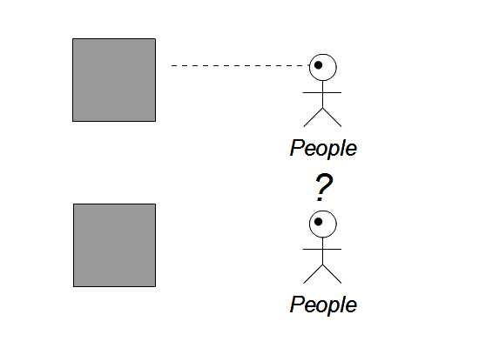
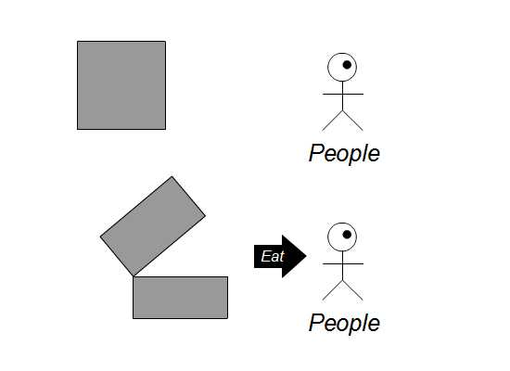
- Control Summary:
WASD for movement. Mouse for aiming. Left click for eating.

- State Transition Diagram:
Player State Diagram:
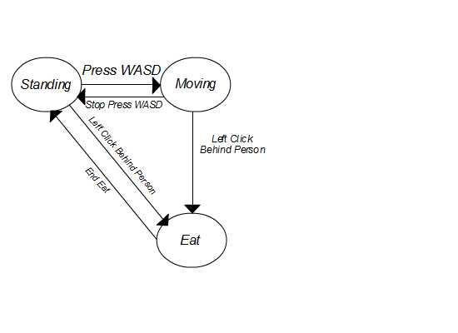
Opponent State Diagram: 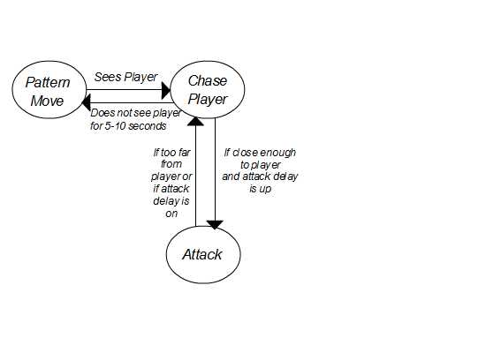

- Design Rules:
Both player and opponents cannot pass through walls. Player must be behind opponents to eat them. Player must complete level objectives to pass to next level.
Artificial Intelligence:
- Opponent AI:
Wander around in fixed patterns. Upon discovery of the player, the AI begins chasing. If player is out of vision for a certain amount of time, AI will return back to patterned positions.
- Non-Player Characters:
None.
- Reactive Items:
None.
Story Overview:
- Plot Summary:
Cube is born. Cube eats people. Cube wins. If Cube dies, humanity wins unless the Cube decides to try the level again.

- Story Board:
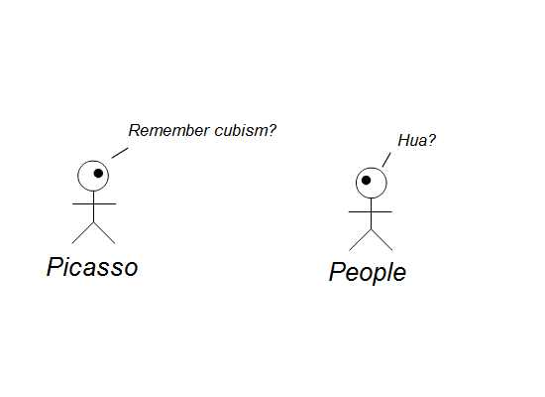
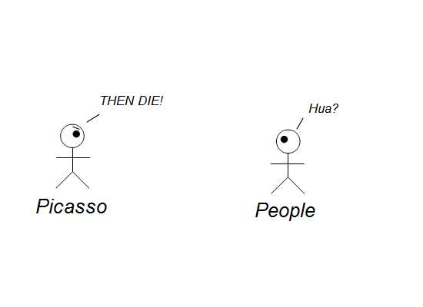

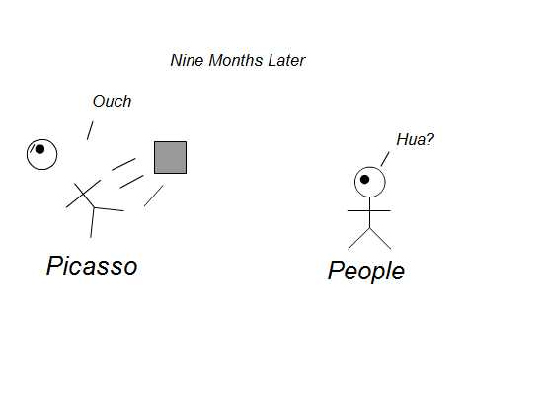
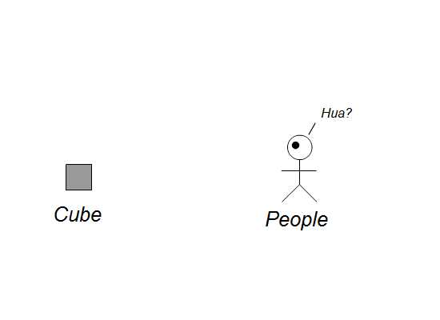
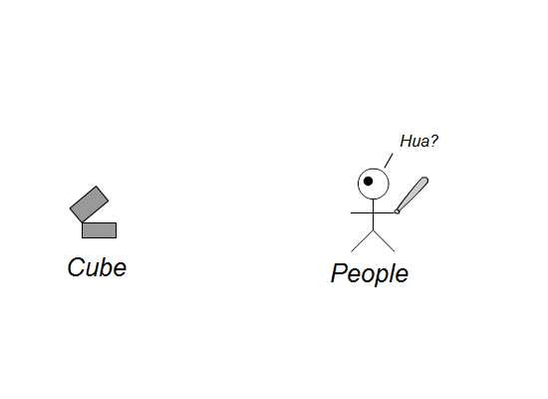
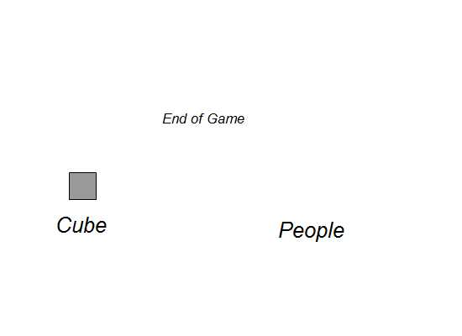

- Character Bible:
Picasso:
Wikipedia says:
“Pablo Diego José Francisco de Paula Juan Nepomuceno María de los Remedios Cipriano de la Santísima Trinidad Ruiz y Picasso known as Pablo Ruiz Picasso was a Spanish expatriate painter, sculptor, printmaker, ceramicist, and stage designer, one of the greatest and most influential artists of the 20th century. He is widely known for co-founding the Cubist movement and for the wide variety of styles that he helped develop and explore.”

He also bears cube children to destroy humanity.

Cube: A slit opens half way through the center of the cube which is used to consume people. When stationary, the cube looks like a box. His motivation is hunger. Only knows Picasso from his Wikipedia page.

Everyone Else: They are food.

Game Progression:
- Flowchart:
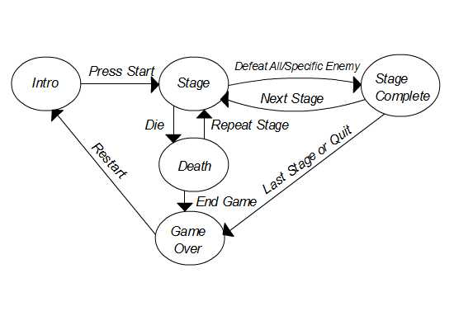

- Level and Scene Details:
In a normal outdoor setting or in a housing structure. Enemies will be placed according to their patterns of movement.
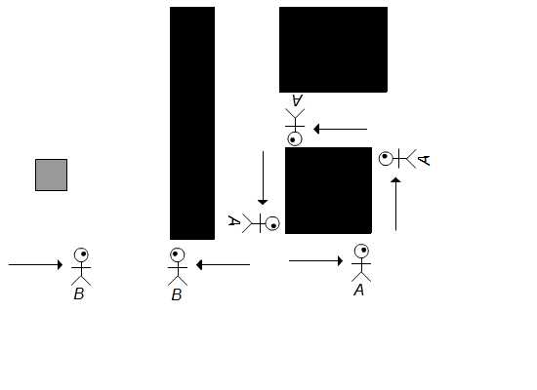
Bibliography:
Picasso Wikipedia page, Kenneth Chung
Lessons Learned:
Love conquers all.

