Torque Game Engine Design Document:
Robocop Rescue
By: Emeric Bechi
1. Overview
a. Appearance
Robocop Rescue is a 3D first person shooter game based on the movie hit Robocop. “James Murphy” who later became Robocop is sent on a rescue mission in a Detroit neighborhood to rescue his partner “Lewis”. The Game environment will be Detroit city with buildings, streets and such. The player will be able to enter some buildings and take cover behind buildings when under attack. The target audience for the game is 12 and up.

b. Story Abstract
Robocop is sent in a Detroit city neighborhood to rescue his partner “Anne Lewis” from prison’s fugitives who have escaped and overtook the city police department. “Lewis” is wounded and is hiding in a Grocery Mart building in front of the police department. Robocop mission is to find her and escort her to a nearby hospital before she dies of her injuries.

c. Game play
The player is in control of Robocop. He can run, jump and shoot his weapons or switch weapons. The player must complete his mission before the time is up, otherwise his partner will die. The mission is to first find your partner and then escort her to the nearest hospital before she dies of her wounds.

d. Development Platform
The game will be developed using the Torque 3D game engine on a windows PC. The game should be able to run on any windows machine with the following minimum requirements:
- XP or higher
- Pentium III or higher, 1GHz
- 512 MB or higher
- DirectX compatible sound card
- ~50 MB Hard drive space

2. Game Mechanics
a. User Interface Description
- Player Movement:
  - ‘WASD’ to move
  - ‘Space bar’ to jump
  - Mouse to change direction

- Camera Control:
  - ‘E’ to zoom
  - ‘Alt-c’ to toggle between camera/player

- Player Action:
  - ‘Left mouse’ click to shoot
  - ‘1’ or ‘2’ to switch weapons (AK47 or MP5)

- Screen Control:
  - ‘page up’ to page message Hud up
  - ‘page down’ to page message Hud down
  - ‘p’ to resize the message Hud

- Screen Play UI:
  - Player’s health will be located in lower left hand corner
  - Ammo will be located right of player’s health bar
  - Robocop partner’s health will be located right of the Ammo bar
  - The weapon currently in use will be in player’s hand
  - Objectives update window will be display on screen when needed

- Main Screen UI:
  - Start Mission: Select this button to start the game
  - Option: Select this button to adjust the audio and visual settings of the game
  - Quit: Select this button to terminate the application
  - About: Select this button to view game credits

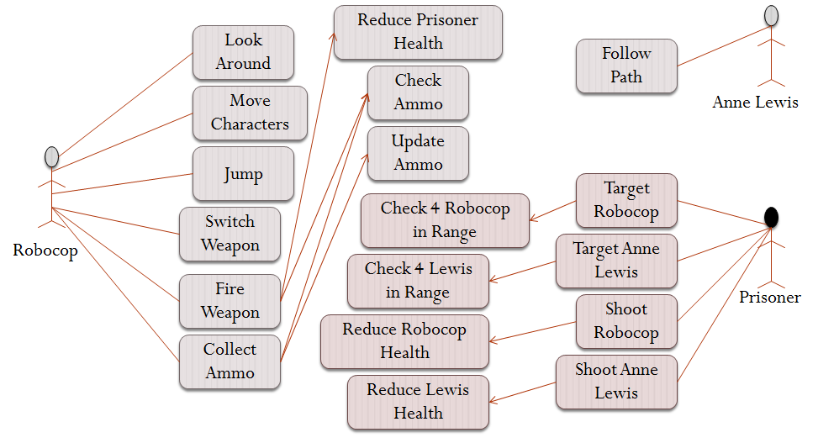
b. Use Cases

Figure 2: Use Case Diagram
c. Storytelling

There’ll be a story of the events that caused the prisoners to escape and also telling the damage that has been done. One of the prisoners started a riot and succeeded in opening all the Jail cells and thus allowed all the prisoners to escape and acquired weapons. They took over the police station and are now terrorizing the whole neighborhood. You are sent to rescue your partner.

d. Level Summary
There’ll be one level in the game due to the shortage in the development manpower.

3. User Interface Design
a. Key Screen Images
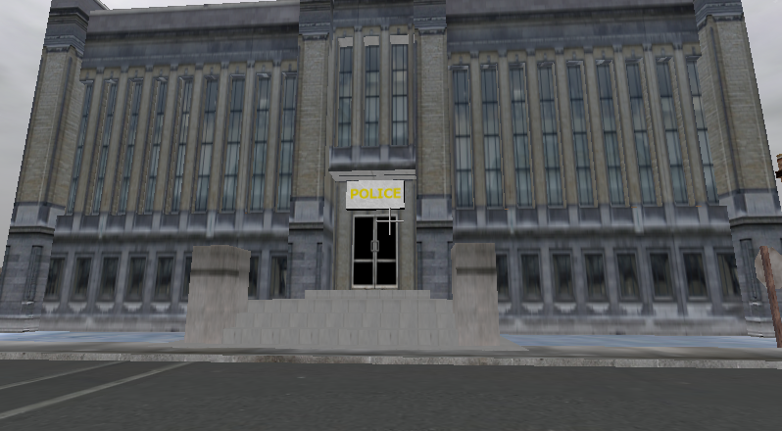
Figure 3: The police department that has been taken over by prisoners.

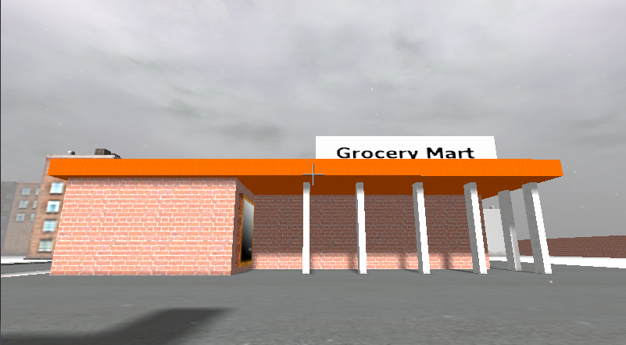
Figure 4: The Grocery store where officer Lewis is hiding.

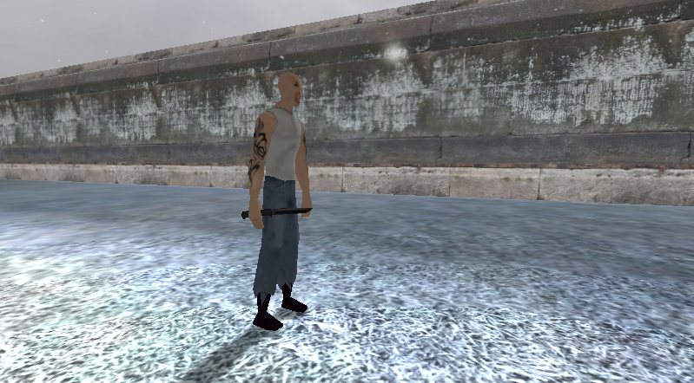
Figure 5: An escaped prisoner who has a knife.

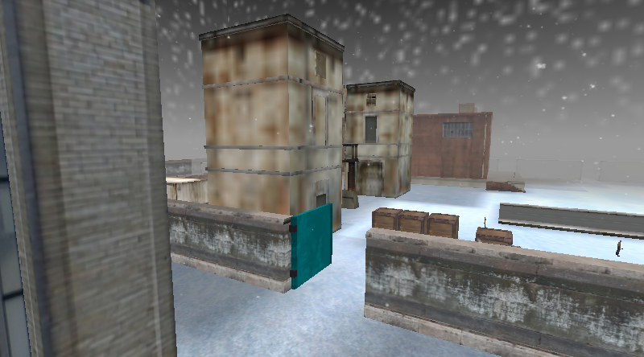
Figure 6: Prison gate opened after prison riot.

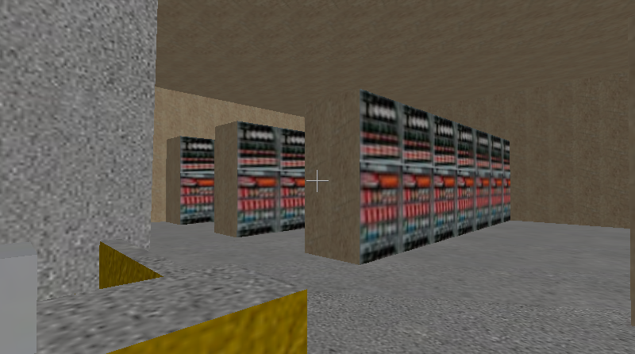
Figure 7: Inside the Grocery store where Officer Lewis is hiding.

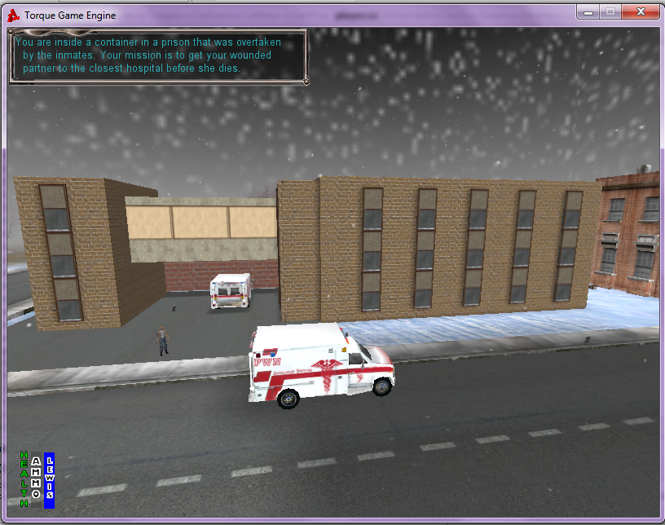

Figure 8: The hospital where the Officer Lewis has to be taken to for treatment of her wounds.

b. Control Summary

W – Move forward
A – Move left
S – Move backwards
D – Move right
Space bar – Jump
Mouse movement – Look around
E – Zoom
Esc – Pause menu
Tab – Switch camera between first and third person views
Left click – Shoot
1 – Switch weapons (AK47)
2 – Switch weapons (MP5)
P – Resize message Hud
Alt C – Toggle between camera/player
pageup – Page message Hud up
pagedown – Page message Hud down

c. State Transition Diagram
A simple state transition diagram showing the movement between menus, game play, and the interaction of checkpoints.

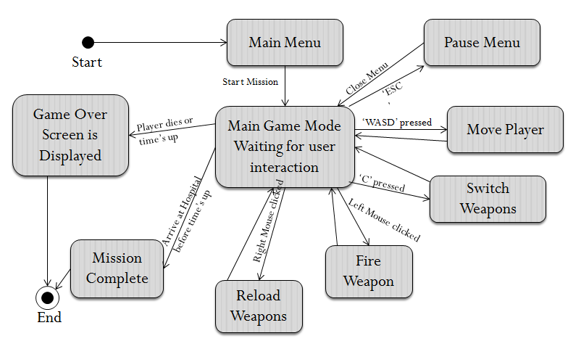
Figure 9: State diagram
d. Design Rules
The main design rule of the game is to make it easy for the user to control the player due to the fact that this game will have a timer associated with it. The game keys are setup in such a way that the player doesn’t have to move his fingers off the keyboard to reach other keys. The timer in the game was added so that players don’t get bored shooting enemies but also move quickly to get the mission done.

4. Artificial Intelligence
a. Opponent AI

The prisoners’ character will be roaming around the neighborhood until they come across Robocop and his partner. If Robocop or his partners are within a certain distance from the prisoner, they’ll be shot at and chased. Prisoner will be a little slower than the player to allow Robocop to escape.

b. Non-Player Characters

There’ll be quite a few non-player characters. One of the non-player characters will be in the store where Robocop partner is. Some will be just walking in the streets. These characters will be stationary or following paths and will not interact with anybody.

c. Reactive Items
There would be some weapons and Ammo to be picked-up when the player is low on Ammo. There will also be health pack for the player.
The two weapons of Robocop are the MP5 and the AK47.

Figure 10: MP5 is Robocop main weapon

Figure 11: AK47 is Robocop secondary weapon

5. Story Overview
a. Plot Summary
The Robocop program requires a recently-deceased "candidate" for conversion. To obtain one, OCP reorganizes the police force to the crime-ridden Metro West precinct expecting an officer will die in duty and become a candidate. One such officer is veteran Alexander James Murphy, who is partnered with Anne Lewis. On their first patrol, they chase down a team of criminals led by crime boss Clarence Boddicker to an abandoned steel mill. Murphy and Lewis separate. Lewis is later rendered unconscious by one of the gang, while the rest of Boddicker's men corner Murphy and sadistically mutilate him with shotguns before Boddicker executes him with a pistol shot to the head. Lewis, disarmed and unable to help, witnesses the murder in horror. Murphy is pronounced dead at the hospital, but OCP takes his body and uses it to create the first Robocop.
In the near future, Detroit, Michigan is on the verge of collapse due to financial ruin and unchecked crime. The police department has been overtaken by prisoners who escaped from their cells due to a riot started by Boddicker. Anne Lewis, Robocop partner, has escaped the police station and is hiding in the Building located in front of the police station. She has been injured and has to be taken to the hospital before it is too late for her. Robocop mission is to take her to the nearest hospital and protect her from further injuries.
b. Story Board
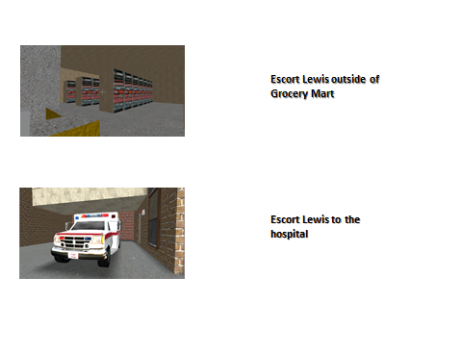
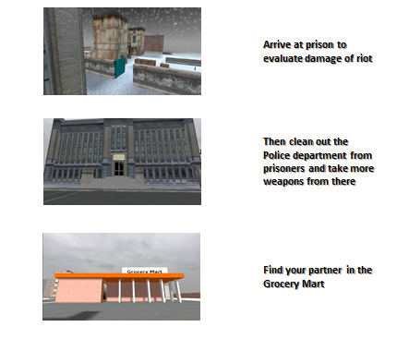

Figure 9: Story Board
c. Character Bible
Robocop (James Murphy)
Role | Main Hero
Race | Humanoid (Human Robot)
History | You were Officer James Murphy. You worked for the Detroit police department. You have been selected to become Robocop after your tragic death on the field during a routine Buss with your partner Lewis.
Current Events | Your partner Anne Lewis is stranded in a grocery mart and has been wounded by prisoners who escaped the police department and took over the neighborhood. You have to rescue her and take her to the hospital before it’s too late for her.
Abilities | You are a robot now and it’s more difficult for you to get injured. You have many weapons at your disposal and you are faster than your enemies when running.

Anne Lewis
Role | Robocop partner
Race | Human
History | Anne is the partner of James Murphy. She witnessed his murder during a routing Buss. She is now the partner of Robocop.
Current Events | Anne is stranded in a Grocery Mart close to the Detroit Police department after it has been taken over by prisoners who started a riot. She is injured and requires urgent medical attention before it’s too late.
Abilities | She follows Robocop around all the way to the hospital. She defends herself when she can.
Prisoners
Role | General enemies
Race | Human
History | They have been busted for drug dealing and organize crimes etc...
Current Events | They escaped the police station prison due to a riots started by their leader. They seized on the police stations and most of the weapons in the building. They killed many officers and are terrorizing the city now.
Abilities | They can chase Robocop and his partner and shoot at them.

6. Game Progression
a. Flowchart

Find Officer Lewis
Escort Officer Lewis to the Hospital

Figure 10: Flow Chart
b. Level and Scene Details
Level 1:
The player will start off inside a container located in the prison yard. The player first has to get some weapons and Ammo to defend himself against the inmates who took over the prison. Then, the player has to get out of the prison by the blue side door of the prison. Then the player will go to the Grocery Mart store in front of the police station building to find his partner. The player can pick up some new weapons in the police station on the way to the Grocery Mart. After finding Officer Lewis, the player will escort her to the Hospital just in time for her to be treated for her injuries.
7. Bibliography & Resource List
- Torque Game Engine and Torque Constructor provided by Garage Games
- Scene Object and buildings from “Street-smart” game
- Game story and main characters from “Robocop” movie
- Torque Scripting Reference: The Game Programmer's Guide to Torque by Edward F. Maurina

8. Lessons Learned
Starting early is always good. I also believe that familiarization with the working tool was really helpful for me to get started.

