3D Game Design Document

White Wash

By

Elizabeth Beddow

Jon Joyce

Brandon King

Matt Portelli

Vincent Shaw



December 21, 2010

Contents

**1.** **OVERVIEW** 3

**a.** **Appearance** 3

**b.** **Story Abstract** 3

**c.** **Gameplay** 3

**d.** **Developer Platform** 3

**2.** **GAME MECHANICS** 3

**a.** **User Interface Description** 3

**b.** **Use Cases (See Figure 2b in VISUAL AIDS)** 3

**c.** **Storytelling** 4

**d.** **Level Summary** 4

**3.** **USER INTERFACE DESIGN** 4

**a.** **Key Screen Images (see Figure 3a in VISUAL AIDS)** 4

**b.** **Control Summary** 4

**c.** **State Transition Diagram (see Figure 3c in VISUAL AIDS)** 4

**d.** **Design Rules** 5

**4.** **ARTIFICIAL INTELLIGENCE** 5

**a.** **Opponent AI** 5

**b.** **Non-Player Characters** 5

**c.** **Reactive Items** 5

**5.** **STORY OVERVIEW** 6

**a.** **Plot Summary** 6

**a.** **Story Board (See Figure 5a in VISUAL AIDS)** 6

**c.** **Character Bible** 6

**6.** **GAME PROGRESSION** 7

**a.** **Flowchart (see Figure 6a in VISUAL AIDS)** 7

**b.** **Level and Scene Details** 7

**7.** **VISUAL AIDS** 8

**8.** **BIBLIOGRAPHY** 12

**9.** **LESSONS LEARNED** 12

1. **OVERVIEW**
2. **Appearance**

The appearance is winter-themed with an emphasis on snow. The game feel is mostly cartoon-like. We are leveraging existing Torque resources and possibly retexture the characters to make a more realistic game.

1. **Story Abstract**

The story takes place in a modern day suburban area in the winter. Joey (the protagonist) unknowingly upsets the bully Butch (the antagonist) in the beginning of the game. From that point on, Joey is trying to run home from school without being defeated by Butch and his gang of bullies.

1. **Gameplay**

The gameplay is based on the Torque FPS starter kit. Instead of using guns to defeat enemies in a traditional FPS, the player is throwing snowballs. Navigating to the end of each level includes actions like running, jumping, and crouching. Players have the choice to avoid or defeat enemy players and environmental hazards. Power-ups are scattered throughout the levels to give the player an advantage.

1. **Developer Platform**

The developing platform for our game is the Torque Game Engine provided for our use in CSE 587. We started with the starter FPS kit as a base design.

1. **GAME MECHANICS**
2. **User Interface Description**

The user interface consists of a health bar, ammo bar (bag), and crosshairs for aiming snowballs. A mini-map which shows enemy activity may be implemented as an additional item on the interface.

1. **Use Cases (See Figure 2b in VISUAL AIDS)**
   * ***Start Game:*** The player can select the “Start Game” option from the Main Menu Screen which shows the Story Screen. After the Story Screen, the player will be placed in the game environment.
   * ***Navigate Environment:*** The player can navigate around the environment using the game controls. Navigation includes moving forward, backward, left and right, jumping, and crouching.
   * ***Throw/Reload Snowballs:*** The player can throw and reload snowballs. Throwing snowballs is an offensive ability used to damage enemy AI and environmental hazards.
   * ***Obtain Items/Power-ups:*** The player can obtain items and power-ups to increase abilities, replenish health bar, and replenish snowball ammo.
   * ***Switch Weapons:*** The player can switch between weapons using a keyboard command.
   * ***Replay Game Upon Failure:*** If the player fails to complete the level, then the game will reload automatically on the current level.
   * ***Win Game:*** The player can win the game when all levels have been completed successfully.
   * ***Quit Game:*** The player can quit at anytime during the game or after the game has been completed.
   * ***Interact With Players:*** The NPC can interact with the player by advancing the storyline, triggering a new level, or providing strategy tips.
   * ***Damage Players:*** The enemy AI can damage players by using snowballs or another form of environmental hazard.
2. **Storytelling**

The story is prefaced by showing intro screens before the actual game starts. After the intro, the player plays the story out through the levels while meeting friendly AI (NPCs) along the way. The NPC interactions advance the story and associate different levels in the game to different sections of the overarching story.

1. **Level Summary**

The gameplay area is made up of four major sections. Each section represents a level in the game. An objective needs to be met to advance to the next section of the game.

* The first section is the Schoolyard. The objective for this level is to kill all of the bullies.
* The second section is Old Man McGreary’s Yard. The objective for this level is to navigate through the maze to reach the end.
* The third section is Stark’s Pond. The objective for this level is to make your way across the pond.
* The fourth and final section is the Cul-de-sac. The objective for this level is to kill all of the bullies. The victory screen will flash when this last objective has been met.

1. **USER INTERFACE DESIGN**
2. **Key Screen Images (see Figure 3a in VISUAL AIDS)**

The game has multiple types of screens including the title screen, loading screen, main screen, conversation screen, and victory screen. The screens may be different depending on the current level and reason for getting a Game Over.

1. **Control Summary**

* W 🡪 Player Move Forward
* A 🡪 Player Move Left
* S 🡪 Player Move Backward
* D 🡪 Player Move Right
* Mouse 🡪 Move Camera
* Left Click 🡪 Throw Snowball
* F 🡪 Reload Snowballs
* Space 🡪 Jump
* Ctrl 🡪 Crouch
* E 🡪 Zoom Button
* Q 🡪 Switch Weapons
* T 🡪 Interact With Friendly NPCs

1. **State Transition Diagram (see Figure 3c in VISUAL AIDS)**
2. **Design Rules**

The design rules for this game are used to add entertainment value and appeal to the concept. An interesting environment to explore provides the player with a reason to explore instead of simply rushing towards the finish line. Setting an appropriate difficulty level makes the game worth playing more than once. For example, power-ups for the player are hidden in locations that are not obvious but also not impossible to find. The game environment is carefully planned in order to minimize glitches by the enemy AI, player, and other environmental objects.

1. **ARTIFICIAL INTELLIGENCE**
2. **Enemy AI**

* ***Grunt***

Grunt AI wait for the player to reach a certain distance away. When the player is within the range or the player deals damage to the grunt, it begins charging at the player and firing. The grunt has a lesser accuracy than the sniper, and will stop charging the player when within a certain distance.

* ***Sniper***

Sniper AI is fixed to a single location. When the player is a certain distance away from the sniper AI, an attack is executed but the AI does not move. The sniper has a greater accuracy than the grunt.

1. **Non-Player Characters**

The Non-Player Characters (NPCs) are friendly objects that interact with the player. NPCs are used for strategy tips, story progression, and advancing to the next level.

1. **Reactive Items**

* ***Bad***

If the player comes in contact with a bad reactive item, then the effect negatively impacts player health. Interaction with water incrementally decreases the health of the player. Interactions with evil exploding snowmen cause the player to have an instant game over. Enemy AI can also interact with the exploding snowmen.

* ***Good***

If the player comes in contact with a good reactive item (or power-up), then the effect positively impacts the player in some way. The launcher power-up provides a more powerful and accurate snowball for the player to utilize. The launcher ammo power-up adds more ammo to the launcher. The health packs instantly increase the health of the player.

1. **STORY OVERVIEW**
2. **Plot Summary**

It started out like any other day at Sundered Elementary. Mr. Johnson was reading aloud from the school manual and the children anxiously waited for that lunch bell to ring and signal their release.

The savory smell of tater tots beckoned him like a siren’s song. A carton of delicious chocolate milk would be the icing on the cake. Oh sweet justice! Joey grabbed the last of the tater tots and chocolate milk. Everything was going Joey’s way and it was shaping up to be a great day… or was it?

Oh no. Butch Hutchinson is in the lunch line just behind Joey and he looks madder than a mosquito in a mannequin factory. This guy really likes his tots.

“You’ve just tasted your last tot, twerp. I’m going to kill you…‘til you’re dead!”

1. **Story Board (See Figure 5a in VISUAL AIDS)**
2. **Character Bible**

* ***Joey McAllister*** – Joey is your typical underachieving 5th grader who would rather be spending his time with friends playing ball or video games. As the pitcher of his little league team and quarterback of his peewee football team, Joey is a natural leader and is his friends look up to him.
* ***Mr***. ***Johnson*** – Mr. Johnson is a very boring teacher with good intentions. After his wife left him, he decided to devote his life to boring the crap out of his students and giving them half-hearted advice. He is there to give you a warning at the Schoolyard.
* ***Butch Hutchinson*** – Butch is the toughest kid in [school name] Elementary. Most kids stay out of his way, but no matter how hard he tries, Joey seems to find himself right in Butch’s warpath time and time again. No one knows where or how this vendetta started, but it seems an ongoing goal of Butch is to torment Joey and his friends.
* ***Timmy McAllister*** – Timmy is a bright kid, far ahead of other kids in his grade. As Joey’s younger brother, Timmy’s presence is often overshadowed by his big brother, the golden boy. Despite his timid nature, Timmy often helps his brother out of a jam with his careful planning and insight. Anyone close to Timmy knows that he is the best source of advice on matters concerning kids in [town name].
* ***Herman “Whizzer” Shambling*** – Whizzer is one of Joey’s closest friends and has inherited his nickname due to his unfortunate bladder control issues. Being the chronic bed wetter that he is, the condition of his bladder can be described as that of a dam that is one drop of water away from its breaking point.
* ***Charles “Chuck” Stevens*** – Chuck is as loyal a friend as any. Joey and Chuck have been in the same class since kindergarten and have become very close. When you need a friend to bail you out of a jam, you can always count on Chuck.
* ***Festus “Old man” McGreary***– This army veteran is a bitter old man with a chip on his shoulder. There’s nothing he hates more than the neighborhood kids cutting through his property. There’s a rumor going around town that old man McGreary has mines hidden in his lawn to keep the kids off his grass.

1. **GAME PROGRESSION**
2. **Flowchart (see Figure 6a in VISUAL AIDS)**
3. **Level and Scene Details**

* ***Level 1 – Schoolyard***

After being threatened by the bullies, the player exits the school building and begins the adventure in the Schoolyard. An NPC is there to offer some advice. The terrain has a winter setting and maintains a normal altitude with minimal variance in height. The school building is surrounded by an open area with surrounding forests, snowy hills, and foliage. Enemy bullies can lurk and attack our player in many places.

* ***Level 2 – Old Man McGreary’s Yard***

The player proceeds into this next area through a narrow passage containing NPCs. The terrain depicts an old man’s property with objects including a shack and a fence maze used to keep kids off the land. Old Man McGreary’s Yard still has a winter setting, but is more expansive to accommodate the maze obstacle. The evil exploding snowmen are scattered throughout the maze as a hindrance. The conclusion to this level is a snowy mountain with a small exit passage.

* ***Level 3 – Stark’s Pond***

Stark’s Pond maintains the winter setting, but contains a large body of water which spans from the center to the far end of the area. The water will be surrounded on three sides by flat and elevated land. Sniper bullies have surrounded the pond and hinder movement through the area. If the player lands in the water, then the health bar incrementally decreases. The pond contains ice platforms that the player can use to cross the pond safely.

* ***Level 4 – Cul-de-sac***

The player proceeds into the next area through a narrow passage containing NPCs. The Cul-de-sac terrain keeps the winter setting, but it is a slightly smaller and more elevated area containing buildings and a mountainous background. It is the final destination for the player. The goal is to reach your home which is located in an elevated position on the farthest side of the area. Bullies are camped out and ready to ambush the player at the top in their almost impenetrable snow base. The player must use the terrain to find a way to reach his home to complete the final objective. After reaching home, the player has completed the game and the play ends.

1. **VISUAL AIDS**

**Quit Game**

**Win Game**

**Failure**

**Replay Game Upon**

**Items/Power-ups**

**Obtain**

**Damage Players**

**Interact With Players**

**Throw/Reload**

**Snowballs**

**Navigate**

**Start Game**

**Non-Player Character**

**AI Enemy "Bully"**

**Player "Bully Victim"**

Game Environment

_

**Use Case View**

**_**

**Figure 2b: Use Case Diagram**

**Environment**

**Figure 3a: Key Screen Images**

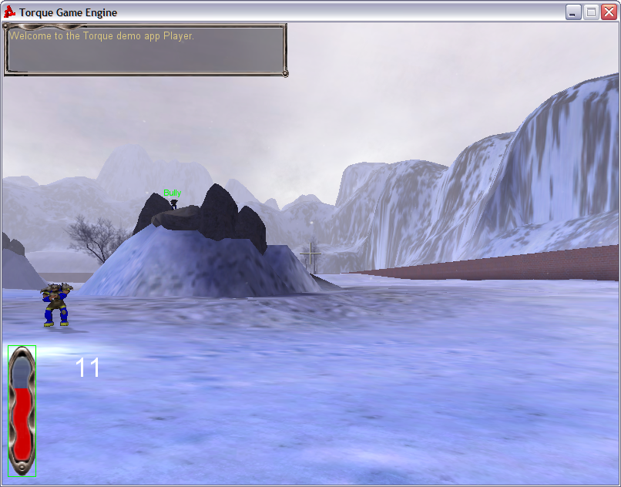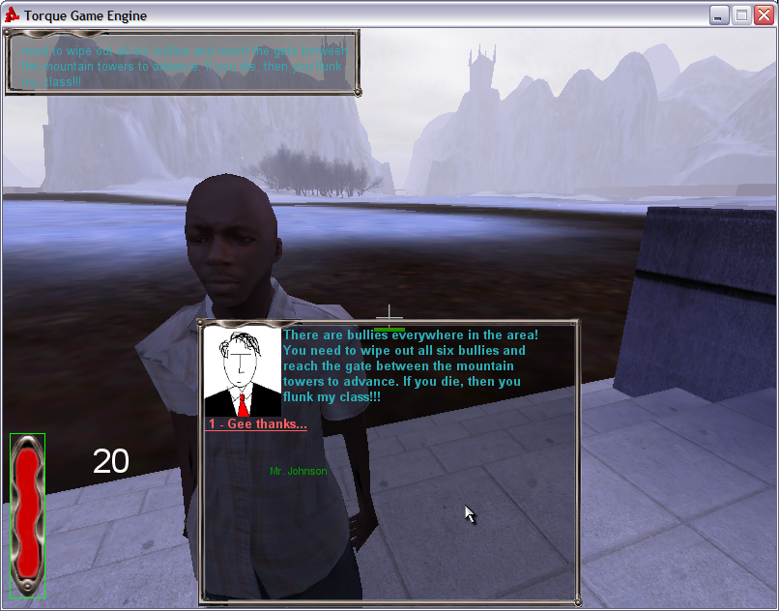

**Figure 3c: State Diagram**



**Figure 5a: Storyboard**

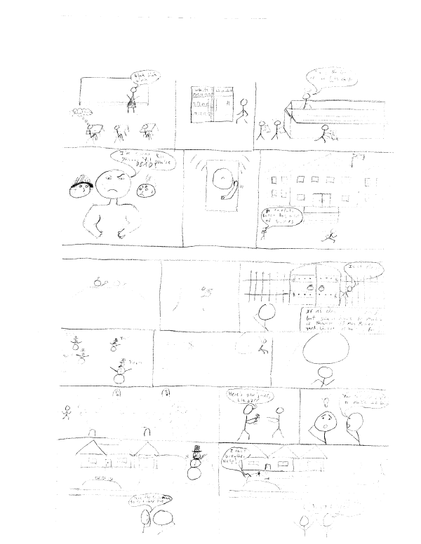

**Figure 6a: Flowchart**

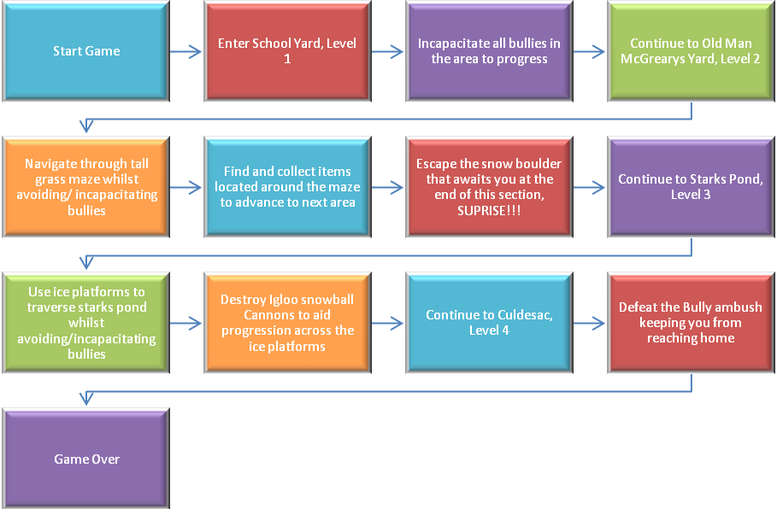

1. **BIBLIOGRAPHY**

* *The Game Programmer’s Guide to Torque* by Maurina, Peters, 2006.

1. **LESSONS LEARNED**

In this project, we have learned how to cooperatively pool our knowledge and resources to successfully build a 3D first-person shooter game using the Torque engine. We have gained a further understanding of game development and design along with the structure in which the Torque engine organizes assets and objects.