CIS 487

2010

Ben Catt, Uzoma Okeke, Derek Petrtyl, and Watson Tong

Assignment 3 – 3D game

Orc War

Table of Contents

1. Overview 2

a. Appearance 2

i. Environment 2

ii. Players 3

iii. Menus 3

b. Story Abstract 4

c. Gameplay 4

i. Weapons 4

ii. Class Specifics 5

iii. Game Modes 6

d. Development Platform 6

i. Hardware 6

ii. Software 6

2. Game Mechanics 7

a. User Interface Description 7

b. Use Cases 8

i. Main Menu 8

ii. Game Menu 9

iii. Main Game 9

c. Storytelling 10

d. Level Summary 10

3. User Interface Design 11

a. Key Screen Images 11

b. Control Summary 12

c. State transition diagrams 12

d. Design Rules 12

4. Artificial Intelligence 13

5. Story Overview 13

a. Plot Summary 13

b. Story Board 14

c. Character Bible 14

6. Game Progression 15

a. Flowchart 15

b. Level and Scene Details 16

7. Bibliography and Resources 16

8. Lessons Learned 16

# Overview

The 3D game titled *Orc War* will largely focus on gameplay, requiring teammates to work carefully together to accomplish their objective against the opposing team. The game will have two races to play as or against, namely Orcs and Humans. Focusing heavily on multiplayer, the game should be played with at least 4 people, although simple AI may be implemented to allow a single-player experience.

## Appearance

The targeted audience of the game should be focused around those of at least age 13, due to comical violence. Reflecting upon the age-group target, the graphics of the game will be simplistic. The level design will vary slightly from each other, but should all be set in a medieval/ancient civilization-era theme.

* + 1. Environment

The environment of *Orc War* will focus on an Old Earth appearance. All maps will be outside environments, largely focusing on size and detail to immerse the players. Depending on the map’s theme, there may be a focus on large, spacious areas (such as a battleground with trenches) or small confined areas.

* Arena maps have center that is very open with few things to hide behind. Areas are generally smaller and force combatants to use melee weapons. Good for DM.
* Fortress maps may have a great wall or fort on either side of the map to use as a base. Those areas provide a lot of cover, making it difficult for the enemy to invade. Good for CTF or Assault/Defend.
* Other maps will vary in size and spaciousness. Some areas will have buildings around, confining players to walk through very tight areas. These places are good to ambush other players. Good for anything.
  + 1. Players

The game is divided into two races: Humans and Orcs. Both races will be wearing armor for cosmetic reasons, but will not have an effect on damage reduction.

Currently under consideration is possibility of several classes, which would offer players different strategies of play:

* Light – Units travel faster, but have lower health. Orcs can wield two short clubs, while Humans have two short swords. These units are shorter and thinner than others.
* Heavy – Units travel slow, but have high health. Orcs wield a two-handed club and have a long reach. Humans carry a two-handed sword. These units are taller and wider than others.
  + 1. Menus

The menu design will be very simple, using rectangular buttons. It will be:

Start-> Host Game or Join Game

Options

About

Quit

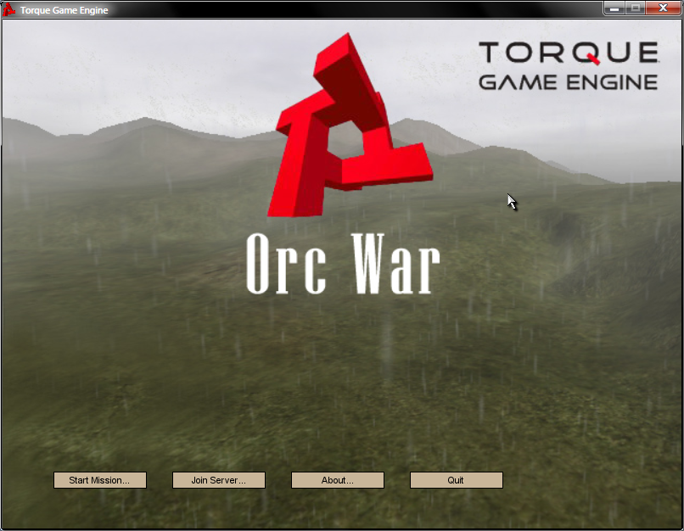

## Story Abstract

Humans discover a rift in the middle of the continent, hidden far in the mountains. Upon further investigation by the humans, the rift widens and mythical creatures from another world emerge, spreading destruction amongst the human world like locusts. These creatures are known as the Orcs.

## Gameplay

*Orc Wars* is a team-based game with multiple modes. There are two sides through which the player can play as: Humans or Orcs.

As the story is set in an old Earth theme, the characteristics of the gameplay will be reflective of that nature. The weapons technology in the game is primitive to say in the least.

Players can take advantage of blocking firearm shots by hiding behind objects such as buildings, walls, or rocks. They can also be useful for planning an ambush. Damage is primarily counted by hitting the torso. Head shots deal a critical amount of damage, often one-hit kills against Light units. Torso shots require multiple hits for the player to die.

* + 1. Weapons
* Primary weapons:
  + Fire arms have low accuracy and a very long reloading time.
  + Once you have started to reload, it cannot be cancelled. This forces the player to weight their options of reloading or switching to melee.
* Melee:
  + Weapons for each side will have a different model. Orcs hold clubs and Humans have short swords.
  + Will be used quite often
    - If you do not kill your opponenet with a shot, you face the risk of being hacked to death or switching to your melee weapon. Unless you have a sizeable distance between you and your enemy, it is probably better to switch to melee. Users should judge when it is best to reload.
    1. Class Specifics
       - Light Unit:
         1. Carries a short-range and low ammo gun/bow.
         2. Can travel over the battlefield quicker than the Heavy units.
         3. Carries two melee weapons
         4. Smaller body means they are harder to hit

Advantages: Can move quicker, dodging attacks and crossing the maps quicker than a Heavy unit. Light units can also attack with a melee faster as they have two. Good for weakening defense with hit-and-run attacks.

Cons: Has lower health and shorter range of attack when compared to Heavy units.

* + - * Heavy:
        1. Carries a medium-range gun/bow that has more ammo than the Light units.
        2. Has more health compared to Light units
        3. Has a farther range in both Primary and Melee weapon

Advantages: Can take more damage and deal more damage than a Light unit. Also carries more ammo for Primary weapon. Good for defending or invading.

Cons: Larger body means that they are easier to hit. They are also slower, so they may be outpaced by Light units.

* + 1. Game Modes  
       - Death Match: Eliminate the other team’s forces to win. One life match.
       - CTF: Capture the flag for a set amount of points. One life match or timed respawn. Did not implement in time.
       - King of the Hill: Stay in the area the longest to add points to the team score until a team reaches the set amount of points (or timed match, winner is the one that has the most amount of points). Timed respawn. Did not implement in time.

## Development Platform

* + 1. Hardware

The game is being developed across 3 laptops and a desktop. The hardware specifications vary from device to device, but the lowest base unit is a laptop with 1.6 Ghz dual-core processor and 2 GB RAM, fitted with an integrated graphics card supporting up to 128 MB.

### Software

The game is being developed using the Torque Game Engine (1.5.2) with the FPS Starter Kit. Torque Constructor will be used for buildings, TorqueDev 1.2 (Formerly CodeWeaver) for IDE+debugging, and Torque GameBuilder.

Character Models will mostly likely be found on the internet for free, although if there are any necessary changes required, 3D software such as Maya or Blender will allow us to edit/create models as needed.

All operating systems will be Windows based (Windows XP and Windows 7).

# Game Mechanics

## User Interface Description

The user interface should be fairly minimal to allow the user to focus on playing the game. The main menu allows the user to *Start Game*, change settings under *Change Options*, check the background of the game (and the credits) by clicking *About*, and to exit the game by choosing *Quit*.   
  
During gameplay, the screen will offer users very little information to maximize viewable game area.

* + 1. Crosshairs will be focused in the middle of the screen
    2. Health bar is placed in the lower left corner
    3. Primary weapons will have an ammo count placed next to health

## Use Cases

### Main Menu



### Game Menu



### Main Game



## Storytelling

While the game does have a small story associated with it, the core of the game is to focus on the multiplayer aspect. There is no progression to the story (it’s just a slaughter-fest). The story will then be accessible through the About game menu.

## Level Summary

At the selection of each map, there will be a brief description regarding the level design. The team will currently focus on big maps and then mix in varying sizes later. Some ideas so far:

* Countryside has large open spaces with foliage to hide behind.
* Town maps will force users into more confined spaces due to building placement (Good for camping or melee).
* Arena maps will remove ammo so that users will only melee.

# User Interface Design

## Key Screen Images

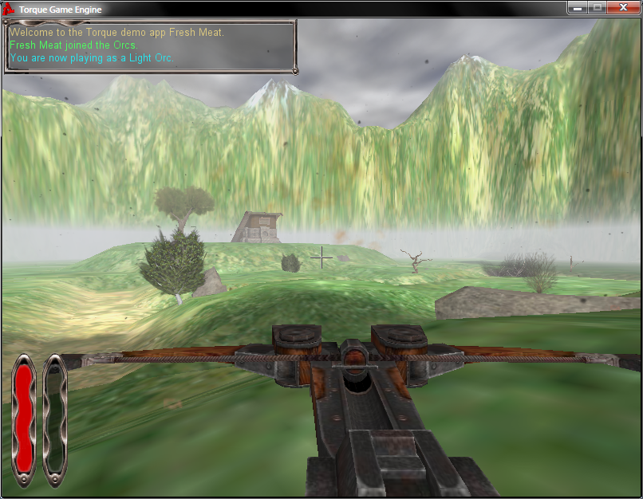

Figure 1 Light Orc Primary

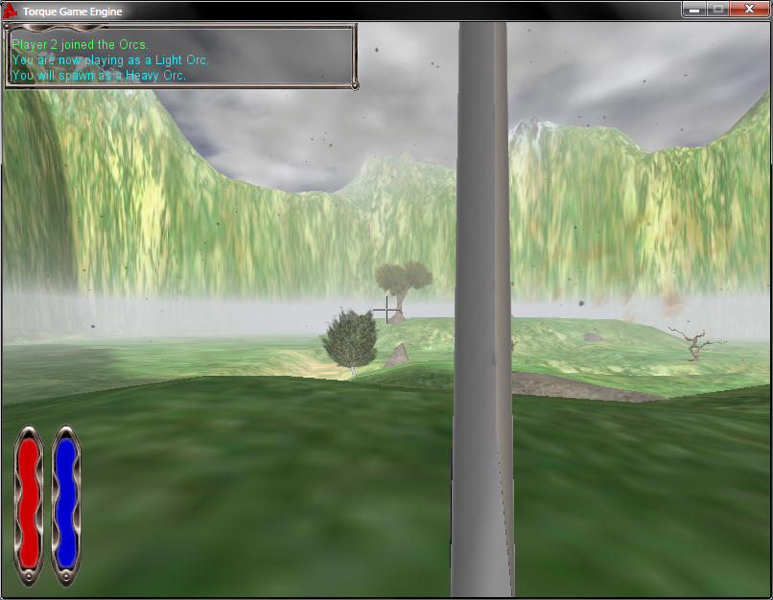

Figure 2 Human Melee

## Control Summary

* + - Movement follows the standard WASD (up, left, down, right) format.
    - Ctrl key for crouch.
    - Space for jump (if added).
    - The mouse is used to control the player’s view/aim.
    - Esc key for accessing menu

## State transition diagrams



## Design Rules

* + - Design the game with team-play in mind to make it essential to win games, especially those with no respawning.
    - Focus on melee combat.
    - Simple controls.
    - Easy to see surroundings and control player.

# Artificial Intelligence

Since this is a multiplayer-focused game, there will only be simple AI, if there is any at all.

* 1. Opponent AI: simple or none will be added.
  2. Non-Player Characters: Maybe we’ll add chickens or something that players can shoot at for fun.
  3. Reactive Items: Aside from the chickens exploding into feathers, the environments will remain largely static. Notable exceptions would be CTF which will glow when someone picks it up.

# Story Overview

## Plot Summary

Humans discover a rift in the middle of the continent, hidden far in the mountains. Upon further investigation by the humans, the rift widens and mythical creatures from another world emerge, spreading destruction amongst the human world like locusts. These creatures are known as the Orcs.

There are two Earths, both born at the same time, but in different dimensions. The Orcs are an ancient civilization as old as the Earth itself. They were the first, arriving on Earth centuries before the Humans came to be the ruler of their world. The history of the Orcs is shrouded in mystery, but their customs and traditions have been engraved into their lives: hunt, conquer, and kill. This is their way of life. The consequences of such wars, of course, strain not only their lives, but their resources as well.

The Humans, living in the alternate Earth, are not much better. Competition is fierce between the leaders. Countries rise and fall in mere months. It is extremely rare for a nation to last a decade before being conquered by another warring state.

However, this year will be different. The portal to the other side has opened. The desire for war is felt on both sides, but the Orcs are desperate. They have exhausted all of the resources on their home world, requiring more minerals and vespene gas. Their compulsion to conquer only adds to the fuel to invade and subjugate this new world to their rule. Thus, this is a battle for survival—the Orcs have nowhere to go and the Humans are faced with invaders.

## Story Board

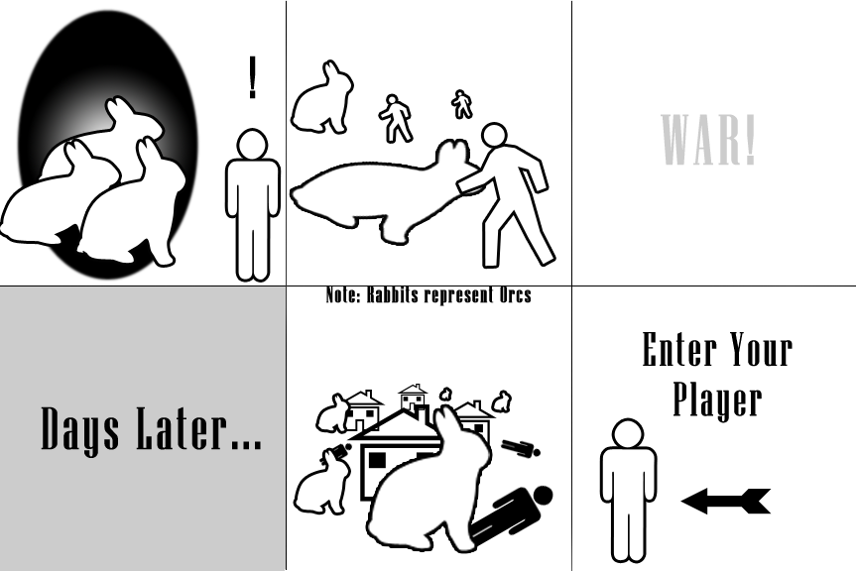

## Character Bible

There are no unique characters. There only exist nameless Orcs and Humans.

# Game Progression

## Flowchart

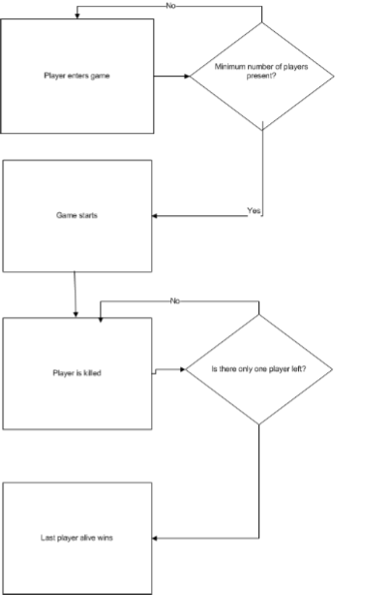

## Level and Scene Details

* + 1. The level is mostly open with some hills at each end and some trenches running across the middle
    2. There will also be plenty of cover to hide behind across the level such as trees or smaller hills

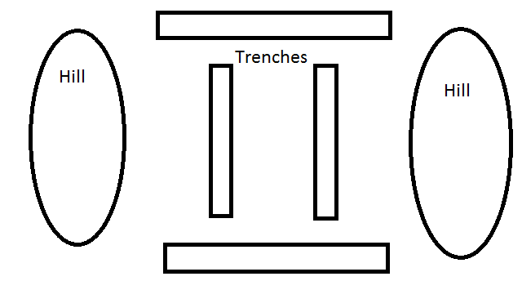

# Bibliography and Resources

* + 1. CIS 487 Website and Torque Tutorials
    2. Torquepowered.com
    3. Torque Community (specifically)
       1. <http://www.torquepowered.com/community/resources/view/2312>
       2. <http://www.torquepowered.com/community/resources/view/11733>
       3. <http://www.torquepowered.com/community/resource/view/2799/>
    4. 3D Studio Max for editing models
    5. Adobe Photoshop for editing background and some texture
    6. Torque Game Engine, TorqueDev, and Torque Constructor

# 8. Lessons Learned

Tutorials found online are often outdated and in some cases, such as this project, it was necessary to work with an older engine (1.5.2 vs 1.7.1) to implement things correctly. Online resources are wonderful—the community aspect provides a lot of help in the form of tutorials. There are online in-game resources available, but it’s a lot of work finding decent ones.