CIS 376 Project 1
Professor Maxim
1/31/2006

Rob Elliott
Anna Garcia

Introduction
The program chosen for this assignment is Winamp. This program is designed to play audio files, video files, and has an assortment of plug-ins allowing it to be multifunctional in the realm of media. It is fairly user friendly in its visualization depending upon the skin chosen to work with, skins being the actual appearance the program takes. The skin we chosen for this project was classic Winamp; most users of the program would be familiar with such a design.
There were several difficulties that we had with Winamp. It is a vastly dynamic program with many functions, several of which the general user would not make use of. Winamp consists of the main player which displays the track name, the amount of kbps and kHz of the track, an equalizer function which allows for user defined settings, a playlist function which allows for easy visualization of the playlist tracks, a speaker balance bar, and a volume bar. As well as those, there are typical basic player functions expected: previous track, play, pause, stop, next track, eject CD, shuffle, and repeat.
The functionality of this program that creates the dynamic appeal is its ability to choose the player to displayed on top of all programs, minimize the main player to the basic functions, hide the main player in the system tray, open or close the playlist for easy access, minimize the playlist to display only the track, resizing the playlist to enable improved visibility for tracks, and several other functions that were not used in this project; for example, the equalizer function. All of these functions allow Winamp to be reasonably configured to user specifications.
The functions chosen for this specific project consisted of using the sliding volume bar, resizing the playlist window, and saving a playlist. The operations models can be found on the following pages; however, a brief overview can be described in the following section.

Task One
Task one is changing the volume. Users of Winamp have in fact one general way to change the volume on the player outside of changing the volume of the speakers by hand or changing the Windows Volume Control, the Winamp sliding volume bar. The display for the volume is shown on the track display when the volume is altered and it can be anywhere with a range of 0-100% with the bar color varying in tone from green, 0%, to red, 100%. This is a reasonably simple process when the main player is displayed; however, it is not visible when the player is hidden in the system tray or the player is minimized. The process of changing the volume can become progressively difficult with each step required. If the player is minimized in the system tray then it is required to click the icon to enable visualization of the player. If the player is in view and does not have the main window displayed, the process required involves clicking the open windowshade button on Winamp which is located between the minimize player and the close player buttons. Finally, the last step in changing the volume is clicking on the volume icon located on the volume bar and sliding it to either direction to increase or decrease volume and then releasing the mouse button.

Task Two
Task two is resizing the playlist. Users may be familiar with the process of creating playlists by dragging files into the Winamp main window or simply double clicking files; however, Winamp has a functional playlist which allows for view of the track, the artist, and allows viewing of additional track information. Resizing the playlist makes the information much easily accessible for the user. Often when Winamp is used, users may simply keep the main player display open and neglect the playlist or close it off. There are several steps required in order to resize the playlist using a mouse drag. The first step required, if the player was not open for display on the window, is to bring up the main player from the system tray. Following the opening of the Winamp player, it may be noted that the player is in windowshade mode which requires the user to click on the maximize windowshade mode button to drop down the main player display. After the display is in view, the user may need to click on the playlist button marked ‘PL’ in order to display the playlist. If the playlist is also minimized, it is required that the user click the toggle windowshade button on the playlist as well. Following this process, the playlist should be open for viewing. In order to change the display size of the playlist, the user must point to the bottom right corner of the playlist border and click and hold down to drag the border to the desired side. After the size is chosen, the user simply releases the mouse button.

Task Three
Task three is saving a playlist. Users that listen to specific tracks often may wish to create a listing of all of their files so that they will not always have to select them all. Winamp allows for users to create their playlist and then store it for use at a later date. The process of saving the playlist, though simple once known, may appear more daunting for users. The first step of saving a playlist calls for the player to be removed from the system tray by way of a single left click of the mouse to display the Winamp player. Next, after the player is displayed on the screen and in the event that the main player is not fully displayed, it may be necessary to maximize the player by way of the toggle windowshade button. After the main player is open, the user may have to click on the playlist icon in order to open the playlist if it is not fully displayed. Following the visualization of the playlist function, it may be require that the user click on the toggle windowshade button on the playlist to display the list of tracks as well as several of its own functions. The button required for the user to click on in order to save the playlist is the ‘LIST OPTS’ icon. From that icon a short menu will be displayed with three icons including ‘NEW LIST,’ ‘SAVE LIST,’ and ‘LOAD LIST.’ The user will have to move the mouse onto the ‘SAVE LIST’ option and click it. Following the users click a save playlist display will appear, similar to saving generic files in Windows. If the save location is not where the user would like the playlist to be saved, the user can proceed through the steps of changing the drive or folder. When the proper drive or folder is selected from the drop down, the user must click on the ‘File name’ save as box to type in the new playlist name. Finally, after the user types in the name they desire, they may click on the save button complete the process.

Test Setup
We took three subjects and asked them to time themselves in six scenarios. Each scenario was one of three tasks in either a good or bad setup. The subjects were interviewed before the test, then introduced to Winamp. They were shown basic functionality, including the tasks to be tested on. They were not given the chance to practice the tasks. The subjects were given a digital stop watch and asked to time themselves in each task, to minimize delay error.
Each test followed this format: "Are you ready? Please change Winamp's volume to fifty-percent." Start time, perform task, stop time.

Subject Analysis
It is worth noting that on observation each subject had a very different style of computer use. Some observations are based on actually watching the subject perform the tasks while specifically noting how the subject 'points to' a target, as well as when they pause, or perform a mental operator. Other observations are bsaed on the pre and post interview with the subject. Our three subjects all specialized in computers, therefore we assumed we would get results that were similar and on the low-end.
Subject A was the fastest overall, rating himself 5/5 in computer ability. His 'point to' technique could be described as smoothly moving to the target, circling past, then correcting and coming back. His pauses (mental operators) were moderate.
Subject B was the slowest, rating herself a 4/5 computer ability. The overall slower speed could be due to her professed lack of familiarity with the application used. Her technique was quite cautious, first solidly visibly finding the target, then moving the mouse quickly to its location.
Subject C was almost as fast as A overall , rating herself as 4/5 in computer ability. Her technique was smoother than B, moving in a near-linear line towards the target, and decelerating as described in class. The difference in A and C could be accounted for by apparently longer mental operators by C.
On reviewing the results of the subjects speed tests in comparison to the models calculated times, We were quite surprised at the accuracy of the keystroke model. It was within 4% in two of the tests, within 24% for three other tests, with only one test being 36% inaccurate. The GOMS model was significantly more inaccurate, achieving 37% at best and 82% at worst.

Results Analysis
Ultimately the accuracy of these models are based on the accuracy of the developer. On review, I believe we introduced too many mental operators. As a rule of thumb, we used one per 'point to' action. It seemed that while subject C did indeed stop at each target, subject A and B only used a mental operator when the target was not previously visible. Also subject A rarely paused at all, which leads us to believe he was performing mental and physical operators simultaneously. One theory is that the brain is aware of and tracks potential targets even while not specifically interacting with them, or another is that the brain 'thinks ahead' towards the next step and tracks targets towards that purpose.
The disparity between the two models can be accounted in a number of ways. The most obvious is our GOMS modeling technique, many subroutines were used. If an often called subroutine, like 'click' was inaccurate, it would cause exponential inaccuracies in functions that called it multiple times (which some do). This problem becomes obvious in T2B and T3B where the process is quite involved.

Conclusion
Having practiced and evaluated the keystroke model and the GOMS model, we understand they are useful tools in providing metrics and quantifying difficult concepts. In any situation where you attach generated numbers to human behavior, we believe the results will never be more than an educated guess. While these models do serve well to give a ‘general estimate’ to efficiency, and can provide a comforting list of graphs and statistics, and are most certainly better than nothing- for good, accurate results nothing is better than actual testing of your end user base.

Subject | T1G (Volume) | T1B (Volume) | T2G (Resize) | T2B (Resize) | T3G (Save) | T3B (Save)
Subj A | 4.48 | 8.04 | 3.94 | 9.57 | 10.59 | 15.98
Subj C | 5.33 | 8.81 | 4.56 | 12.42 | 11.60 | 18.02
Subj B | 7.62 | 12.58 | 6.51 | 17.74 | 18.00 | 29.86
Subj Avg | 5.81 | 9.81 | 5.00 | 13.24 | 13.40 | 21.29
Keystroke | 6.00 | 11.50 | 6.00 | 16.40 | 13.50 | 28.90
GOMS |  | 13.40 |  | 22.00 |  | 38.70
KS Avg Error | 3.3% | 17.2% | 19.9% | 23.8% | 0.8% | 35.8%
GOMS Avg Error |  | 36.6% |  | 66.1% |  | 81.8%

 | GOAL: Change Winamp Volume to 50% (Good) |  |  | 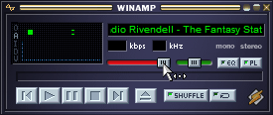  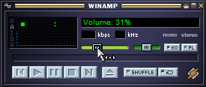
 | Initiate Volume Change | m | 1.2
 | Find Volume Icon | m | 1.2
 | Point with mouse to volume icon | p | 1.1
 | mouse Button press down | b | 0.1
 | Drag to desired volume level | p | 1.1
 | Verify volume Level | m | 1.2
 | mouse Button press up | b | 0.1
Total | 6
 | GOAL: Change Winamp Volume to 50% (Bad)
 | Initiate Volume Change | m | 1.2 | 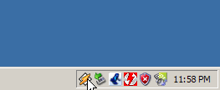
 | Hand to Mouse | h | 0.4
 | Find Winamp Taskbar Icon | m | 1.2
 | Point to winamp taskbar icon | p | 1.1
 | press and release MB | bb | 0.2
 | Find Winamp winshade mode button | m | 1.2
 | Point to winamp winshade mode button | p | 1.1
 | Press and release MB | bb | 0.2
 | Find Volume Icon | m | 1.2
 | Point with mouse to volume icon | p | 1.1
 | mouse Button press down | bb | 0.2
 | Point to desired volume level | p | 1.1
 | Verify volume Level | m | 1.2
 | mouse Button press up | b | 0.1
Total | 11.5
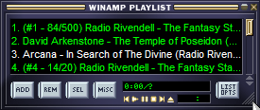
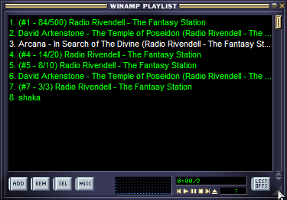
 | GOAL: Resize Playlist Window ~50 Pixels (Good)
 | Initiate Resize Playlist | m | 1.2
 | Find lower left border | m | 1.2
 | Point with mouse to playlist lower left border | p | 1.1
 | MB press down | b | 0.1
 | Point to desired dimensions | p | 1.1
 | Verify desired dimensions | m | 1.2
 | MB press up | b | 0.1
Total | 6
 | GOAL: Resize Playlist Window ~50 Pixels (Bad)
 | Initiate Resize Playlist | m | 1.2
 | Hand to mouse | h | 0.4
 | Find winamp taskbar icon | m | 1.2
 | Point to winamp taskbar icon | p | 1.1
 | Press and release MB | bb | 0.2
 | Find windowshade mode button | m | 1.2
 | Point to toggle windowshade mode button | p | 1.1
 | press and release MB | bb | 0.2 | 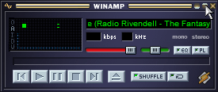
 | Find toggle playlist button | m | 1.2
 | point to toggle playlist button | p | 1.1
 | press and release MB | bb | 0.2
 | find toggle playlist windowshade button | m | 1.2
 | point to toggle playlist windowshade button | p | 1.1
 | press and release MB | bb | 0.2
 | Find lower left border | m | 1.2 | 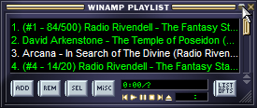
 | Point with mouse to playlist lower left border | p | 1.1
 | MB press down | b | 0.1
 | Point to desired dimensions | p | 1.1
 | Verify desired dimensions | m | 1.2
 | MB press up | b | 0.1
Total | 16.4
 | GOAL: Save Playlist (Good) |  |  | 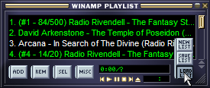  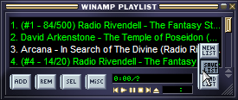  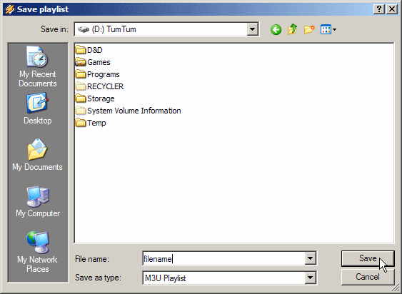
 | Initiate Save Playlist | m | 1.2
 | Find list options button | m | 1.2
 | Point with mouse to list options | p | 1.1
 | press and release mb | bb | 0.2
 | Find save playlist | m | 1.2
 | point to save playlist | p | 1.1
 | press and release mb | bb | 0.2
 | hands to keyboard | h | 0.4
 | think of 'filename' | m | 1.2
 | type 'filename' | kp*8 | 1.6
 | Verify 'filename' | m | 1.2
 | Hand to Mouse | h | 0.4
 | find Save Button | m | 1.2
 | Point with mouse to Save Button | p | 1.1
 | Press and release MB | bb | 0.2
Total | 13.5
 | GOAL: Save Playlist (Bad)
 | Initiate Save Playlist | m | 1.2
 | Hand to mouse | h | 0.4
 | Find winamp taskbar icon | m | 1.2
 | Point to winamp taskbar icon | p | 1.1
 | Press and release MB | bb | 0.2
 | Find toggle windowshade mode button | m | 1.2
 | Point to toggle windowshade mode button | p | 1.1
 | press and release MB | bb | 0.2
 | find toggle playlist button | m | 1.2
 | point to toggle playlist button | p | 1.1
 | press and release MB | bb | 0.2
 | find toggle playlist windowshade button | m | 1.2
 | point to toggle playlist windowshade button | p | 1.1 | 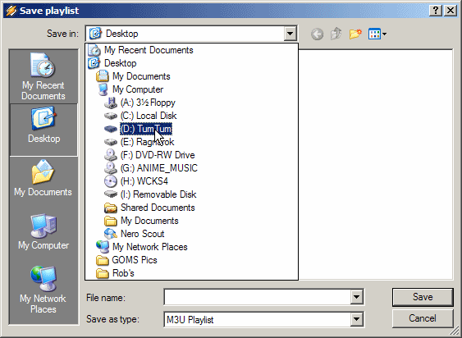
 | press and release MB | bb | 0.2
 | find list options button | m | 1.2
 | Point with mouse to list options | p | 1.1
 | press and release mb | bb | 0.2
 | find save playlist | m | 1.2
 | point to save playlist | p | 1.1
 | press and release mb | bb | 0.2
 | find 'save in' dropdown box | m | 1.2
 | point to 'save in' dropdown box | p | 1.1
 | press and release | bb | 0.2
 | find appropriate drive | m | 1.2
 | point to appropriate drive | p | 1.1 | 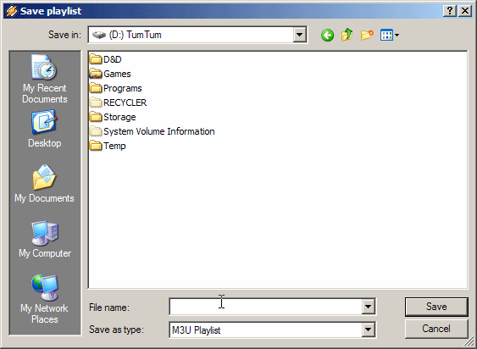
 | press and release | bb | 0.2
 | hands to keyboard | h | 0.4
 | think of 'filename' | m | 1.2
 | type 'filename' | kp*8 | 1.6
 | Verify 'filename' | m | 1.2
 | Hand to Mouse | h | 0.4
 | find Save Button | m | 1.2
 | Point with mouse to Save Button | p | 1.1
 | Press and release MB | bb | 0.2
Total | 28.9
 | GOMS
 | Method for Goal: Click Object
 | 1. Locate object on screen | m | 1.2
 | 2. Move pointer to object location | p | 1.1
 | 3. Depress mouse button | b | 0.1
 | 4. Release mouse button | b | 0.1
 | 5. Return with goal accomplished
Total | 2.5
 | Method for Goal: Drag Object to Destination
 | 1. Locate object on screen | m | 1.2
 | 2. Move pointer to object location | p | 1.1
 | 3. Hold left mouse button down | b | 0.1
 | 4. Locate destination on screen | m | 1.2
 | 5. Move pointer to destination | p | 1.1
 | 6. Verify destination | m | 1.2
 | 7. Release left mouse button | b | 0.1
 | 8. Return with goal accomplished
Total | 6
 | Method for Goal: Prepare Winamp Window for manipulation
 | 1. If Winamp is visible, goto step 3 | m | 1.2
 | 2. Accomplish Goal: Click Winamp Taskbar Icon | click | 2.5
 | 3. If Winamp is not in Winshade Mode, goto step 5 | m | 1.2
 | 4. Accomplish Goal: Click Winamp Toggle Winshade Button | click | 2.5
 | 5. Return with goal accomplished
Total | 7.4
 | Method for Goal: Prepare Playlist Window for manipulation
 | 1. If Winamp is visible, goto step 3 | m | 1.2
 | 2. Accomplish Goal: Prepare Winamp Window for manipulation | prepWin | 7.4
 | 3. If Playlist is visible, goto Step 5 | m | 1.2
 | 4. Accomplish Goal: Click Playlist Button | click | 2.5
 | 5. If Playlist is Fullsize, goto step 7 | m | 1.2
 | 6. Accomplish Goal: Click Playlist Toggle Winshade Button | click | 2.5
 | 7. Return with Goal Accomplished
Total | 16
 | Method for Goal: Enter text in textbox
 | 1. Accomplish Goal: Click Filename Box | click | 2.5
 | 2. Type Text | kp*8 | 1.6
 | 3. Verify Text | m | 1.2
 | 4. Return with Goal Accomplished
Total | 5.3
 | Method for Goal: Save file using SaveAs Dialog Box
 | 1. If Drive is correct, goto step 4 | m | 1.2
 | 2. Accomplish Goal: Click 'Save in' Dropdown Box | click | 2.5
 | 3. Accomplish Goal: Click Correct Drive | click | 2.5
 | 4. If Folder is correct, goto step 6 | m | 1.2
 | 5. Accomplish Goal: Click Correct Folder | click | 2.5
 | 6. Accomplish Goal: Enter filename in 'File name' textbox | entertext | 5.3
 | 7. Accomplish Goal: Click Save | click | 2.5
 | 8. Return with goal Accomplished
Total | 17.7
 | Method for Goal: Change Winamp Volume to 50%
 | 1. Accomplish Goal: Prepare Winamp Window for manipulation | prepWin | 7.4
 | 2. Accomplish Goal: Drag WA Volume slider to 50% Location | Drag | 6
 | 3. Return with goal accomplished
Total | 13.4
 | Method for Goal: Resize Playlist Window ~50 pixels
 | 1. Accomplish Goal: Prepare Playlist for manipulation | prepPlay | 16
 | 2. Accomplish Goal: Drag corner of playlist ~50 pixels | Drag | 6
 | 3. Return with goal accomplished
Total | 22
 | Method for Goal: Save Playlist
 | 1. Accomplish Goal: Prepare Playlist for manipulation | prepPlay | 16
 | 2. Accomplish Goal: Click LIST OPTS Button | click | 2.5
 | 3. Accomplish Goal: Click SAVE LIST Button | click | 2.5
 | 4. Accomplish Goal: Save file using SaveAs Dialog Box | SaveAs | 17.7
 | 5. Return with goal accomplished
Total | 38.7

