User Task Modeling
In The GIMP 2.2.9

A play in six acts.
By: Brian Schroeder

Introduction:
This project identifies three common tasks performed in the GNU Image Manipulation Program (The GIMP.) Each example includes a higher-level GOMS model of a user task and, under each GOMS step (in the style of the MS Visual Studio disassembly window), the corresponding Keystroke Level Model steps. Also, each of the three user tasks are presented in a specific situation where they perform optimally (using the mouse only) and in another situation where some additional steps are required for the tools to perform well. Although they have been attached to specific functions, they are still basically abstractions of the method for using entire classes of tools. The first example outlines the process for applying nearly any filter to an image with the main exception being that many filters have a myriad of options which, under certain circumstances (generally when the preview of the result is undesired), require additional time to configure. The bad case involves attempting to apply some filters to an image that has access to less than the systems full compliment of colors, ie. GIF-type image. The second example involves using a drawing tool. The good example is when you can see the layer of the image you are drawing on, the bad example is where there are other layers obstructing the layer you want to use the tool on. The third task is not quite as abstracted as the previous two, it involves using a selection tool to select a portion of an image with similar color. The good example involves an image with good saturation and contrast with a relatively tight color threshold on the selection tool selecting most of the users indented region, the poor example involves too broad a threshold on a poorly saturated image selecting most of the image.

The models were designed to model users with a passing familiarity with the program (a poor choice on my account, not the easiest sort of person to find, so my model users needed a quick training session to get them up to speed.)

- Goal: Applying a Gaussian blur filter to an image
  - File is full-color mode
    - Assumptions:
      - Image is already open.
      - Image is visible.
    - GOMS/KLM
Step 1: Locate correct menu item for Gaussian Blur filter
        - M: Recall the location of filter (Filters->Blur->Gaussian Blur)
        - P: Move pointer to Filters menu item.
        - BB: Click on menu item
        - P: Move over Blur sub menu
        - BB: Click on sub menu
        - P: Move over Gaussian Blur filter
        - BB: Click on Gaussian Blur
Step 2: Verify settings
        - M: Approve/disapprove blur radius
        - M: Approve/disapprove blur method
Step 3: If disapproved of
modify setting
        - M: Determine which setting needs to be changed
        - P: Move pointer to appropriate option
        - BB: Select/change a setting
else
approve settings.
        - P: Move pointer to OK button
        - BB: Select OK button
        - W: Wait for system to perform operation (image/system dependent)
        - M: Confirm that operation took place to liking
Step 4: Return with goal accomplished
5*M+5*P+ 5*BB+W = 5.5+6.0+1.0+w = 12.5 sec +W

  - Image has indexed palette. (not full color)
    - Assumptions:
      - Image is already open.
      - Image is visible.
    - GOMS/KLM
Step 1: Locate correct menu item for Gaussian Blur filter
        - M: Recall the location of filter
        - P: Move pointer to Filters menu item.
        - BB: Click on menu item
        - P: Move over Blur sub menu
        - BB: Click on sub menu
        - P: Move over Gaussian Blur filter
If second time through
proceed to keystroke 18
        - M: Recognize that Gaussian blur has been disabled as an option
        - P: Move back over Filters menu
        - BB: Click on menu to deselect it.
Step 2: Check to see if image is using indexed palette.
        - M: Look for the word "indexed" in image title bar
Step 3: If found
Convert image to full color
        - M: Recall location of RGB (Image->Mode->RGB)
        - P: Move pointer to Image menu item
        - BB: Click on Image menu.
        - P: Move pointer to Mode sub menu
        - BB: Select Mode sub menu
        - P: Move pointer to RGB option
        - BB: Select RGB option
goto Step 1
else
report bug
** Not elaborated here **
        - BB: Click on Gaussian Blur
Step 4: Verify settings
        - M: Approve/disapprove blur radius
        - M: Approve/disapprove blur method
Step 5: If disapproved of
modify setting
        - M: Determine which setting needs to be changed
        - P: Move pointer to appropriate option
        - BB: Select/change a setting
else
approve settings.
        - P: Move pointer to OK button
        - BB: Select OK button
        - W: Wait for system to perform operation (image/system dependent)
        - M: Confirm that operation took place to liking
Step 6: Return with goal accomplished
9*M+12*P+11*BB+W = 10.8+13.2+2.2+W = 25.2sec

- Goal: Draw a line with the paintbrush tool
  - Desired visible layer is selected
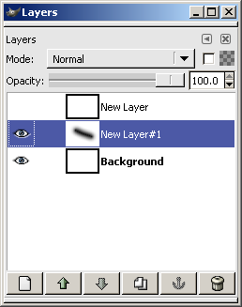
    - Assumptions:
      - Multiple-layer image is already open.
      - Image is visible.
      - The active layer is visible.
      - Tool palette is visible.
    - GOMS/KLM
Step 1: Select paintbrush tool from tool palette
        - M: Remember the location of paintbrush tool on tool palette
        - P: Move pointer to paintbrush
        - BB: Select paintbrush button
Step 2: Draw a line
        - M: Determine where to place the line
        - P: Move pointer to start point for line
        - B: Press down mouse button
        - P: Move pointer to end point for line
        - M: Confirm that line is as desired
        - B: Release button
Step 3: Return with goal accomplished
3*M+3*P+2*B+BB = 3.6+3.3+0.2+0.2 = 7.3sec

  - Incorrect layer is selected and is not visible.

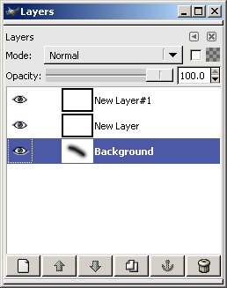
    - Assumptions:
      - Multiple-layer image is already open.
      - Image is visible and all layers are turned on.
      - Layer dialog box is visible.
      - Image has no alpha channels or layer blending.
      - Tool palette is visible.
    - GOMS/KLM
Step 1: Select paintbrush tool from tool palette
        - M: Remember the location of paintbrush tool on tool palette
        - P: Move pointer to paintbrush
        - BB: Select paintbrush button
Step 2: Draw a line.
        - M: Determine where to place the line
        - P: Move pointer to start point for line
        - B: Press down mouse button
        - P: Move pointer to end point for line
        - M: Confirm that line is as desired
Step 3: If line does not appear
confirm layer settings
        - M: Check which layer is active
Goto Step 4
Otherwise
Return with goal accomplished
Step 4: Undo accidental line
        - M: Recall location of Undo (Edit->Undo)
        - P: Move pointer to Edit menu
        - BB: Click on edit menu
        - P: Move to 'Undo'
        - BB: Click on Undo
        - M: Check to see that accidental mark disappears from layer thumbnail
Step 5: While there are visible layers above desired layer
Turn off viewing of a layer above target layer
        - P: Move to view icon of layer above desired layer
        - BB: Click on view icon to toggle layer off
Step 6: Goto Step 2
8*M+8*P+4*BB+2*B = 9.6+8.8+0.8+0.2 = 19.4sec

- Goal: Select a portion of an image with a similar color
  - Tight threshold or image with high contrast

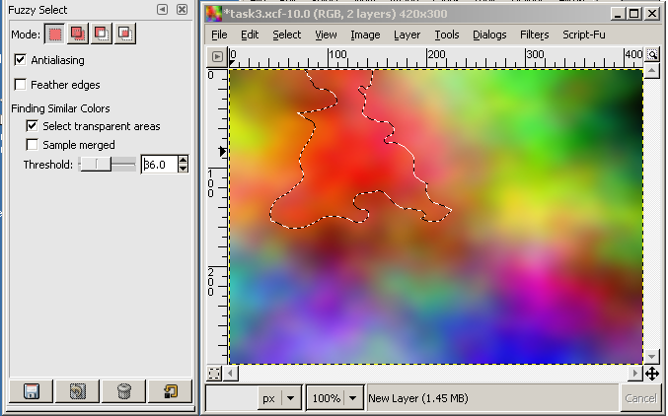
    - Assumptions:
      - Image is open and fully visible
      - Threshold is less than or equal to the standard deviation of the value.
      - Tool palette is visible.
    - GOMS/KLM
Step 1: Choose "Select contiguous regions" button from the tool palette
        - M: Locate "Select contiguous regions" on tool palette (the fourth button)
        - P: Move pointer to correct tool
        - BB: Select tool
Step 2: Select region from image
        - M: Determine what portion of area to select
        - P: Move pointer to area of image to select from
        - BB: Select region
Step 3: Return with goal accomplished
2*M+2*P+2*BB = 2.4+2.2+0.4 = 5.0sec

  - Large threshold or image with low contrast

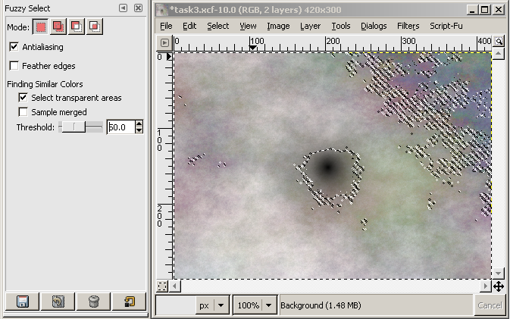
    - Assumptions:
      - A directory window with multiple image files is visible and active.
      - Threshold is greater than or equal to twice the standard deviation of the value.
      - Tool palette is visible.
    - GOMS/KLM
Step 1: Choose "Select contiguous regions" button from the tool palette
        - .M: Locate "Select contiguous regions" on tool palette (the fourth button)
        - P: Move pointer to correct tool
        - BB: Select tool
Step 2: Select region from image
        - M: Determine what portion of area to select
        - P: Move pointer to area of image to select from
        - BB: Select region
Step 3: If selected region is too large
clear previous selection area
        - M: Recall location of Undo (Edit->Undo)
        - P: Move pointer to Edit menu
        - BB: Click on edit menu
        - P: Move to 'Undo'
        - BB: Click on Undo
adjust threshold of selection tool
        - M: Locate Threshold in tool options beneath tool palette
        - P: Move pointer to threshold slider
        - B: Click on slider and hold.
        - P: move mouse slightly to adjust threshold amount down appropriately
        - B: Release mouse button
goto Step 1
otherwise
Return with goal accomplished
4*M+6*P+4*BB+2*B = 4.8+6.6+0.8+0.2 = 12.4sec

Data:
All times are in seconds.
Person | Task 1 |  | Task 2 |  | Task 3
Situation | Good | Poo | Good | Poor | Good | Poor
User 1 | 12 | 17 | 6 | 12 | 4 | 16
User 2 | 18 | 26 | 8 | 21 | 7 | 20
User 3 | 9 | 15 | 5 | 11 | 3 | 11
Average | 13 | 19.33 | 6.33 | 14.67 | 4.67 | 15.67
Projected | 12.5 | 25.2 | 7.3 | 19.4 | 5.0 | 12.4
Difference | 0.5 | -5.87 | -0.97 | -4.73 | -0.33 | 3.27
%Error | 4 | -23.28 | -13.24 | -24.4 | -6.67 | 26.34

Conclusions:
Overall, my projections for the good scenario were not too far off averaging about 7% error overall. I believe some of the difference may come from skill levels (User 3 being about twice as 'skilled' as user 2). It appears that I overestimated generally, but I feel that the overestimation is more a result of the 'P' action not accounting for small movements like selecting items from a sub menu, but I also may have used too many mental operators. I noticed that the results in the poor operation on task 3 were significantly over. I believe this is a result of the threshold slider being particularly small and requiring a per-pixel precision to select a more appropriate threshold.

