Part number: L-1200-P
Description: Vehicle Frame/Rocker Lift - Extended Travel - Air Operated - Portable
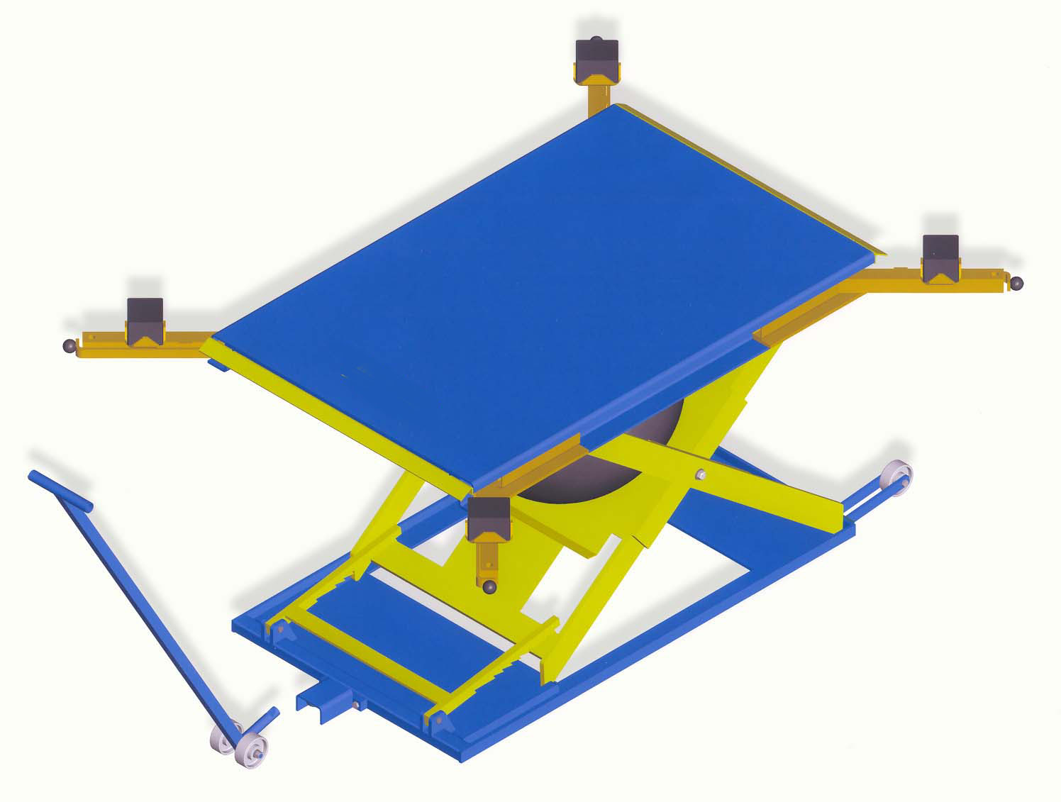
Pictures:

Detailed description: The L-1200-P air operated vehicle lift is designed for applications that require an optimal vehicle working height. An operator’s use of an L-1200-P lift leads to higher efficiency and productivity for shops or more money for the bottom line. The lift’s purpose is to create a stress-free environment for the operator(s) by moving the vehicle to a more ergonomic location, the efficiency of the operator is increased, the time to complete a given task is generally reduced, and the operator’s health is maintained by minimizing stress and strain of the human body during the job task.
File name: L-1200-P.jpg

The lift is ideal for all body repair and paint applications specifically, for use within spray booths. Many operators prefer the L-1200-P lift for conducting more thorough inspections and estimates. The lift is also chosen to perform tire changes, tire rotations, and brake work. The lift ensures ergonomically sound work practices when conducting engine repair work, windshield replacement and other types of repair work.

Best practice application: Body repair, spray booths, vehicle inspection and estimation, tire change / rotation, brake work, windshield repair / replacement, engine and drive train repair.
Technical information:
Air input (psi) | 60 – 120
Capacity (lb): | 6000
Platform size (in): | 41.5 x 63
Lowered height (in): | 4.25
Travel (in): | 32.25
Raised height (in): | 36.5
Controller: | Foot operated
Stationary / portable: | Portable dolly handle
Load: | Vehicle frame / rocker

Safety features: Internal Automatic Safety Ratchet
Pop-Off Safety Valve

Your choice of options: Controller

