Part number: K-900-S
Description: Vehicle Suspension/Tire Lift - Direct Lifting - Air Operated
Pictures:

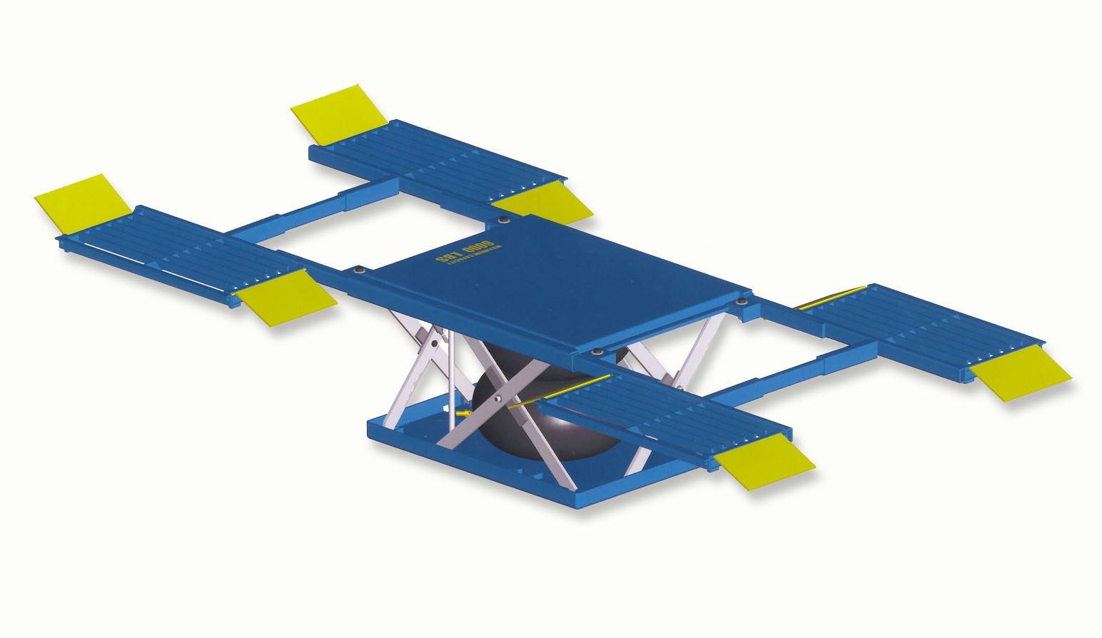

File name: K-900-S REC.jpg
Detailed description: The K-900-S vehicle suspension /tire air operated lift is specifically engineered to improve productivity by allowing the operator to move the vehicle to a more ergonomic work height. The time to complete a given task is generally reduced, and the operator’s health is maintained by minimizing stress and strain of the human body during the job task. The lift is ideal for all body repair work, and other automotive repair applications.
File name: K-900-S.jpg

Best practice application: Body repair, spray booths, vehicle inspection and estimation, tire change / rotation, brake work,.

Technical information:
Air input (psi) | 60 - 120
Capacity (lb): | 5000
Platform size (in): | 79.25 x 151. not including ramps
Lowered height (in): | 4.5
Travel (in): | 25
Raised height (in): | 29.5
Controller: | Hand operated
Stationary / portable: | Stationary
Load: | Vehicle suspension / tire
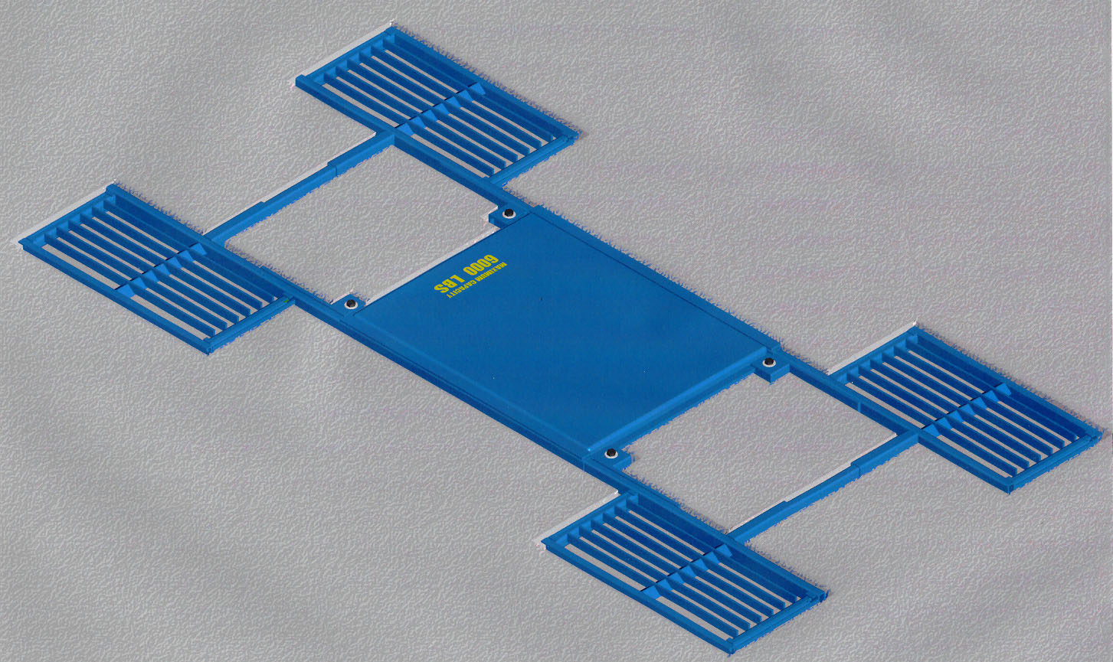
Safety features: Internal Automatic Safety Arm
Pop-Off Safety Valve

Your choice of options: Color
Controller
Recessed Installation

