Part number: K-900-RF
Description: Vehicle Frame/Rocker Lift - Air Operated - Portable Rail (front to back travel)
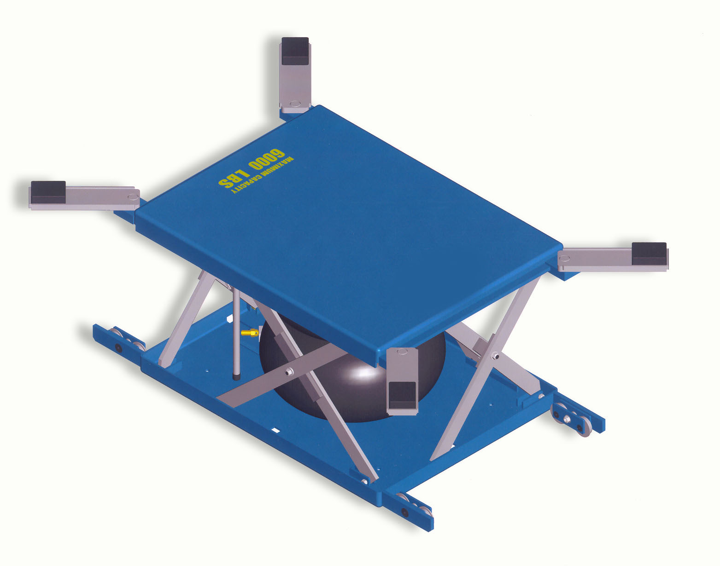
Pictures:

File name: 979.jpg
Detailed description: The K-900-RF vehicle frame/rocker air operated lift is specifically engineered to improve productivity by allowing the operator to move the vehicle to a more ergonomic work height. The time to complete a given task is generally reduced, and the operator’s health is maintained by minimizing stress and strain of the human body during the job task. The K-900-RF allows for forward/backward transportation of the vehicle from station to station throughout the shop. The lift is ideal for all body repair work, and other automotive repair applications.
File name: K-900-RF.jpg

Best practice application: Body repair, spray booths, vehicle inspection and estimation, tire change / rotation, brake work.

Technical information:
Air input (psi) | 60 - 120
Capacity (lb): | 5000
Platform size (in): | Deck: 38 x 50 Overall: 39.25 X 61.50
Clearance - floor to bottom of lift (in): | 1.3
Lowered height (in): | In-ground: 4.75 Above ground: 5.25
Travel (in): | 25
Raised height (in): | In-ground: 29.75 Above ground: 30.25
Controller: | Hand operated
Stationary / portable: | Portable rail - forward movable

Safety features: Internal Automatic Safety Arm
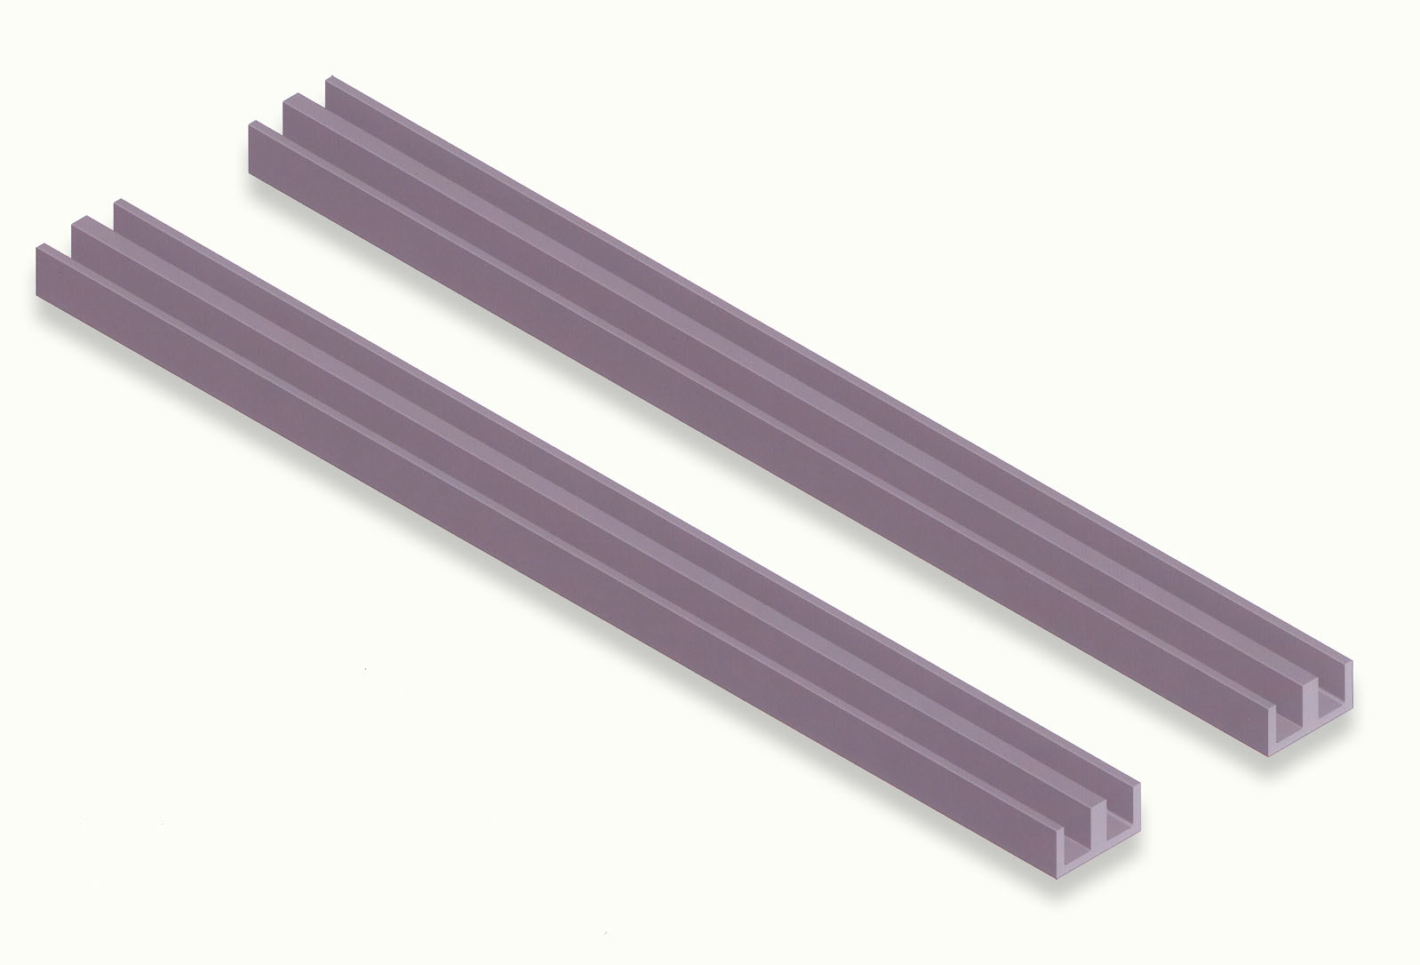
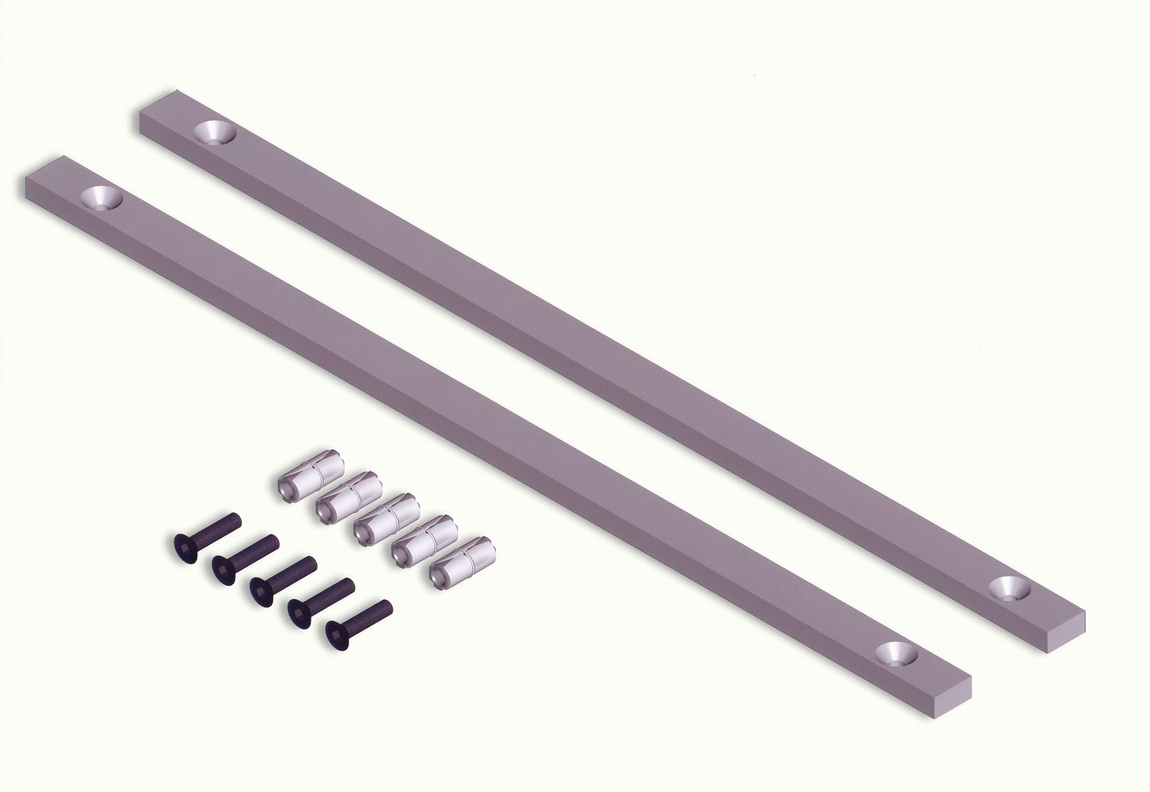
Pop-Off Safety Valve

Your choice of options: Color
Controller
Sideways Movable
In-Ground Rail
Above-Ground Rail
File name: 975.jpg

