2.0 Test Plan

2.1 Software modules, ADT's and methods to be tested:
For our testing purposes, the items in question are the data structures and their related modules and methods. A module consists of any two or more methods that work in conjunction to perform a certain task, and the data type that is modified by those methods. It is the interface between the modular functions that are to be examined, with the corresponding input and output used as measures of a module's integrity. Any test results are to be cross-referenced with the requirements document in order to measure conformance. Each phase of the testing process will examine the following areas: functional validity and correctness, interface integrity, information content, and performance. In regards to the Risk Table Builder, the specific methods and data structures to be tested are directly below, with their resultant modules following:

level 0;
main(), (controls the whole shootin' match)
constructor(), (creates the list)
user interface
database

level 1 methods:
void MakeDataBase(), (creates database)
void LinkList::InsertFromUser(), (receives risk data from user, places in db)
void LinkList::RiskInputFromDB(), (receives risk from db)
void sort(), (sorts list elements)
void LinkList::output(), (sends risks to data file)
void LinkList::print(), (outputs the risks)
switch(), (controls invocation based on users input)

level 2 methods:
void LinkList::Insert(), (inserts an element into the linked list)
void LinkList::RetrieveRisk(), (retrieves list element)
void LinkList::InitCursor, (initializes the cursor)

level 3 methods:
bool LinkList::AtEnd(), (boolean function to determine end of list)
void LinkList::InsertInDB(), (places info into new element)
vod LinkList::Advance(), (move cursor to next element)

Abstract data types:
struct ListElement, (data element for the list)
class LinkList, (list of risks)

The following digraph represents the functional hierarchy:
Print
Main
MakeDb
Insert
Level 1
Level 2
Switch
RiskFromDb
Insert_User
RetrieveRisk
Constructor
output
InsertInOrder
Sort
AtEnd
Level 3
Advance
Init cursor
Level 0

2.2 Testing strategy:

2.2.1 Unit Testing:
At agreed upon regularly scheduled intervals, the system's developmental progress will be subject to peer review. If necessary the test scheduling will correspond to the completion to a system module. The purpose of these reviews is to discover any incorrect, insufficient or extraneous code. This will be achieved by focusing on "the operations encapsulated by the class and the state behavior of the class", (Pressman, 98, pg 649). Also at regularly scheduled intervals, the system will be subject to a formal inspection by project management.
In order to assure correctness, a battery of unit tests will be implemented. The purpose of these tests is to measure the functional integrity within each individual module. The tests are to include a formal proof of algorithm correctness and symbolic execution, the latter utilizing "basis path testing" and PDL techniques, also known as "white box" testing. Issues to consider are: matching of parameters and arguments and relative attributes, I/O interface, and memory management.

2.2.2 Integration Testing:
Once the individual modules and their relative data structures and methods have been tested, the integration phase will examine the interaction between the relevant modules. "Test harnesses" will be constructed so that a "dummy" caller can invoke each method, and any database interaction will be with a fictitious database. The actual testing method used for this phase will be the "black box" method. In utilizing this method, only the module's input and output are examined-the specific implementation is not considered.

2.2.3 Validation Testing:
The testing strategy for the validation of the system as a whole will also utilize the "black-box" method. This method will concentrate on visible user input and output, without examining the inner workings of each function, in order to determine whether the correct system has been built. All possible user input must be examined and any deficiencies addressed. Like the integration testing, this phase will be performed in a "bottom-up" manner, as shown in the digraph depicted above. This order moves in a "breadth-first" fashion, with each level representing an order of method invocation.

2.2.4 High-order Testing:
Once the system has been completed and the integration testing performed, the software is put in place into the working environment and a "systems test" is applied. In this phase the system interacts with actual user input and the complete database. This phase utilizes the "black box" testing technique as well, and must insure that the system performs up to specification within the working environment, as detailed in the requirements document.

2.3 Testing Resources and Staffing:
Specialized resources for the testing of Risk Table Builder are fairly minimal, the only necessary components being a web-enabled system that has access to the risk database. The staff responsible for the testing will be a collective of personnel from CKN Technologies and a client representative. For the "walkthrough" portion of the unit testing, CKN staff will examine the SCI's in question, with an impartial CKN manager acting as FTR coordinator. If desired by the client, an ITG can be specified to carry out the testing phase.

2.4 Test Work Products:
The "test work products" for the system amount to the deliverables from the testing phases. As the unit and integration testing will be utilizing "test harnesses", the resulting test work product for these phases will be the records of the total number of errors encountered for each module, their relative probability and their impact. The test products for the system as a whole, gleaned from the validation and high-order testing phases, will include records of "Mean Time Between Fail", "Mean Time To Repair", "Mean Time To Change" and any and all documentation developed during the testing phases.

2.5 Test Record Keeping:
At every stage of the testing process, record keeping and result evaluation is to be the responsibility of the testing personnel, with the project management overseeing the process. The software librarian is responsible for insuring that the results are kept up to date with the system documentation, so that any discrepancies can be traced.

2.6 Test metrics:
The test metrics involved throughout the testing process are to measure the overall performance of the system. Some metrics to consider are:
- Mean time between fail
- Mean time to repair
- Mean time to change
- Availability
- Reliability
For the component level testing:
- Cohesion, (test of functional strength)
- Coupling , (test of a function's independence)
- Global coupling, (number of global variables used as data and control)
- Environmental coupling, (measures of 'fan-out' and 'fan-in')
For sample metrics:
- Function points, (can be derived from the design document)
- Bang metric, (functional primitives, data elements, objects, relationships, states, transitions)
- Specification quality, specificity and metric completeness
For high-level design metrics:
- Structural complexity
- Data complexity
- System complexity
Metrics for measuring test effort:
- Software science effort, (total testing effort for the complete system)
- Modular percentage effort, (estimate of effort allocated to a particular module)

2.7 Testing Tools and environment:
For the purposes of this specific development application, no specialized testing tools are deemed necessary. In terms of the testing environment, all testing phases prior to the "high-order" or "system" testing are to be done at the development site. Once the system has passed the validation phase, testing can then be moved to the client site, so that it can be checked for interfacing with the clients existing systems.

2.8 Testing Schedule:
For the testing phases, the following schedules will apply, with room for flexibility as needed:
Unit testing: 4 weeks
Integration testing: 3 weeks
Validation testing: 2 weeks
High order testing: 4 weeks
1 2 3 4 5 6 7 8 9 10 11
3.0 Test Procedure:

3.1 Software To Be Tested:
As mentioned in section 2.1 the following Software Configuration Items are to be tested:
Abstract data types:
struct ListElement, (data element for the list)
class LinkList, (list of risks)

level 3 methods:
bool LinkList::AtEnd(), (boolean function to determine end of list)
void LinkList::InsertInDB(), (places info into new element)
vod LinkList::Advance(), (move cursor to next element)

level 2 methods:
void LinkList::Insert(), (inserts an element into the linked list)
void LinkList::RetrieveRisk(), (retrieves list element)
void LinkList::InitCursor, (initializes the cursor)

level 1 methods:
void MakeDataBase(), (creates database)
void LinkList::InsertFromUser(), (receives risk data from user, places in db)
void LinkList::RiskInputFromDB(), (receives risk from db)
void sort(), (sorts list elements)
void LinkList::output(), (sends risks to data file)
void LinkList::print(), (outputs the risks)
switch(), (controls invocation based on users input)

level 0;
main(), (controls the whole shootin' match)
constructor(), (creates the list)

3.2.1 Unit Test Cases:
The chosen methodology for unit testing, as described earlier, is the "white-box testing" approach. This will be implemented by utilizing flow graph representation of the PDL for each sub-function. The PDL and flow graphs are below, the basis paths tests follow:
5
6b
7
1
3
2
4
6a
FLOW GRAPH: AtEnd
LEVEL 3

PDL
Procedure: AtEnd

1. if list is empty
2. then return true
set return value to true;
3. else if list is at the end
4. then return true
set return value to true;
5. else set the return value to false;
6a. end if
6b. end if
7. end
PDL

Procedure: InsertInOrder
FLOW GRAPH: InsertInOrder
14
1-4
5
6
7
8
9
10
11
12
13
15
- create a new ListElement and a pointer to it;
- assert the memory was set aside;
- store key in Key field;
store category in Category field;
store risk in risk in Risk field;
store impact in Impact field;
store probability in Probability field;
- set new ListElement successor to NULL:
- if new list or 1st ListElement probability is < new
ListElement probability
- then set new ListElement successor = Head;
set Head = new ListElement pointer;
set Cursor = Head;
- else create a ListElement pointer named current
- while current != NULL and current successor
probability is < new ListElement probability
current = current successor
9. end while
start successor = current successor;
current successor = start;
- end if
- increment the variable size;
- if the ListElement was inserted in the last position
- then set Rear = start
- end if
- end

PDL
Procedure: Advance
1
2
3
4
FLOW GRAPH: Advance
- if Cursor != NULL
- Then move the pointers Prev and Cursor up one ListElement
set the pointer Prev = to the pointer Cursor
set the pointer Cursor = to Cursors successor
- end if
- end

LEVEL 2

PDL
Procedure: Insert
11,12
10
1
9
5-8
4
3
2
FLOW GRAPH: Insert
- if cursor is = to head
- then insert the new ListElement
create a new ListElement and set head = to it;
assert that memory was set aside;
set head successor = cursor;
set cursor = head;
- else insert the new ListElement between prev and cursor
create a new ListElement and set prev successor = to it;
assert that memory was set aside for the new node;
set prev successor successor = cursor;
set cursor = prev successor;
- end if
- set cursor Risk = risk;
- set Cursor Key = key;
- set Cursor Category = category;
- increment size by one;
- if the ListElement is the last node
- then reset the pointer rear
set rear = cursor;
- end if
1
2
3
4
5
6
7
8
9
10
11
FLOW GRAPH: RetrieveRisk
- end

PDL
Procedure: RetrieveRisk

- if there is no link list
- then set success = false;
- else iterate the list until key is found
- while not at the end of the list
- if key is equal to Key
- then return the correct values
set risk = cursor risk;
set category = cursor category;
set boolean parameter to true;
return;
- end if
- call advance;
- end while
- end if
- end

1
2
3
FLOW GRAPH: InitCursor

PDL
Procedure: InitCursor
- reset Cursor = to Head;
- set Prev = to NULL;
- end

LEVEL 1

PDL
Procedure: MakeDataBase
1
2
FLOW GRAPH: MakeDataBase

- insert data into systems data base
call insert with a risk , category, and key #1;
repeat the step above till key = 96;
- end

PDL
Procedure: InsertFromUser
- types or variables used
create a char array of length 320;
create string variables risk and category and initialize them to “ “;
create integer variables probability and impact;
- clear the users screen;
- print asking the user for a risk factor;
- read the risk factor
- set the risk factored just read = to the string variable risk;
- create space on the screen for the user using endl;
- output to the screen the 8 categories;
- print asking the user to input a category;
- read the input using the variable category;
- print asking the user to input a probability;
- if the probability is < 1 or >99
- then prompt the user for a new probability until they are in range
- while the probability is < 1 or > 99
clear the screen;
print asking the user for new probability between 1 and 99;
read the new probability;
- end while
- end if
- print asking for impact;
- print categories of different impacts for the user;
- read the impact;
- if the impact is not between 1 and 4
- then prompt the user for a new impact until they are in range
- while impact is not between 1 and 4
clear the screen;
print asking for new impact;
print categories of impacts;
read the impact;
- end while
- end if
- insert the users data into a database by calling InsertInOrder() function and passing the correct data as parameters
- increment the global variable that represents the users key by one;
- end
1-10
11
13
12
14
16-18
15

FLOW GRAPH :InsertFromUser

20
21
22
23
26
24,25
19
FLOW GRAPH: InsertFromUser

PDL
Procedure: sort
- create a new ListElement and make a pointer thasst points to it;
- assert that memory was put aside for the new ListElement;
- for comparison of first ListElement till last ListElement
- for comparison of second ListElement till last ListElement
compare data in 1st ListElement to 2nd ListElement, 3rd ListElement etc;
compare data in 2nd ListElement to 3rd ListElement, 4th ListElement etc;
compare until last ListElement is reached;
- if any ListElement impact data field is < 1st ListElement Impact data field
- then swap the data in the ListElements
set temp risk data = 2nd ListElement risk data;
set temp probability data = 2nd ListElement probability data;
set temp impact data = 2nd ListElement impact data;
set temp category data = 2nd ListElement category data
set 2nd ListElement risk data = 3rd ListElement risk data;
set 2nd ListElement probability data = 3rd ListElement probability
set 2nd ListElement impact data = 3rd ListElement impact data;
set 2nd ListElement category data = 3rd ListElement category data;
set 3rd ListElement risk data = 2nd ListElement risk data;
set 3rd ListElement probability data = 2nd ListElement probability;
set 3rd ListElement impact data = 2nd ListElement impact data;
set 3rd ListElement category data = 2nd ListElement category data;
7
3
1,2
4
5
6
1010
9
8
FLOW GRAPH: Sort
- end if
- end for
- end for
- end

PDL
Procedure: RiskInputFromDB

- types initialized to 0 or “ “ as appropriate
integers; num, impact, probability;
strings; risk, category;
bool success;
char verify
- clear screen
- build the user interface to interact with the user
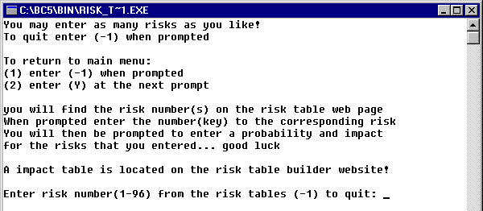
- while the user has more risks to enter
set Boolean variable verify to ‘n’ or true;
- while the user finds the correct risks to match their key from the web
set success = false;
interact with the user to get their risk key;
read key;
- if key is the quit signal
- then return to the main program
clear the screen;
return;
Procedure: RiskInputFromDB.cont

- end if
- if the key is not between 1 and 96
- then prompt for a new key until they get it right
- while the key is not between 1 and 96
prompt the user to their mistake and ask for a new key;
read key;
- end while
- end if
- retrieve the risk, key, category, and Boolean success from the system db
- prompt the user to make sure their key matches the systems risk;
- read verify
- end while
- initialize the cursor using initCursor;
- prompt the user for a probability;
- read probability;
- if the probability is not between 1 and 99
- then prompt the user for a new probability repeatedly until corrected
- while probability is not between 1 and 99
clear the screen;
prompt the user for a new probability;
read probability;
- end while
- end if
- prompt the user for a risk impact;
- provide the user with impact categories;
- read impact;
- if the impact is not between 1 and 4
- then prompt repeatedly until correct impact entered
- while impact ,1 or > 4
prompt for new impact;
read new impact;
- end while
- end if
- insert the users data risk, key, category, probability, and impact into the users database using the InsertInOrder function;
- increment the global variable that represents the users key;
- clear the screen;
- end while
- end

while
1-3
7
8
6
5
4
While
if
then
End if
9
10
if
then
11
while
12
End while
13
14-16
17
End if
FLOW GRAPH: RiskInputFromDB

End while (5)
18-20
26-28
25
24
23
22
21
if
then
while
End while
End if
29
30
31
32
if
then
33
while
End while
End if
FLOW GRAPH: RiskInputFromDB, cont

33-36
37
38
End while (4)
end
FLOW GRAPH: RiskInputFromDB, cont

Procedure: output

- create an object of ofstream and use that object to create/open a file named RTable.txt;
- create a pointer to a ListElement named start and set it = to the pointer head;
- create a header for the risk table include key and risk and send to text file;
1-3
5
4
9
6,7
10,11
8
FLOW GRAPH: Output
- while the list exists iterate the list
send to the txt file the key and risk from each ListElement;
set start = start successor;
- end while
- set start = to the pointer head;
- create a header which includes key, category, impact, probability, and
RMMM for the risk table itself and send it to the txt file;
- while the list exists iterate the list
send to the text file the key, category, impact, and probability
in a formatted output.
Set start = start successor;
- end while
- send to the text file a explanation of impact abbreviations
and helpful tips like what RMMM is for;
- end

PDL
Procedure: print

- create a pointer to a ListElement named start and set it = to the pointer head;
- clear the screen.
- create a header for the risk table include key and risk and print it to the screen;
- while the list exists iterate the list
print to the screen the key and risk from a ListElement;
set start = start successor;
- end while
1-3
4
11
10
9
8
6,7
5
FLOW GRAPH: Print
- set start = to the pointer head;
- create a header which includes key, category, impact,
probability, and RMMM for the risk table itself and
print it to the screen;
- while the list exists iterate the list
print the key, category, impact, and probability
in a formatted output.
Set start = start successor;
- end while
- print to the screen a explanation of impact abbreviations
and helpful tips like what RMMM is used for;
- end

Actual code:
switch(op)
{
case 1:
l.RiskInputFromDB(k);
break;
case 2:
while(choice == 'y')
{
l.InsertFromUser(k);
cout << "\nWould you like to enter another risk (y/n): ";
cin >> choice;
cout << endl;
clrscr();
}
break;
default: cout << "try again...";
}
1
5
2
3
4
FLOW GRAPH: Switch

LEVEL 0:

PDL
Main()
1-6
7
FLOW GRAPH: Main
- create chars and int
- create link lists l and k
- call MakeDataBase(l)
- output user prompt
- call switch
- call k.print()
- end
The following section represents the basis path, or "white box", testing for the unit testing phase. Included are the methods purpose, paths and expected results.

Procedure: AtEnd
Purpose: To determine whether there is a list that new elements can be added to.

Step 2:
Number of conditional statements = 2 + 1 = 3 (Computational Complexity). So the number of paths is three.

Step 3:
Path 1:1-2-6b-7
Path 2: 1-3-4-6a-6b-7
Path 3: 1-3-5-6a-6b-7

Step 4:
Path 1 test:
- list is empty: true
Expected results:
- will set return value of AtEnd to true
Path 2 test:
- list is at the end: true
Expected results:
- will set return value of AtEnd to true
Path 3 test:
- list is at the end: false
Expected results:
- will set return value of AtEnd to false.

Procedure: InsertInOrder
Purpose: Insert elements into the linked list in order

Step 2:
Number of conditional statements = 5 + 1 = 6. (computational complexity). So the number of paths is six.

Step 3:
Path 1: 1-2-3-4-5-6-10-11-12-13-14-15
Path 2: 1-2-3-4-5-6-10-11-12
Path 3: 1-2-3-4-5-7-8-9-8-10-11-12-13-14-15
Path 4: 1-2-3-4-5-7-8-10-11-12-13-14-15
Path 5: 1-2-3-4-5-7-8-10-11-12
Path 6: 1-2-3-4-5-7-8-9-8-10-11-12

Step 4:
Path 1 test case:
- new list or 1st ListElement probability is < new ListElement probability: (true,true), (true,false), or (false,true)
- the ListElement was inserted in the last position: true
Expected results:
- creates a new list element
- sets memory aside
- stores key, category, risk, impact, and probability in appropriate fields
- sets new element successor equal to head
- sets head equal to new list element pointer
- sets cursor equal to head
- sets rear equal to start.

Path 2 test case:
- new list or 1st ListElement probability is < new ListElement probability: (true,true), (true,false), or (false,true)
- ListElement was inserted in the last position: false
Expected results:
- creates a new list element
- sets memory aside
- stores key, category, risk, impact, and probability in appropriate fields
- sets new element successor equal to head
- sets head equal to new list element pointer
- sets cursor equal to head

Path 3 test case:
- new list or 1st ListElement probability is < new ListElement probability: (false,false)
- current != NULL and current successor probability is < new ListElement probability: (true,true)
- the ListElement was inserted in the last position: true
Expected results:
- creates a new list element
- sets memory aside
- stores key, category, risk, impact, and probability in appropriate fields
- creates a list element pointer named current
- set the current pointer equal to the it’s successor
- set start successor equal to current successor
- set current successor equal to start
- increment the variable size
- sets rear equal to start

Path 4 test case:
- new list or 1st ListElement probability is < new ListElement probability: (false,false)
- current != NULL and current successor probability is < new ListElement probability: (false,false), (false,true), or (true,false)
- the ListElement was inserted in the last position: true
Expected results:
- creates a new list element
- sets memory aside
- stores key, category, risk, impact, and probability in appropriate fields
- creates a list element pointer named current
- set start successor equal to current successor
- set current successor equal to start
- increment the variable size
- sets rear equal to start

Path 5 test case:
- new list or 1st ListElement probability is < new ListElement probability: (false,false)
- current != NULL and current successor probability is < new ListElement probability: (false,false), (false,true), or (true,false)
- the ListElement was inserted in the last position: false
Expected results:
- creates a new list element
- sets memory aside
- stores key, category, risk, impact, and probability in appropriate fields
- creates a list element pointer named current
- set start successor equal to current successor
- set current successor equal to start
- increment the variable size

Path 6 test case:
- new list or 1st ListElement probability is < new ListElement probability: (false,false)
- current != NULL and current successor probability is < new ListElement probability: (true,true)
- the ListElement was inserted in the last position: false
Expected results:
- creates a new list element
- sets memory aside; stores key, category, risk, impact, and probability in appropriate fields
- creates a list element pointer named current
- set the current pointer equal to the it’s successor
- set start successor equal to current successor
- set current successor equal to start
- increment the variable size

Procedure: Advance
Purpose:

Step 2:
Number of conditional statements = 1 + 1 = 2 (computational complexity). So the number of paths is two.

Step 3:
Path 1: 1-4
Path 2: 1-2-3-4

Step 4:
Path 1 test case:

Cursor != NULL: false
Expected results:
- end if statement, nothing happens.
Path 2 test case:

Cursor != NULL: true
Expected results:
- The prev pointer and cursor pointer will point to next element in the list. This is done by pointing the prev pointer to the cursor pointer and pointing the cursor pointer to it’s successor.

Procedure: Insert
Purpose: To insert new elements into the list.

Step 2:
Number of conditional statements = 2 + 1 = 3 (computational complexity). So the number of paths is three.

Step 3:
Path 1: 1-2-4-5-6-7-8-12
Path 2: 1-3-4-5-6-7-8-9-10-11-12
Path 3: 1-3-4-5-6-7-8-9-12

Step 4:
Path 1 test case:
- Cursor = = head: true
Expected results:
- insert the new list element
- create a new list element and set head equal to it
- set memory aside
- set head successor equal to cursor
- set cursor equal to head
- set cursor risk equal to risk
- set cursor key equal to key
- set cursor category equal to category
- increment size by one

Path 2 test case:
- Cursor = = head: false
- list element is the last node: true
Expected results:
- set new list element between prev and cursor pointers
- create a new list element and set prev successor equal to it
- set memory aside for the new node
- set prev successor successor equal to cursor
- set cursor equal to prev successor
- reset the pointer rear
- set rear equal to cursor

Path 3 test case:
- Cursor = = head: false
- list element is the last node: false
Expected results:
- set new list element between prev and cursor pointers
- create a new list element and set prev successor equal to it
- set memory aside for the new node
- set prev successor successor equal to cursor
- set cursor equal to prev successor

Procedure: RetrieveRisk
Purpose: Retrieves the individual risks.

Step 2:
Number of conditional statements = 3 + 1 = 4 (computational complexity). So the number of paths is four.

Step 3:
Path 1: 1-2
Path 2: 1-3-4-5-6-7-8-9-4-10-11
Path 3: 1-3-4-5-7-8-9-4-10-11
Path 4 : 1-3-4-10-11

Step 4:
Path 1 test case:
- there is no link list: true
Expected results:
- sets success equal false

Path 2 test case:
- there is no link list: false
- not at the end of the list: true
- the key is equal to key: true
Expected results:
- the list will be iterated until the key is found
- return the correct values
- sets risk equal to cursor risk
- sets category equal to cursor category
- sets boolean parameter to true
- calls advance

Path 3 test case:
- there is no link list: false
- not at the end of the list: true
- the key is equal to key: false
Expected results:
- the list will be iterated until the key is found
- calls advance

Path 4 test case:
- there is no link list: false
- not at the end of the list: false
Expected results:
- the list will be iterated until the key is found.

Procedure: InitCursor
Purpose: To initialize the head and prev pointers

Step 2:
Number of conditional statements = 0 + 1 = 1 (computational complexity). So the number of paths is one.

Step 3:
Path 1: 1-2-3

Step 4:
Path 1 test:
Expected results:
- resets cursor equal to head and sets prev equal to null

Procedure: MakeDataBase
Purpose: To make the systems database.

Step 2:
Number of conditional statements = 0 + 1 = 1 (computational complexity). So the number of paths is one.

Step 3:
Path 1: 1-2

Step 4:
Path 1 test:
Expected results:
- call insert with a risk , category, and key #1
- repeat the step above till key equals 96

Procedure: InsertFromUser
Purpose: To take information from the user and inserts their riska into their own database.

Step 2:
Number of conditional statements = 3 + 1 = 4(computational complexity). So the number of paths is seven. In this function if condition 11 is true so must condition 13 and vice versa. Also, similarly, if function 19 is true then so must condition 21 and vice versa. This reduces the number of conditional statements to 3 although it seems as though 6 appear in the function.

Step 3:
Path 1: 1-2-3-4-5-6-7-8-9-10-11-12-13-14-15-16-17-18-19-20-21-22-23-24-25-26
Path 2: 1-2-3-4-5-6-7-8-9-10-11-12-13-14-15-16-17-18-19-23-24-25-26
Path 3: 1-2-3-4-5-6-7-8-9-10-11-15-16-17-18-19-20-21-22-23-24-25
Path 4: 1-2-3-4-5-6-7-8-9-10-11-15-16-17-18-19-23-24-25

Step 4:
Path 1 test case:
- the probability is < 1 or >99: (true,true), (false,true), or ( true,false)
- the impact is not between 1 and 4: true
Expected results:
- creates a char array of length 320
- creates a string variables risk and category and initializes them to “ “
- creates an integer variable probability and impact
- it then clears the users screen
- it asks the user for a risk factor
- it reads that risk factor
- it sets the risk factor just read equal to the string variable risk
- creates space on the screen for the user
- outputs the 8 categories to the screen
- asks the user to input a category
- reads the input using the variable category
- asks the user to input a probability
- prompts the user for a new probability until they are in the correct range
- asks for the impact of the risk
- prints the categories of different impacts for the user
- reads the impact
- prompts the user for a new impact until they are in the correct range
- clears the screen
- asks again for new impact
- prints the categories of the impacts
- reads the impact
- inserts the users data into a database by calling InsertInOrder() function and passing the correct data as parameters
- increments the global variable that represents the users key by one

Path 2 test case:
- the probability is < 1 or >99: (true,true), (false,true), or ( true,false)
- the impact is not between 1 and 4: false
Expected results:
- creates a char array of length 320
- creates a string variables risk and category and initializes them to “ “
- creates an integer variable probability and impact
- it then clears the users screen
- it asks the user for a risk factor
- it reads that risk factor
- it sets the risk factor just read equal to the string variable risk
- creates space on the screen for the user
- outputs the 8 categories to the screen
- asks the user to input a category
- reads the input using the variable category
- asks the user to input a probability
- prompts the user for a new probability until they are in the correct range
- inserts the users data into a database by calling InsertInOrder() function and passing the correct data as parameters
- increments the global variable that represents the users key by one

Path 3 test case:
- the probability is < 1 or >99: (false,false)
- the impact is not between 1 and 4: true

Expected results:
- creates a char array of length 320
- creates a string variables risk and category and initializes them to “ “
- creates an integer variable probability and impact
- it then clears the users screen
- it asks the user for a risk factor
- it reads that risk factor
- it sets the risk factor just read equal to the string variable risk
- creates space on the screen for the user
- outputs the 8 categories to the screen
- asks the user to input a category
- reads the input using the variable category
- asks the user to input a probability
- asks for the impact of the risk
- prints the categories of different impacts for the user
- reads the impact
- prompts the user for a new impact until they are in the correct range
- clears the screen
- asks again for new impact
- prints the categories of the impacts
- reads the impact
- inserts the users data into a database by calling InsertInOrder() function and passing the correct data as parameters
- increments the global variable that represents the users key by one

Path 4 test case:
- the probability is < 1 or >99: (false,false)
- the impact is not between 1 and 4: false
Expected results:
- creates a char array of length 320
- creates a string variables risk and category and initializes them to “ “
- creates an integer variable probability and impact
- it then clears the users screen
- it asks the user for a risk factor
- it reads that risk factor
- it sets the risk factor just read equal to the string variable risk
- creates space on the screen for the user
- outputs the 8 categories to the screen
- asks the user to input a category
- reads the input using the variable category
- asks the user to input a probability
- asks for the impact of the risk
- prints the categories of different impacts for the user
- reads the impact
- inserts the users data into a database by calling InsertInOrder() function and passing the correct data as parameters
- increments the global variable that represents the users key by one

Procedure: sort
Purpose: Sorts the risks that the user has indicated they want input into there table.

Step 2:
Number of conditional statements = 1 + 1 = 2 (computational complexity) So the number of paths is two.

Step 3:
Path 1: 1-2-3-4-5-6-7-8-9-10
Path 2: 1-2-3-4-5-8-9-10
Step 4:
Path 1 test case:
- Any ListElement impact data field is < 1st ListElement Impact data field: True
Expected results:
- Create a new ListElement and make a pointer that points to it.
- Verify that memory was put aside for it.
- compare data in 1st ListElement to 2nd ListElement, 3rd ListElement etc
- compare data in 2nd ListElement to 3rd ListElement, 4th ListElement etc
- compare until last ListElement is reached
- swap the data in the ListElements
- set temp risk data = 2nd ListElement risk data;
- set temp probability data = 2nd ListElement probability data;
- set temp impact data = 2nd ListElement impact data;
- set temp category data = 2nd ListElement category data
- set 2nd ListElement risk data = 3rd ListElement risk data;
- set 2nd ListElement probability data = 3rd ListElement probability
- set 2nd ListElement impact data = 3rd ListElement impact data;
- set 2nd ListElement category data = 3rd ListElement category data;
- set 3rd ListElement risk data = 2nd ListElement risk data;
- set 3rd ListElement probability data = 2nd ListElement probability;
- set 3rd ListElement impact data = 2nd ListElement impact data;
- set 3rd ListElement category data = 2nd ListElement category data;

Path 2 test case:
Any ListElement impact data field is < 1st ListElement Impact data field: False
Expected results:
- Create a new ListElement and make a pointer that points to it.
- Verify that memory was put aside for it.
- compare data in 1st ListElement to 2nd ListElement, 3rd ListElement etc
- compare data in 2nd ListElement to 3rd ListElement, 4th ListElement etc
- compare until last ListElement is reached

Procedure: RiskInputFromDB
Purpose: To input the pre-defined risks from the web-site into the users risk table.
Step 2:
Number of conditional statements = 10 + 1 = 11 (computational complexity) So the number of paths is eleven.
Step 3:
Path 1: 1-2-3-4-5-6-7-8-9-10-11-12-13-14-15-16-17-18-19-20-21-22-23-24-25- 26-27-28-29-30-31-32-33-34-35-36-37-38
Path 2: 1-2-3-4-5-6-7-8-9-10-11-12-13-14-15-16-17-18-19-20-21-22-23-24-25- 26-27-28-29-30-31-33-34-35-36-37-38
Path 3: 1-2-3-4-5-6-7-8-9-10-11-12-13-14-15-16-17-18-19-20-21-22-23-25- 26-27-28-29-34-35-36-37-38
Path 4: 1-2-3-4-5-6-7-8-9-10-11-12-13-14-15-16-17-18-19-20-21-22-23-25- 26-27-28-29-30-31-33-34-35-36-37-38
Path 5: 1-2-3-4-5-6-7-8-9-10-11-12-13-14-15-16-17-18-19-20-21-22-23-25- 26-27-28-29-30-31-34-35-36-37-38
Path 6: 1-2-3-4-5-6-7-8-9-10-11-12-13-14-15-16-17-18-19-20-21-26-27-28-29-30-31-34-35-36-37-38
Path 7: 1-2-3-4-5-6-7-8-9-10-11-13-14-15-16-17-18-19-20-21-22-23-24-25- 26-27-28-29-30-31-32-33-34-35-36-37-38
Path 8: 1-2-3-4-1-2-3-4-5-6-7-8-9-14-15-16-17-18-19-20-21-22-23-24-25- 26-27-28-29-30-31-32-33-34-35-36-37-38
Path 9: 1-2-3-4-5-6-9-10-11-12-13-14-15-16-17-18-19-20-21-22-23-24-25- 26-27-28-29-30-31-32-33-34-35-36-37-38
Path 10: 1-2-3-4-5-18-19-20-21-22-23-24-25-26-27-28-29-30-31-32-33-34-35-36-37-38
Path 11: 1-2-3-4-38

Step 4:
Path 1 test case:
- All conditions are true
Expected Results:
- Types initialized
- clear screen
- build the user interface to interact with the user
- set Boolean variable verify to ‘n’ or true
- set success = false
- interact with the user to get their risk key
- read key
- prompt for a new key until they get it right
- prompt the user to their mistake and ask for a new key;
- retrieve the risk, key, category, and Boolean success from the system db
- prompt the user to make sure their key matches the systems risk;
- read verify
- initialize the cursor using initCursor;
- prompt the user for a probability;
- read probability;
- prompt the user for a new probability repeatedly until corrected
- clear the screen;
- prompt the user for a new probability;
- read probability;
- prompt the user for a risk impact;
- provide the user with impact categories;
- read impact;
- prompt repeatedly until correct impact entered
- prompt for new impact;
- read new impact;
- insert the users data risk, key, category, probability, and impact into the users database using the InsertInOrder function;
- increment the global variable that represents the users key;
- clear the screen;

Path 2 test case:
- All conditions true except;
- impact 1 or > 4: false
Expected Results:
- Types initialized
- clear screen
- build the user interface to interact with the user
- set Boolean variable verify to ‘n’ or true
- set success = false
- interact with the user to get their risk key
- read key
- prompt for a new key until they get it right
- prompt the user to their mistake and ask for a new key
- retrieve the risk, key, category, and Boolean success from the system db
- prompt the user to make sure their key matches the systems risk
- read verify
- initialize the cursor using initCursor
- prompt the user for a probability
- read probability
- prompt the user for a new probability repeatedly until corrected
- clear the screen
- prompt the user for a new probability
- read probability
- prompt the user for a risk impact
- provide the user with impact categories
- read impact
- prompt repeatedly until correct impact entered
- insert the users data risk, key, category, probability, and impact into the users database using the InsertInOrder function
- increment the global variable that represents the users key
- clear the screen

Path 3 test case:
- All conditions true except;
- impact between 1 and 4: False
Expected Results:
- Types initialized
- clear screen
- build the user interface to interact with the user
- set Boolean variable verify to ‘n’ or true
- set success = false
- interact with the user to get their risk key
- read key
- prompt for a new key until they get it right
- prompt the user to their mistake and ask for a new key
- retrieve the risk, key, category, and Boolean success from the system db
- prompt the user to make sure their key matches the systems risk
- read verify
- initialize the cursor using initCursor
- prompt the user for a probability
- read probability
- prompt the user for a new probability repeatedly until corrected
- clear the screen
- prompt the user for a new probability
- read probability
- prompt the user for a risk impact
- provide the user with impact categories
- read impact
- insert the users data risk, key, category, probability, and impact into the users database using the InsertInOrder function
- increment the global variable that represents the users key
- clear the screen

Path 4 test case:
- All conditions are true except;
- probability is between 1 and 99: False
Expected Results:
- Types initialized
- clear screen
- build the user interface to interact with the user
- set Boolean variable verify to ‘n’ or true
- set success = false
- interact with the user to get their risk key
- read key
- prompt for a new key until they get it right
- prompt the user to their mistake and ask for a new key;
- retrieve the risk, key, category, and Boolean success from the system db
- prompt the user to make sure their key matches the systems risk;
- read verify
- initialize the cursor using initCursor;
- prompt the user for a probability;
- read probability;
- prompt the user for a new probability repeatedly until corrected
- prompt the user for a risk impact;
- provide the user with impact categories;
- read impact;
- prompt repeatedly until correct impact entered
- prompt for new impact;
- read new impact;
- insert the users data risk, key, category, probability, and impact into the users database using the InsertInOrder function;
- increment the global variable that represents the users key;
- clear the screen;

Path 5 test case:
- All conditions are true except
- probability is between 1 and 99: False
- impact is between 1 or > 4: False
Expected Results:
- Types initialized
- clear screen
- build the user interface to interact with the user
- set Boolean variable verify to ‘n’ or true
- set success = false
- interact with the user to get their risk key
- read key
- prompt for a new key until they get it right
- prompt the user to their mistake and ask for a new key;
- retrieve the risk, key, category, and Boolean success from the system db
- prompt the user to make sure their key matches the systems risk;
- read verify
- initialize the cursor using initCursor;
- prompt the user for a probability;
- read probability;
- prompt the user for a new probability repeatedly until corrected
- prompt the user for a risk impact;
- provide the user with impact categories;
- read impact;
- prompt repeatedly until correct impact entered
- insert the users data risk, key, category, probability, and impact into the users database using the InsertInOrder function;
- increment the global variable that represents the users key;
- clear the screen;

Path 6 test case:
- All conditions are true; except
- probability is between 1 and 99: false
- Impact is 1 or >4: false
Expected Results:
- Types initialized
- clear screen
- build the user interface to interact with the user
- set Boolean variable verify to ‘n’ or true
- set success = false
- interact with the user to get their risk key
- read key
- prompt for a new key until they get it right
- prompt the user to their mistake and ask for a new key;
- retrieve the risk, key, category, and Boolean success from the system db
- prompt the user to make sure their key matches the systems risk
- read verify
- initialize the cursor using initCursor
- prompt the user for a probability
- read probability
- prompt the user for a risk impact
- provide the user with impact categories
- read impact
- prompt repeatedly until correct impact entered
- insert the users data risk, key, category, probability, and impact into the users database using the InsertInOrder function
- increment the global variable that represents the users key
- clear the screen

Path 7 test case:
- All conditions are true; except
- The key is not between 1 and 96: false (this is for the while only)
Expected Results:
- Types initialized
- clear screen
- build the user interface to interact with the user
- set Boolean variable verify to ‘n’ or true
- set success = false
- interact with the user to get their risk key
- read key
- retrieve the risk, key, category, and Boolean success from the system db
- prompt the user to make sure their key matches the systems risk
- read verify
- initialize the cursor using initCursor;
- prompt the user for a probability
- read probability
- prompt the user for a risk impact
- provide the user with impact categories
- read impact
- prompt repeatedly until correct impact entered
- insert the users data risk, key, category, probability, and impact into the users database using the InsertInOrder function
- increment the global variable that represents the users key
- clear the screen

Path 8 test case:
- All conditions are true; except
- Key is not between 1 and 96: false ( this is for the if and the while, which may be true or false because if the if is false it never evaluates the while)
Expected Results:
- Types initialized
- clear screen
- build the user interface to interact with the user
- set Boolean variable verify to ‘n’ or true
- set success = false
- interact with the user to get their risk key
- read key
- prompt for a new key until they get it right
- retrieve the risk, key, category, and Boolean success from the system db
- prompt the user to make sure their key matches the systems risk
- read verify
- initialize the cursor using initCursor
- prompt the user for a probability
- read probability
- prompt the user for a risk impact
- provide the user with impact categories
- read impact
- prompt repeatedly until correct impact entered
- insert the users data risk, key, category, probability, and impact into the users database using the InsertInOrder function
- increment the global variable that represents the users key
- clear the screen

Path 9 test case:
- All conditions are true; except
- Key is the quit signal: false
Expected Results:
- Types initialized
- clear screen
- build the user interface to interact with the user
- set Boolean variable verify to ‘n’ or true
- set success = false
- interact with the user to get their risk key
- read key
- prompt for a new key until they get it right
- prompt the user to their mistake and ask for a new key
- retrieve the risk, key, category, and Boolean success from the system db
- prompt the user to make sure their key matches the systems risk
- read verify
- initialize the cursor using initCursor
- prompt the user for a probability
- read probability
- prompt the user for a new probability repeatedly until corrected
- clear the screen
- prompt the user for a new probability
- read probability
- prompt the user for a risk impact
- provide the user with impact categories
- read impact
- prompt repeatedly until correct impact entered
- prompt for new impact
- read new impact
- insert the users data risk, key, category, probability, and impact into the users database using the InsertInOrder function
- increment the global variable that represents the users key
- clear the screen

Path 10 test case:
- All conditions are true; except
- User finds the correct risks to match their key from the web: false
Expected Results:
- Types initialized
- clear screen
- build the user interface to interact with the user
- set Boolean variable verify to ‘n’ or true
- initialize the cursor using initCursor
- prompt the user for a probability
- read probability
- prompt the user for a new probability repeatedly until corrected
- clear the screen
- prompt the user for a new probability
- read probability
- prompt the user for a risk impact
- provide the user with impact categories
- read impact
- prompt repeatedly until correct impact entered
- prompt for new impact
- read new impact
- insert the users data risk, key, category, probability, and impact into the users database using the InsertInOrder function
- increment the global variable that represents the users key
- clear the screen

Path 11 test case:
- All conditions are true; except
- User has more risks to offer: false
Expected Results:
- Types initialized
- clear screen
- build the user interface to interact with the user
- set Boolean variable verify to ‘n’ or true

Procedure: output
Purpose: To output the users risks from the program to a file named RTable.txt.
Step 2:
Number of conditional statements = 2 + 1 = 3 (computational complexity) So the number of paths is three.
Step 3:
Path 1: 1-2-3-4-5-6-7-8-9-10-11
Path 2:1-2-3-4-5-6-7-8-10-11
Path 3:1-2-3-4-6-7-8-10-11
Step 4:
Path 1 test case:
- All conditions are true
Expected Results:
- create an object of ofstream and use that object to create/open a file named RTable.txt
- create a pointer to a ListElement named start and set it = to the pointer head
- create a header for the risk table include key and risk and send to text file
- send to the txt file the key and risk from each ListElement
- set start = start successor
- set start = start successor
- set start = to the pointer head
- create a header which includes key, category, impact, probability, and RMMM for the risk table itself and send it to the txt file
- send to the text file the key, category, impact, and probability in a formatted output.
- Set start = start successor
- send to the text file a explanation of impact abbreviations and helpful tips like what RMMM is for

Path 2 test case:
- All conditions are true; except
- The second list exists: false
Expected Results:
- create an object of ofstream and use that object to create/open a file named RTable.txt
- create a pointer to a ListElement named start and set it = to the pointer head
- create a header for the risk table include key and risk and send to text file
- send to the txt file the key and risk from each ListElement
- set start = start successor
- set start = to the pointer head
- create a header which includes key, category, impact, probability, and RMMM for the risk table itself and send it to the txt file
- send to the text file a explanation of impact abbreviations and helpful tips like what RMMM is for

Path 3 test case:
- All conditions are true; except
- The first list exists: false

Expected Results:
- create an object of ofstream and use that object to create/open a file named RTable.txt
- create a pointer to a ListElement named start and set it = to the pointer head
- create a header for the risk table include key and risk and send to text file
- set start = to the pointer head
- create a header which includes key, category, impact, probability, and RMMM for the risk table itself and send it to the txt file
- send to the text file the key, category, impact, and probability in a formatted output.
- Set start = start successor
- send to the text file a explanation of impact abbreviations and helpful tips like what RMMM is for

Procedure: print
Purpose: To print the users table from the Rtable.txt file.
Step 2:
Number of conditional statements = 2 + 1 = 3 (computational complexity) So the number of paths is three.
Step 3:
Path 1: 1-2-3-4-5-6-7-8-9-10-11
Path 2:1-2-3-4-5-6-7-8-10-11
Path 3:1-2-3-4-6-7-8-10-11
Step 4:
Path 1 test case:
- All conditions are true
Expected Results:
- create a pointer to a ListElement named start and set it = to the pointer head
- clear the screen
- create a header for the risk table include key and risk and print it to the screen
- print to the screen the key and risk from a ListElement
- set start = start successor
- set start = to the pointer head
- create a header which includes key, category, impact, probability, and RMMM for the risk table itself and print it to the screen
- print the key, category, impact, and probability in a formatted output
- Set start = start successor
- print to the screen an explanation of impact abbreviations and helpful tips like what RMMM is used for

Path 2 test case:
- All conditions are true; except
- The second list exists: false
Expected Results:
- create a pointer to a ListElement named start and set it = to the pointer head
- clear the screen
- create a header for the risk table include key and risk and print it to the screen
- print to the screen the key and risk from a ListElement
- set start = start successor
- set start = to the pointer head
- create a header which includes key, category, impact, probability, and RMMM for the risk table itself and print it to the screen
- print to the screen an explanation of impact abbreviations and helpful tips like what RMMM is used for

Path 3 test case:
- All conditions are true; except
- The first list exists: false
Expected Results:
- create a pointer to a ListElement named start and set it = to the pointer head
- clear the screen
- create a header for the risk table include key and risk and print it to the screen
- set start = to the pointer head
- create a header which includes key, category, impact, probability, and RMMM for the risk table itself and print it to the screen
- print the key, category, impact, and probability in a formatted output
- Set start = start successor
- print to the screen an explanation of impact abbreviations and helpful tips like what RMMM is used for

Procedure: switch
Purpose: To find out whether the user is inputting anymore pre-defined risks or adding their own.
Step 2:
Number of conditional statements = 2 + 1 = 3 (computational complexity) So the number of paths is three.
Step 3:
Path 1: 1-5
Path 2: 2-3-5
Path 3: 2-4-5
Step 4:
Path 1 test case:
- case 1: true
Expected Results:
- call RiskInputFromDB

Path 2 test case:
- case 2: true
- choice =1 ‘y’: true
Expected Results:
- call InsertFromUser
- output the statement “Would you like to enter another risk(y/n):”
- inputs choice
- clears screen

Path 2 test case:
- case 2: true
- choice =1 ‘y’: false
Expected Results:
- prompts the user to “try again…”

Main()
Purpose: To create variables, linked lists, call functions and primarily run the program.
Step 2:
Number of conditional statements = 0 + 1 = 1 (computational complexity) So the number of paths is one.
Step 3:
Path 1: 1-2-3-4-5-6-7
Step 4:
Path 2 test:
- No conditions
Expected Results:
- Create chars and int
- Create link lists l and k
- Call MakeDataBase
- Output user prompt
- Call switch
- Call k.print



3.2.2 Integration Testing

The integration phase examines the aspect of interfacing between each sub-function. In doing so, it is necessary to construct "test harnesses"-artificial drivers for the functions being examined. Upon completion of this testing phase, the drivers are removed and stored by the data librarian so that any discrepancies uncovered at a later time can be traced and cross-referenced. The order of the testing is "bottom-up". The graphical representation and test harnesses follow, along with the purpose and expected results of each test module.

AtEnd/Insert

To test this interface, the stub calls Insert which in turn calls AtEnd. The Boolean result returned is the test result.
Insert

AtEnd
void AEstub()
Test result
void AEstub()
{
LinkList l;
l.Insert("test", 99999, "no");
}

The following output added to AtEnd for testing ONLY:

cout << EndList << endl;

Purpose: The purpose of testing this module is to judge the integrity of the interface between the Insert and AtEnd methods.

Expected results:
The expected results for this test will be a list element, representing an entered risk.

InsertInOrder/InsertFromUser

For this interface, stub calls InsertFromUser which calls InsertInOrder. InsertFromUser prompts for input, which is passed to InsertInOrder.
InsertFromUser

InsertInOrder
void IIOstub()
Test result
void IIOstub()
{
LinkList k;
cout << InsertFromUser(&k) << endl;
}

The following output is added to InsertInOrder for testing ONLY:
cout << start→Key << start→Risk << start→Category << start→Probability
<< start→Impact << endl;

Purpose: The purpose for testing this module is to examine the interface between "InsertFromUser" and "InsertInOrder". At issue is whether the linked list 'k' has been successfully passed by reference.

Expected results: For this test, the expected results will be the fields "Key", "Risk", "Category" and "Probability" for the respective list entered.

Advance/RetrieveRisk
This integration test examines the interface between Advance and RetrieveRisk.
RetrieveRisk

Advance
void Astub()
Test result
void Astub()
{
LinkList m;
string risk = "test";
string category = "ctest";
RetrieveRisk(risk, 99, category, success);
}
The following dummy output is added to "advance" for testing purposes only:
cout << cursor << endl;

Purpose: This module is tested to verify the integrity between the "RetrieveRisk" and "Advance" methods.

Expected result: The result for this specific test will be the advanced cursor position.

Insert/MakeDB
Examining the interface between Insert and MakeDB
MakeDB

Insert
void Istub()
Test result

void Istub()
{
LinkList N;
N.Insert("Unrealistic testing!", 9999, "no")
}

The following dummy output is applied to Insert for testing only:
>> cout >> risk >> key >> category >> endl;

Purpose: This test is to verify the interface between the "MakeDB" and "Insert" methods.

Expected results: If this tests runs properly, it should output the risk, key and category entered.

void RFDstub()
RiskFromDb

RetrieveRisk
void RFDstub()
Test result
{
LinkList O;
RetrieveRisk(1, 1, CC, false);
}
The following dummy output is for testing purposes;
cout >> Risk >> Category >> endl;

Purpose: This test is run to verify that the correct risk is retrieved from the database.

Expected results: The test should return the risk and its category.

void ICstub()
{
RiskFromDb

InitCursor
void ICstub()
Test result
LinkList P;
InitCursor;
}

Purpose: This test assures that the cursor has been incremented.

Expected results: The test returns the incremented cursor position.

3.2.3 Validation Testing

For the validation portion of the testing phase, a "black-box" method will also be used. All possible user inputs will be examined, and cross-referenced against the requirements specification. Any exceptions will be documented, with the system's previous state, offending user input or action, the errant output and the expected output, and the severity and degree of impact included in the documentation. If the exception can be corrected while remaining on schedule, then it will be addressed, otherwise an alternative method for resolution will be negotiated with the client.

RISK TABLE BUILDER
Input a
Input b
Input c
Input d
Input e
Output a
Output b
Output c
Output d
Output e

RESULTS IN FOLLOWING SECTION

3.2.4 High-order Testing:
Once the system has been completed and the integration testing performed, the software is put in place into the working environment and a "systems test" is applied. In this phase the system interacts with actual user input and the complete database. This phase utilizes the "black box" testing technique as well, and must insure that the system performs up to specification within the working environment. The types of tests run on the system include: recovery, security, stress, performance, and beta testing.

3.3 Testing Resources and Staffing:
Specialized resources for the testing of Risk Table Builder are fairly minimal, the only necessary components being a web-enabled system that has access to the risk database. The staff responsible for the testing will be a collective of personnel from CKN Technologies and the client. For the "walkthrough" portion of the unit testing, CKN staff will examine the SCI's in question, with an impartial CKN manager acting as FTR coordinator. If desired by the client, an ITG can be specified to carry out the testing phase.

3.4 Test Work Products:
As the unit and integration testing will be utilizing "test harnesses", the resulting test work product will be link elements of various risks, their relative probability and impact. The results from the validation and high-order testing will merely mirror user output from the system. These work products represent the deliverables that are created as a result of the testing phase: see corresponding sections.

3.5 Test Record Keeping:
At every stage of the testing process, record keeping and result evaluation is to be the responsibility of the testing personnel, with the project management overseeing the process. Any output and performance issues are directly referenced against the requirements document. The software librarian is responsible for insuring that the results are kept up to date with the system documentation, so that any discrepancies can be traced.

VALIDATION "BLACK BOX" TESTING

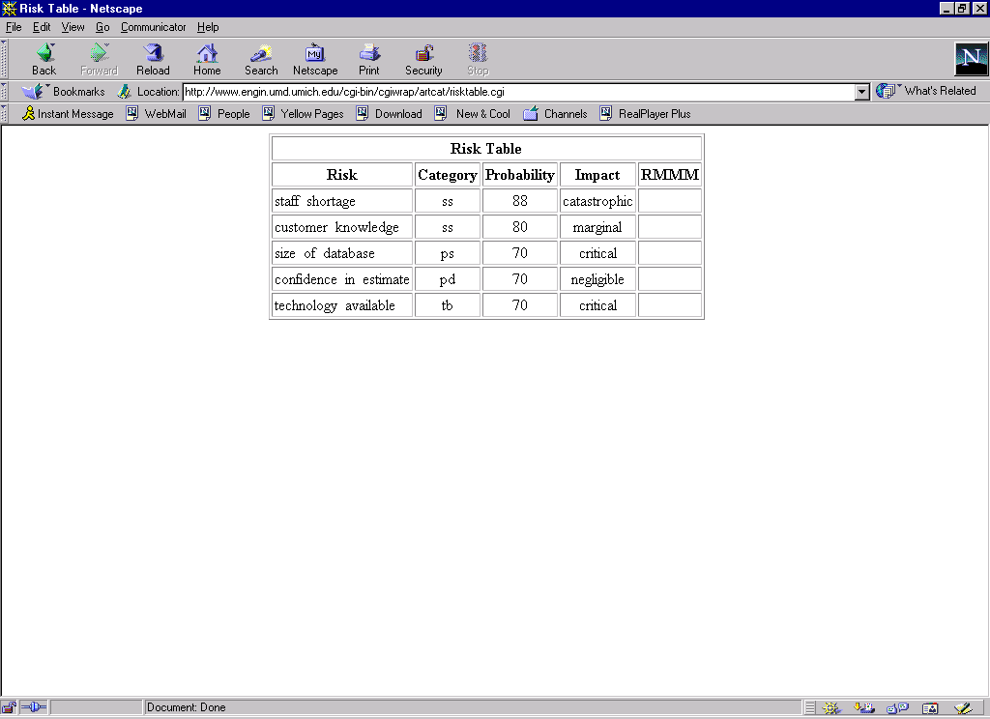
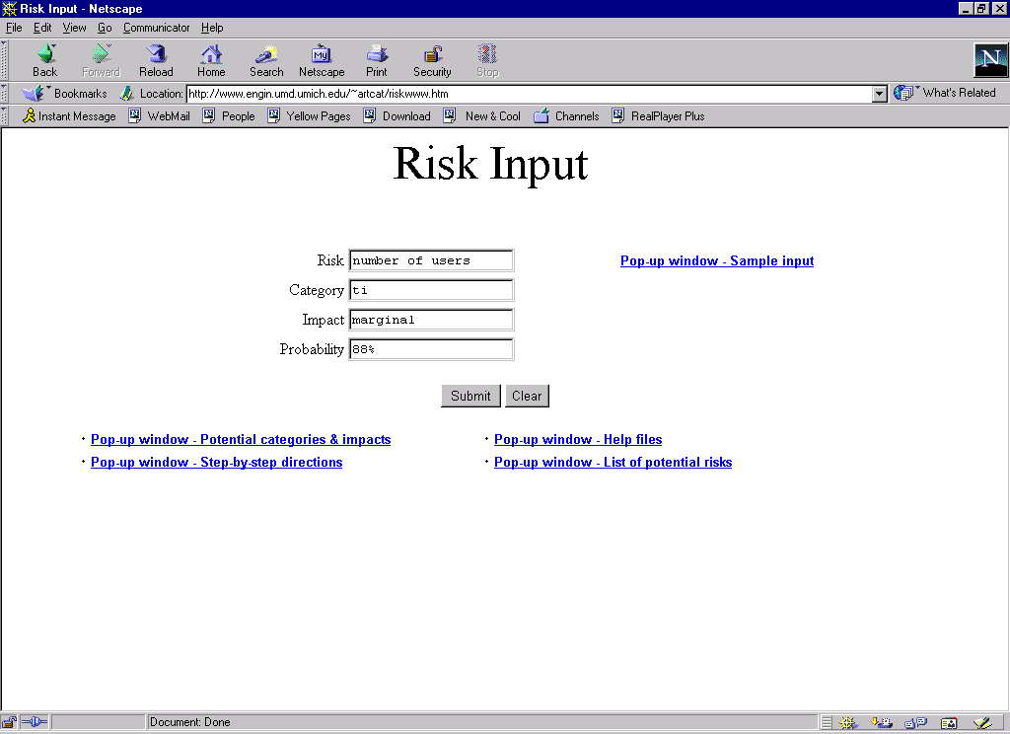
A sample of a typical run
A typical entry, (with %)

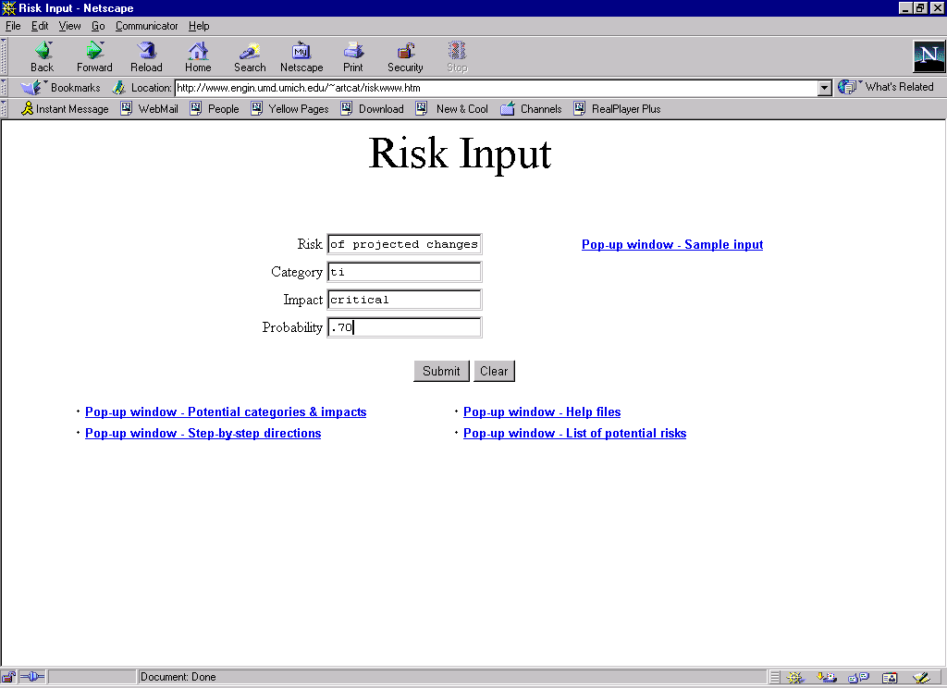
Another typical entry, (decimal percentage)

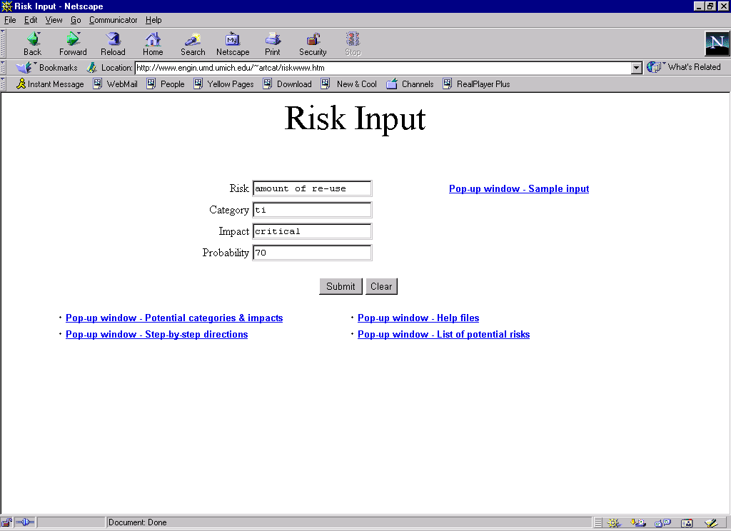

Typical entry, (with integer)

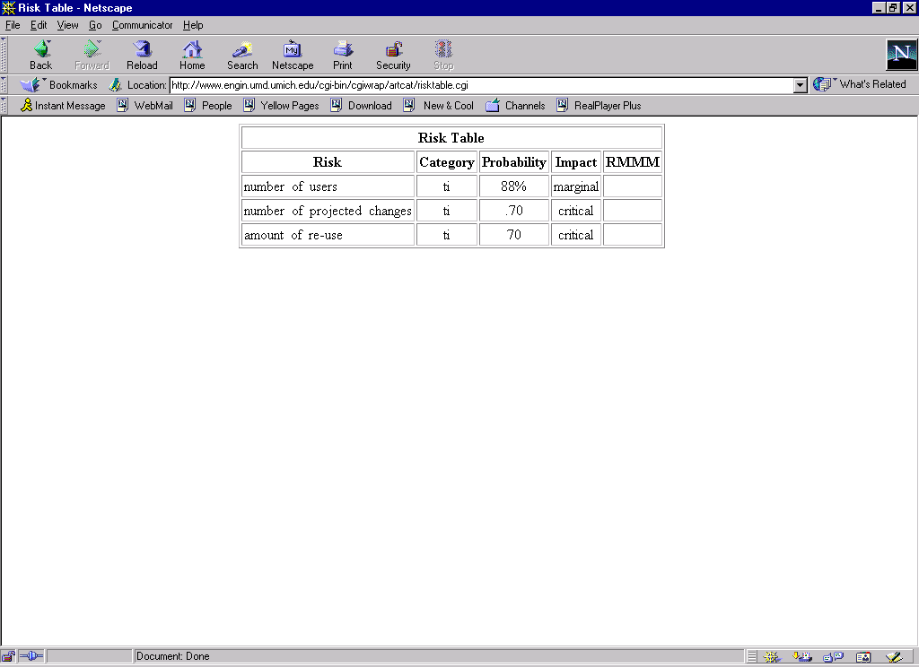
Output from above inputs

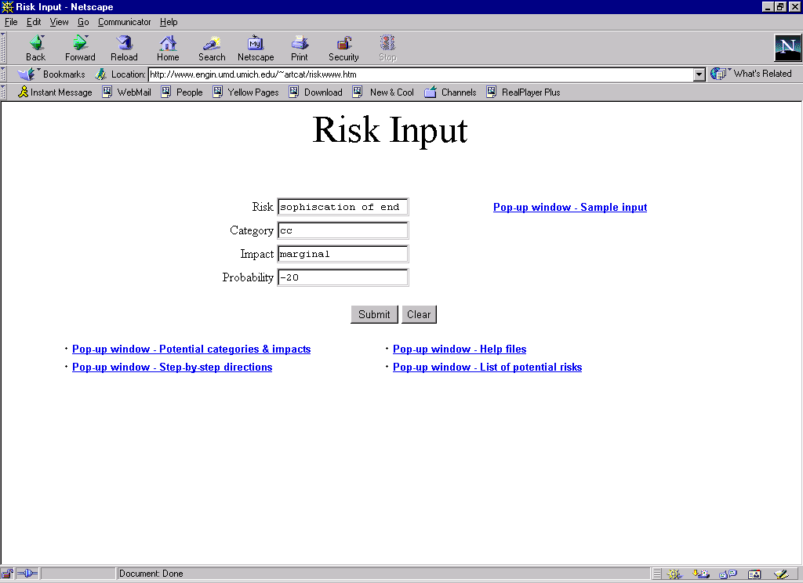
Atypical input, (negative probability)

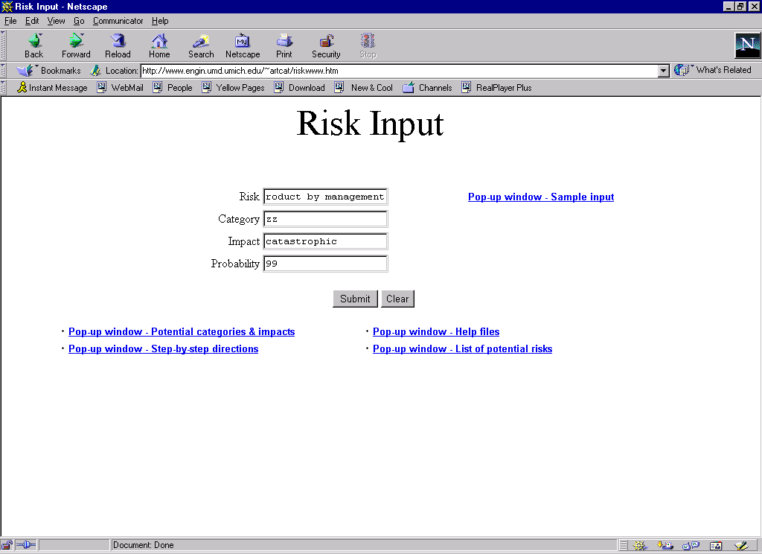
Atypical input, (unidentified risk type)

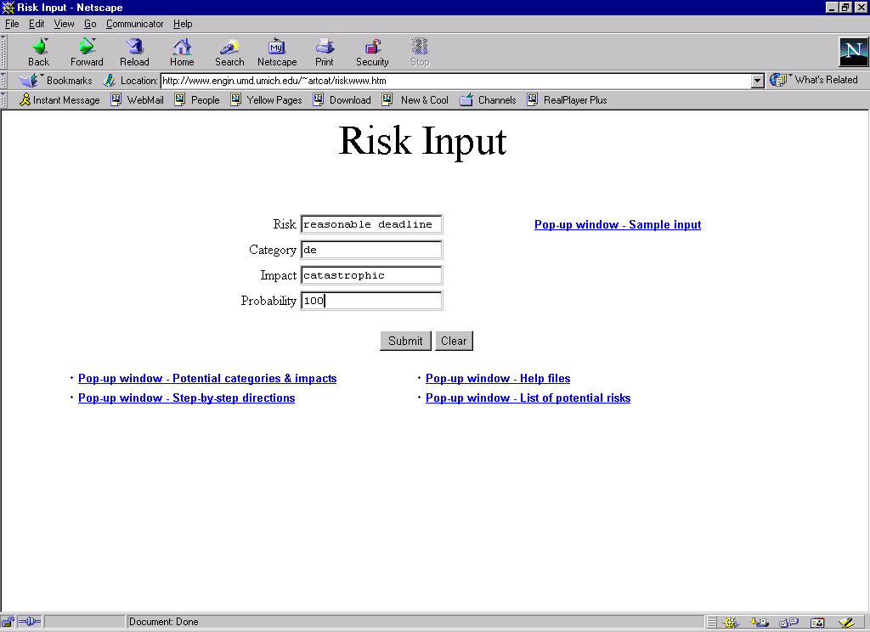

Atypical entry, (probability at 100)

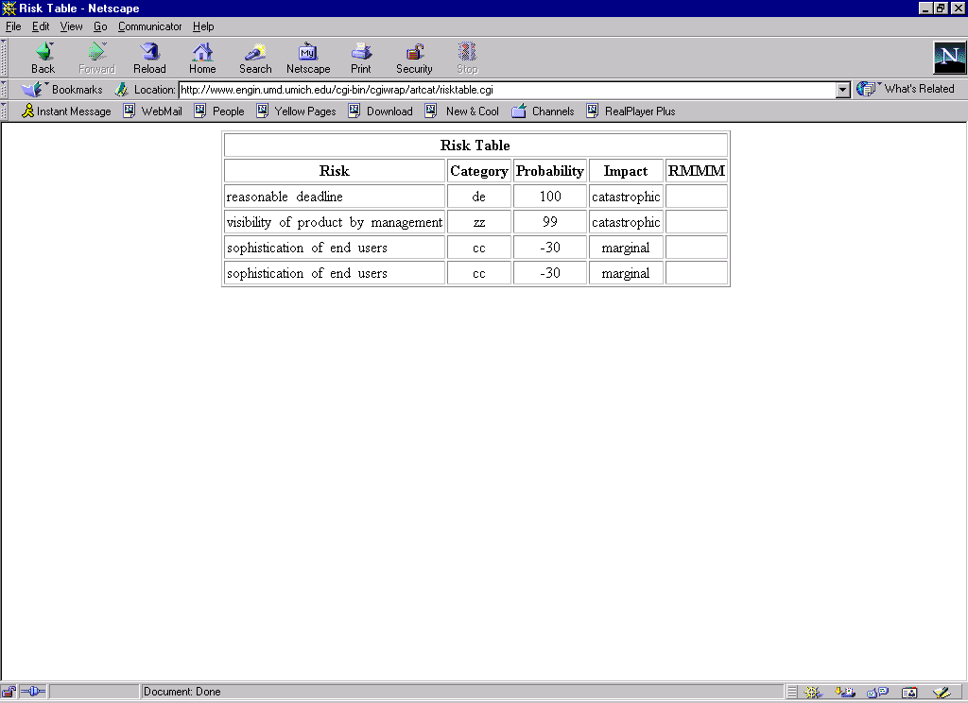
Output from above entries

Analysis: Given the above outputs, it is apparent that the user provide exactly the correct data, as there currently is no error checking. It is also essential that the user enters consistent data, and that the user knows what is meant by the data they enter. This is a result of being able to enter probabilities in a variety of formats, (60%, 70, .80), and entering risks that otherwise do not appear in the system's database.

Print
Main
MakeDb
Insert
Level 1
Level 2
Switch
RiskFromDb
Insert_User
RetrieveRisk
Constructor
output
InsertInOrder
Sort
AtEnd
Level 3
Advance
Init cursor
Level 0

Print
Main
MakeDb
Insert
Level 1
Level 2
Switch
RiskFromDb
Insert_User
RetrieveRisk
Constructor
output
InsertInOrder
Sort
AtEnd
Level 3
Advance
Init cursor
Level 0

3.1.1 Program structure: architecture diagram
The diagrams below constitute the basic system architecture.

User interface
System back-up and administrator verification
Risk table builder
Risk assessment table
RTable.dat
User identified risk
Risk key
Risk table builder web page
Use request
Prompts, queries
New risks tables and user entries
Validated dated
input | process | output
Self-test and maintenance

User interface
Database formatting subsystem
Database update
Risk identification subsystem
Web input reading subsystem
Database query input processing subsystem
Web submission
.exe input
Risks
key
Risk identify request
Operator interface subsystem
Applicable risks
Risk entry
Format
prompt
Format request
Table output
Accepted risks and user data
input  User output formatting subsystem  Risk management report subsystem  Identified risks  Database access subsystem  Identified risks | process | output
Database back-up subsystem
System administrator validation subsystem
System administrator queries
Confirmed entries

Self-test and maintenance

3.1.2 Alternative architecture considerations:

In the consideration of alternative architectures, the basic system functionality must remain intact. This tends to indicate a change in the "process" and "input" components of the Architectural Context Diagram. Implementing any alteration would amount to limit the user's ability to enter and identify their own risks, thereby negatively affecting the system's marketability to expert users.

Another potential architectural change would be in the operating environment. By allowing the user to utilize the web to download the executable applications, the system becomes more marketable to a broader demographic base. To remove this utility would mean to severely hamper the system's desirability.

3.2 Architectural Component Description:
Below are Process Specifications for each component in the Architectural Diagram
Operator interface
Operator interface subsystem

The operator interface for the Risk Table Builder prompts the user for the type of risks they would like to consider. These could be chosen from a list of risks stored in the system database, or they could be entered by the user themselves. If the user is on the system's web-site, they can submit a query for applicable risks before downloading the system executable file.

Web input reading
Web input reading subsystem

The "web input reading subsystem" performs two basic tasks. First, it accepts user input for the identification of risks. These risks are later entered into the system's executable for assessment and processing purposes. Secondly, the subsystem processes any requests for downloading the software.

Database query input subsystem
Database query input

The "database query input" subsystem receives any perceived risks from the user for assessment and categorization. These risks are cross-referenced with those contained in the database for the formulation of the Risk Builder Table.

Risk identification
Risk Identification Subsystem

The "risk identification subsystem" receives the risks from the query input subsystem. It is the cross-referencing component of the system, returning the applicable risks, their categories and any other pertinent information.

Database access
Database Access Subsystem

The "database access subsystem" is the component that interacts with the database. This subsystem works in conjunction with the "risk identification subsystem" in pinpointing the risks to be considered.

Risk reporting
Risk management report subsystem

Once the risks have been identified and collected, the "risk management report subsystem" processes the risks by prioritizing them in terms of impact and probability.

User output
User Output Format Subsystem

The "user output format subsystem" prepares the accumulated risks into a tabular format This is output to a screen and a data file.

Database output
Database Output Subsystem

The "database output subsystem" is the component that updates the database. Any additional pertinent information in terms of new risks is then stored in the system.

System admin validation
System Admin. Validation Subsystem

It is the System Administrator's responsibility to insure that the links on the web page remain valid. Any 404 errors must be addressed, corrected or removed.

Database backup
Database back-up subsystem

It is the System Administrator's responsibility to insure that system is backed-up on a regular basis. Any system failures must be addressed in a timely fashion.

7.1 Requirements Traceability Matrix
The matrix below relates each software requirement to a component and data structure.

 | Operator defined risks | Ease of use | Editable .dat file | Maintainable database | Reliability | Advanced search | Internet applicability
Operator interface | x | x | x |  |  | x | x
Input reading | x |  |  |  | x | x | x
Query input | x |  |  |  | x | x | x
Risk identification | x |  |  |  | x | x
Database access | x |  | x | x | x | x
Risk reporting |  | x |  |  |  | x
User output |  | x |  |  |  | x
Database output |  |  | x | x
Sys. Admin. validation |  |  | x | x | x
Database back up |  |  | x | x | x
Data structures
Linked list | x |  | x | x |  | x
"struct" | x |  | x | x |  | x
Switch statement | x |  | x | x

7.2 Packaging and Installation Issues:

The system will be delivered in two ways: on a CD-ROM and by downloading from the system's website. As these are very common installation and packaging practices, no unusual considerations are foreseen in this area.

7.3 Design Metrics:
The design metrics to consider are as follows:
- Mis-identification of a risk
- User's risk not added to data base
- Mean time between fail
- Incorrect risk table output
- Incorrect system installation
- Incorrect system download
- Web site capacity

Wait state
Link to web access
Link to download .exe
Download .exe
User enters risk
User enters category
User enters impact
User enters probability
User submits
entry
User prompts for output
User prompts for web

Web page accessed
Risk prompt

Receive risk
Category prompt

Receive category
Impact prompt

Receive impact
Probability prompt

Receive probability
Prompt for entry

User enters risk
User prompts as finished

Risk table compiled
Risk table output

Return to wait state
User prompts .exe download

Download page
accessed
User downloads

Shows as complete
Download complete

Return to wait

User prompts for more entries

Return to risk prompt

